International representative success for
Guildford McCredie Uniting Soccer Club

McCredie is proud of being able to boast three ex players who have gone on to international honours.

* Mohammed Naim Rahimi who played U12 – 17 and a number of seasons of All Age with McCredie would be added to the Afghan National Team in 2018 and as at January 2019 has 2 caps.

Afghan National Team
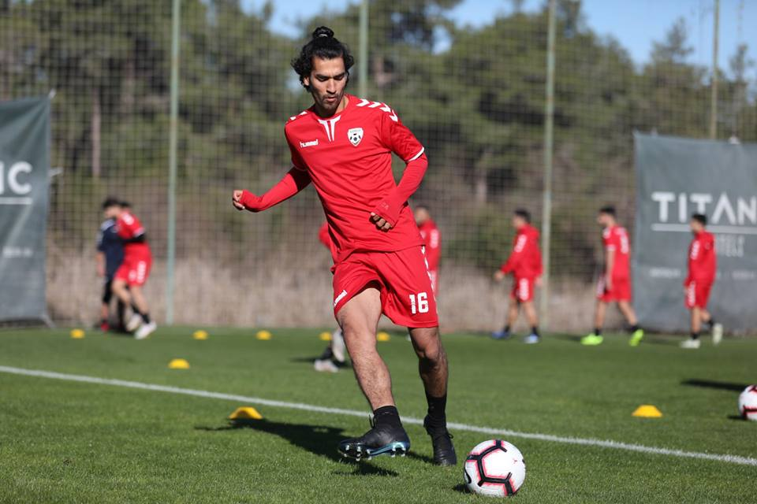

Malaysia Premier Liga

Mohammed Rahimi (DRB-Hicom F.C ) 2013/14
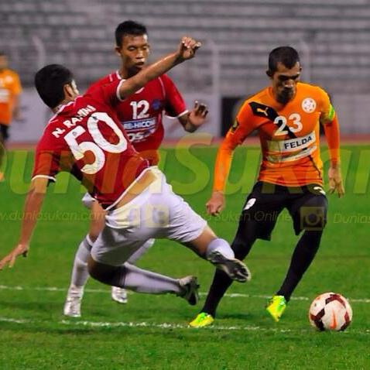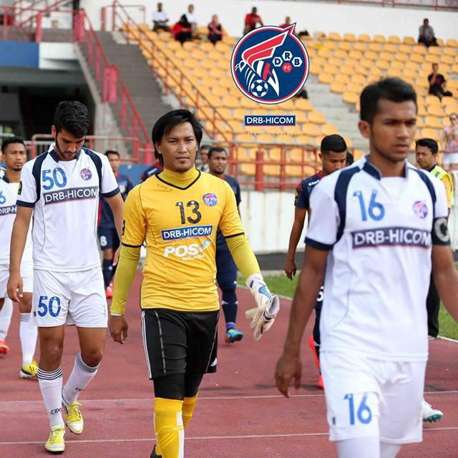

No.50

S. League (Singapore)

Mohammed Rahimi (Tampines Rovers ) 2014/15

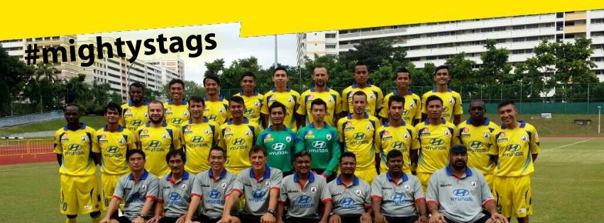
4th from right 2nd row

* Martin Lo who played under 7, 8, 9, 11 and Raahauge Cup with McCredie was selected to play in the 2010 Australian under 13s in Malaysia.

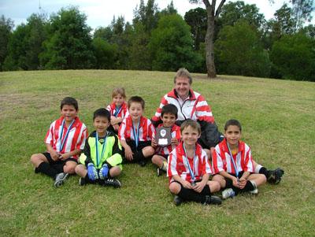 | 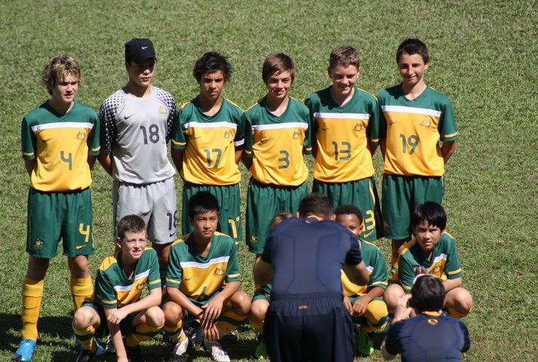
In 2004, in his first year with the club, Martin plays goalie in the victorious U7 six a side team | In Malaysia with the U13 Australian team  (Martin second from left – front)
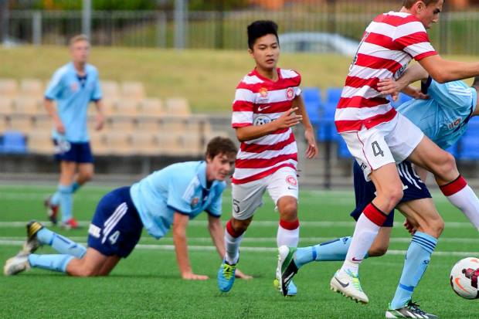 | 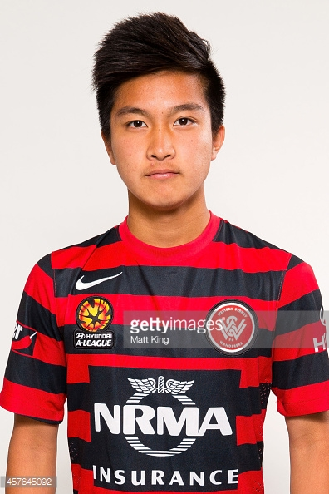
2013 in action for Western Sydney Wanderers National Youth League | In 2015 Martin signed with A League’s Western Sydney Wanderers
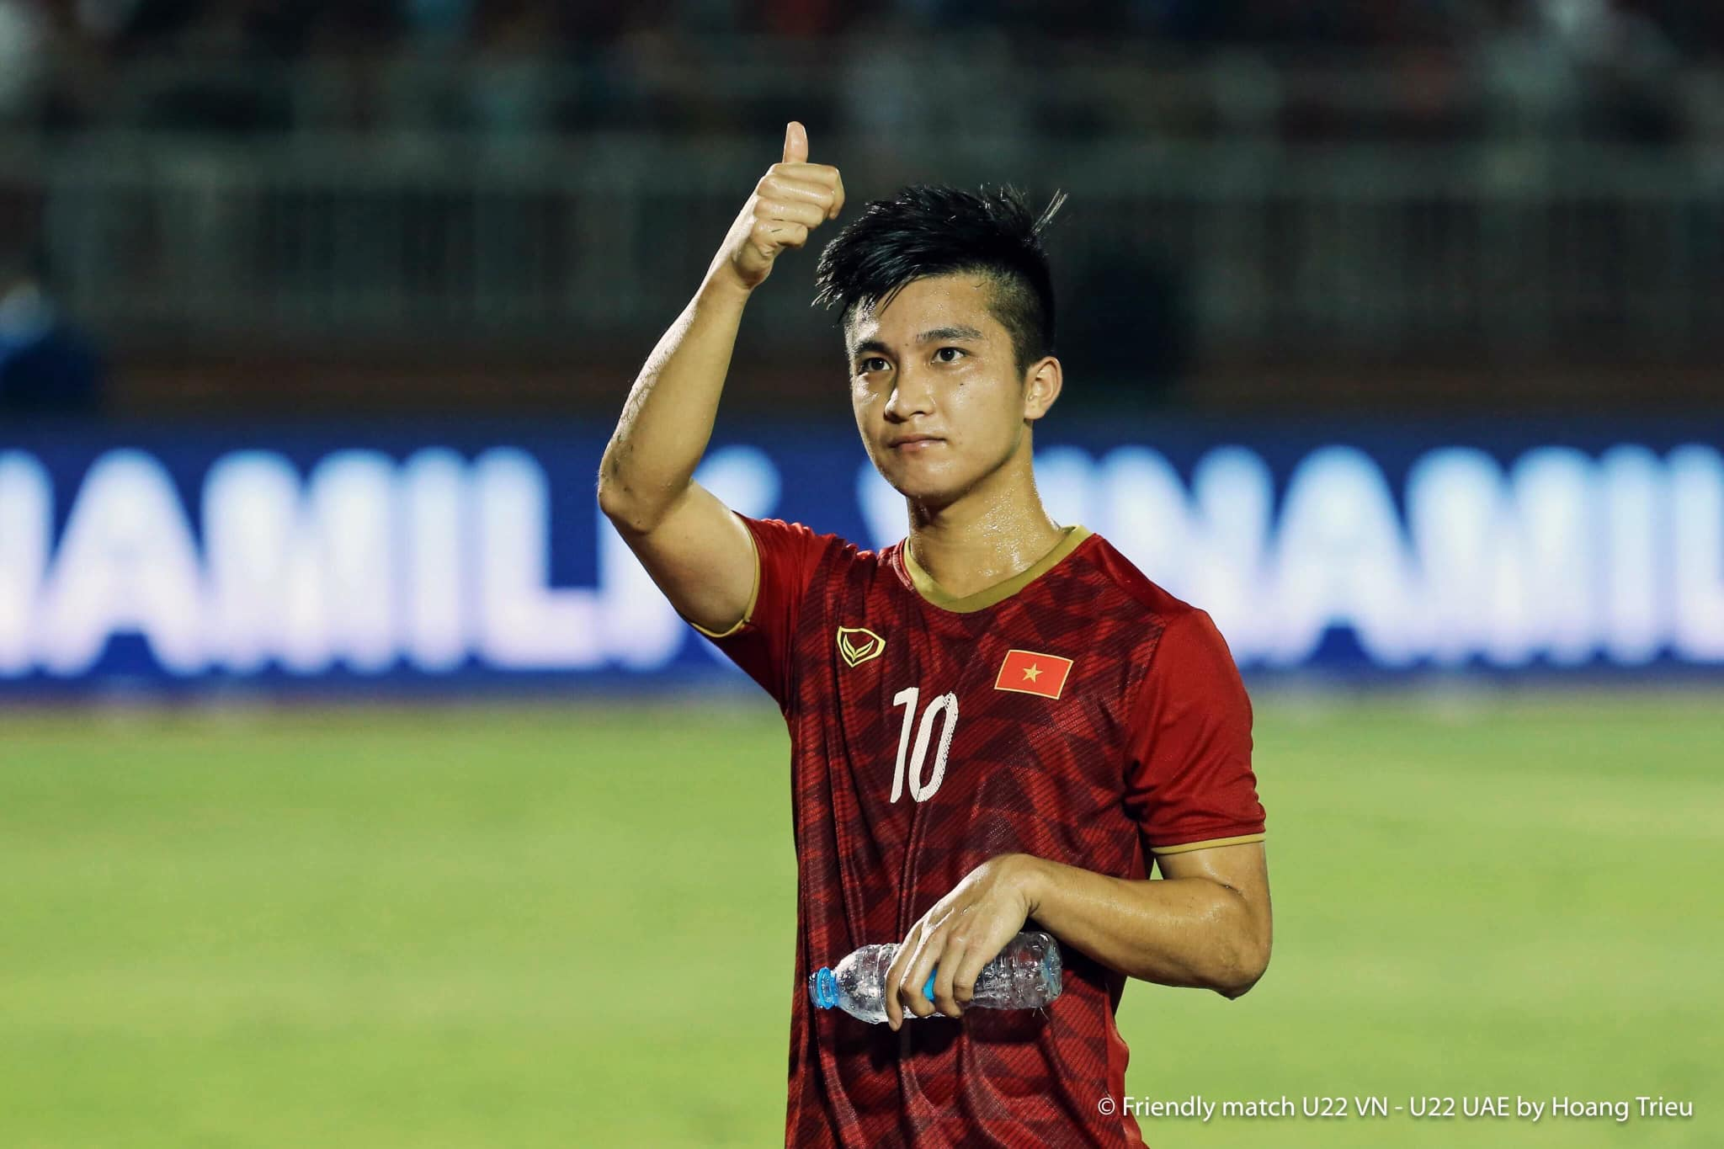 | 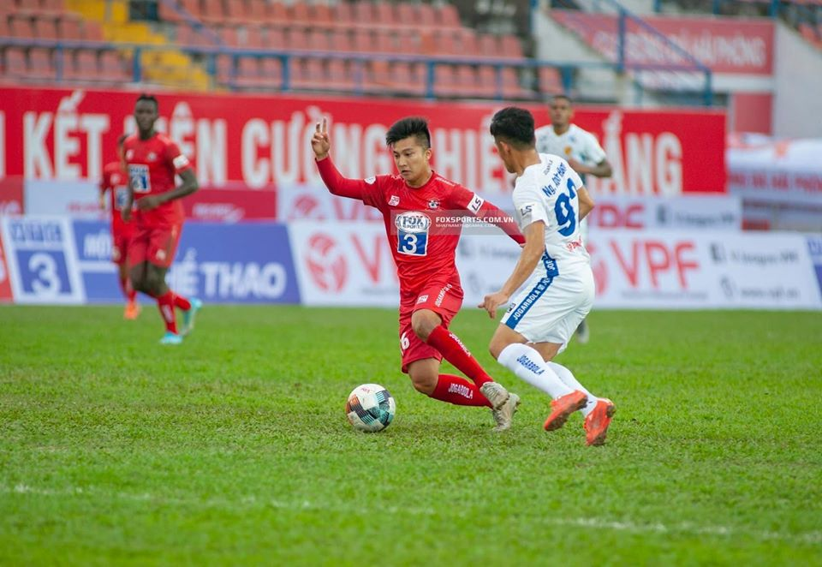
In 2019 Martin debuted for Vietnam U23s | In 2020 Martin debuted for CLB Hai Phong in Vietnam’s Premier League

* Pita Rabo played in our 2000 Raahauge Cup Squad and subsequently captained the Fiji National side and participated in the 2002 and 2006 World Cup Qualification campaigns.

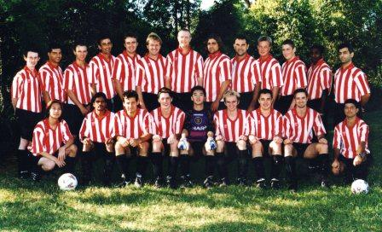 | 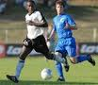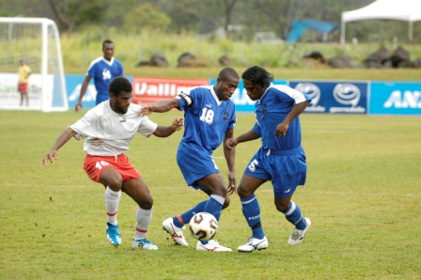
Raahauge Cup Squad 2000  (Pita second from right – back row) | Pita in action for Fiji

McCredie Players to have gone on to higher honours

Senior

Full International

Pita Rabo (Fiji – Captain)
Mohammed Naim Rahimi (Afghanistan 2018 - )

U23s

Martin Lo (Vietnam)

A League

Mark Cindric Western Sydney Wanderers – 2013/14

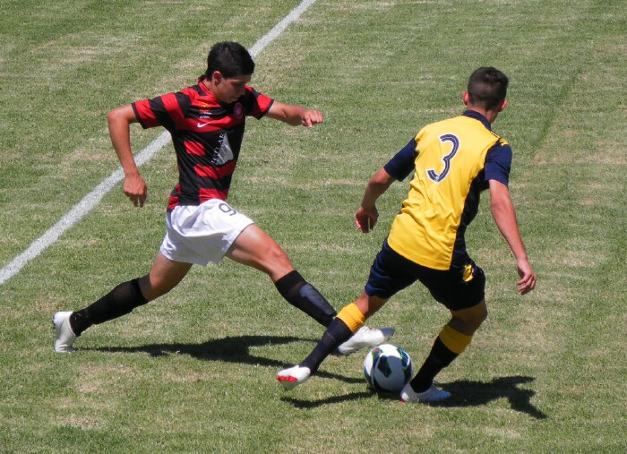

Martin Lo Western Sydney Wanderers – 2014/15
CLB Hai Phong (Vietnam) - 2020

Men’s Premier Elite 2, NPL 1

Mohammed Rahimi (Sydney Olympic)

Men’s Premier Elite 2, NPL 2

Kuag Reec (Northern Spirit)
Mohammed Rahimi (Bankstown Berries, Blacktown Spartans)

Women’s State League

Mika Oo (Parramatta Ladyhawks)

Junior

Junior International

Martin Lo (Australia U13s, Vietnam U23s)

Representative

Tony Lo (National Youth League – Sydney FC)
(Western Sydney at State Championships)
(Granville – Metropolitan Cup)
Martin Lo (National Youth League – Western Sydney Wanderers)
(Western Sydney at State Championships)
(Granville – Metropolitan Cup)
Mohammed Rahimi (Western Sydney at State Championships)

Mark Cindric (National Youth League – Western Sydney Wanderers)

Premier Youth League, Premier Elite 1

Tony Lo (Parramatta Eagles, Rockdale City Suns)
Martin Lo (Bankstown Lions, NSWIS)
Mark Cindric (Marconi Fairfield)
David Semialjac (Marconi Fairfield)
Daniel Joya (Marconi Fairfield)
Rabur Abdallah (Parramatta Eagles)
Daniel Jabou (Blacktown Spartans, Marconi Fairfield)
Abdallah Conteh (Apia Leichhardt, Manly)

Super Youth League, Premier Elite 2

Ahmed Abdul Hamid (Fraser Park)
Abdullah Conteh (Blacktown Spartans)
Mohammed Rahimi (West Sydney Berries)
Daniel Jabou (Granville Rage)
Aaron Demirel (Granville Rage)
Tony Lo (West Sydney Berries, NSWIS)
William Wark (Bankstown Lions)
Mick Lakin (Macarthur Rams)
Martin Lo (NSWIS)
Kuag Reec (Hills Brumbies)
Junior Clark (Hills Brumbies)
John Kazzi (Parramatta Eagles)
Deng Deng (Bankstown Berries)
Tawab Taufiq (Fraser Park)
Jamal Swalah McDahrou (Rydalmere)
Mase Swalah McDahrou (Rydalmere)
Ali Hawchar (Mount Druitt)
Luke Fernandes (Dulwich Hill)
Abdul Jalloh (Parramatta FC)

NPL 4

Muhammed Alizada (Parramatta FC) Abdul Jalloh (Parramatta FC)
Mamoud Jalloh (Parramatta FC)

SAP

Will List (Parramatta Eagles)
Yel Chan (Blacktown Spartans)

Yusuf Hadi (Parramatta FC)
Daniel Alouche (Parramatta FC)
Alex Azar (Parramatta FC)

Division 1 State Youth League

Junior Clark (Hills Brumbies)
William Wark (Granville Rage)
Aaron Demirel (Granville Rage)

NSWCFA Representative

Dylan Trevor (AAM - 2011)
Adem Stevens (AAM - 2012) (All stars 2012)
William Wark (AAM – 2016, 2018-19) (All Stars 2016)
Amarvir Batth (AAM – 2016)
Angus Chance (AAM – 2017)
Mohammed Rahimi (AAM – 2017)
Darren Warren (AAM – 2017)
Yousif Almaroof (AAM – 2019)

Genell Hunt (AAL – 2014, 2016)
Mika Oo (AAL – 2014)
Taufa Kivalu (AAL - 2014)
Megan Warwick (AAL – 2015)
Jenna Nowlan (AAL – 2016-2019)
Rana Karakus (AAL – 2017)
Natasha Muru-Tucker (AAL – 2017-2019)
Destiny Joseph (AAL – 2018-2019)
Sharlene Muru-Tucker(AAL – 2019)

Darren Warren (U23 – 2014,16,17, 19)
Mohammed Rahimi (U23 – 2016) (Player of the tournament 2016, All Stars 2016)

William Wark (U18 – 2012, 2014-15)
Junior Clark (U18 – 2012, 2013)
Mohammed Rahimi (U18 – 2012) (Player of the tournament 2012, All Stars 2012)
Abdallah Conteh (U18 – 2012, 2014)
Mahammad Abdul Hamid (U18 – 2014-15)
Warren Spencer – Scarr (U18 – 2016)
Mahmoud Jalloh (U18 – 2019)
Muhamed Alizada (U18 – 2019)

William Wark (U16 – 2013)
Mahammad Abdul Hamid (U16 – 2013)
John Kazzi (U16 – 2014)
Willem Booker (U16 – 2014) (All stars 2014)
Alan Trad (U16 – 2014)
Ali Hawchar (U16 – 2015)
Ahmad Saad Ekdawy (U16 – 2016)
Jakob Kaihea (U16 – 2016, 2017)
Mahmoud Jalloh (U16 – 2017-2018)
Muhamed Alizada (U16 – 2018)
Ibrahim Koroma (U16 – 2019)

Thuzar Oo (U16G – 2014)
Sulafa Ageeb (U16G – 2015-16)
Sharlene Muru – Tucker (U16G – 2015,16,17) (All Stars 2016-2018)
Chloe Hildred (U16G – 2016)
Tahlia Hildred (U16G – 2016)

John Kazzi (U14 – 2012)
Willem Booker (U14 – 2012)
Jason Tran (U14 – 2012)
Peter Youssef (U14 – 2012)
Joel Booker (U14 – 2013)
Jacob Mitwali (U14 – 2013)
Kabin Rana (U14 – 2013, 2014)
Salem Boustany (U14 – 2013)
Matthew Richards (U14 – 2013, 2014)
Jasper Carr (U14 – 2015)
Jakob Kaihea (U14 – 2015)
Ahmed Saad Ekdawy (U14 – 2015)
Andrew Ibraheem (U14 – 2016) (All Stars 2016)
Ryan Booker (U14 – 2016)
Abdul Jalloh (U14 – 2016, 2017)
Mahmoud Jalloh (U14 – 2016)
Joe Azzi (U14 – 2016)
Nedim Fazlic (U14 – 2016)
Mounir Hadid (U14 – 2017)
Jackson Galea (U14 – 2017) (All stars 2017)
Aakrist Nepal (U14 – 2017)

