No. 15/05

Club Secretary – Greg 9682 7779
Assistant Secretary – Peter 9632 9203
Interested in sponsoring a team or advertising in this newsletter? – call Craig 0405 399 571
_____________________________________________________________________________________
TRAINING – There will be no training on Wednesday 6/7/05 for 6Reds, 7 Reds, U8s, U14s, RCN;
There will be no training on Wednesday 13/7/05 for the U8s.
All other teams CHECK WITH YOUR MANAGER IF YOU ARE NOT SURE.
 |  |  | POINTS TABLE
Under 8 Division 1 |  |  | UNDER 9 Division 1 |  |  | UNDER 10 Division 1
OLQP Falcons P | 22 |  | Guildford McCredie Uniting | 19 |  | Guildford McCredie Uniting | 18
OLOR Kellyville G | 18 |  | St Bernadettes Castle Hill L | 15 |  | St Michaels Baulkham Hills D | 16
St Bernadettes Castle Hill E | 15 |  | OLOR Kellyville W | 14 |  | OLQP Falcons | 16
St Michaels Baulkham Hills R | 14 |  | Coverdale Christian School | 13 |  | St Bernadettes Castle Hill E | 16
Guildford McCredie Uniting | 13 |  | OLQP Falcons Q | 11 |  | Carlingford Uniting | 11
St Michaels Baulkham Hills W | 9 |  | Rouse Hill Anglican College | 9 |  | Coverdale Christian School | 6
Blacktown Reformed | 6 |  | St Michaels Baulkham Hills P | 6 |  | Lidcombe Churches | 5
OLQP Falcons L | 5 |  | Blacktown Uniting | 1
Lidcombe Churches | 4
Carlingford Uniting | 4
UNDER 11 |  |  | UNDER 12 |  |  | UNDER 13
OLQP Falcons P | 22 |  | Guildford McCredie Uniting | 20 |  | Greystanes Churches maroon | 20
Wentworthville Uniting | 16 |  | OLQP Falcons | 20 |  | OLQP Falcons | 17
OLQP Falcons Q | 14 |  | Lidcombe Churches | 19 |  | Lidcombe Churches | 15
Lidcombe Churches | 14 |  | St Bernadettes Castle Hill | 11 |  | Guildford McCredie Uniting | 13
Guildford McCredie Uniting | 12 |  | Wentworthville Uniting | 11 |  | Coverdale Christian School | 13
Carlingford Uniting | 12 |  | Carlingford Uniting | 10 |  | St Michaels Baulkham Hills | 4
St Bernadettes Castle Hill | 9 |  | St Columbas Castle Hill | 7 |  | Greystanes Churches blue | 4
St Michaels Baulkham Hills | 7 |  | St Michaels Baulkham Hills | 7 |  | Rouse Hill Anglican College | 2
Greystanes Churches | 4 |  | Blacktown Reformed | 5
UNDER 14 |  |  | UNDER 16 |  |  | Raahauge Cup North Firsts
Guildford McCredie Uniting | 21 |  | St Michaels Baulkham Hills | 20 |  | Guildford McCredie Uniting | 23
Lidcombe Churches | 16 |  | St Columbas Castle Hill | 17 |  | Carlingford Uniting | 20
St Columbas Castle Hill | 13 |  | Lower Mountains Churches | 17 |  | St Patricks Strathfield | 16
St Michaels Baulkham Hills | 11 |  | Lidcombe Churches | 15 |  | Greystanes Churches | 15
Blacktown Reformed | 5 |  | Guildford McCredie Uniting R | 14 |  | Penrith Churches | 10
 |  |  | St Matthews Baulkham Hills | 13 |  | St Columbas Castle Hill | 9
 |  |  | Guildford McCredie Uniting W | 6 |  | Wentworthville Uniting | 6
 |  |  | Blacktown Reformed | 6 |  | Bethany Baptist | 5
 |  |  | Penrith Churches | 2
 |  |  | Blacktown Uniting | 0
Raahauge Cup North Res. |  |  | Raahauge Cup Div. 1 Firsts |  |  | Raahauge Cup Div. 1 Reserves
Guildford McCredie Uniting | 22 |  | Castle Hill Baptist | 19 |  | Castle Hill Baptist | 21
Greystanes Churches | 18 |  | Campbelltown Wasps | 17 |  | Moorebank Rovers | 21
St Patricks Strathfield | 17 |  | St Matthews Baulkham Hills | 17 |  | Arncliffe Presbyterian | 18
Penrith Churches | 16 |  | Guildford McCredie Uniting | 16 |  | Guildford McCredie Uniting | 13
Carlingford Uniting | 15 |  | Arncliffe Presbyterian | 15 |  | St Matthews Baulkham Hills | 13
Wentworthville Uniting | 8 |  | Mortdale Baptist | 12 |  | Mortdale Baptist | 10
St Columbas Castle Hill | 6 |  | Columna | 9 |  | Campbelltown Wasps | 10
Blacktown Uniting | 2 |  | Hills Alliance | 3

PHOTOS
Thankyou to all the parents and players who enabled the club photos to be taken on Saturday. It was very important that this happened as the photographer is heavily booked.

We still have two junior teams and the senior teams to have their photos and we are busily trying to sort out a time to take these.
U7 Whites, U14s and the four Raahauge Cup teams will be notified shortly.

RAIN
In the event of rain we need everybody to cooperate.

Rain is nobody’s fault but we are all disappointed when games are cancelled.
On training day if it rains ring your team manager.
Saturdays they will ring you if the game is off (by all means ring them if you’re not sure).
Mobile phones turned off, changed numbers, emails not checked and managers not contacted can all lead to problems in communication.
The following information is reprinted from earlier newsletters to assist.

RAIN – WHAT TO DO

It’s raining, it’s Saturday!! Is the game on??

Your manager will know if the game is on, give them a call. Very rarely is a decision made before Friday evening. If I have not called your manager, the game is on, even if it is raining!

It’s raining and it’s training tonight!! Is training on??

Coaches and managers call the wet weather line 9294 8586. If the ground is closed you cannot train, even if it’s not raining!! Parents and players call the manager or coach.

If for any reason your child is unable to play you must ring your team manager who will relay this information to the coach.
TEAM | COACH |  | MANAGER |  | Mobile contact
6 RED |  |  | Theresa Woetai 9689 1878 |  | 0425 205 138 Theresa
6 WHITE | Waleed Wehbe 9632 4889 |  | Helen Mills 9632 1740 |  | 0409 553 992 Helen
7 RED | Roger Wehbe 9681 7857 |  | Sean Barkley 9681 6868 |  | 0419 666 007 Sean
7 WHITE | Tom List 9637 0161 |  | Craig 0405 399 571 |  | 0405 399 571 Craig
7 BLACK | Katherine French 9892 1428 |  | Megan Warwick 9632 9203
8 | Greg Wark 9682 7779 |  | Carolynne Wark 9682 7779 |  | 0438 682 777 C’lynne
9 | Carl Mower 9760 1662 |  | Frank Skiller 9885 3558 |  | 0403 836 592 Frank
10 | Sam Eid 9637 1112 |  | Emile Elcheikh 8720 2753 |  | 0413 361 112 Sam
11 | Goya Hedayat 9635 4503 |  | Philip Rafter 9688 2478 |  | 0414 461 371 Philip
12 | Ian Warwick 9632 9203 |  | Lana Borg 9885 3900 |  | 0402 748 017 Ian
13 | Robert Hopper 9788 2063 |  | Tracey Hopper 9788 2063 |  | 0432 802 084 Tracey
14 | Greg Wark 9682 7779
16 RED | Robert French 9892 1428 |  | Helen French 9892 1428 |  | 0412 762 373 Helen
16 WHITE | Marco Olmos 0409 327 468 |  | William Naing 9637 1189 |  | 0411 798 851 William
Raahauge Cup North Firsts |  | Greg Wark 9682 7779 |  | Philip Rafter 9688 2478 |  | 0414 461 371Phil
Raahauge Cup North Reserves |  | Greg Wark 9682 7779 |  | Philip Rafter 9688 2478 |  | 0414 461 371Phil
Raahauge Cup Div 1 Firsts |  | Peter Hession 9632 8860 |  | John Houlford 9632 7511 |  | 0402748 017John
Raahauge Cup Div 1 Reserves |  | Peter Hession 9632 8860 |  | John Houlford 9632 7511 |  | 0402748 017John


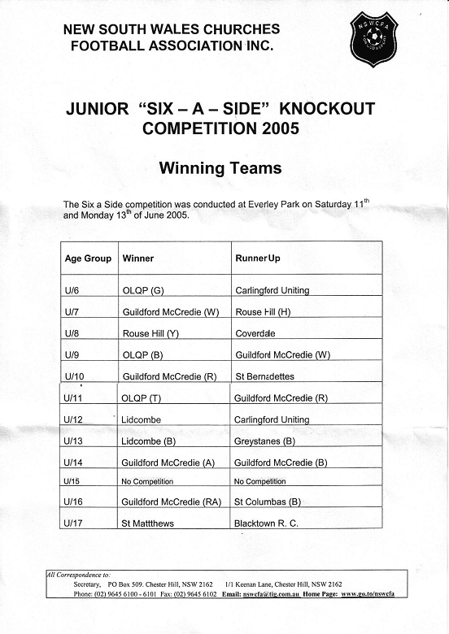

KNOCKOUTS

There has been no confirmation of the next round draws.

It could be expected though that the games from 2/7 would be replayed on 16/7. (We have asked that the 10s be played at another time –but who knows?)
We are still in the U8, U10, U11, U12, U14, two teams still in U16, two senior teams still in the B Grade.
DRAW – Saturday 9th July SENIORS ONLY

Raahauge Cup North Div.

Reserves vs Blacktown Uniting

Firsts vs Bethany Baptist at Golden Grove (Isaac Smith Pde., Kings Langley)

(Reserves Kick off at 1.30pm, Firsts at 3.15pm) (Meet at Golden Grove at 1.00pm)
KNOCKOUT vs Penrith Churches Monday 4/7/05 8pm at Jones (Banks St. Merrylands)

Raahauge Cup First Div.

Reserves vs Moorebank Rovers

Firsts vs Columna at Birrong (cnr Wellington & Woods Rd., Birrong)

(Reserves Kick off at 1.30pm, Firsts at 3.15pm) (Meet at Birrong at 1.00pm)
________________________________________________________________________________
DRAW – Saturday 16th July

U6 RED vs McCredie White at Everley mini (Everley Rd., South Granville)

10am Kickoff (meet at Everley at 9.30am)

U6 WHITE vs McCredie Red at Everley mini (Everley Rd., South Granville)

10am Kickoff (meet at Everley at 9.30am)

U7 RED vs Fairfield City at Everley mini (Everley Rd., South Granville) 11am Kickoff (meet at Everley at 10.30am)

U7 WHITE vs OLOR Kellyville W at Everley mini (Everley Rd., South Granville)

9am Kickoff (meet at Everley at 8.30am)

U7 BLACK vs St Bernadettes Castle Hill at Excelsior 1A (Excelsior Ave., Castle Hill)

9am Kickoff (meet at Excelsior at 8.30am)

U8 vs Carlingford Uniting at Homelands Reserve (Homelands Ave., Telopea)

11am Kickoff (meet at Homelands at 10.30am)

U9 vs OLQP Falcons Q at Daniel 1 (Daniel St., Greystanes)

9.45am Kickoff (meet at Daniel at 9.15am)

U10 vs Bye

U11 vs OLQP Falcons P at Daniel 1 (Daniel St., Greystanes)

12pm Kickoff (meet at Daniel at 11.30am)

U12 vs St Columbas Castle Hill at Everley 1 (Everley Rd., South Granville)

9.30am Kickoff (meet at Everley at 9am)

U13 vs OLQP Falcons at Uren (Karani Ave., West Guildford)

11am Kickoff (meet at Uren at 10.30am)

U14 vs Blacktown Reformed at Everley 1 (Everley Rd., South Granville)

10.30am Kickoff (meet at Everley at 10am)

U16 RED vs Lidcombe Churches at Everley 1 (Everley Rd., South Granville)

11.45am Kickoff (meet at Everley at 11.15am)

U16 WHITE vs Lower Mountains Churches at Everley 3 (Everley Rd., South Granville)

11am Kickoff (meet at Everley at 10.30am)

Raahauge Cup North Div. vs St Patricks Strathfield at Everley 1 (Everley Rd., South Granville) (Reserves Kick off at 1.30pm, Firsts at 3.15pm) (Meet at Everley at 1.00pm)

Raahauge Cup First Div. vs Castle Hill Baptist at Excelsior 2 (Excelsior Ave., Castle Hill)

(Reserves Kick off at 1.30pm, Firsts at 3.15pm) (Meet at Excelsior at 1.00pm)

