No. 8/07

TEAM PHOTOS WILL BE TAKEN OVER THE NEXT TWO WEEKS
PLEASE CHECK THE BACK PAGE CAREFULLY TO CHECK ON YOUR PHOTO TIME
PLEASE BE ON TIME FOR YOUR PHOTO
ALL PHOTOS MUST BE PAID FOR IN ADVANCE – SEE YOUR TEAM MANAGER

Thankyou for everyone’s cooperation last Saturday. Councils did not close grounds until 7am Saturday morning which meant a lot of last minute calls. When it is wet, games remain on until you are called. If it is wet managers please attempt to keep your phone available. If you are a player be as patient as possible, we cannot let you know anything definite before 7am. Calling me earlier than that just ties up my phone and may stop me from getting the information you want me to know.

Club Secretary – Greg 9682 7779 Assistant Secretary – Peter 9632 9203 Sponsorship - Helen 9892 1428

Newsletter 7/07 was not printed but was emailed and is available on the website.

ALL FEES ARE NOW OVERDUE AND A $20 LATE FEE APPLIES.

Tables are now available on the website at www.mccredie.org.au/soccer
Also on the website is a history of competition winners since 1962 – have a look, by pressing ‘control, f’ you can find any competition or club you are interested in, also there are some new links to other clubs on our site.
_____________________________________________________________________________________
RESULTS from Saturday 28th April 2007

All junior games cancelled due to councils closing grounds.

RC South RESERVES vs Bye

RC South FIRSTS vs Waratah United postponed until Thursday 10th May 7.30pm

RC North RESERVES vs Nile Eagles Reserves 1 – 5
We didn’t get thrashed today like we were expecting to. The result does not indicate how close the game was. Our defence, Peter, George, Maher and Steve, were given a real work out along with the rest of the team never giving up and playing with some improved teamwork. Wayne was put under a lot of pressure making some great saves. Waleed, Scott and Abbos put the opposition under pressure with Waleed finally scoring a goal. Thanks again to the players who helped out again today.
Goalscorer: Waleed Wehbe 1

RC North FIRSTS vs Nile Eagles 4 – 2
Finally we went out and played with our hearts instead of our mouths and proved that we still have something left in our old legs. A big thank you to the reserve grade boys - George, Abbos, Rhys and Steven for filling in. Two great goals from Abbos and one from Peter Palmano gave us a 3-0 lead in the first half. The Eagles scored two back quickly in the second and then Rafaele finished the game with an absolute screamer from halfway. The game finished 4-2. Well done guys - lets keep it up.
Goal scorers – Abbos Ahmedov 2, Peter Palmano 1, Raffaele Messineo 1

RC 1 RESERVES vs St Patricks Strathfield 3 – 2
Continued on our winning way with some neatly taken goals, a screamer from the other side of halfway and sensible play in the wet.
Goal scorers – Ricardo Zuniga 1, Maky Maky 1, Caner Temel 1

RC 1 FIRSTS vs St Patricks Strathfield 4 – 2
We are scoring plenty of goals so it’s about time we cracked it for a win. Jose Quiroga had his best game this year with lots of purposeful running and plenty of ball. Jose made sure he was very involved today. Pece continued his class up front, giving opposition fullbacks a lesson in defending and Booph and Dylan had crackers again. A strong performance.
Goal scorers – Pece Kotevski 2, Mirwais Waseeq 1, Jose Quiroga 1

PHOTO OPTIONS AND PRICES

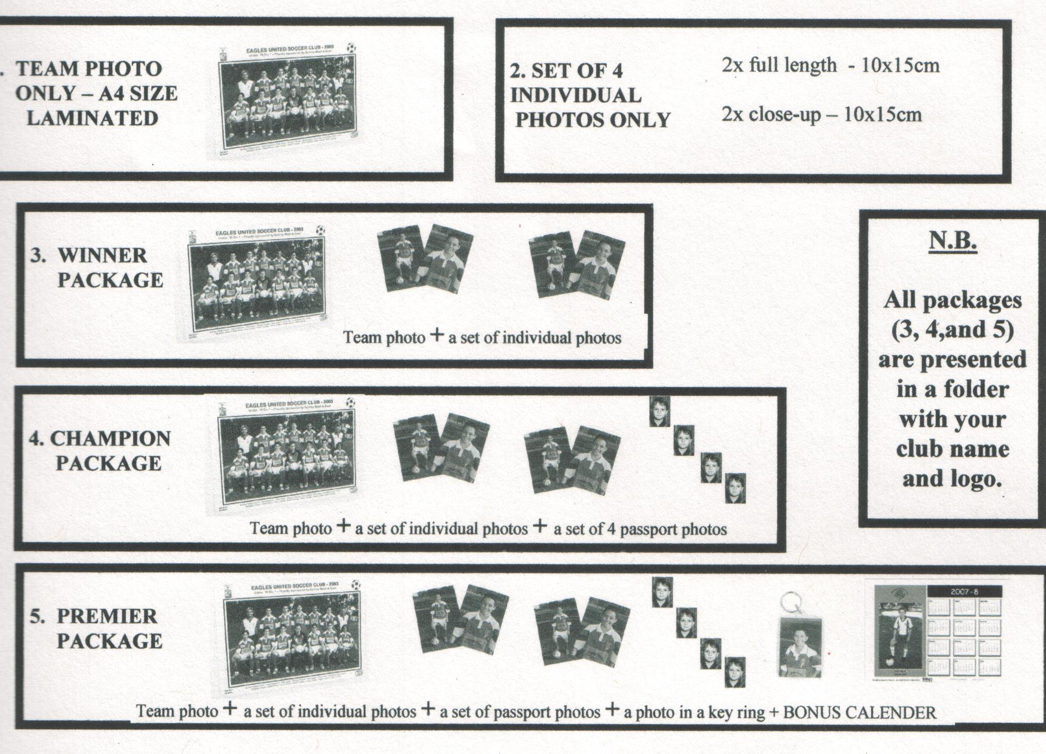

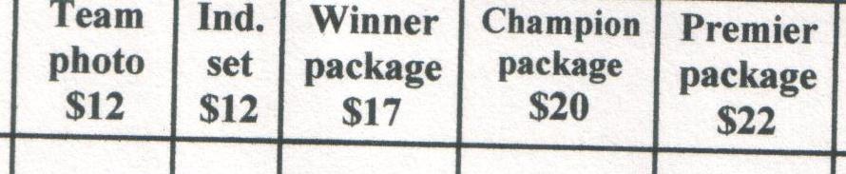

Managers – please note instructions on back of envelope you have been given.

Please also stress to your teams the importance of being on time. Any body not wanting to purchase a photo must also be on time so that the team photo is not spoiled for their team mates.

Envelopes completed, with cash inside are to be given to the photographer on the Saturday, before the photos are taken.

 |  |  | POINTS TABLE |  |  | AFTER ROUND 3
UNDER 8 Division 1 |  |  | UNDER 9 Division 1 |  |  | UNDER 9 Division 2
Carlingford Uniting Gold | 9 |  | St Michaels Baulkham Hills W | 9 |  | St Michaels Baulkham Hills G | 9
OLQP Falcons Q | 9 |  | Guildford McCredie White | 7 |  | Blacktown Reformed | 6
Guildford McCredie Uniting | 6 |  | Carlingford Uniting | 7 |  | OLOR/St Angelas Kellyville White | 6
St Michaels Baulkham Hills D | 6 |  | St Bernadettes Castle Hill E | 4 |  | Guildford McCredie Red | 3
Wentworthville Uniting | 6 |  | Lidcombe Churches | 4 |  | St Bernadettes Castle Hill Tigers | 3
St Bernadettes Castle Hill L | 4 |  | OLOR/St Angelas Kellyville Red | 1 |  | Wentworthville Uniting | 3
OLOR/St Angelas Kellyville G | 4 |  | St Michaels Baulkham Hills V | 1 |  | OLQP Falcons P | 3
Greystanes Churches | 0 |  | OLQP Falcons Q | 0 |  | St Michaels Baulkham Hills M | 3
Rouse Hill Anglican College | 0
St Michaels Baulkham Hills C | 0 |  | UNDER 11
 |  |  | Guildford McCredie Uniting | 9
UNDER 10 |  |  | St Michaels Baulkham Hills S | 9
OLQP Falcons Q | 9 |  | Lidcombe Churches | 9
Guildford McCredie Uniting | 7 |  | Wentworthville Uniting | 6
Rouse Hill Anglican College | 7 |  | OLQP Falcons | 6
Carlingford Uniting | 3 |  | St Bernadettes Castle Hill | 4
St Bernadettes Castle Hill E | 3 |  | Greystanes Churches | 3
St Michaels Baulkham Hills R | 3 |  | St Michaels Baulkham Hills P | 3
Newington Gunners | 3 |  | Carlingford Uniting | 3
 |  |  | St Michaels Baulkham Hills R | 1
UNDER 12 |  |  | OLOR/St Angelas Kellyville | 0
Wentworthville Uniting | 9
St Michaels Baulkham Hills D | 6 |  | UNDER 13/14 |  |  | Youth
St Michaels Baulkham Hills B | 6 |  | Carlingford Uniting 13 | 9 |  | Guildford McCredie Black | 9
Guildford McCredie Uniting | 6 |  | Guildford McCredie Uniting 13 | 6 |  | Guildford McCredie White | 6
Carlingford Uniting | 6 |  | Carlingford Uniting 14 | 4 |  | St Michaels Baulkham Hills P | 6
Newington Gunners | 6 |  | St Columbas Castle Hill | 4 |  | Lidcombe Churches | 6
OLQP Falcons | 4 |  | Guildford McCredie Uniting 14 | 3 |  | Guildford McCredie Red | 3
St Bernadettes Castle Hill | 4 |  | Lidcombe Churches | 0 |  | St Demiana Punchbowl | 3
St Columbas Castle Hill | 1 |  |  |  |  | Blacktown Reformed | 3
Blacktown Reformed | 0 |  |  |  |  | St Michaels Baulkham Hills L | 0
Raahauge Cup South Firsts |  |  | Raahauge Cup North Firsts |  |  | Raahauge Cup North Res.
Miranda Congregational | 7 |  | Parramatta Salvation Army | 9 |  | St Patricks Strathfield | 9
Salvo United | 6 |  | Nile Eagles | 9 |  | Nile Eagles | 9
South Hurstville Uniting | 6 |  | St Columbas Castle Hill | 7 |  | Guildford McCredie Uniting | 7
Gymea Baptist | 6 |  | Greystanes Churches | 5 |  | Parramatta Salvation Army | 6
Cronulla United | 4 |  | Guildford McCredie Uniting | 4 |  | Greystanes Churches | 5
Waratah United | 4 |  | St Patricks Strathfield | 3 |  | St Michaels Baulkham Hills | 5
Narwee Baptist | 3 |  | Wentworthville Uniting | 3 |  | St Columbas Castle Hill | 1
Arncliffe Presbyterian | 3 |  | Kings Old Boys | 3 |  | Wentworthville Uniting | 0
Mortdale Baptist | 3 |  | St Michaels Baulkham Hills | 0 |  | Chester Hill Sports | 0
Guildford McCredie Uniting | 0 |  | Penrith Churches | 0
Raahauge Cup South Res. |  |  | Raahauge Cup Div. 1 Firsts |  |  | Raahauge Cup Div. 1 Res
St Marys Coptic | 9 |  | Telopea CC | 9 |  | Penrith Churches | 9
St George Rowers | 7 |  | St Merkorious | 9 |  | Guildford McCredie Uniting | 6
Salvo United | 7 |  | Columna | 6 |  | Telopea CC | 6
South Hurstville Uniting | 6 |  | Wentworthville Uniting | 4 |  | Castle Hill Baptist | 5
Cronulla United | 6 |  | Moorebank Rovers | 4 |  | St Merkorious | 4
Miranda Congregational | 4 |  | Penrith Churches | 3 |  | Wentworthville Uniting | 4
Team Thunder | 3 |  | Castle Hill Baptist | 3 |  | St Patricks Strathfield | 3
Guildford McCredie Uniting | 1 |  | St Patricks Strathfield | 3 |  | St Lukes Concord | 3
Mortdale Baptist | 0 |  | Guildford McCredie Uniting | 2 |  | St Columbas Castle Hill | 1
 |  |  | St Columbas Castle Hill | 0 |  | Viva Uniting | 1
DRAW – Saturday 5th May 2007

U6 RED vs St Columbas Castle Hill B at Excelsior 2B (Excelsior Ave., Castle Hill) 10.00am Kickoff (meet at Excelsior at 9.30am)

U6 WHITE vs St Columbas Castle Hill O at Excelsior 2B (Excelsior Ave., Castle Hill) 9.00am Kickoff (meet at Excelsior at 8.30am)

U7 WHITE vs OLQP Falcons Q at Daniel (Daniel St., Greystanes) 10.00am Kickoff (meet at EVERLEY AT 8.50am FOR THE TEAM PHOTOS)

U7 RED vs OLOR/St Angelas Kellyville at Everley (mini) (Everley Rd., South Granville) 11.00am Kickoff (meet at EVERLEY AT 10.00am FOR THE TEAM PHOTOS)

U8 vs Wentworthville Uniting at Everley 3 (Everley Rd., South Granville) 10.00am Kickoff (meet at EVERLEY AT 9.00am FOR THE TEAM PHOTOS)

U9 WHITE vs St Michaels Baulkham Hills W at Granville 4 (Claremont St., Merrylands) 10am Kickoff (meet at Granville at 9.30am)

U9 RED vs St Michaels Baulkham Hills G at Granville 4 (Claremont St., Merrylands) 11am Kickoff (meet at Granville at 8.30am)

U10 vs St Bernadettes Castle Hill E at Granville 4 (Claremont St., Merrylands) 12pm Kickoff (meet at Granville at 11.30am)

U11 vs Wentworthville Uniting at Everley 1 (Everley Rd., South Granville) 9.00am Kickoff (meet at EVERLEY AT 8.15am FOR THE TEAM PHOTOS)

U12 vs Blacktown Reformed at Everley 1 (Everley Rd., South Granville) 10.00am Kickoff (meet at EVERLEY AT 9.15am FOR THE TEAM PHOTOS)

U13 vs St Columbas Castle Hill at Everley 3 (Everley Rd., South Granville) 11.00am Kickoff (meet at EVERLEY AT 10.00am FOR THE TEAM PHOTOS)

U14 vs Carlingford Uniting 13 at Everley 1 (Everley Rd., South Granville) 11.00am Kickoff (meet at EVERLEY AT 10.15am FOR THE TEAM PHOTOS)

U15 White vs Lidcombe Churches at Everley 3 (Everley Rd., South Granville) 12.00pm Kickoff (meet at EVERLEY AT 11.00am FOR THE TEAM PHOTOS)

U16 Black vs St Demiana Punchbowl at Everley 1 (Everley Rd., South Granville) 12pm Kickoff (meet at Everley at 11.30am)

U17 Red vs St Michaels Baulkham Hills P at Bella Vista(Cnr Crown Tce. & Bella Vista Dve, Bella Vista) 12.00pm Kickoff (meet at Bella Vista at 11.30am)

Raahauge Cup North Div. Reserves vs Chester Hill Sports
Firsts vs Kings Old Boys at Everley 3 (Everley Rd., South Granville)

(Reserves Kick off at 1.30pm, Firsts at 3.15pm) (Meet at Everley at 1.00pm)

Raahauge Cup South Div. vs Salvo United at Birrong (Cnr Woods & Wellington Rds., Birrong)

(Ashley) (Reserves Kick off at 1.30pm, Firsts at 3.15pm) (Meet at Birrong at 1.00pm)

Raahauge Cup First Div. Reserves vs Viva Uniting

Firsts vs Columna at Everley 1 (Everley Rd., South Granville)

(Reserves Kick off at 1.30pm, Firsts at 3.15pm) (Meet at Everley at 1.00pm)

