No. 11/08
Club Secretary – Greg 9682 7779 Assistant Secretary – Peter 9632 9203
Interested in sponsoring a team or advertising in this newsletter? – call Helen on 9892 1428

No RC1 or under 17 training this week due to the State of Origin on TV.

Six a side
Incredibly, and very disappointingly, for the third year running, the annual six a side carnival was washed out last weekend. The rain throughout the week meant the decision by Parramatta Council to close their grounds was no surprise, but it was still very disappointing. There are plans to attempt to reschedule the event for junior teams to the middle week (Saturday 12th July) of the school holidays where there is a spare Saturday.

The under 6s and 7s will have their six a side postponed until the final weekend of the season, when other ages are playing President’s Cup. Greg

Website – www.mccredie.org.au/soccer

Don’t forget to check the website. Even when newsletters are not printed (like last week because of rain) they are still loaded onto the website. Stacks of other stuff too like, past annual reports, photos, Association records and links to some of the clubs you are playing against.

KNOCKOUTS

This week the under 11s have a knockout match. (The under 10s were to have played but will proceed to the next round with a forfeit from St Michaels V)

Next week the under 8s, 12s and RC1 will have their next rounds.

PHOTOS
The last of the club photos are this weekend with the under 7 Reds, under 10s and RC1 squad having their photos taken. Please be prompt to the photo times and remember that photos must be paid for in advance.



 |  |  | POINTS TABLE |  |  | as at 9th June
UNDER 8 |  |  | UNDER 9 |  |  | UNDER 10
OLOR/St Angelas Kellyville W | 21 |  | OLQP Falcons Q | 19 |  | St Michaels Baulkham Hills W | 21
St Michaels Baulkham Hills P | 15 |  | St Bernadettes Castle Hill L | 18 |  | St Michaels Baulkham Hills M | 16
St Michaels Baulkham Hills S | 13 |  | OLOR/St Angelas Kellyville G | 13 |  | Guildford McCredie Uniting | 14
St Bernadettes Castle Hill L | 13 |  | St Michaels Baulkham Hills C | 13 |  | St Michaels Baulkham Hills G | 12
Guildford McCredie Uniting | 8 |  | Carlingford Uniting | 13 |  | St Michaels Baulkham Hills V | 12
OLQP Falcons Q | 8 |  | St Michaels Baulkham Hills L | 10 |  | Lidcombe Churches | 11
Wentworthville Uniting | 3 |  | St Michaels Baulkham Hills D | 7 |  | OLOR/St Angelas Kellyville W | 10
 |  |  | Guildford McCredie Uniting | 3 |  | St Bernadettes Castle Hill L | 7
UNDER 11 |  |  | Penrith Churches | 3 |  | St Bernadettes Castle Hill E | 5
Guildford McCredie Uniting | 21 |  |  |  |  | OLQP Falcons | 5
Rouse Hill Anglican College | 21 |  | UNDER 12/13 |  |  | OLOR/St Angelas Kellyville Red | 4
St Bernadettes Castle Hill E | 16 |  | Guildford McCredie Uniting | 19
OLQP Falcons Q | 15 |  | Wentworthville Uniting 13 | 19 |  | UNDER 13
Newington Gunners | 15 |  | St Michaels Baulkham Hills B 13 | 17 |  | St Johns Auburn | 20
St Bernadettes Castle Hill T | 13 |  | St Michaels Baulkham Hills S | 16 |  | Guildford McCredie Uniting | 19
St Michaels Baulkham Hills F | 11 |  | Wentworthville Uniting | 16 |  | Lidcombe Waratah Black | 18
OLOR/St Angelas Kellyville | 6 |  | Lidcombe Churches 13 | 15 |  | Baulkham Hills Sports | 16
St Michaels Baulkham Hills R | 4 |  | St Michaels Baulkham Hills P | 12 |  | Lidcombe Waratah White | 14
OLQP Falcons P | 3 |  | OLOR/St Angelas Kellyville | 10 |  | Castle Hill United | 9
Wentworthville Uniting | 0 |  | Carlingford Uniting | 7 |  | Wenty Waratah | 7
 |  |  | Lidcombe Churches | 6 |  | Granville Kewpies | 6
UNDER 14 |  |  | St Bernadettes Castle Hill | 3 |  | Greystanes | 4
Castle Hill RSL Rockets | 20 |  | OLQP Falcons | 3 |  | Pendle Hill Tigers | 1
Lidcombe Waratah | 18 |  | St Michaels Baulkham Hills R | 0
Guildford McCredie Uniting | 16 |  |  |  |  | UNDER 17
Dundas United | 12 |  | UNDER 15 |  |  | Guildford McCredie Uniting | 21
Baulkham Hills Sports | 12 |  | Guildford McCredie Uniting | 22 |  | St Michaels Baulkham Hills | 18
Kellyville Kolts | 8 |  | Merrylands United | 22 |  | Coptic United South | 9
Winston Hills Bears | 6 |  | Baulkham Hills White | 21 |  | Coptic United West | 3
Greystanes | 6 |  | Wenty Waratah | 18 |  | The Kings School | 0
Granville Waratah | 0 |  | Winston Hills Bears | 10
 |  |  | Granville Kewpies | 7
Raahauge Cup North Firsts |  |  | Pendle Hill Tigers | 7 |  | Raahauge Cup North Res.
Guildford McCredie Uniting | 24 |  | Baulkham Hills Black | 3 |  | St Patricks Strathfield | 22
St Columbas Castle Hill | 16 |  | Castle Hill United | 1 |  | St Michaels Baulkham Hills | 20
Kings Old Boys | 13 |  |  |  |  | St Columbas Castle Hill P | 14
Wentworthville Uniting | 11 |  |  |  |  | St Columbas Castle Hill B | 13
St Michaels Baulkham Hills | 11 |  | RC1, RCN data incomplete |  |  | Wentworthville Uniting | 11
St Patricks Strathfield | 10 |  | 14 & 15 Bye = 1 point |  |  | Guildford McCredie Uniting | 9
Penrith Churches | 4 |  | all other comps bye = 3 points |  |  | Kings Old Boys | 3
 |  |  | Game in hand
Raahauge Cup Div. 1 Firsts |  |  |  |  |  | Raahauge Cup Div. 1 Res
Viva Cabramatta Uniting | 24 |  |  |  |  | St Lukes Concord | 22
Greystanes Churches | 21 |  |  |  |  | Viva Cabramatta Uniting | 21
Columna | 19 |  |  |  |  | Greystanes Churches | 18
Wentworthville Uniting | 17 |  |  |  |  | Guildford McCredie Uniting | 16
Guildford McCredie Uniting | 13 |  |  |  |  | Lidcombe Churches | 14
Carlingford Uniting | 13 |  |  |  |  | Castle Hill Baptist | 12
Castle Hill Baptist | 9 |  |  |  |  | Wentworthville Uniting | 11
Coptic United | 7 |  |  |  |  | Carlingford Uniting | 8
Parramatta Salvation Army | 1 |  |  |  |  | Coptic United | 8
St Patricks Strathfield | 1 |  |  |  |  | Parramatta Salvation Army | 0

_______________________________________________________________________________________________
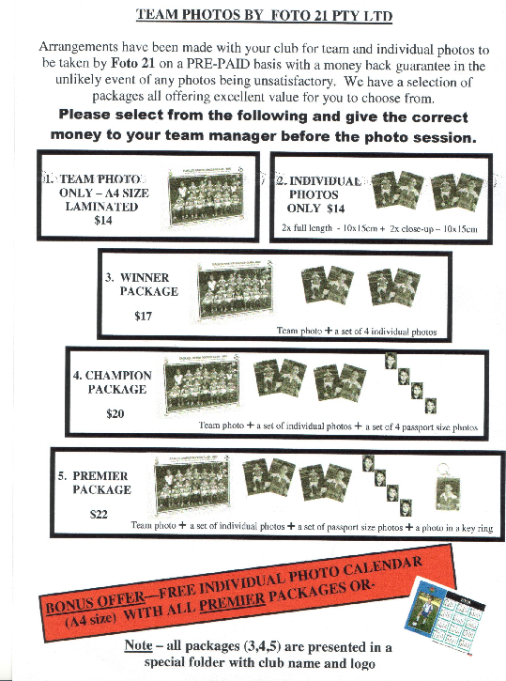

Team Photo Schedule (14/6/08) –

U7 RED Everley @ 9am 14/6/08

U10 Everley @10am 14/6/08

Raahauge Cup First Div. Everley @ 3pm 14/6/08

_______________________________________________________________________________
From the Auburn Review – 28th May

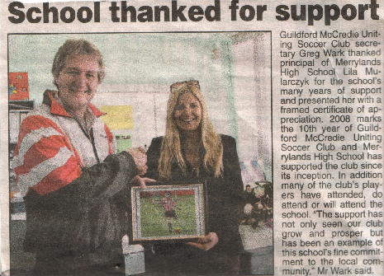

DRAW – Saturday 14th June 2008

U6 RED vs Lidcombe Churches at Phillips 1A (Martin St., Lidcombe)

10.00am Kickoff (meet at Phillips at 9.30am)

U6 WHITE vs OLOR/St Angelas Kellyville G at Freame 2 (Rees St., Mays Hill)

9.00am Kickoff (meet at Freame at 8.30am)

U7 WHITE vs McCredie Red at Freame 2 (Rees St., Mays Hill)

10.00am Kickoff (meet at Freame at 9.30am)
(Whites will be wearing the yellow change strip)

U7 RED vs McCredie White at Freame 2 (Rees St., Mays Hill)

10.00am Kickoff (meet at Freame at 9.00am)

U8 vs St Michaels Baulkham Hills S at Crestwood 3 (Peel St., Baulkham Hills)

11.30am Kickoff (meet at Crestwood at 11.00am)

U9 vs St Michaels Baulkham Hills C at Bella Vista (Cnr Crown Tce. & Bella Vista Dve. Bella Vista)

11.40am Kickoff (meet at Bella Vista at 11.10am)

U10 vs St Bernadettes Castle Hill L at Freame (Rees St., Mays Hill)

11.00am Kickoff (meet at Freame at 10.00am for the team photo)

U11 vs St Bernadettes Castle Hill L at Excelsior 1 (Excelsior Ave., Castle Hill)

12.00pm Kickoff (meet at Excelsior at 11.30am)
AND KNOCKOUT vs St Michaels Baulkham Hills F at Daniel (Daniel St., Greystanes) 3.30pm Kick off

U12 vs St Michaels Baulkham Hills R at Bella Vista (Cnr Crown Tce. & Bella Vista Dve. Bella Vista)

12.30pm Kickoff (meet at Bella Vista at 12.00pm)

U13 vs Castle Hill United at Granville Park (Claremont St., Merrylands)
9.30am Kick off (meet at Granville at 9.00am)

U14 vs Winston Hills Bears at Granville Park (Claremont St., Merrylands)
10.45am Kick off (meet at Granville at 10.15am)

U15 vs Baulkham Hills Black at Granville Park (Claremont St., Merrylands)
12.00pm Kick off (meet at Granville at 11.30am)

U17 vs Coptic United South at Jones 1 (Banks St., Merrylands)

11.45am Kickoff (meet at Jones at 11.15am)
COPTIC HAVE FORFEITED – No 17s match

Raahauge Cup North Div. vs St Patricks Strathfield at Powell 2 (Victoria Ave., Concord West)

(Reserves Kick off at 1.30pm, Firsts at 3.15pm) (Meet at Powell at 1.00pm)

Raahauge Cup First Div. vs Wentworthville Uniting at Jones 1 (Banks St., Merrylands) (Reserves Kick off at 1.30pm, Firsts at 3.15pm) (Meet at Jones at 1.00pm)
(Squad photo at 2.55pm)

