16/08

Club Secretary – Greg 9682 7779 Assistant Secretary – Peter 9632 9203
Interested in sponsoring a team or advertising in this newsletter? – call Helen on 9892 1428

Six a side Wrap up – Results are in this newsletter – I hope everyone had a great day. We had two Champion sides and three runners Up. Congratulations to the 6 Reds and 11s for winning their competitions and to the 6 Whites, 8 Whites and 12 Whites for being Runners Up. It’s nice for the future of the club to dominate the 6s so!
Our canteen was a big winner too – which is nice, especially considering the previous two six a sides have been washed out and we have missed this valuable revenue.
I would like to thank Peter and Dorothy on behalf of everyone for their efforts in the canteen and also Helen, Robert and Wayne French, Carl Mower, Tom List, Chris Hamlin, Ismet Zenelaj, Christine Melki and Ian Warwick for your extra efforts during the day to assist our club.

All Knockouts will resume after the school holidays – U8, 10, 11, 12 and 17 are all still going.
The RC1 side is also into the A Grade final.

LAPATHON – Could players please return their lapathon money to their managers this week? Any player who did not attend can still contribute towards the fundraiser by making a donation to their manager.

Under 17s and RC1- training Wednesday 7pm.

We still have club jackets $65 and polo shirts $40 available for sale – see Greg or ask at the canteen. Items must be paid for before they will be supplied.

Raffle tickets were given out last week. This raffle will be drawn at our presentation day in October – but obviously we want to sell as many tickets as we can as quickly as we can. Please hand sold books and money to your team manager. Extra books are available on request.
______________________________________________________________________________________
Some important reminders –

- Please remember, if your team is the first to play on our home ground each week it is your team’s responsibility to set up the nets and the corner flags and have the game ready to commence on time. ALL parents are expected to help. The coach can’t coach your children and the manager complete the match card and collect fees and be expected to set up the field at the same time!
- If for any reason your child is unable to play or attend training you MUST inform your coach or manager.
- If you have questions regarding your team, ask your manager. If you have any questions regarding administrations, ask the club’s secretary.
- If it is raining on a Saturday morning call the team manager to see if the game is on. Most often games will still be on so do not just stay at home; you will be letting your child's team down!
- Please assist the coach and manager; they are working unpaid for your child. There may be nets to put up or pull down, corner posts to stick in, players to be picked up (particularly if a parent has more than one child playing in different teams) or shirts to wash.
- This club, the NSW Churches Football Association and the Granville & Districts SFA have high expectations of our parents and players. Please support our teams, but no abuse of players or officials will be tolerated and bans or fines could result.


RESULTS from Sat 12/7/08


Six a side – Under 6 - 12

U6 RED Round 1 vs Lidcombe Churches 3 - 0 Goal scorers – Joe Azzi, Qais Sungkar
Round 2 vs Newington Gunners 4 - 0
Goal scorers - Joe Azzi, Qais Sungkar, Joshua Elkerr
Round 3 vs Lidcombe Churches 5 - 0 Goal scorers - Joe Azzi, Qais Sungkar
FINAL vs McCredie White 7 - 0
Goal scorers - Joe Azzi, Qais Sungkar

Under 6 Red – Champions 2008
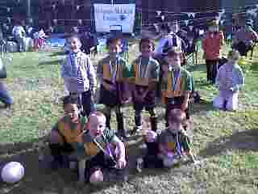

Under 6 White 2008 – Runners Up

U6 WHITE Round 1 vs St Michaels Baulkham Hills 1 – 1 (lost on corners)
Goal Scorer – Willy List 1
Round 2 vs Carlingford Uniting 3 – 0
Goal scorer – Willy List 2, Milos Mijatovic 1.
Round 3 vs St Michaels Baulkham Hills 1 – 1 (won on corners)
Goal scorer – Willy List 1
FINAL vs McCredie Red 0 – 4

U7 RED Round 1 vs Newington Gunners lost
Round 2 vs McCredie White lost

U7 WHITE Round 1 vs OLOR/St Angelas Kellyville Red lost
Round 2 vs McCredie Red won
Round 3 vs ? lost

U8 Red Round 1 vs Newington Gunners 0 – 3
Round 2 vs St Michaels Baulkham Hills S lost

U8 WHITE Round 1 vs St Michaels Baulkham Hills S 6 - 0
Goal scorers – Rusheel Raj 3, Ali Hawchar 2, Daniel Wark 1
Round 2 vs Bye
Round 3 vs OLOR/St Angelas Kellyville 2 – 2 (won on corners)
Goal scorer – Rusheel Raj 2
Round 4 vs St Michaels Baulkham Hills S 7 – 0
Goal scorers – Rusheel Raj 4, Ali Hawchar 2, Tevin Rillera 1
FINAL vs OLQP Falcons 0 – 2

U8 Black Round 1 vs Carlingford Uniting lost
Round 2 vs OLQP Falcons lost

U9 Round 1 vs OLOR/St Angelas Kellyville lost
Round 2 vs St Michaels Baulkham Hills lost

U10 Red Round 1 vs St Michaels Baulkham Hills Magpies 0 – 3
Round 2 vs St Michaels Baulkham Hills Warriors B 0 – 0 (lost on corners)

U10 White Round 1 vs St Michaels Baulkham Hills Warriors B 3 - 1
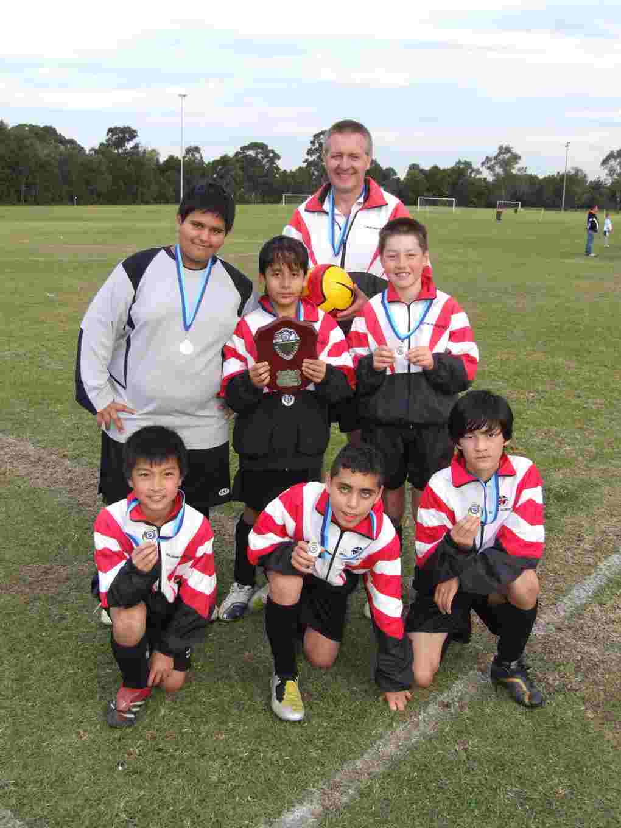
Goal Scorers – Arbin Zenelaj 2, Cameron Hunt 1
Round 2 vs Bye
Round 3 vs St Michaels Baulkham Hills Magpies 0 - 2

U11 Red Round 1 vs OLQP Falcons 5 - 0
Goal scorers – Daniel Jabou 4, James Valencia 1
Round 2 vs Bye
Round 3 vs OLQP Falcons 5 - 0
Goal scorers – Daniel Jabou 3, Mohammad Morad 2
FINAL vs Newington Gunners 4 - 1
Goal scorer – Daniel Jabou 4

U11 White Round 1 vs OLOR/St Angelas Kellyville 2 - 0
Goal scorers – Joey Nader 1, Shayan Kashef 1
Round 2 vs St Michaels Baulkham Hills R 4 – 2
Goal scorer – Yasir Sungkar 2, Gonzalo Diaz 1, Shayan Kashef 1
Round 3 vs Newington Gunners 0 - 4

U12 Red Round 1 vs Lidcombe Churches 0 - 2
Round 2 vs OLOR/St Angelas Kellyville 0 – 5

U12 White Round 1 vs Carlingford Uniting 5 – 1
Goal scorers – Jeremy Gonzales 3, Milad Atai 1, Ahmad Moumand 1 U11 2008 Champions
Round 2 vs Bye
Round 3 vs Carlingford Uniting 3 - 0
Goal scorers - Milad Atai 2, Own goal 1
FINAL vs OLOR/St Angelas Kellyville 0 – 0 (lost on corners)

Senior Round 13 Matches

RC North RESERVES vs Kings Old Boys 2 - 4
Bottom of the table clash, unfortunately today there were 2 oppositions. On their own we would have been able to take Kings Old Boys to the cleaners. Unfortunately we were also opposed by the happenings of Friday night, which carried over into Saturday. 1-0 down early in the game by a soft goal, then 2-0 down due to a controversial penalty, before Elvir put in a great goal. Followed by Ben who did likewise. Unfortunately they put another soft goal in just before half time. The second half was pretty slow. As they made subs our tired legs got the better of us and they put one more in. Ben had a great game, and special thanks to Pete from the firsts for goal keeping for us, he did a great job.
Goal scorer – Elvir Serifovic 1, Ben Campton 1

RC North FIRSTS vs Kings Old Boys 1 - 0
With a full side we walked on the field confident that we could take the win comfortably but instead we had to bust our chops. The kings don’t stop running and we do. But luckily there’s a lot more experience in the Guildford boys and with Palmano’s goal we gave them hell, defending everything they threw at us. The bar was clipped many times and we had many more chances to score but it didn’t go in and the ref also gave both teams a hard time. A great game from Palombit and Luca but too many yellows guys. Let’s put it in for these last few games and try to finish on top WELL DONE
Goal scorer – Peter Palmano 1

RC 1 RESERVES vs Lidcombe Churches 4 – 0
Great result guys which puts us 4 points clear of 5th place with 4 games to play and possibly as good as second place depending on other results. Special mention to Steven Ghadieh for his clever use of our goal posts when clearing the ball from the penalty spot. Very skilful!!!
Goal scorers – Shebit Kuchath 3, Sameer Yusefi 1

RC 1 FIRSTS vs Columna 4 – 2
After scoring early we somehow managed to go 2 down well before half-time. In the last 10 we put 3 away to get the win we deserved. Firsts are still an outside chance for the semis guys. We usually beat the top teams, now we have to make sure of it against the lower ranked sides!! We have a good run home, Columna still have to play Carlingford, Castle Hill, Wenty and Greystanes.
Goal scorers – Pece Kotevski 3, Shebit Kuchath 1

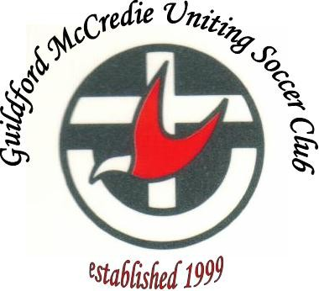

DRAW – Saturday 19th July

U6 RED vs OLQP Falcons M at Everley (mini) (Everley Rd., South Granville)

9.00am Kickoff (meet at Everley at 8.30am)

U6 WHITE vs St Columbas Castle Hill at Greenup (Cecil Ave., Castle Hill)

10.50am Kickoff (meet at Greenup at 10.20am)

U7 WHITE vs Newington Gunners G at Everley (mini) (Everley Rd., South Granville)

11.00am Kickoff (meet at Everley at 10.30am)

U7 RED vs Carlingford Uniting at Homelands 2 (Homelands Ave., Telopea)

11.00am Kickoff (meet at Homelands at 10.30am)

U8 vs St Bernadettes Castle Hill L at Everley 1 (Everley Rd., South Granville)

10.00am Kickoff (meet at Everley at 9.30am)

U9 vs OLQP Falcons Q at Daniel 1 (Daniel St., Greystanes)

9.00am Kickoff (meet at Daniel at 8.30am)

U10 vs St Bernadettes Castle Hill L at Excelsior 1 (Excelsior Ave., Castle Hill)

11.00am Kickoff (meet at Excelsior at 10.30am)

U11 vs OLOR/St Angelas Kellyville at Everley 1 (Everley Rd., South Granville)

11.00am Kickoff (meet at Everley at 10.30am)

U12 vs Lidcombe Churches 13 at Everley 1 (Everley Rd., South Granville)

12.00pm Kickoff (meet at Everley at 11.30am)

U13 vs Baulkham Hills Sports at Ted Horwood 1 (Park Rd., Baulkham Hills)
10.20am Kickoff (meet at Ted Horwood at 9.50am)
U14 vs Dundas United at Curtis Oval 2 (Yates Ave., Dundas) 11.40am kick off (meet at Curtis at 11.10am)

U15 vs Castle Hill United at Granville Park (Claremont St., Merrylands)
9.30am Kick off (meet at Granville Park at 9.00am)

U17 vs Coptic United West at Bert Saunders 2 (Kiata Rd., Doonside)

11.45am Kickoff (meet at Bert Saunders at 11.15am)

Raahauge Cup North Div. vs St Columbas Castle Hill at Everley 1 (Everley Rd, South Granville)
(Reserves Kick off at 1.30pm, Firsts at 3.15pm) (Meet at Everley at 1.00pm)

Raahauge Cup First Div. vs Parramatta Salvation Army at Jones 2 (Banks St., Merrylands)
(Reserves Kick off at 1.30pm, Firsts at 3.15pm) (Meet at Jones at 1.00pm)

