OTB 18 /08

www.mccredie.org.au/soccer

Club Secretary – Greg 9682 7779 Assistant Secretary – Peter 9632 9203
Interested in sponsoring a team or advertising in this newsletter? – call Helen on 9892 1428

Congratulations
to the Under 17s for their great Knockout win last Wednesday night defeating St Michaels 3-0.
Our original under 8s from 1999 (with 4 original players still playing) have finished their junior knockout soccer with a victory. Well done.

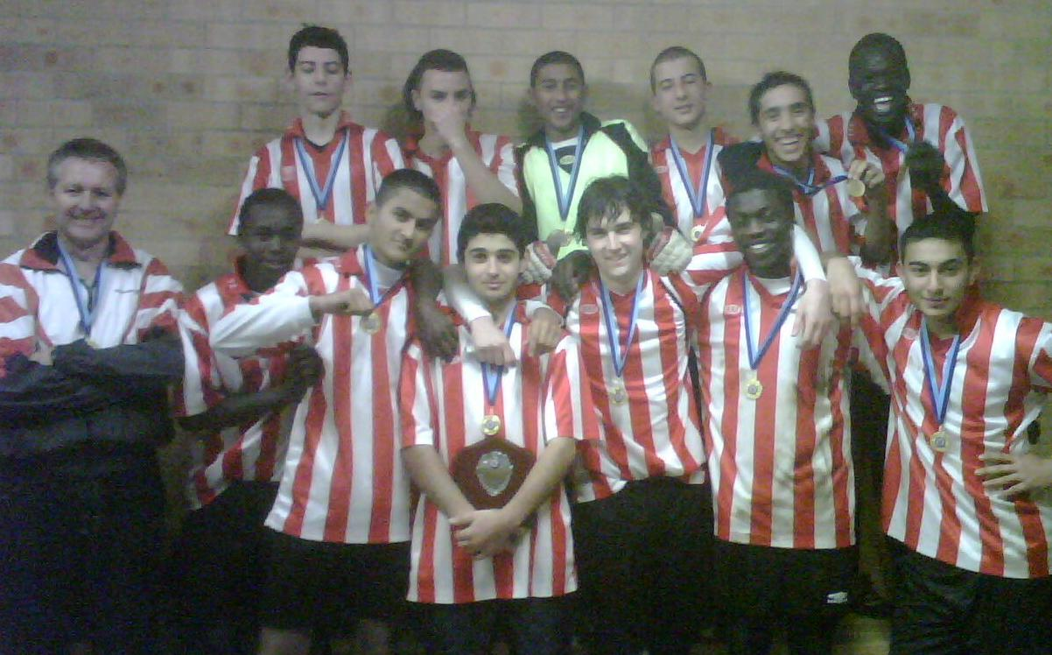

Knockouts this week – U11s (semi), U12s (semi) and RC1 (final).

LAPATHON – Managers, please follow up all outstanding lapathon money as a matter of urgency this week. Thanks.

Under 17s and RC1- no training Wednesday due to A Grade knockout final.

Raffle tickets have been given out. This raffle will be drawn at our presentation day in October – but obviously we want to sell as many tickets as we can as quickly as we can. Please hand sold books and money to your team manager. Extra books are available on request.
______________________________________________________________________________________

RESULTS from Saturday 26th July 2008

U6 RED vs OLQP Falcons R 9 - 0
Was a great game to watch, once again our team had the upper hand and played hard, but the Falcons stepped up and made us work for every try. All the boys had smiles on thier faces as every one had a go at getting some goals for thier team. Great team spirit, boys. Man of the Match: Joshua Elkerr.
Goal scorers – Qais Sungkar 4, Joe Azzi 2, Andrew Ibraheem 1, Joshua Elkerr 1, Mosese Masima 1

U6 WHITE vs Wentworthville Uniting 4 - 2
The boys were pumped to get on the field today, and their efforts sure matched their enthusiasm. Our first half was by far our best. Willy scored our first goal only within a couple of minutes to be followed up by Tam. Jackson, although scoreless had a golden boot on today and kicked the ball like a demon. Milos was in goals for the first half and when with all that energy bubbling over had a great energetic second half on the field. Vertigan saved a couple of great goals in the second half and Arber will be playing for Australia as sweeper if he continues the way he is going. Great effort guys. Man of the match Jackson Hunt.
Goal Scorers – Willy List 3, Tam Do 1

U7 RED vs OLOR/St Angelas Kellyville White 0 - 12
A tough game against the six a side champions but we acquitted ourselves well and are getting better each wee. Ben did a really good job goal keeping and Fred, our man of the match, tried all the way to the end.

U7 WHITE vs Carlingford Uniting 2 - 9
All boys played well today. The extra effort in thier concentration today was remarkable, and you can tell the boys are trying their hardest. Keep up the good work!! Joshua was outstanding today, he received our 'most improved' medal. Antoine and his 'big strong kicks' earned him 'man of the match' along with Nedim who scored our 2 goals!!! As the season is coming to an end, it will be a shame to see the boys stop playing as they are just forming into their own unique little soccer players.
Goal scorer – Nedim Fazlic 2

U8 vs Wentworthville Uniting 2 – 0
Well done boys excellent play. We had two U6 boys today & we all played together like a well oiled machine. Almost everyone kept their positions & we passed to each other almost the whole match, which we haven’t been doing this year.
James was fantastic in defence & his huge kicks earned him the man of the match. Ronan scored his first goal with some outstanding positional play & never gave up all game. We had speed & great ball skills to boot. Qais scored our other goal & for a U6 player both he & Joey held their own & were really a force to be reckoned with. Awesome game, well done. Man of the Match - James Tiller
Goal Scorers - Ronan Galeb 1, Qais Sungkar 1

U8 Knockout vs OLOR/St Angelas Kellyville 0 - 4
Well done again boys, you kept your positions for most of the game & you kept them scoreless for almost the whole of the first half. We passed much better to each other & really set up some good plays but were unlucky with the goal shots. We also halved the score from last time we played OLOR. We had speed but just not enough for today but we are getting closer & closer so watch out for us next game.

U9 vs Penrith Churches 2 – 1
What a great game – and we won! Jack and Harrison scored two thumping goals. Ehren was our man of the match, working hard to play his position. Thanks to Ryan Carder from the under 7s for helping out today.
Goal scorers – Harrison Castles 1, Jack Keenan 1

U10 vs Lidcombe Churches 5 - 0
A very good and result against a decent side that has caused some upsets this year. We started strongly and some of the things we have worked really hard on started to come off with Sam, Peter, Arbin and Cameron creating good chances from crosses from the right side. We were good across the park today especially John, Shaun and Josh who all played really well. Aiden was very good at the back and Jason was ever reliable. Emily was great getting forward and playing some nice balls into the centre. In all a good performance today and another step closer. Player of the match Josua McGuire.
Goal scorers Arbin Zenelaj 3, Peter Youssef 2

U10 KNOCKOUT vs St Michaels Baulkham Hills W 2 – 3 (Golden Goal)
This game was played at a frantic pace and it was worthy of a Grand Final. We controlled possession and the marking was rock solid.The midfield marked well and counter attacked but half time saw things scoreless. Both sides pushed forward in the second half looking for a winner and we went down 1 -0 from a rebound off a clearance. We were not going to give up and Cameron equalized off a lovely pass from Emily and it was Game on. We conceded another goal but this game had more to come. Cameron was fouled outside the box and Aiden stepped up and blasted home from 22 yards and we were back in it. Full time was 2 - 2 and extra time beckoned. The boys were exhausted after playing 2 games today and the Warriors clinched it with a goal and the Under 10s were shattered. They gave everything to win this game and we created more chances but it wasn't to be. Proud parents and proud coaching staff. We are just delighted with the effort. I have never been happy losing but we couldn't have done anymore today. Player of the Match - Sam Killick.
Goal Scorers - Cameron Hunt 1, Aiden Beehag 1


U11 vs OLQP Falcons P won on forfeit

U12 vs OLQP Falcons 4 - 2
What started out as a very sloppy first half, with far too many misdirected passes and poor clearing kicks ended up with a very solid second half. In the second half the mid fielders and forwards passes were timed correctly, whilst the defenders remained strong and several times made fast covering tackles to keep the opposition out of the scoring box. MVP were Katarina Cindric, Hassan Sungkar & Jordon Sarmento
Goal scorers – Jeremy Gonzales 1, Jackson Mower 1, Milad Atai 1, Wassim Baggie 1

U13 vs Wenty Waratah 7 - 1
A very good win today. We had the full team, with Paul making his comeback. Dhanushan has been playing very well so he's gonna have to work hard to get his spot back. The first half was arguably one of the best the team has played this year. Everyone palyed well. Jonathon was superb as a defensive midfielder, and the attacking midfield of Jean-Claude, Jason, Junior and Barkhad are controlling and passing the ball around a lot more. Shaun as the lonely target man upfront is always good, always attracting a lot of attention which makes room for our midfielders to run and shoot. I'm sure the team will go far this year if we keep performing like this, and training hard as well to improve even more. Man of the match: Jonathon.
Goal scorers – Shaun Borg 3, Junior Clark 3, Jean-Claude El-Batti 1

U14 vs Castle Hill RSL 2 - 3
Gave the team coming first 2 soft and very early goals. With heads down it looked like it was going to be a painful day as the opposition seemed to have hit their stride. But some eagerness from Omar resulted in a goal which saw the boys finally get into gear. From then on we were the ones controlling play with them on the back foot. M. Rahimi drew us level but a corner against us late in the 2nd half where we could not clear it cost us. Too many boys to congratulate for their efforts – Omar for his runs, Moustafa H for finally getting fired up and tackling, Mushtaba for filing in at right back and played fantastic, Justin for his last man work, Eloy for his tackles, Liam for holding our midfield, M Awad & Trung for keeping … all in all a top effort by ALL the boys. Just need to focus on doing this from the kickoff.
Goal scorers – Mohamed Rahimi 1, Omar Ghorra 1

U15 vs Baulkham Hills Sports W 2 - 4
We had our first defeat for the season today and the boys were obviously disappointed. We had our chances to win the game but the bounce of the ball just didn't fall for us today. Dharshan was strong at the back with Hideki and Hassan having good games out wide. Unlucky today boys, but it's better to lose one now than in a couple of weeks time.
Goal scorers – Myles Nyawasha 1, Mustafa Nazary 1

U17 vs Coptic United South won on forfeit

RC North RESERVES vs Bye

RC North FIRSTS vs Bye

RC 1 RESERVES vs Viva Cabramatta Uniting 4 – 2
We started the afternoon like we were in last place and they were an 8 man Manchester United. They had 8, we had 11, they had two goals and we had touched it only enough times to pass it to them. It was truly awful. We worked our way back into it and Shebit gave us a boost with a fantastic individual effort up front, 1-2. Shortly before half time a Booph cross found a floundering fullback who neatly converted an own goal 2-2. In the second half we were all over them and first Shebit again, and then John Dor, put us 4-2 up and into first place in the comp with two rounds left before the semis.
Goal scorers – Shebit Kuchath 2, John Dor Achiek 1, own goal 1

RC 1 FIRSTS vs Viva Cabramatta Uniting 2 – 6
The great afternoon finished there I’m afraid. The card was messed up leaving our goal keeper watching from the sideline and Viva took full advantage. For a brief moment at 1-1 we were in it, but that faded quickly. But – we beat them last round, we will play them this Wednesday with a strong side in the knockout final and hopefully, with two wins in the next two rounds we will still find ourselves in the semis.
Goal scorers – John Dor Achiek 1, Cuong Lo 1

DRAW – Saturday 2nd August

U6 RED vs Lidcombe Churches at Everley (mini) (Everley Rd., South Granville)

9.00am Kickoff (meet at Everley at 8.30am)

U6 WHITE vs OLOR/St Angelas Kellyville G at Kellyville 3 (Memorial Ave., Kellyville)

10.00am Kickoff (meet at Kellyville at 9.30am)

U7 WHITE vs OLQP Falcons L at Everley (mini) (Everley Rd., South Granville)

11.00am Kickoff (meet at Everley at 10.30am)

U7 RED vs St Michaels Baulkham Hills S at Bella Vista (Crown Tce., & Bella Vista Dve., Bella Vista)

8.30am Kickoff (meet at Bella Vista at 8.00am)

U8 vs St Michaels Baulkham Hills S at Crestwood 3 (Peel St., Baulkham Hills)
11.40am Kick off (meet at Crestwood at 11.10am)

U9 vs St Michaels Baulkham Hills L at Everley 1 (Everley Rd., South Granville)

9.00am Kickoff (meet at Everley at 8.30am)

U10 vs OLOR/St Angelas Kellyville W at Everley 1 (Everley Rd., South Granville)

10.00am Kickoff (meet at Everley at 9.30am)

U11 vs St Bernadettes Castle Hill E at Everley 1 (Everley Rd., South Granville)

11.00am Kickoff (meet at Everley at 10.30am)
KNOCKOUT semi vs Newington Gunners at Tom Uren (Karani Ave., West Guildford) 2.30pm kickoff

U12 vs St Michaels Baulkham Hills 13 at Bella Vista (Crown Tce., & Bella Vista Dve., Bella Vista)

12.00pm Kickoff (meet at Bella Vista at 11.30am)
KNOCKOUT semi vs St Michaels Baulkham Hills S at Tom Uren (Karani Ave., West Guildford) 3.30pm kickoff

U13 vs Granville Kewpies at Colquhoun Park (Blaxcell St., Granville)
9.30am Kickoff (meet at Colquhoun at 9.00am)
U14 vs Greystanes at Bathurst Street Park (Bathurst St., Greystanes) 11.30am kick off (meet at Bathurst St at 11.00am)

U15 vs Wenty Waratah at Granville Park (Claremont St., Merrylands) 9.30am kick off (meet at Granville at 9.00am)

U17 vs St Michaels Baulkham Hills at Crestwood 3 (Peel St., Baulkham Hills)
10.30pm Kick off (meet at Granville at 9.45am to car pool)

Raahauge Cup North Div. vs St Michaels Baulkham Hills at Bella Vista (Crown Tce., & Bella Vista Dve., Bella Vista)
Reserves kick off at 1.30pm Firsts kick off at 3.15pm (meet at Bella Vista at 1pm)

Raahauge Cup First Div.

Reserves vs St Lukes Concord

Firsts vs St Patricks Strathfield at Everley 1 (Everley Rd., South Granville)
Reserves kick off at 1.30pm Firsts kick off at 3.15pm (meet at Everley at 1pm)

A GRADE KNOCKOUT FINAL vs Viva Cabramatta Uniting at Jones (Banks St, Merrylands) Wed 30/7 8pm kick off

