No. 9/08
Club Secretary – Greg 9682 7779 Assistant Secretary – Peter 9632 9203
Interested in sponsoring a team or advertising in this newsletter? – call Helen on 9892 1428
_______________________________________________________________________________________________

KNOCKOUTS THIS WEEK
Under 8 and Under 9
Knockouts start this weekend. You have matches on Saturday morning and a knockout match on Saturday afternoon. Details on the back page of this newsletter.
RC1 and RCN you have knockouts mid week.

PHOTOS: Team photos start this Saturday. The remainder will be taken on the 14/6.
YOU MUST ATTEND THE PHOTO ON TIME AND EVEN IF YOU DON’T WANT TO BUY ONE. If you do wish to purchase, you must pay BEFORE the photo is taken and please give the right money. Thanks.

RC1 & U17 - No training this week due to A grade knockout on Weds night.

RESULTS from Saturday 24th May 2008

U6 RED vs OLQP Falcons R 15 – 0
A wonderful game played against the Falcons. Christian started to get involved more with the game and John Paul made some excellent saves in goals. Joshua tested the opposition and started to take on the whole 6 himself. Man of the match – Andrew Ibraheem.
Goal scorers – Joe Azzi 10, Qais Sungkar 5.
U6 WHITE vs Wentworthville Uniting 5 – 0
Another outstanding display from the group that is developing quickly into a great little team. Willy and Jackson continue to build a great attacking combination with Jackson opening the scoring very early on and Willy getting our second. The attack continued as Milos added the third but then the game changed. Wenty woke up and attacked hard but our boys kept clearing the ball and countering with Tam scoring a gutsy goal with nice little fist pump and Will made it 5 just before half time. The second half was a little quiet but Altin made some amazing saves in goal including a diving effort to stop a certain goal. A clean sheet and happy coaching staff and supporters. Man of the Match - Altin.
Goal Scorers – Will List 2, Jackson Hunt 1, Milos Mijatovic 1, Tam Do 1

U7 RED vs St Michaels Baulkham Hills T 0 - 10
Robert, our man of the match, had his first time in goals and I don’t think it will be his last. He did what was asked and more. Thanks also to John Paul from the under 6s for helping out this week.

U7 WHITE vs OLQP Falcons L 1 - 6
There was a fantastic effort today! The boys played exceptionally well, even though we had no reserves, they kept their game up for the whole match. Nedim scored our goal today, and he kept persisting for the whole game which made him our 'Man of the match". Siam was our 'most improved' today, he managed to keep going after the ball and taking it from our opponents. Keep up the good work boys!! Goal scorer – Nedim Fazlic 1

U8 vs Wentworthville Uniting 6 - 0
Well done boys. The other team were 2 short for most of the first half, but they held their own. We capitalized and scored 4 goals in that half. The boys were kicking much better but a little too much dribbling still happening, the listening is much better but more is required, & some are unsure of their positions. All in all the boys kicked to each other more & more boys got their teeth into this game & it was a great win & a much needed win. Tevin was player of the match for keeping his position throughout the game & Daniel received the encouragement award for scoring his first 2 goals for the season, excellent work boys.
Goal scorers: Daniel Wark 2, Rusheel Raj 2, Ali Hawchar 2

U9 vs Carlingford Uniting 0 - 5
No report

U10 vs St Michaels Warriors 1 - 5
We were very excited about the top of the table clash and started strongly, worrying St Michaels defenders and looking dangerous. We conceded a goal against the run of play and another soft goal soon after that hurt. We were losing the battles in midfield and St Michaels made it 3 but Erkan scored a great goal to give us some hope at half time. A few changes didn't work and the leaders gained control and added two more. We stuck at it and Arbin and Peter tried really hard. Cameron was everywhere and Albion was really good in goal. Sam did well in his first game at sweeper but we just didn't have the guns today. We tried hard but every player needs to put their best effort in every week to challenge the best sides. Man of the Match - Arbin
Goal Scorer – Erkan Karacayil 1

U11 vs OLQP Falcons Q 4 - 0
Well deserved result for a team really playing some very good soccer this season. Daniel finished very well, Mohamed, Alan and Gonzalo were solid in defence and Martin was outstanding. But at 1-0 it was Kyle in goals, who made a sensational save to deny the opposition striker and ensure that Falcons couldn’t get into the game. Kyle was player of the match.
Goal scorers – Daniel Jabou 4

U12 vs Bye

U13 vs Granville Kewpies 2 – 0
No report

U14 vs Greystanes 4 – 1
We took the first half to get our act together. In the second half we mixed it up and dominated the opposition. Once again great work by all our four backs. Mohammad H. has really improved as our centre back over the last few weeks. Liam did great work holding our midfield and Mushtaba created great opportunities and runs up front.
Goal scorer - Mohammed Rahimi 3, Trung Nguyen 1

U15 vs Wenty Waratah 5 - 4
Today was probably our worst performance to date. We started well scoring two quick goals but never finished the opposition off allowing them to nearly draw level on several occasions. We lost our shape and allowed Wenty to get first to the ball on numerous occasions. Myles and Mustafa were again strong up front causing Wenty headaches and Mojthaba was good dropping back when needed to help in defence. Still a lot of work to do, will have to plug our defence up again.
Goal scorers –Myles Nyawasha 3, Mustafa Nazary 1, Amarvir Singh 1

U17 vs Coptic United West 5 - 2
I have coached this team for 10 years and except for some of the diabolical under 8 performances in 1999, today was the most embarrassing. Our 8 still managed to win, but the game was awful. All we needed to do was put the ball on the ground and pass it to feet. Instead we ran around like headless chooks and either attempted to dribble the ball for 100 metres (until we were tackled) or kick the stuffing out of it. Caner saved us in the end. For the players who failed to show up and didn’t inform us – Thanks.
Goal scorers – Caner Temel 4, Patrick Ajnas 1

RC North RESERVES vs Bye

RC North FIRSTS vs Bye

RC 1 RESERVES vs St Lukes Concord 0 - 4
St Lukes’ total team age is about 490 and they bring a fair bit of experience on to the park. The ground at Powell Creek should be tipped into the creek too. We hung with them and with 18 minutes to go were just 0-1 down and with a penalty missed. Probably got a bit desperate to score, left positions and let them through. Next time – at Everley boys.

RC 1 FIRSTS vs St Patricks Strathfield 3 - 2
Welcomed back Mariel from illness today and he made an immediate impact, scoring one and setting up the second. It was important to consolidate our ladder position with a win which is what we did. Lukman was sensational in goals and Pece, Caner, Toufic, Cuong , Steven and Marco all played well.
Goal scorers – Mariel Achiek 1, Cuong Lo 1, Caner Temel 1



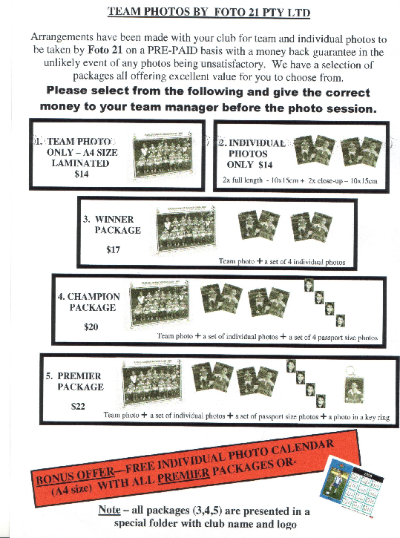

Team Photo Schedule –

U6 RED Everley @ 10.10am 31/5/08

U6 WHITE Everley @ 8.15am 31/5/08

U7 WHITE Everley @ 11am 31/5/08

U7 RED Everley @ 9am 14/6/08

U8 Everley @ 8.15am 31/5/08

U9 Everley @ 9am 31/5/08

U10 Everley @10am 14/6/08

U11 Everley @11am 31/5/08

U12 Everley @ 11am 31/5/08 (then to Bella Vista)

U13 Everley @9.45am 31/5/08 (then to Coleman)

U14 Everley @ after your match 31/5/08

U15 Everley @ after your match 31/5/08

U17 Everley @ 10am 31/5/08

Raahauge Cup North Div. Reserves Everley @ 1pm 31/5/08

Firsts Everley @ 2.45pm31/5/08

Raahauge Cup First Div. Everley @ 3pm 14/6/08

DRAW – Saturday 31st May

U6 RED vs OLOR/St Angelas Kellyville W at Everley (mini) (Everley Rd., South Granville)

11.00am Kickoff (Team Photo 10.10am SHARP at Everley Park)

U6 WHITE vs OLQP Falcons C at Everley (mini) (Everley Rd., South Granville)

9.00am Kickoff (Team Photo 8.15am SHARP at Everley Park)

U7 WHITE vs St Bernadettes Castle Hill L at Everley (mini) (Everley Rd., South Granville)

12.00pm Kickoff (Team Photo 11am SHARP at Everley Park)

U7 RED vs Newington Gunners G at Wilson 2 (Newington Rd., Silverwater)

10.00am Kickoff (meet at Wilson at 9.30am)

U8 vs St Michaels Baulkham Hills P at Everley 1 (Everley Rd., South Granville)

9.00am Kickoff (Team Photo 8.15am SHARP at Everley Park)

AND KNOCKOUT vs St Michaels Baulkham Hills C at Tom Uren (Karani Ave., West Guildford) 3.15pm kick off

U9 vs St Bernadettes Castle Hill L at Everley 1 (Everley Rd., South Granville)

9.50am Kickoff (Team Photo 9.00am SHARP at Everley Park)

AND KNOCKOUT vs OLQP Falcons P at Tom Uren (Karani Ave., West Guildford) 1.15pm kick off

U10 vs St Michaels Baulkham Hills G at Crestwood 4 (Peel St., Baulkham Hills)

12.10pm Kickoff (meet at Crestwood at 11.40pm)

U11 vs Wentworthville Uniting at Everley 1 (Everley Rd., South Granville)

12pm Kickoff (Team Photo 11am SHARP at Everley Park)

U12 vs St Michaels Baulkham Hills P at Bella Vista (Cnr Crown Tce. & Bella Vista Dve. Bella Vista)

12.30pm Kickoff (Team Photo 11am SHARP at Everley Park)

U13 vs Lidcombe Waratah Black at Coleman Park 1
11.40am Kick off (Team Photo 9.45am SHARP at Everley Park)

U14 vs Lidcombe Waratah at Coleman Park 2
10.30am Kick off (meet at Coleman at 10.00am) (Team Photo 12.10pm at Everley Park)

U15 vs Winston Hills Bears at Granville Park (Claremont St., Merrylands) 9.30am Kick off (meet at Granville at 9.00am) (Team Photo 11.10am at Everley Park)

U17 vs Coptic United West at Everley 1 (Everley Rd., Granville South)
10.35am Kick off (Team Photo 10am SHARP at Everley Park)

Raahauge Cup North Div. vs Wentworthville Uniting at Everley 1 (Everley Rd., South Granville)

(Reserves Kick off at 1.30pm, Firsts at 3.15pm) (Meet at Everley at 1.00pm)
(Reserves Team Photo 1pm at Everley Park) (FirstsTeam Photo 2.45pm at Everley Park)
A GRADE KNOCKOUT vs Columna Thursday 29/5/08 8.30pm Jones 2 (Banks St., Merrylands)

Raahauge Cup First Div. vs Carlingford Uniting at Homelands (Homelands Ave., Telopea)

(Reserves Kick off at 1.30pm, Firsts at 3.15pm) (Meet at Homelands at 1.00pm)
A GRADE KNOCKOUT vs St Matthews Baulkham Hills A Wednesday 28/5/08 8.30pm Freame (Rees St., Mays Hill)

