OTB 10/11

Club Secretary – Greg 9682 7779 President – Peter 9632 9203

Interested in sponsoring a team or advertising in this newsletter? – call one of the above numbers.

www.mccredie.org.au/soccer

Meetings This Week

Committee Meeting – Tuesday 31st May 7.00 pm

General Meeting (Coaches and Managers’ attendance required) – Tuesday 31st May 7.30 pm
__________________________________________________

RESULTS for Round 8: 28th May 2011

U6 vs OLQP Falcons 2 – 1
What a game!!!! We finally beat them. Last time we played against OLQP we lost 10-1. This time round we strived on and won.
Matthew and Samuel scored our goals with great strength. Hannah and Woody were on fire. They were unstoppable and gave it their all. OLQP were shocked by our comeback that they even questioned the age of our players. Woody was man of the match for his excellent improvement. What a great game it was!!!!! Can't wait for next week!
Goal scorers – Matthew Youssef 1, Samuel Kidane 1

U7 RED vs OLOR/St Angelas Kellyville W 3 – 2
A real cliff-hanger today. A good, close game with McCredie coming out on top. Must have been the goal of the season when Dean passed the ball for Aaron to smash it through for his 3rd goal of the day. Great defence again managed to keep the opposition to 2 goals. Man of the Match went to Ben, while Dean got the Encouragement award. Loudest parent award goes to Charles Depares, for giving us all a headache!
Goal scorer – Aaron Batth 3

U7 WHITE vs OLQP Falcons T 0 – 7
Today unfortunately we were defeated as OLQP is a very strong team. It was hard just trying to just get past them. Mase played his first game today and received the achievement award as he played very well. George was the player of the week as he stopped many goals getting past him. Fingers crossed for next week.

U8 vs OLOR/St Angelas Kellyville W 1 – 5
Today we played the top team, they pressed us and the score showed it. Positive points were: we at least scored and our goalie for the day saved several goals. Our fullbacks were very busy defending, and our halves and forwards had several breakaway runs which troubled Kellyville. The score didn't reflect the fight Kellyville had to go through to get the ball in the net. But on the other hand, we need to improve as we gave an own goal and penalities for hand ball and tackling opponents. We also made errors with throw-ins, steering or kicking the ball in front of our goal giving Kellyville opportunities. Most improved, Mounir and Oliver for big efforts, man of match Shaleen for excellent work in goals.
Scorer: Christian Frangie 1

U9 RED vs McCredie White 3 – 0
No report – again. Please organise someone to complete match reports in future weeks. Thanks.

U9 WHITE vs McCredie Red 0 - 3
We played well today vs the Reds but could not overcome their speed and ability in front of goal. Jackson and Kenny worked well at the back. Housed and Will created some good chances and Charlie did well.

U10 vs St Bernadettes Castle Hill L 1 – 2
We only had 10 again today so a big thank to the under 9s who filled in to give us a full team. We scored early when Antoine chased down a through ball and laid it back to Ryan to give us an early lead. We fought hard all game but unfortunately St Bernadettes scored a goal at the very end of each half against some very tired legs to scrape away with the win. Unlucky today boys, will have to work on our fitness and positional play at training. Ryan was man of the match for his support effort up front.
Goal scorer – Ryan Carder 1

U11 vs OLQP Falcons A 1 – 0
When you are on the top of the comp there is an expectation that you will play like that. In the first half today a neutral observer would have thought we were closer to the bottom – we were dreadful. Air swings, standing back watching, balls off shins – it was all there. At half time the team got a rev up and played a bit better in the second half. The goal came about 10 minutes from full time. A very nice cross by Ronan was finished by Salem. But a few minutes later it was Jesse who saved the day with a great save, plucking the ball out of mid air. We will certainly need to improve on this.
Goal scorer – Salem Boustany 1

U12 vs Winston Hills Bears 4 – 2
Our back line and goalie worked much harder then the previous games. Man of the match is Taha, for another great game, with another nice goal, and some great defence. The most improved player, going to Mohammed for playing an all round good game, especially in the second half when you played your position very well. Good job, team especially in the second half.
Goal scorers – John Kazzi 3, Housaini Taha 1

U13 vs Greystanes 1 - 2
We scored first today but were fairly average in the first half. Peter was busy up front and Jahid worked hard. Aiden was strong at sweeper. We conceded straight after we scored and again on half time. We played ok in the 2nd but again we just lacked passion and execution. We now face a long battle back if we are to get into contention this year with the top 2 teams up next.
Player of the Match - Aiden Beehag.
Goal scorer - Peter Yousef

RC 1 RESERVES vs Parramatta Salvation Army 2 - 0
We made hard work of the win.
Goal Scorer: - Tom Ninnes 2

RC 1 FIRSTS vs Parramatta Salvation Army 0 - 4
We compounded previous weeks’ errors by once again not playing as a team.

RESULTS for Kings Seven a side 29/5/11

U13
We expected to do well after our semi final result last year but we did not fire today. We played well vs Pendle Hill in the first round but the next 2 games were not good. Thanks to all who came and to the parents for their support.

U14
Today provided an opportunity to invite some ex players back to compete in the Kings Sevens. They came from far and wide to claim McCredie’s first trophy for 2011 and our club’s first victory in this tournament after 3 years of trying. The boys were undefeated beating the highly fancied ASA side in the first game and claiming a nail biting final on penalties. It was a delight to see these guys so happy to win a trophy for the club that started the love of soccer for many of them.

Group matches
vs Australian Soccer Academy 4 – 1
Players of the match – Martin Lo, Divan Laubscher
Goal scorers – Daniel Jabou 1, Martin Lo 1, Mohammed Abdul Hamid 1, William Wark 1

vs West Pennant Hills/Cherrybrook Lions 3 – 0
Players of the match – Martin Lo, William Wark
Goal scorer – Martin Lo 3

vs Trinity College 1 – 0
Players of the match – James Conaghan, Divan Laubscher
Goal scorer – Jason Cacharron 1

Semi Final
vs Kings 4 – 0
Goal scorers – Jason Cacharron 1, William Wark 1, Mohammed Abdul Hamid 1, Luke Wilson 1

Final
vs Trinity College 0 – 0 (2 – 1 on penalties)
Goal scorers – Daniel Jabou 1, William Wark 1

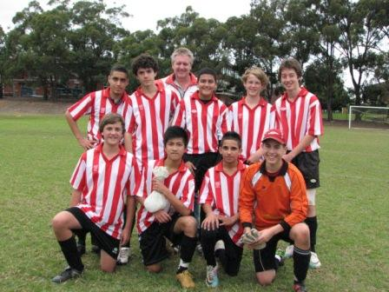

Under 14
2011 Kings Sevens Champions!

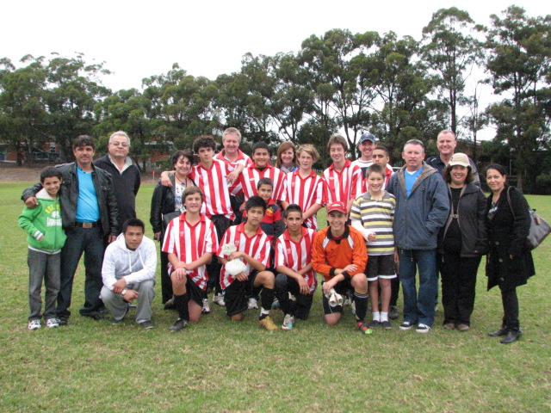

Please remember to return any unreturned Lapathon money this week to your team manager. Thanks.

.

Draw - Saturday 4th June 2011

U6 vs St Bernadettes Castle Hill E at Eric Mobbs 1 (Excelsior Ave., Castle Hill)

9.20am Kickoff (meet at Eric Mobbs at 8.50am)

U7 RED vs St Bernadettes Castle Hill T at Everley (mini) (Everley Rd., South Granville)

9.20am Kickoff (meet at Everley at 8.50am) (set up and dismantle field)

U7 WHITE vs St Bernadettes Castle Hill L at Eric Mobbs 1 (Excelsior Ave., Castle Hill)

8.30am Kickoff (meet at Eric Mobbs at 8.00am)

U8 vs OLQP Falcons at Daniel Street 1 (Daniel St., Greystanes)

9.00am Kickoff (meet at Daniel at 8.30am)

U9 RED vs OLQP Falcons Q at Daniel Street 1 (Daniel St., Greystanes)

10.00am Kickoff (meet at Daniel at 9.30am)

U9 WHITE vs St Bernadettes Castle Hill T at Everley (Everley Rd., South Granville)

10.00am Kickoff (meet at Everley at 9.30am) (set up and dismantle field)

U10 vs OLQP Falcons at Daniel Street 1 (Daniel St., Greystanes)

11.00am Kickoff (meet at Daniel at 10.30am)

U11 vs Lidcombe Churches at Everley 1 (Everley Rd., South Granville)

11.00am Kickoff (meet at Everley at 10.30am) (set up field)

U12 vs North Rocks at Everley 2 (Everley Rd., South Granville)

11.00am Kickoff (meet at Everley at 10.30am) (set up and dismantle field)

U13 vs Lidcombe Waratah at Everley 1 (Everley Rd., South Granville)

12.00pm Kickoff (meet at Everley at 11.30am) (dismantle field)

Raahauge Cup First Div. vs St Patricks Strathfield at Powell Creek 1 (Victoria Ave., Concord West)

(Reserves Kick off at 1.30pm, Firsts at 3.15pm) (Meet at Powell at 1.00pm)

AND B GRADE KNOCKOUT

Raahauge Cup First Div. vs Chester Hill Sports B at Jones 1 (Banks St., Merrylands)
Wednesday 1st June 7pm Kick off (meet at 6.30pm)

