OTB 12/12
Club Secretary – Greg 9682 7779 President – Peter 9632 9203

Interested in sponsoring a team or advertising in this newsletter? – call one of the above numbers.

www.mccredie.org.au/soccer
________________________________________________________
Lapathon
The club’s major fundraiser for 2012 will be our lapathon. This will be held on 18th July – more information in coming weeks (moved to avoid State of Origin clash & school holidays)
_______________________________________________________
Referee course – lecture and exam Free.
19th June at 6.45pm Wentworthville Uniting Church
_____________________________________________________________________________________________________________________________
It’s getting colder!!!
Club jackets are available.
Kids sizes are $30 and adult sizes are $65.
See Greg or check the canteen at Everley
Club Photos

Photos have been booked for the following dates

16th June Under 7, 8 W, 9, 10, RCN

17th June Ladies

Wednesday 20th June 6W

23rd June Under 6 R, 6 B, 8 R, 11, 12, 14
_____________________________________________________________________________________________
RESULTS – 2nd/3rd June
U6 Red vs St Bernadettes Castle Hill Lions 6 - 3
It was a very exciting game this team gave us a challenge , our attackers and defenders working very hard I could not single out one player who played the best they all played well as a team. Adeng was the player of the match working very hard , Zachariah allowing only three of the eight goal attempts made by the opposition, he is improving every week Ali and Dimo were fantastic in defence and crazy Zachary was always saving the day with his wild kicks.Ritchie was a handful for the opposition and Hannah had great ball control while Yar keeps on improving her skills and little Joshua as usual knowing only one way to go and thats foward and towards the goal thanks team for the great day ! Goal scorers Adeng Yelchan 1, Ali Fahme 2 Dimo Dimo 2 Joshua Depares 1

U6 White vs St Bernadettes Castle Hill Tigers 2 – 1
For the second week in a row our team played with no reserves on the bench due to illness going through the camp. Every player stepped up and executed their roles on the playing field. Throughout the first half Sebastian, Dylan, Diego, Daniel and Lucy kept their supporters entertained by playing a free flowing game from one end of the field to the other while Kassem was great in goals. Our first goal came in the 12th minute of the game from a throw in that was taken by Dylan. Dylan found an unmarked Diego, who passed the ball onto Daniel, and then Daniel kicked the ball beating the keeper. The second half was played in the same style as the first half. Kassem played as a forward while Diego and Lucy shared goal keeping duties. The second goal came after the opposition was awarded a corner. They took the corner but lost control of the ball, passing it backwards to a waiting Kassem. Kassem ran from his side of the halfway line and shot the ball passed the goal keeper. Every week the girl and boys that make up the team show signs of improvement. Their skill levels increase and their confidence is always on a high. This week, Kassem was awarded the man of the match award for his display in goals and on the field. Thank you team for keeping us entertained. Goal scorers - Daniel Kvesic 1, Kassem Kassem 1.

CONGRATULATIONS to the Sultanas on the birth of Emily Gracie.
U6 Black vs Hills Spirit Blue 4 - 2
What can i say!!! These boys are proving themselves to be great players every week. Ali saved a few goals as goalie with fantastic kicks. Joey shone his magic goals on us as usual. Ayaan ran with the ball making sure no one gets in his way. Anthony, Joshua and Hassan gave their best. Great play boys Goal scorers – Joey Farah 4

U7 vs OLQP Falcons O 6 - 0
A magnificent game was played at Everley Park today walking away with a 6-0 win against St. Bernadettes. Victor kept the goal as a clean sheet with massive help from Samuel, Woody and Baran who chased the ball as if his life was depending in it. Tamir running like a bullet trying to score but missed few times, good try Tamir. Reggie was all there today awesome! Armin and Matthew got control of the ball and Matthew scored our first goal at the first minute and it kept going and going and going. Tatiana gave her best today and Mustafa cleared so many balls. Big improvement with the under 7. Hope you all stay pumped up for next week. Man of the match: Victor Doueihi
Goal scorer - Matthew Youssef 6
U8 RED vs Hills Spirit Green 2 - 0
Today we had a good win. We played well and didn't give up. I think we need to have some goal shooting practice as we had a few too many missed opportunities which we should have put away. All in all it was a good effort but I know we can do better. Gregory had another great game, Adam saved a certain goal whilst Austin made some good defensive tackles but Player of the Match went to Ben Hardy who made some great tackles and held his position throughout the whole game which is what we are trying to teach the players.
Goal scorer – Anthony Tannous 2

U8 WHITE vs Hills Spirit White 2 - 2
What a game today Guildford. Michael scored our first goal in the first minute of the game it was unbelievable, good on you Michael. Akol was in goals first half and he dived onto many attempted goals and only 1 slipped by. Bailey was great as sweeper, he has got great defence skills, keep up the good work. Second half Kiir was in goals he also did a great job and again only 1 got past him. Mustapha nearly scored but unfortunately he just missed. Then luckily Michael came through and scored a second goal. So we had a draw today, it was a great game today the kids just kept going. Great work Guildford keep it up!
Goal scorer- Michael Barakat 2

U9 vs Wentorthville Uniting 1 - 1
We had a pretty wet and slippery game but again our boys played magnificently. Deng and Christopher showed some excellent soccer skills today, Will, Joel and Ryan made sure the ball never by passed them kicking it at every chance, everyone had to put in extra effort, especially Yel and Christian who took many many shots at goals but were very unlucky to just score 1, obviously meaning the other team had a very good goalie. Excellent game boys and keep up the good effort .
Goal scorer Yel Chan-1

U10 vs St Bernadettes Castle Hill Lions 2 – 0
What a start to a cold winter Saturday morning. We started of really slow and then eventually the boys started to show some interest. Joey scored our first goal today and he played great throughout the game. Half way through the game it started to rain so the boys really did the best they could to maintain their spirits. Joshua pulled out some great defence and Yusuf was great with his defending. Jonathan was involved more this week. Qais was great with his crosses as Nedim scored our second and final goal from that cross. Poorly played but good results we need to work more at training. Man of the match: Yusuf Jamil
Goal scorers: Joe Azzi 1, Nedim Fazlic 1

U11 vs Pendle Hill Tigers 3 - 0
We dominated our opposition today and started to play some very attractive soccer, using the full width and length of the field. The only frustration was our inaccuracy in front of goal; otherwise we could've scored a lot more. Ali, Jasper and Ahmad all had great games at the back, turning away any possible attacks on our goal. Chan and Tong were putting in some great crosses from out wide which was great to watch. We are starting to play a lot more like a team and not just individuals which is pleasing to see.
Goal scorers – Deng Deng 1, Chan Chan 1, Tong Dimo 1

U12 vs North Rocks 1 - 5
Today we were thoroughly outclassed, but we have played much better against higher ranked teams in past weeks. Not enough urgency and poor technique hurt us and North Rocks made the most of their chances. Stand out performers today were Serge Boustany and Ronan Galeb who led the way with urgency, passing and getting to the ball first. Congratulations to Kabin for his first goal for the club after 4 years of playing in the backs. Well finished Kabin. Goal scorer – Kabin Rana 1
U14 vs Guildford County 5 - 0
The most impressive thing about today’s win was the passing and support play. It's good to see some of the work at training coming through on the field. The 4 goals in the first half came from a combination of good team work and John Kazzi's skill at finishing. We lost our way a bit in the second half as we didn't keep our positions and we were lucky that Jason was everywhere at the back, cleaning up and making sure they didn't score. The 5th goal, late in the second half was a beauty. Emir raced back to help the defence inside our box, passing the ball to the middle where Hassan, Emily, Kane and Vehid passed back and forth the length of the field for Emily to put a lovely cross in for Vehid to head the ball in for his first goal with Guildford McCredie, congratulations! Well done 14s on the win, but let's not get carried away, they only had 9 players for half the game, and we face the competition leaders next week.
Player of the Match - Jason Tran Goal scorers – John Kazzi 4, Vehid Dupovac 1

All Age Ladies vs Winston Hills Bears 3 - 1
We won! Woo hoo! And we jump from 9th to equal 6th! Where do I start? We won with just 12 including 3 players leaving the field (and going back on) with injuries and it poured most of the match. Sarah Irving as always was brilliant in goals – even if in the second half she froze and had little to do. Sarah Huynh and Sarah Rebenko were solid at the back as usual too and Katrina battled on despite injury. Mo had her strongest game of the year at centre back and Sarah Dubois her strongest at right half. Aluel was sensational all game despite being reduced to running on one leg due to injury – but still she kept going. Hendrika, Ania and Elise provided good midfield support and Mika and Genell formed a great partnership up front, Mika winning player of the match and Genell bagging her second hattrick. Gotta love soccer!!!
Goal scorer – Genell Hunt 3

RC N Reserves vs Bye

RCN Firsts vs Zimwarriors 2 – 5
Let’s start with the positives. Steven Ghadieh played a blinder with great tackling, intelligent dispersal and a cool head. Tony, Martin, Riad and Hakan cut them to pieces through the midfield in the first half and Virinder was dangerous throughout the match. The first half was in fact, the best football I have seen for some time and was a fitting match between two top teams. In the first fifteen minutes of the second half Zim scored 4 and we need to analyse carefully what went wrong in that 15 minutes. In the cold light of day we need to put aside the external frustrations of the weather, poor ground and a second away match to Zim and consider what happened in those 15 minutes because it was there that the game was lost.
Goal scorer – Virinder Chaggar 2

The dates for photos are on page 1 of the newsletter
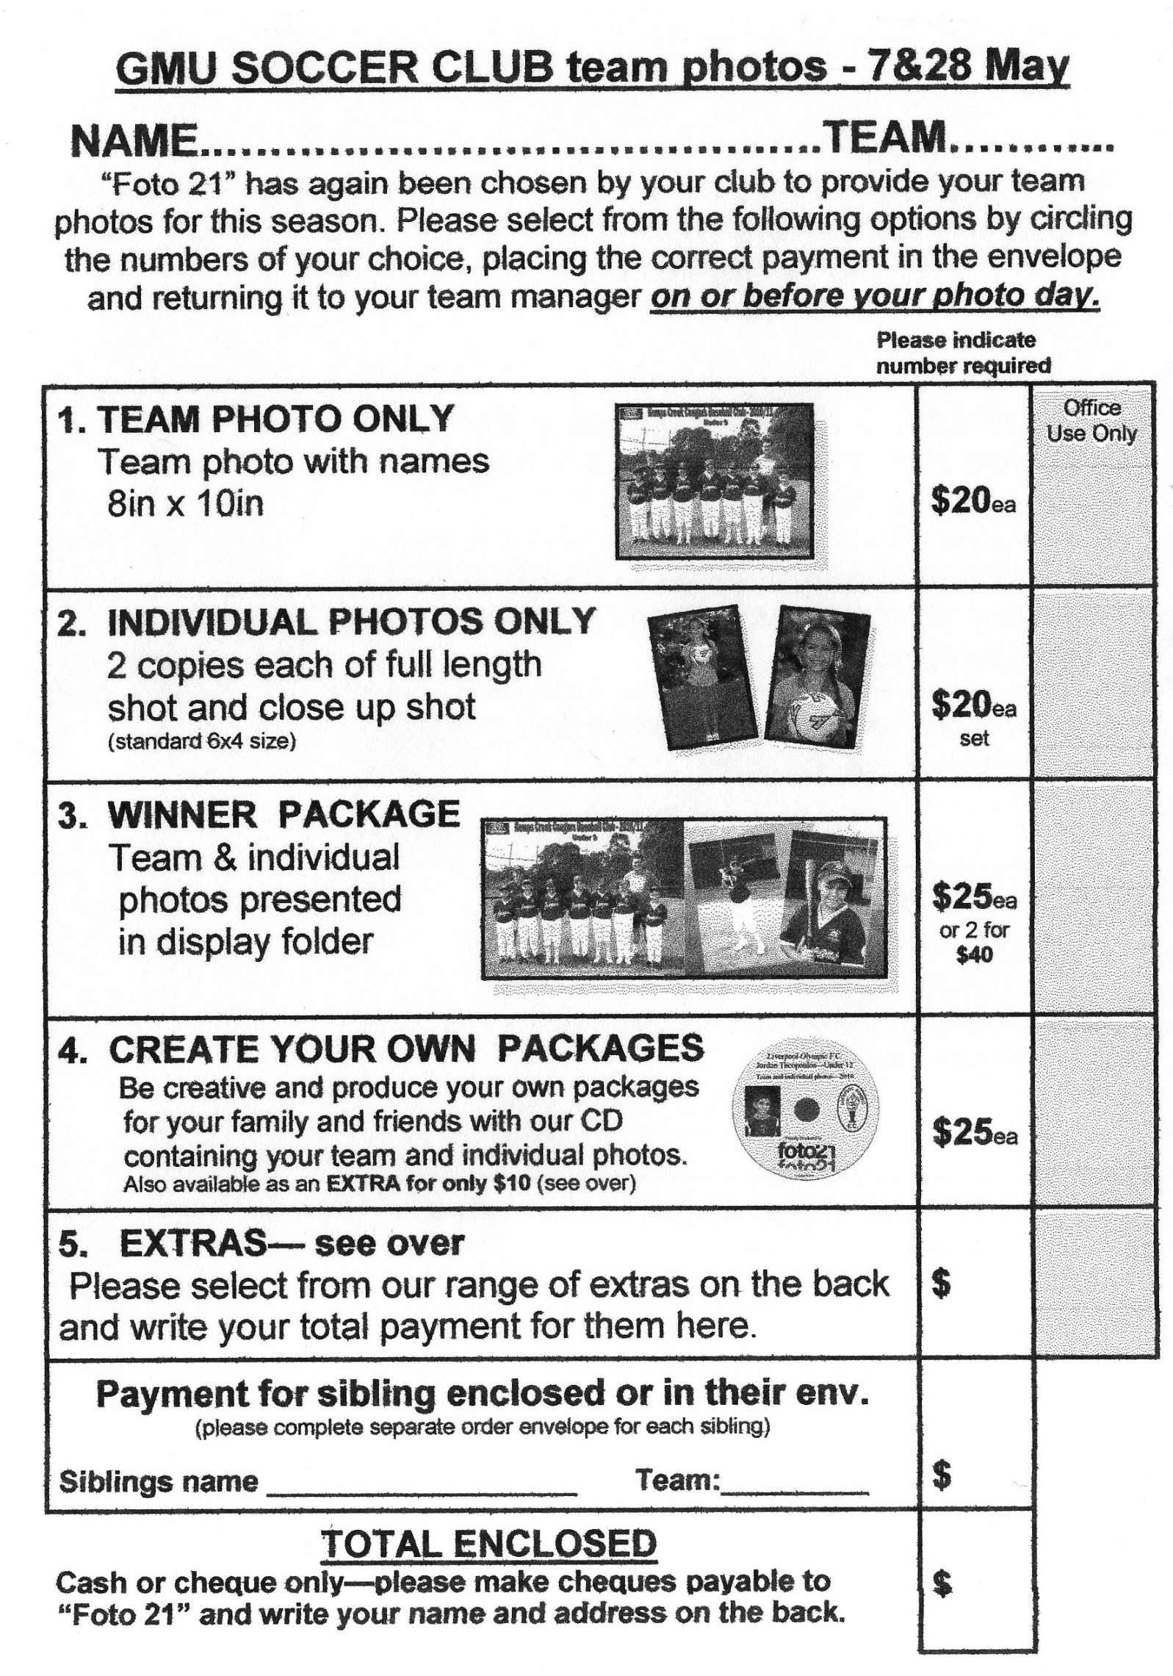

Draw - Saturday 9th June 2012

Six a side Tournament – Everley Park, South Granville

U6 Red 7.30am for an 8am kick off Ronnie
Remember this is a special gala event

* some players will need to play in different teams tomorrow – players cannot change teams after the start of the day

*Teams will continue to play matches while they keep winning

*Under 9 and 10 teams will play a round robin – not a knockout

* managers and coaches please check the special rules – only 7 players per team, no interchange, countback on corners and goal kicks if goals equal to decide the winner

U6 White 9.00am for a 9.30am kick off Moises

U6 Black 9.00am for a 9.30am kick off Robert

U7 Red 8.15am for an 8.45am kick off Wayne

U7 White 8.15am for an 8.45am kick off Frank

U8 Red 10.30am for an 11.00am kick off Adam

U8 White 10.30am for an 11.00am kick off Dean

U9 Red 8.15am for an 8.45am kick off Hamid

U9 White 8.15am for an 8.45am kick off Steven??

U10 Red 7.30am for an 8.00am kick off Sam

U10 White 7.30 am for an 8.00am kick off Genell??
Competition round 9

U11 vs Winston Hills Bears at Everley 1 (Everley Rd., South Granville)

8.30am Kickoff (meet at Everley at 8.00am)

U12 vs Castle Hill United White at Fred Catterson 4 (Catterson Dve., Castle Hill)

10.45am Kickoff (meet at Catterson at 10.15am)

U14 vs Auburn FC at Webbs Avenue 4 (Webbs Ave., Auburn)
10.30 am Kickoff (meet at Webbs at 10.00am)

Round 3 washout - replay

Raahauge Cup North Div.

Reserves vs Penrith Churches at Walshaw (Hector Rd., Bass Hill)

1.15pm Kickoff (Meet at Walshaw at 12.45pm)

Firsts vs Coptic United at Walshaw (Hector Rd., Bass Hill)

3.15pm Kickoff (Meet at Walshaw at 12.45pm)

Draw Sunday 10th June 2012

All Age Ladies vs Winston Hills White at Max Ruddock 1 (Romulus St., Winston Hills)
1.15pm Kickoff (Meet at Max Ruddock at 12.45pm)

Managers – don’t forget to check this draw against the published draws on the website and contact me if there are inconsistencies. Greg

