OTB 13/12
Club Secretary – Greg 9682 7779 President – Peter 9632 9203

Interested in sponsoring a team or advertising in this newsletter? – call one of the above numbers.

www.mccredie.org.au/soccer
_______________________________________________________________________________________________________________________________
Referee course – lecture and exam Free.
19th June at 6.45pm Wentworthville Uniting Church
_____________________________________________________________________________________________________________________________
Club Photos start THIS WEEK
Please remember

- photos must be paid for before the photos are taken – your manager will collect the money and hand to the photographer on the day

- All players must be ready for the team photo at the required time (DON’T BE LATE!)

- All players must be in the team photo – even if they are not buying a photo

- DO NOT wear shirts under your jersey, and ensure all players are in correct uniform – our shorts and socks are ALL BLACK

16th June Under 7, 8 W, 9, 10, RCN

17th June Ladies

Wednesday 20th June 6W

23rd June Under 6 R, 6 B, 8 R, 11, 12, 14
_____________________________________________________________________________________________
RESULTS – 9th/10th June
Six a side Results

U6 Red R1 vs St Columbas Castle Hill won
R2 vs Lidcombe Churches lost

U6 White R1 vs Bye
R2 vs Hills Spirit Red 0 - 3
R3 vs Kings School 2 – 4
Goal scorers – Daniel Kvesic 1, Fouad Ayoub

U6 WHITE vs Hills Spirit (red) 0-3
Due to sickness and holidays, our team was not the same without Kassem, Sebastian, Lucy, Alex and Chris. So Dylan, Daniel, Diego, Fouad and our U6 Red recruits, Joshua and Yardeng went out and gave it their best. Taking advantage of the new team make-up the Hills Spirit Red’s quickly jumped to a 1 goal head-start, our team defended well and missed a few good opportunities, going into the half 1-0 down. After a quick break, the team looked almost set to level the score, but good saves by their goalie managed to keep us out. Unfortunate confusion midway through the 2nd half in our goal area, led to an own goal and from there the Hills Spirit Red managed to close it out with a 3rd goal. Our team tried their best, but were beaten by a better team on the day.

U6 White vs Kings 2-4
Given a second chance through the draw, our team probably still thinking about the previous game allowed the Kings to jump to a 1-0 lead after just seconds into the game. The team managed to regroup, with Joshua doing some great runs with the ball, Diego made some good ball turns and defensive kicks which allowed Daniel to get some space to level the score at 1 all. Yardeng played great in the game saving many good shots at goal by the Kings. Another own goal by our young lads late into the first half really hurt the team and they didn’t have much time to shake that off, as the Ref disappointingly didn’t allow the teams a half-time break. None-the-less at the 2nd half kick-off the U6 Whites were determined and showed great spirit, Dylan and Fouad managed to work together early on to create an opportunity which saw Fouad boot a great goal to level it at 2-2. The team looked like they were going to get the job done, as the game swung from side-to-side and Joshua having a few more shots at goal but were wonderfully saved. Unfortunately for us another lapse in concentration in our goal area saw the Kings capitalise with a goal to lead 3-2. Our boys and 1 girl were clearly tired towards the end and was unable to chase down the lone Kings player who broke away to score the 4th goal for the opposition and seal the victory. A valiant attempt by the team and they looked like they were going to pull off the victory, but clearly they were missing their friends on this day. Also a big thank you to Joshua and Yardeng from the U6 Reds for playing with us. Goal scorers – Daniel Kvesic 1, Fouad 1.

U6 Black
Great first game win 3-0 with only 5 players. But, unfortunately our star players went home sick after first game so the rest of the matches had to be forfeited. Good game to those players who did show.
R1 vs Bye
R2 vs Hills Spirit White 3 - 0
Goal scorer – Joey Farah 3
R3 vs Lidcombe Churches

U7 Red R1 vs McCredie White 5 – 0
R2 vs won
R3 vs lost
We had three games. An exciting kick off where all the players gave it a 100%. Everyone maintained his position and showed team play. We won the first game and we nailed the second. But I guess a long wait after that the kids got tired and it was obvious at the third game. Not to forget Armin, Tamer, Mohammed, Baras, Ritchie and Tatiana who all helped out to ensure we got two under 7 teams and give a fair go to all the players who showed up that day, you guys rock and you did a wonderfully job!

U7 White R1 vs McCredie Red 0 – 5
R2 vs 0 - 6
U8 RED R1 vs Hills Spirit Blue 0 – 2
R2 vs McCredie White 1 - 4

U8 WHITE R1 vs Bye
R2 vs McCredie Red 4 – 1
Goal scorers Mustapha Fahme 2, Mase Swalah McDahrou 2
R3 vs Wentworthville Uniting 0 - 3

U9 White R1 vs Hills Spirit White 0 - 2
R2 vs Wentworthville Uniting 2 – 1
Goal scorers – Christopher Germanos 1, Yilmaz Temel 1
R3 vs McCredie Red 0 – 5
Good to see you boys stepping up and taking charge,Very impressed with your peformance today.

U9 Red R1 vs Wentworthville Uniting 3 – 0
Goal scorers – Christian Frangie 1, Yel Chan 1, Shaleen Nagar 1
R2 vs Hills Spirit White 3 - 1
Goal scorers – Yel Chan 2, Shaleen Nagar 1
R3 vs McCredie White 5 – 0
Goal scorer - Christian Frangie 2, Yel Chan 2, Shaleen Nagar 1
Final vs Hills Spirit White 2 – 0
Goal scorer – Yel Chan 2
A great day with an excellent result. Our team of champions played with all their hearts and fought all the way to the end. Thankyou to everyone

U10
We had two u10 teams this year entered in the 6 a side and it was fun, happy and stressful day - like every year.
The U10 reds team played some superduper football and were unfortunate to lose the first 3 games. They finished off well though our 4th game. Good effort boys.
Our U10 White team, didn’t start too well considering it was a 8am kick off and a very cold morning. During the day we had some very tough games losing on goal kicks against St Columbas (our first 6 a side loss in 5 years!) but winning our other matches. In the Grandfinal we were again pitted against St Columbas and it was the best game ever played in the history of football. There was team effort, structure and positioning, tactics and strategies, passing and through balls. Qais scored a magnificent scissors kick goal from Nedim’s cross and Yusuf just was awesome setting up excellent balls for the strikers. Nedim was so strong this game and played with no mistakes. Joshua and Saf kept the defence strong but let’s come to our keeper Jamal. MAN OF THE MATCH as he saved 2 goals that I think professionals couldn’t even do. He was just awesome. Great end result boys we won the 6 a side again :).

10 Red R1 vs St Columbas Castle Hill 0 – 2
R2 vs Wentworthville Uniting
R3 vs McCredie White 0 – 9
R4 vs OLQP Falcons 1 – 0
Goal scorer – Andrew Ibraheem 1

10 White R1 vs OLQP Falcons 5 – 0
Goal scorers – Joe Azzi 2, Nedim Fazlic 2, Qais Sungkar 1
R2 vs St Columbas Castle Hill 0 – 0 (lost on goal kicks)
R3 vs McCredie Red 9 – 0
Goal scorers – Nedim Fazlic 3, Qais Sungkar 3, Yusuf Jamil 2, Joshua Elkerr 1
R4 vs Bye
FINAL vs St Columbas Castle Hill 3 – 0
Goal scorers – Nedim Fazlic 2, Qais Sungkar 1
Round 9 Results
U11 vs Winston Hills Bears 3 – 1
We started slowly and allowed our opponents to get to the ball first and dominate a majority of the play in the first half. We woke up after half time and started to get to the ball first which saw us take the lead and eventually close out the game towards the end of the second half. Ahmad, Ali and Deng had really good games at the back closing down our opponent’s attacks. Chan and Ferdinando were good in providing opportunities for Tong to score. While Jasper put in a good effort in goals in the second half for his first attempt in that position.
Goal scorers – Tong Dimo 2, Chan Chan 1

U12 vs Castle Hill United White 1 - 5
No getting past the fact that we were pretty dreadful for the first 40 minutes of this game with very little urgency and basic skills letting us down. Diving in in tackles, poor disposal and even air swings! In the last ten minutes though we played like we were a few weeks ago and looked really good. Come on boys it really is about how badly you want to compete, because we know you can do it. Joel was great all game (as usual), Daniel tried hard all day and Joshua Yanto was fantastic, displaying the urgency we need and inspiring his team mates with his efforts. Well done Josh. Goal scorer – Salem Boustany 1

U14 vs Auburn FC 3 – 2
What an amazing game! Auburn were undefeated and top of the table. They expected to walk all over us, but our U14s stood up and showed everyone that they are premiership contenders. We kept them to 0-0 at half time through great defence, good saves by Hamze and a great header off the line by James. We were also unlucky not to score a few times on the back of some hard work by John and Kane. The second half was end to end. We were passing the ball, supporting each other and not giving Auburn many opportunities. We had the running of the game, we built up the pressure, and the goals came, John showing how to finish team goals. This was truly a team effort that all of you should be proud of. Player of the Match - Willem Booker Special mention, the backs (awesome) - Jason Tran, James Russell , Venkata Kollimarla, Joshua McGuire Goal scorer – John Kazzi 3

All Age Ladies vs Winston Hills Bears White 1 – 0
The newsletter is almost full so – Sarah Dubois (player of the match and sensational), Ania Luckiewicz marked brilliantly, Aluel great ball skills and what about Mika’s goal? 50 metre run, runs around 3, shows lightning speed and a cracking shot. Can’t not mention Hendrika’s great keeping including two fantastic 1-1 saves! Awesome. – 2 wins in a row – we are hot! Goal scorer – Mika Oo 1

RC N Reserves vs Penrith Churches 4 – 1
A really strong display against one of the sides near the top. Adem made an immediate impact when he came on and Reza finished a tap in after a good team build up. It was only in the second half where we scored again, from a well taken corner to the near post and …. Straight in. We let them strike back, but from the kick off, seeing the keeper off the line Hakan hit it first time. We have all seen this opportunity many times but I’ve never seen it work before. It killed them and the fight back they planned really died 2 minutes later as Darren saved the penalty. Adem grabbed one for himself at the end and it finished 4-1.
Goal scorers – Reza Taufiq 1, Greg Wark 1, Hakan Mete 1, Adem Stevens 1

RCN Firsts vs Coptic United 4 - 2
Back in the winner’s circle with a very solid team performance. None of the problems of last week and Steven and Riad looked solid together at the back, Kyle played well and Adem, Luk and Virinder cut them to pieces up front. The goals included a well taken direct free kick by Hakan (for his second of the day) and a sensational finish from Virinder from 25 yards. Really pleasing effort from all.
Goal scorers – Virinder Chaggar 1, Hakan Mete 1, Lukman Sungkar 1, own goal 1

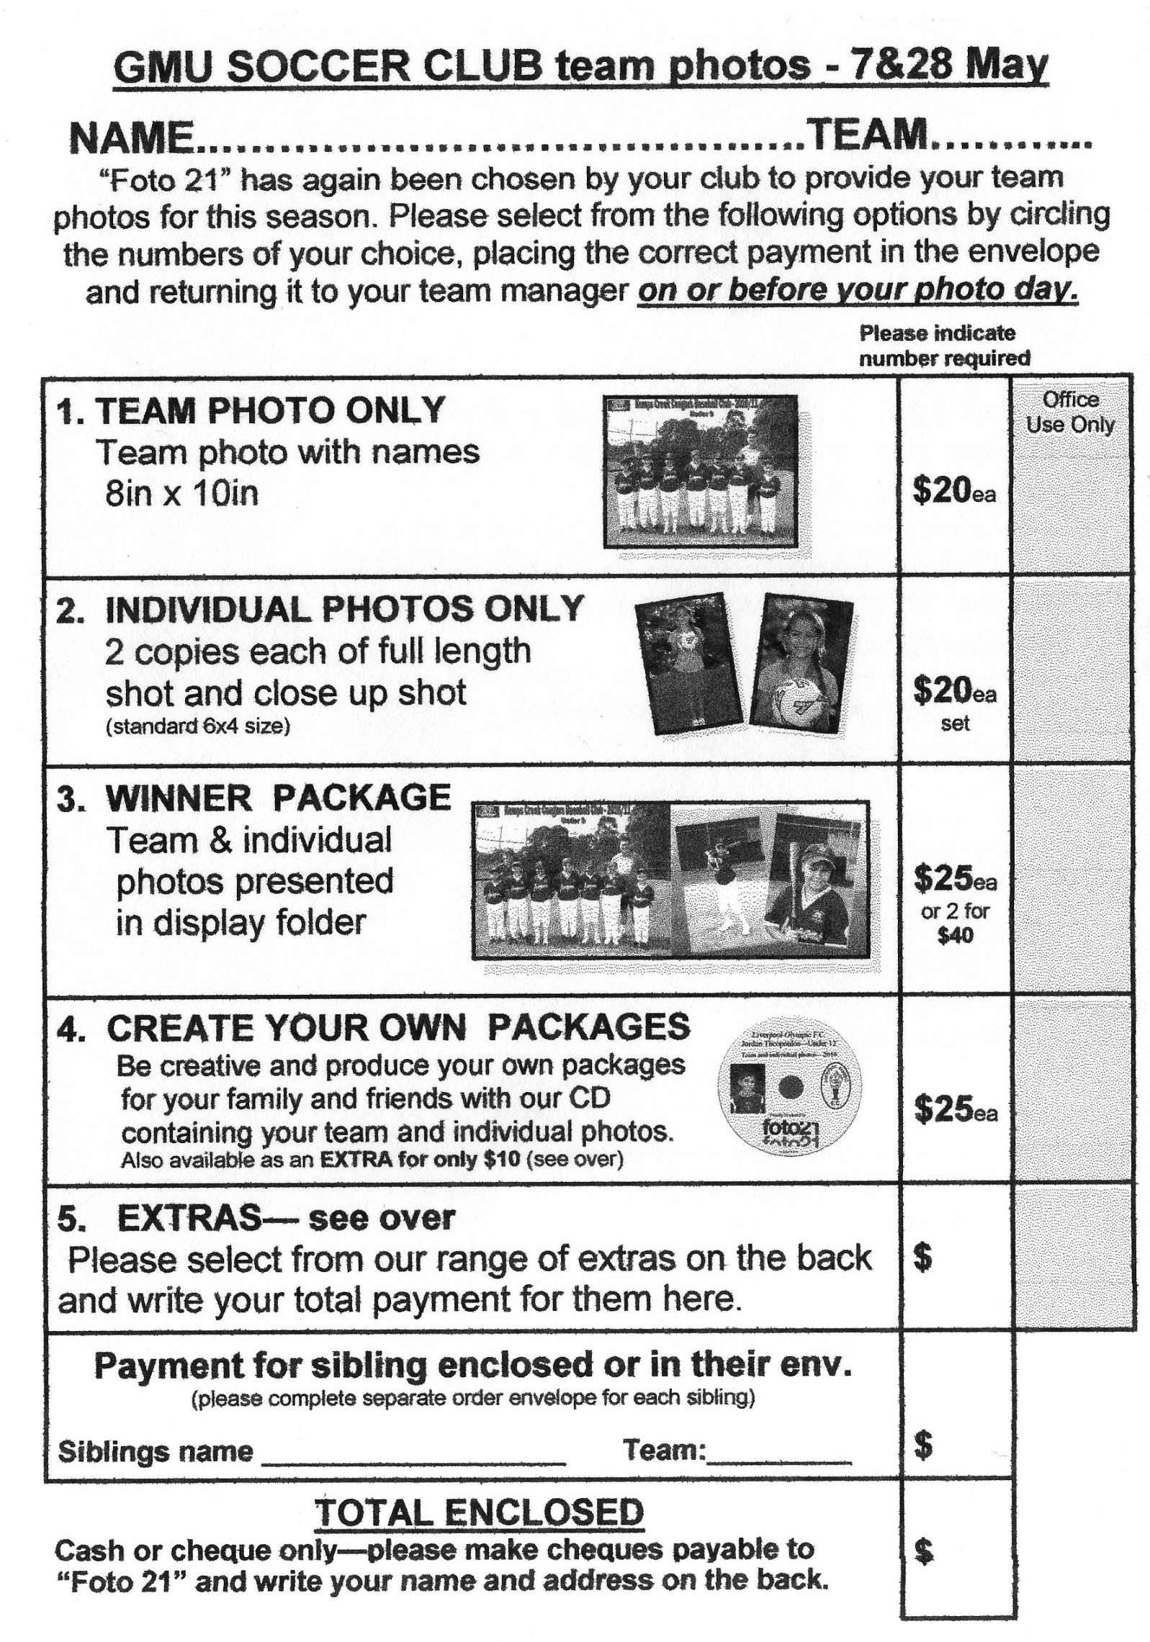

Managers – don’t forget to check this draw against the published draws on the website and contact me if there are inconsistencies. Greg

Draw - Saturday 16th June 2012

U6 Red vs Hills Spirit Black at Kellyville (Memorial Ave., Kellyville)
9.00am Kickoff (meet at Kellyville at 8.30am)

U6 White vs Hills Spirit Blue at Kellyville (Memorial Ave., Kellyville)
8.00am Kickoff (meet at Kellyville at 7.30am)

U6 Black vs SBFC Lions at Eric Mobbs 1B (Excelsior Ave., Castle Hill)
9.00am Kickoff (meet at Eric Mobbs at 8.30am)

U7 vs OLQP Falcons O at Daniel (Daniel St., Greystanes)
10.00am Kickoff (meet at Everley at 8.45 am FOR PHOTO)

U8 Red vs OLQP Falcons L at Daniel (Daniel St., Greystanes)
9.00am Kickoff (meet at Daniel at 8.30am)

U8 White vs Lidcombe Churches at Everley 2 (Everley Rd., South Granville)
10.00am Kickoff (meet at Everley at 9.00am for PHOTO) (set up field)

U9 vs OLQP Falcons L at Everley 2 (Everley Rd., South Granville)
11.00am Kickoff (meet at Everley at 10.00am for PHOTO) (dismantle field)

U10 vs Hills Spirit White at Everley 1 (Everley Rd., South Granville)
12.00pm Kickoff (meet at Everley at 11.00am for PHOTO) (set up field)

U11 vs Auburn FC at Webbs 2 (Webbs Ave., Auburn)
10.40am Kickoff (meet at Webbs at 10.10am)

U12 vs Bye

U14 vs North Rocks at North Rocks 1 (North Rocks Rd., North Rocks)
11.40am Kickoff (meet at North Rocks at 11.10am)

Raahauge Cup North Div.

Reserves vs Kings Old Boys
1.15pm Kickoff (Meet at Everley at 12.45pm)

Firsts vs Epping Church of Christ at Everley 1 (Everley Rd., South Granville)
3.15pm Kickoff (Meet at Everley at 2.45pm for PHOTO)
(dismantle field)

Draw Sunday 17th June 2012

All Age Ladies vs Ermington at Everley 3 (Everley Rd., South Granville)
1.15pm Kickoff (Meet at Everley at 12.20 pm for PHOTO)

Managers – don’t forget to check this draw against the published draws on the website and contact me if there are inconsistencies. Greg

