OTB 14/12
Club Secretary – Greg 9682 7779 President – Peter 9632 9203

Interested in sponsoring a team or advertising in this newsletter? – call one of the above numbers.

www.mccredie.org.au/soccer
_______________________________________________________________________________________________________________________________
Referee course – lecture and exam Free.
19th June at 6.45pm Wentworthville Uniting Church
_____________________________________________________________________________________________________________________________
Club Photos start THIS WEEK
Please remember

- photos must be paid for before the photos are taken – your manager will collect the money and hand to the photographer on the day

- All players must be ready for the team photo at the required time (DON’T BE LATE!)

- All players must be in the team photo – even if they are not buying a photo

- DO NOT wear shirts under your jersey, and ensure all players are in correct uniform – our shorts and socks are ALL BLACK

New photo schedule:

23rd June Under 6R, 6B, 8R, 8W, 11, 12, 14

21st July Under 6W, 7, 9, 10, RCN

8th July TBC Ladies
_____________________________________________________________________________________________
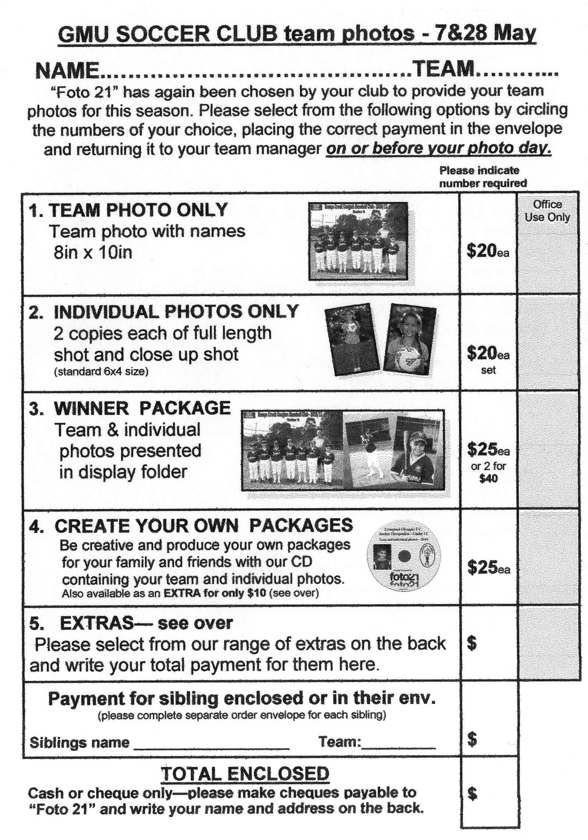

Under 8 Under 9
 | Wentworthville Uniting | 19
 | OLQP Falcons (O) | 19
 | Hills Spirit (Blue) | 14
 | Guildford McCredie (Red) | 13
 | SBFC Tigers | 10
 | OLQP Falcons (L) | 9
 | Guildford McCredie (White) | 5
 | Hills Spirit (White) | 5
 | Lidcombe Churches | 5
 | Hills Spirit (Green) | 2
 | Guildford McCredie | 19
 | OLQP Falcons (L) | 19
 | Hills Spirit (White) | 15
 | Hills Spirit (Blue) | 10
 | SBFC Tigers | 6
 | Wentworthville Uniting | 5
 | SBFC Eagles | 4
 | OLQP Falcons (O) | 3

Under 10 Under 11 Under 12

 | Guildford McCredie | 21
 | SBFC Tigers | 19
 | SBFC Lions | 14
 | OLQP (L) | 11
 | Lidcombe Churches | 8
 | OLQP (O) | 6
 | Hills Spirit (White) | 5
 | Wentworthville Uniting | 4
 | SBFC Eagles | 2
Auburn FC | 21
Guildford McCredie | 19
Kellyville | 14
Merrylands SFC | 13
Winston Hills | 12
Pendle Hill | 9
Norwest Cougars | 8
Castle Hill United | 4
Lidcombe Waratah | 22
North Rocks | 20
Castle Hill United WHT | 19
Castle Hill United BLK | 19
Winston Hills | 18
OLOR St Angela's | 14
Kellyville | 10
Guildford McCredie | 6
Wenty Waratah | 3

Under 14 All Age Ladies
Rouse Hill | 24
Auburn FC | 19
Holroyd Rangers | 14
Pendle Hill | 14
Winston Hills WHT | 13
Guildford McCredie | 10
Lidcombe Waratah | 8
Winston Hills BLK | 7
Ermington United | 6

Lidcombe Churches | 20
Auburn FC | 19
Guildford McCredie | 18
Granville Kewpie | 17
Winston Hills | 15
Kellyville | 14
Guildford County | 11
North Rocks | 7
Baulkham Hills | 4

 | Wentworthville Uniting (B) | 23
 | Guildford McCredie | 22
 | Greystanes Churches | 18
 | Penrith Churches | 16
 | Parramatta Salvation Army | 14
 | The Kings School Old Boys | 12
 | Wentworthville Uniting | 10
 | Hills Spirit | 3
 | St Columbas Castle Hill | 3

Raahauge Cup North Reserves Raahauge Cup North First Grade

 | Lidcombe Churches | 26
 | Guildford McCredie | 25
 | Zimwarriors | 18
 | Coptic United | 15
 | Castle Hill Baptist | 15
 | Wentworthville Uniting (B) | 12
 | Wentworthville Uniting (A) | 10
 | Parramatta Salvation Army | 8
 | Epping Church of Christ | 7
 | St Columbas Castle Hill | 2

Last week’s rep trials for under 8, 9 and 10 have been rescheduled to this Friday

Managers – don’t forget to check this draw against the published draws on the website and contact me if there are inconsistencies. Greg

B Grade Knockout Semi – Tuesday 20/6/12

Raahauge Cup vs Greystanes Churches at Jones (Banks St., Merrylands)
7.00pm Kick off (Meet at Jones at 6.30pm) (set up field)

Draw - Saturday 23rd June 2012

U6 Red vs McCredie Black at Everley (mini) (Everley Rd., South Granville)
9.00am Kickoff (meet at Everley at 8.20am for PHOTO)

U6 White vs St Columbas Castle Hill at Eric Mobbs 1B (Excelsior Ave., Castle Hill)
9.00am Kickoff (meet at Eric Mobbs at 8.30am)

U6 Black vs McCredie Red at Everley (mini) (Everley Rd., South Granville)
9.00am Kickoff (meet at Everley at 8.15am for PHOTO)

U7 vs Lidcombe Churches at Phillips 1 (Martin St., Lidcombe)
9.00am Kickoff (meet at Phillips at 8.30am )

U8 Red vs OLQP Falcons L at Everley 2 (Everley Rd., South Granville)
11.00am Kickoff (meet at Everley at 10.15am for PHOTO) (dismantle field)

U8 White vs OLQP Falcons O at Everley 2 (Everley Rd., South Granville)
10.00am Kickoff (meet at Everley at 9.15am for PHOTO) (set up field)

U9 vs Hills Spirit White at Kellyville (Memorial Ave., Kellyville)
10.00am Kickoff (meet at Kellyville at 9.30am)

U10 vs OLQP Falcons L at Daniel 2 (Daniel St., Greystanes)
10.00am Kickoff (meet at Daniel at 9.30am)

U11 vs Castle Hill United at Everley 1 (Everley Rd., South Granville)
8.30am Kickoff (meet at Everley at 8.30am for PHOTO) (set up field)

U12 vs OLOR Kellyville at Everley 1 (Everley Rd., South Granville)
9.30am Kickoff (meet at Everley at 9.00am for PHOTO)

U14 vs Lidcombe Churches at Everley 1 (Everley Rd., South Granville)
10.45 am Kickoff (meet at Everley at 10.00am for PHOTO)

Raahauge Cup North Div.
Reserves vs Penrith Churches at Bert Saunders (Kiata Rd., Doonside)
1.15pm Kickoff (Meet at Bert Sanders at 12.45pm)

Firsts vs Coptic United at Bert Saunders (Kiata Rd., Doonside)
3.15pm Kickoff (Meet at Bert Sanders at 12.45pm)

Draw Sunday 24th June 2012

All Age Ladies vs Rouse Hill Rams at Merrylands Park (Cnr Merrylands Rd & Burnett St., Merrylands)
1.15pm Kickoff (Meet at Merrylands Park at 12.45 pm)

