OTB 18/10

www.mccredie.org.au/soccer

Club Secretary – Greg 9682 7779 President – Peter 9632 9203

Interested in sponsoring a team or advertising in this newsletter? – call one of the above numbers.

Some updates

Special thanks to Claudia (our Fundraising Coordinator) who has organised our last three Bar Be Ques at Woolworths. We have made about $1600 from these events. Thanks also to Frank and Norm especially who helped out.

Our thoughts are with Eloy Calderon (under 16s) who has been in hospital for some time. Our thoughts are with you, Carlos and the family and we hope to see you back in the red and white stripes soon.

Congratulations to Mohamed Rahimi (from our U16s) – who represented Sydney West at the State Championships. Mohamed scored 5 goals during the tournament and the team finished second overall.

Congratulations to Caner Temel who (a couple of games ago) netted his 200th goal for the club. Caner was one of our original players in 1999 playing in the under 8s and now runs around in the RC1 First Grade.

Congratulations too to Lorena and Gonzalo Diaz on the birth of Alphonse! The club’s future remains bright!

As we get to the pointy end of the season – the under 8 Reds are in second place, under 8 Whites in third place, under 10 Whites are in second place, under 11s are in the top 4, under 12s are close to the top 4, under 13s and 15s are in the top 4 and the under 16s are fighting hard to get into the top 4 in division 1. The RCN are also working to get into the top 4 and the RC1 reserves are hopeful of finishing first or second. Certainly most our teams are well and truly in contention.
___________________________________________________________________________________________

PHOTOS

The first team’s photographed have had their photos returned to the club. These have been distributed to managers for your collection.

The remaining teams will be photographed on Saturday July 31st. Prices are below.
___________________________________________________________________________________________

RESULTS from Saturday 17th July 2010

U6 vs OLQP Falcons P 6 – 5
This week was a great week for under 6's McCredie team as they had a brilliant win over the Falcons. The score was 6-5 McCredie way. It was very close and both teams tried their best to come out on top. There could only be one winner and the McCredie team claimed that with their effort and tried their best, had fun and got out there and had a go. Each team member had a brilliant outcome in the game using team work and team skills to stay in the game and exceed in winning. The player of the match was Edward Tu who played magnificently throughout the game with the help from all team mates. The McCredie did well it was a tough game but they came though in the end. Keep up the good work!
Goal scorer – Aaran Batth 5, own goal 1

U7 RED vs Lidcombe Churches 8 – 0
The cold morning didn’t seem to slow this pack of champions, what a great start to the game. The opposition were no match to our mighty guns, Shaleen, John-Paul, John Luke, Anthony and Christian constantly dominating ball possession. We went to half time with a lead of 4 goals .The second half was even better, the other team remained scoreless for the whole game. With even more goals in the second half, every one was having a go, even little Jacob and Victor getting near the goals. Elias and Rahul also having a stand out game. This was our biggest win. GREAT GAME BOYS!!!!!!!!!!! Man of the match – Elias.
Goal scorers – Shaleen Nagar 2, Anthony Tannous 2, Christian Frangie 2, John-Paul 1, Elias Matta 1

U7 WHITE vs Newington Gunners G 3 – 0
Today the boys played in a cohesive manner, passing the ball and thinking about how to make way through the Gunners. Lachlan engaged the opposition with good kicks and showed who the best at the throw-ins is. William was well in the game with good drives up the middle of the pack. Mosese got in the game showing he would kick and run resulting in 2 goals. Abdallah spent the first half in goals then had some good long distance kicks in the second half pressuring the Gunners in their half. Oliver came to the rescue in the back line making it difficult for the Gunners to reach our goal. Ryan again worked on the sweep position stopping the Gunners runaway attempts. Thanks to Joel U6’s who did good work in the forwards, and giving us a reserve player. MVP Lachlan, Best and fairest Abdallah and Goofy to Ryan for his excellent long distance goal.
Goal scorers – Mosese Masima 2, Ryan Booker 1

U8 RED vs OLQP Falcons P 10 – 0
What a great start to the game, Falcons didn’t know what hit them. We dominated the game our defence was strong and our attack was hard. In the first half, Qais scored 4, if we had more time I think all the team members would have scored their own goal. Great work, keep it up. Player of the match – the team.
Goal scorers - Qais Sungkar 4, Nedim Fazlic 2, Hashmat Sardar 2, Joshua Elkerr 1, Robert Kahila 1

U8 WHITE vs St Bernadettes Castle Hill L 0 – 1
We were up against it today one short with 5 players on holidays but the boys dug deep and played really well. Arber and Elias were both outstanding and Yousef was everywhere but we just did not have the troops to counter when we had chances. We missed some key players but the boys never gave up and were unlucky not to get a point
Players of the Match - Arber and Elias.

U10 RED vs Wentworthville Uniting 2 – 0
Again we started slowly today and were watching our opposition which saw us on the back foot for a lot of the first half. Luke scored a good goal against the run of play and we went into half time 1 nil up. The second half saw us running slightly down hill and we dominated most of the play. Mohamed was strong making several impressive runs from the back, Joel was again solid at the back and Lawrence is adapting well with his move to the midfield. Harrison earned 1 man of the match for making crucial saves as keeper in the second half when Wenty got a breakaway. Matthew earned the other man of the match award for scoring his first goal of his career with the club.
Goal scorers – Luke Fernandes 1, Matthew Ghanoum 1

U10 WHITE vs OLOR Kellyville G 1 – 0
What a game, it was so tense just like the world cup. With 4 players short we enlisted the help of 2 under 8’s and what a bonus they were. Will List and Jackson Hunt thank you both for a fantastic effort and little Will the pocket rocket scored the only goal for the match. Jesse was fantastic as goalie and Will List were both awarded with Player of the match. We were scoreless till 5 minutes to go in the 2nd half when Will shot a beauty. Men of the Match: Jesse Ambara and Will List
Goal scorer – Will List 1

U11 vs Bye

U12 vs Auburn FC 2 – 1
We took some time to settle down today and conceded an unlucky own goal in the first half. We missed a penalty but Clayton pinched the equaliser and it was all square at half time. Some harsh words from the coach and with the season on the line the team lifted and we should have got a few more. A perfect corner found Cameron’s back and we were home. We need to tough it out from here on but we can get there week by week. Player of the Match - Willem Booker Goal scorers – Cameron Hunt 1, Clayton Telfer 1

U13 vs Dundas United 1 – 4
I couldn't be more proud of the team today. We went down but there is more to this story that the result alone doesn't show. Today we played the top team and we had only 9 players, they had 3 subs. We went down early but fought back to be 1-1 at half time. A miracle looked possible and the team tried so hard right until the final whistle. Wil and Ali shone in defence. Abulfazel and Alfred were fantastic in midfield and Rony and Mohamed really tested their defence all match. The team didn't give up at any time and made their coach and club very proud today.
Goal scorer – Mahammad Abdul Hamid 1

U15 vs Wenty Waratah 5 – 1
A very slow start to this game, and at half time and only 1 -0 up, we really didn't take control of the game. We looked tired and as if we were all still on holidays. Fortunately, our fullbacks (Mark, David, Dean and Paul) as usual, didn't let us down and made sure Wenty had little chance of scoring against us. The second half was much better, as we moved to the ball, controlled possession and started to run onto some good through balls from the midfield. We need to get into high gear much earlier in the game if we are to beat some better opposition. Special mention goes to Junior Clark, who scored a hat-trick, and Jordan who played awesome in both attack and defence. Man of the match was Kameel, who played with great enthusiasm attacking the ball at all times and shows more skill every game, passing his opposition and getting the ball to key players up field. He is great in centre mid-field, and with Junior, Jason and George alongside, he completes a fine group of midfield players. Nice Game boys, but we must get better. Man of the match - Kameel.
Goal scorers – Junior Clark 3, Jeremy Gonzales 1, Jordan Sarmento 1

U16 vs Wenty Waratah 1 – 0
Team decided on a new nickname of “The Spartans” due to lack of numbers. Had 10 players for most of the match against their 15 (including subs). But we dominated from massive efforts by all the boys. First half we contained and looked to get something on the break – which we were unfortunate not to do. Second half we decided to go all out for the win and attack so we played a 3-3-3 system that kept Wenty deep in their own half. Abdul, Pat and Jeremy fantastic in the backs even when outnumbered, Hayden made the few attempts they had look pedestrian, Deniz tireless in centre midfield especially considering the injury he was carrying which was all taped up, Mushtaba and Nick on the wings pinned them in their half and dug deep to support the defence, Rahimi was the spark in attack but just wasn’t lucky (with 3 great shots that beat everyone but the crossbar being some of his more spectacular efforts), Antony and Mohammed Abed played tirelessly upfront harassing their defenders which severely broke up Wenty’s rhythm. Man of the match – the team; including Cameron who was back on his feet supporting us which gave the boys that extra lift.
Goal scorer – Nicholas Stamos 1

RC North FIRSTS vs King Old Boys 5 – 2
McCredie had a great win against Kings Old Boys as we marked the come back of our inspirational leader Carlos. The game was scoreless at half time and tension was building for an explosive second half. Explosive it was, McCredie scored early via Rafael with a toe poker that surprised the keeper; from that point the flood gates opened and the game changed shape. McCredie ran out eventual winners with 5 to 2 win.
Goal scorers – Rafael Aleman 2, Antonio De Apolinario 2, Christian Diaz 1

RC 1 RESERVES vs St Patricks Strathfield 2 – 0
Pure guts and effort by everybody today.
Goal scorer – Cuong Lo 2

RC 1 FIRSTS vs St Patricks Strathfield 0 – 5
Though we were all doubling up it was a great effort by everyone. If we hadn’t already played a full match the team showed we could cause them serious trouble. Special mention to Cuong and Marial who kept running up front even when the rest of the team was focused on containment. Extra special mention to the boys for not retaliating to St Pats tackles despite the referee giving them carte blanche.

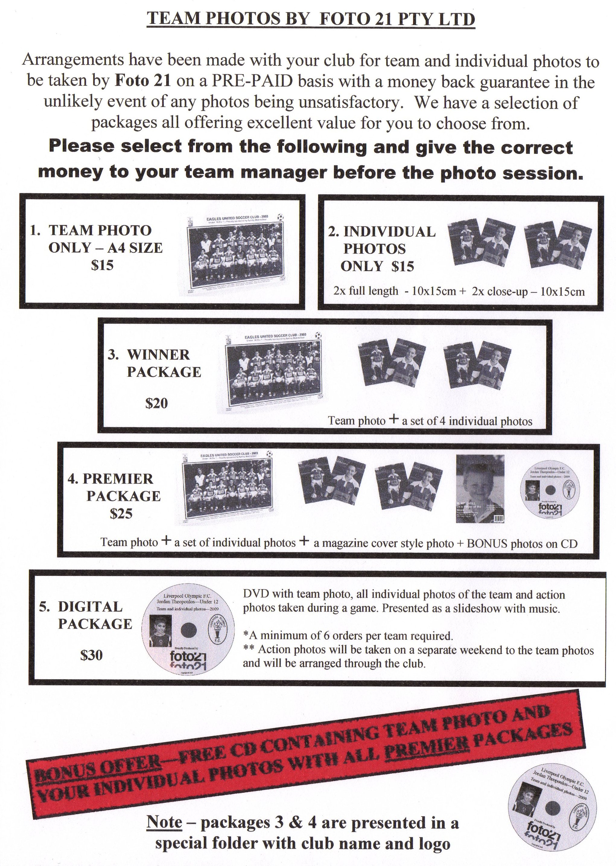

Draw - Saturday 24th July 2010

U6 vs St Bernadettes Castle Hill H at Everley (mini) (Everley Rd., South Granville)

10.00am Kickoff (meet at Everley at 9.30am) (dismantle field)

U7 WHITE vs St Bernadettes Castle Hill H at Everley (mini) (Everley Rd., South Granville)

9.00am Kickoff (meet at Everley at 8.30am) (set up field)

U7 RED vs OLOR Kellyville W at Kellyville A (Memorial Ave., Kellyville)

10.00am Kickoff (meet at Kellyville at 9.30am)

U8 WHITE vs St Bernadettes Castle Hill T at Everley 3 (Everley Rd., South Granville)

10.00am Kickoff (meet at Everley at 9.30am) (set up field)

U8 RED vs Lidcombe Churches at Phillips 2 (Martin St., Lidcombe)
9.00am Kickoff (meet at Phillips at 8.30am)

U10 WHITE vs OLQP Falcons Q at Daniel (Daniel St., Greystanes)

10.00am Kickoff (meet at Daniel at 9.30am)

U10 RED vs OLQP Falcons P at Everley 1 (Everley Rd., South Granville)

11.00am Kickoff (meet at Everley at 10.30am) (dismantle field)

U11 vs North Rocks at Everley 1 (Everley Rd., South Granville)

9.00am Kickoff (meet at Everley at 8.30am) (set up field)

U12 vs North Rocks at North Rocks Park (Cnr Farnell Ave & North Rocks Rd., North Rocks)

9.30am Kickoff (meet at North Rocks at 9.00am)

U13 vs Norwest at Francesco Crescent (Francesco Cres., Bella Vista)

10.20am Kickoff (meet at Francesco at 9.45am)

U15 vs Granville Waratah at Robin Thomas 1 (Harris St., Parramatta)

11.55am Kickoff (meet at Robin Thomas at 11.30am)

U16 vs Castle Hill United at Everley 2 (Everley Rd., South Granville)

10.30am Kickoff (meet at Everley at 10.00am) (set up & dismantle field)

Raahauge Cup North Div. vs Parramatta Salvation Army at Jones 2 (Banks St., Merrylands) 3.15pm Kickoff (meet at Jones 2 at 2.45pm)

Raahauge Cup First Div. vs St Matthews Baulkham Hills at Greenup (Cecil Ave., Castle Hill)

( Reserves at 1.30pm, Firsts at 3.15pm) (Meet at Greenup at 1.00pm)
____________________________________________________________________________________

B Grade Knockout Final – Wednesday 28th July 2010

Raahauge Cup North Div. vs Carlingford Uniting at Jones 2 (Banks St., Merrylands) 7.00pm Kick off

