OTB 19/10

www.mccredie.org.au/soccer

Club Secretary – Greg 9682 7779 President – Peter 9632 9203

Interested in sponsoring a team or advertising in this newsletter? – call one of the above numbers.

Ouch! Last Saturday was a difficult round with a number of our sides, that needed wins, not getting them. Thankfully at least the 8 whites and 16s broke this trend!

Good luck this week to the RCN side who play in the B Grade Knockout final!
___________________________________________________________________________________________

REMINDER TO THE Under 10s and 13s – this week we will train on Tuesday – same times as usual.
___________________________________________________________________________________________
PHOTOS
The following teams have team photos this Saturday.

U7 WHITE, U8 RED, U13, U15, Raahauge Cup First Div.

These managers have their envelopes to collect payment – remember payment must be made before the photo. Every player must be present for the photo (even if you are not buying one)
The prices are on page 3 of this newsletter.
___________________________________________________________________________________________

RESULTS from Saturday 24th July 2010

U6 vs St Bernadettes Castle Hill H 3 – 0
What a sensational game this weekend by our under 6s. It was a tough game but we played like champions and came away with a great win over the Bernadettes. Jasmine Achi took our player of the week for her outstanding effort throughout the game and a big congratulations to Dean Simidis who took main goal scorer with 2 amazing goals and also Aaran Batth bringing home one more for the team. Big thankyou to St Bernadettes for a great game. Goal scorers – Dean Simidis 2, Aaran Batth 1

U7 RED vs OLOR Kellyville W 1 - 9
This week we faced Kellyville, Last time they beat us 12 -nil.But that didnt worry the Team as much as it worried me.With a quick prep talk about going out on the park and play the best they can.Wasnt to long before Kellville began to score and score,A quick reshuffle in defence, Our little team faught with all their hearts but they were no match for the other teams big kicks. To prove our DIE HARD attitude, Shaleen and Christian came up with an absolute brilliant play to allow Christian to score against a team wich seemed impossible to do so. That goal it self was better than winning the game. The second half was better,Not allowing Kellyville to score as many goals as the first half. It was great to watch a smaller team improve so much and challenge a team which is older. Loss 1-9 man of the match with a great goal Christian Goal scorer – Christian Frangie 1

U7 WHITE vs St Bernadettes Castle Hill H 3 – 1
Today’s game showed the elements of team play, passing the ball from player to player and rotation of players when tired.
The boys helped each other well done. The highlights were Williams attacks up the center of the rucks, Abdallah’s kick and runs
pushing St. Bernadettes back into their half, Oliver’s strong kicks, Ryan’s safety net in the back line clearing attempts to attack our goal. Mosese again the kick and run pressuring St Bernadettes and putting play in St Bernadettes half. William MVP, Mosese best & fairest, Oliver Goofy. Goal scorers – Mosese Masima 1, Ryan Booker 1, Abdallah El Bayaa 1

U8 RED vs Lidcombe Churches 2 – 2
Today was the game we were waiting for, it was so tense I don't know who was worried, the team players, coach or the parents. Mine you Lidcombe were run out, and a bit worried themselves, we score first thanks to Nedim then Lidcombe scored. The ball was going back and fourth, Robert scored the second goal, but the boys hold their ground and put a lot of pressure on Lidcombe, but out of no were Lidcombe scored five minuets to the end of the game, Jamal didn't see it coming, boys if you want to win please turn up to training and parent please let the coach do his job. Player of the day I give it to our goal keeper Jamal Swalah Mcdahrou, saving a lot of goals. Well done team.
Goal scorers - Nedim Fazlic 1, Robert Kahila 1

U8 WHITE vs St Bernadettes Castle Hill T 5 – 1
We started little bit slow today and needed the opposition to score first for our boys to wake up. Will and Tam scored in first half and needed a well deserved break. Will 3rd goal was something which we don't see very often even in A-League. A free kick from 20 yards, and the ball went in top right corner. Well done to everyone. All 9 players deserved player of the match award. Yusuf and Tam were excellent dragging their fullbacks. Yunus, Viththegan and Amit were very good in midfield. Jackson was unstoppable today. Arber rock solid at the back. Elias great in goals and saved at least 4 goals and earned player of the match today.
Goal scorers – Will List 4, Tam Do 1

U10 RED vs OLQP Falcons P 3 – 0
We only had the bare eleven today but started like a house on fire against an opposition who are up in the top four. We completely dominated the first half and through some cracking goals from Luke and Mohamed off set pieces we had a 3 nil lead at half time. The second half saw us tire and we had to dig deep to keep our advantage. Matthew and Nick were good in goals never looking like letting one in. Joel, Alex and Marc-Anthony were again strong at the back. Ryan played really well in midfield even with an injury and Jehad did well dropping back from up front to help out. Man of the match was Luke.
Goal scorers – Luke Fernandes 2, Mohamed Hamdan 1

U10 WHITE vs OLQP Falcons Q 0 – 4
Proud of everyone in the team today it was a smashing game. We were equal if not better than they were in the first half & kept them scoreless, we had our chances but just couldn’t capitalize on them. We only had one reserve & with such a hard fought first half we just ran out of puff for the second half. Without a doubt we have an excellent shot at them in the finals. Well done everyone you all deserved the men of the match award with Jesse Ambara scoring himself the best man of the match for today’s game he was definitely kept busy, well done Jesse.

U11 vs North Rocks 0 – 1
Unlucky game, although the other team played very well and had one of the best keepers we have seen all year, We didn’t give up and kept trying our luck in taking shots. Better luck next time.

U12 vs North Rocks 0 – 2
A game of two halves with a disappointing result. In the first half we had no cohesion, we were out of position, we had trouble kicking the ball and we were generally outplayed by our opposition. Emily and Peter were the exception and played out of their skin. Somehow we went to the break 0-0. 5 minutes into the second half we had a new team, we marked well and we looked to pass to each other. The backs were tight, the halves supported and Sajad was muscling his way to the ball first, feeding the ball to Arthur and Cameron who were both unlucky not to score. Unfortunately, we made two simple mistakes within a few minutes of each other, resulting in two goals. Jahid did everything asked of him, putting in a 100% effort, earning him man of the match. A special mention goes to Clayton who had a great game up front and was unlucky not to score a few times.

U13 vs Norwest 1 – 2
Disaster unfortunately. With a 1 nil lead at half time and EJ in goals only having touched the ball once we had every right to believe the game would be ours. Unfortunately two simple mistakes cost us dearly and EJ had two more touches – to pick the ball out of the net. The penalty with seconds remaining and no time for any more kicks was the final straw in a very difficult morning. James was outstanding all game, as was Wil and Aywan played one of his best games today. On a positive note our goal was very nice with Kerem playing a nice ball to Mahammad on half way and Mahammad and Rony working the ball down the field between them and into the net. It will be difficult but I’m going to try and remember that goal only when I think back to this match in the future.
Goal scorer – Mahammad Abdul Hamid 1

U15 vs Granville Waratah 1 – 4
Well, today was one of those days where nothing goes right. We missed three, what should have been easy, goals and made three simple errors in front of goal that allowed our opposition three soft goals. It was painful to watch, as we never fought for possession, and when we did get it, we handed it back far too easily. There was no fight in our dog today. Our backs were great as usual, but couldn't do everything. Our midfield and forwards made too many mistakes and we paid dearly. We need to lift our game to the next level if we are to compete against this team in the finals. Thanks to the few players who played even though they were sick. Standout players were Jeremy, Paul, Abe, Mark, and David, who consistently give 110% and keep our team alive in this competition. Man of the Match - Paul
Goal scorer – Abe Sousan 1

U16 vs Castle Hill United 13 – 3
Despite the impressive result this was not a performance to be proud of. Abdul, Jeremy, M. Abed and especially Antony with a man of the match performance pulled the team back into contention. Without their efforts it could have being very embarrassing. Thanks to Rhys for refereeing also.
Goal scorers – Antony Vojvoda 4, Mohamed Rahimi 3, Nick Stamos 3, Mohamed Abed 2, Abdul Abdul Hamid 1

RC North FIRSTS vs Parramatta Salvation Army 2 – 3
No report
Goal scorers -

RC 1 RESERVES vs St Matthews Baulkham Hills 0 – 4
No report

RC 1 FIRSTS vs St Matthews Baulkham Hills 0 – 10
No report

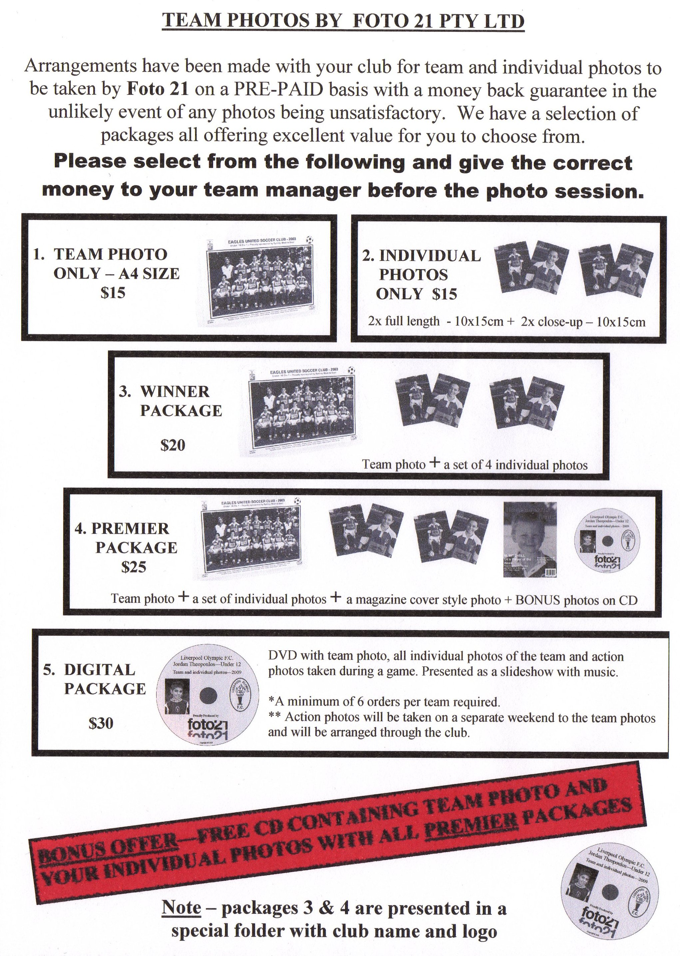

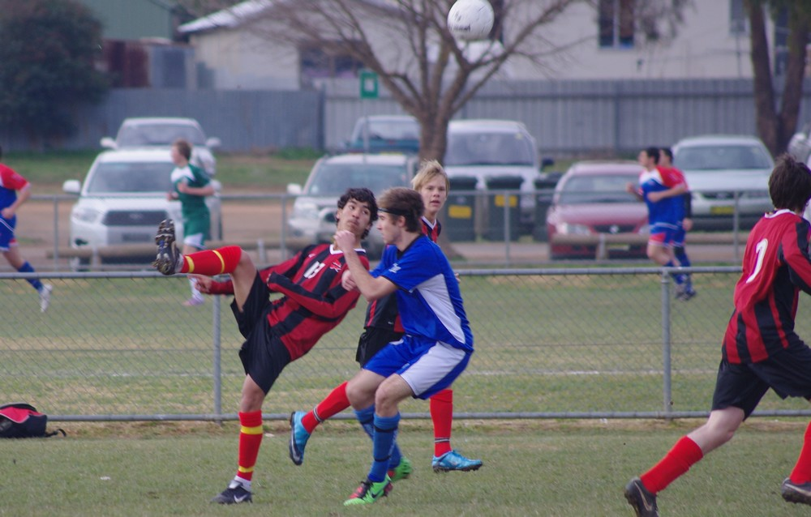

Mohammed Rahimi (U16s) – in action representing Sydney West at the State Championships

Draw - Saturday 31st July 2010

U6 vs Auburn FC A at Webbs Avenue 3 (Webbs Ave., Auburn)

11.00am Kickoff (meet at Webbs at 10.30am)

U7 WHITE vs OLQP Falcons W at Everley (mini) (Everley Rd., South Granville)

9.00am Kickoff (meet at Everley at 8.00am for team photo) (set up field)

U7 RED vs OLQP Falcons R at Daniel St 2A (Daniel St., Greystanes)

8.45am Kickoff (meet at Daniel at 8.15am)

U8 WHITE vs Wentworthville Uniting at Everley 3 (Everley Rd., South Granville)

10.00am Kickoff (meet at Everley at 9.30am) (set up field)

U8 RED vs Newington Gunners at Everley 3 (Everley Rd., South Granville)

11.00am Kickoff (meet at Everley at 10.15am for team photo) (dismantle field)

U10 WHITE vs OLOR Kellyville White at Kellyville (Memorial Ave., Kellyville)

12.10pm Kickoff (meet at Kellyville at 11.40am)

U10 RED vs St Bernadettes Castle Hill at Everley 1 (Everley Rd., South Granville)

12.00pm Kickoff (meet at Everley at 11.30am

U11 vs Auburn FC at Webbs Avenue 2 (Webbs Ave., Auburn)

9.30am Kickoff (meet at Webbs at 9.00am)

U12 vs Merrylands SFC at Everley 3 (Everley Rd., South Granville)

12.00pm Kickoff (meet at Everley at 11.30am) (set up field)

U13 vs Baulkham Hills Sports at Everley 1 (Everley Rd., South Granville)

9.00am Kickoff (meet at Everley at 8.15am for team photo) (set up field)

U15 vs Guildford County at Everley 1 (Everley Rd., South Granville)

10.15am Kickoff (meet at Everley at 9.15am for team photo)

U16 vs Auburn FC at Webbs Avenue 1 (Webbs Ave., Auburn)

1.00pm Kickoff (meet at Webbs at 12.30pm)

Raahauge Cup North Div. vs Kings Old Boys at Everley 3 (Everley Rd., South Granville) 3.15pm Kick off (meet at Everley at 2.45pm) (dismantle field)

Raahauge Cup First Div. vs Penrith Churches at Everley 1 (Everley Rd., South Granville)

(Reserves Kick off at 1.30pm Firsts at 3.15pm) (meet at Everley at 1pm – team photo at 3pm)
(dismantle field)

____________________________________________________________________________________

B Grade Knockout Final – Wednesday 28th July 2010

Raahauge Cup North Div. vs Carlingford Uniting at Jones 2 (Banks St., Merrylands) 7.00pm Kick off

