OTB 20/10

www.mccredie.org.au/soccer

Club Secretary – Greg 9682 7779 President – Peter 9632 9203

Interested in sponsoring a team or advertising in this newsletter? – call one of the above numbers.

A disastrous washout for the RC1 reserves and under 16s. Hopefully we can all get on the park next week.
___________________________________________________________________________________________
PHOTOS
The following teams have had their team photos rescheduled for this Saturday.

U7 WHITE, U8 RED, U13, U15, Raahauge Cup First Div.

Both the under 13s and 15s will need to meet at Everley before going to their matches.

These managers have their envelopes to collect payment – remember payment must be made before the photo. Every player must be present for the photo (even if you are not buying one)
The prices are on page 3 of this newsletter.
___________________________________________________________________________________________

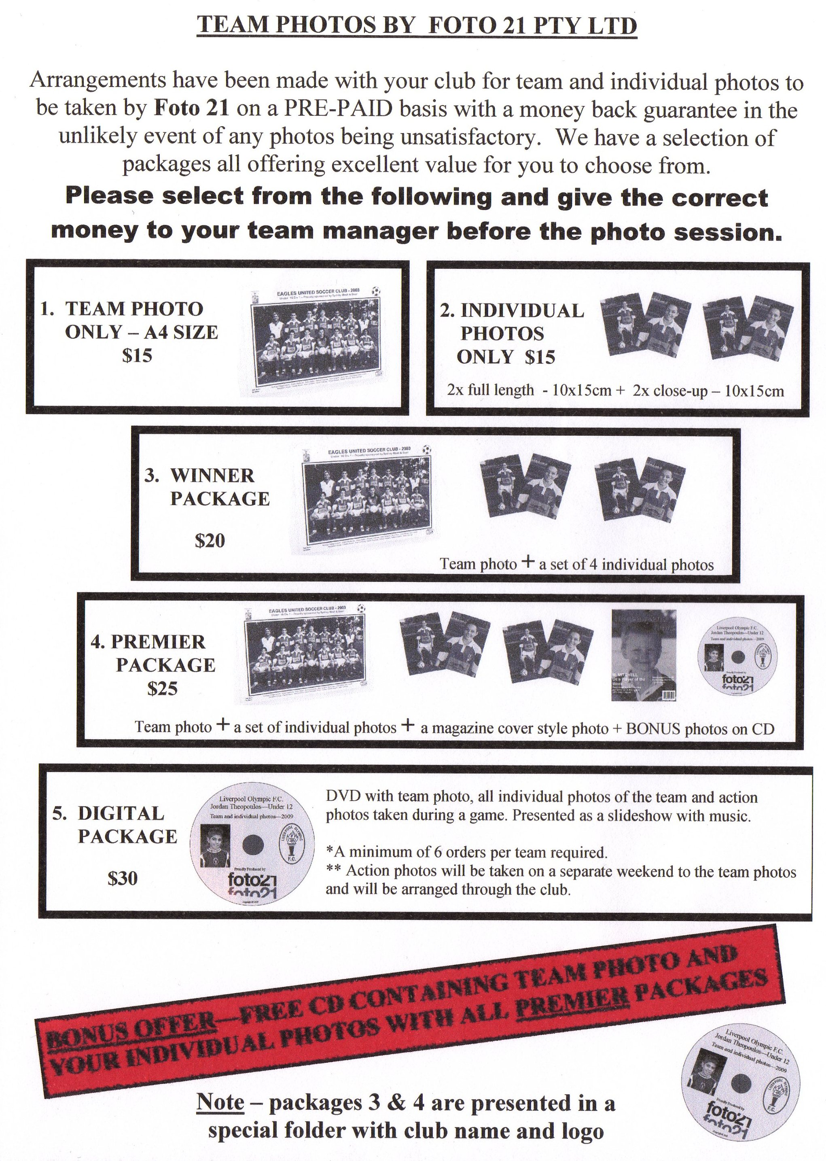

Draw - Saturday 7th August 2010

U6 vs Newington Gunners Red at Freame (mini) (Rees St., Mays Hill)

10.00am Kickoff (meet at Freame at 9.30am)

U7 WHITE vs St Bernadettes Castle Hill E at Freame (mini) (Rees St., Mays Hill)

9.00am Kickoff (meet at Freame at 8.00am for team photo)

U7 RED vs Bye

U8 WHITE vs Wentworthville Uniting at Freame (Rees St., Mays Hill)

10.00am Kickoff (meet at Freame at 9.30am) (dismantle field)

U8 RED vs OLOR Kellyville R at Freame (Rees St., Mays Hill)

9.00am Kickoff (meet at Freame at 8.15am for team photo) (set up field)

U10 WHITE vs Newington Gunners at Freame (Rees St., Mays Hill)

11.00am Kickoff (meet at Freame at 10.30am)

U10 RED vs OLOR Kellyville W at Greenup (Cecil Ave., Castle Hill)

11.00am Kickoff (meet at Greenup at 10.30am)

U11 vs Baulkham Hills at Everley 1 (Everley Rd., South Granville)

9.00am Kickoff (meet at Everley at 8.30am) (set up field)
Decision at 7am

U12 vs Bye

U13 vs Castle Hill United at Fred Catterson 4 (Catterson Dve., Castle Hill)

11.20am Kickoff (meet at Freame at 9.45am for team photo)

U15 vs Granville Kewpies at Colquhoun (Lavinia St., Granville)

9.30am Kickoff (meet at Freame at 8.15am for team photo)

U16 vs Toongabbie at Everley 1 (Everley Rd., South Granville)

10.30am Kickoff (meet at Everley at 10.00am) Decision at 7am (dismantle field)

Raahauge Cup North Div. vs Penrith Churches at Jamison 8 (Cnr York & Jamison Rds., Penrith) 3.15pm Kick off (meet at Jamison at 2.45pm) (dismantle field)

Raahauge Cup First Div. Reserves vs Bye

Firsts vs Chester Hill Sports B at Jones 2 (Banks St., Mays Hill)

(Firsts at 3.15pm) (meet at Everley at 2.45pm – team photo at 3pm)
(dismantle field)

____________________________________________________________________________________

B Grade Knockout Final – Tuesday 10th August 2010

Raahauge Cup North Div. vs Carlingford Uniting at Jones 2 (Banks St., Merrylands) 7.00pm Kick off

