OTB 23/10

www.mccredie.org.au/soccer
Club Secretary – Greg 9682 7779 President – Peter 9632 9203

B Grade Knockout Final vs Carlingford Uniting won 3- 2 on penalties after a scoreless draw after extra time
A combined RCN/RC1 Reserves combination competed for the knockout championship last week (after numerous weeks in a row being washed out). A close match that could have gone either way with numerous posts hit by both teams. We dominated the first half but they came back strong in the second. Luk and Javier pulled off some great saves to keep a clean sheet. Pece upfront supported by Adem & Cuong were unlucky not to decide the match. Great penalties by all and Luk again wins a penalty shootout.
Goal scorers - Pece Kotevski 1, Cuong Lo 1, Phil Rafter 1

RESULTS from Saturday 21st August 2010

U6 vs OLQP Falcons B
No report

U7 RED vs St Bernadettes Castle Hill T 4 – 2
Last game for the season, which means last report (yeehah).What a game! We started with our young players on first. They struggled a little. The other team scoring quite easily early in the game. Once all our bigger stars were on the field, we had a great game on our hands. Our boys played awesome, Shaleen was impressive, finally getting some power behind his kicks and scoring a great goal. Elias also stood out with his enthusiasm and constant determination. With big hearts and great spirit, these boys were unstoppable, especially John Paul who always walks over the opposition. Anthony’s presence is always felt with a good goal off a corner. My little green boot pocket rocket Christian scored 2 wonderful goals. John Luke was great in the goals in the first half; Abraham, Victor and Jacob were well involved in the game. It was great to end the season with a good win of a great game. A special mention to our parents this week who were extra noisy (oh I mean supportive). Man of the match - WHOLE TEAM. See you guys next year!
Goal scorers – Christian Frangie 2, Shaleen Nagar 1, Anthony Tannous 1

U7 WHITE vs OLOR Kellyville B
No report

U8 RED vs OLQP Falcons P 8 – 0
No report
Goal scorers – Qais Sungkar 6, Joe Azzi 1, Nedim Fazlic 1

U8 WHITE vs St Bernadettes Castle Hill L 0 – 1
We knew we had to win as did all the boys and we tried everything to get past the lions but they stopped everything we threw at them. All of the boys tried their hearts out and we are so very proud of their efforts all year. Thanks to all of the parents and supporters of the under 8s white. See you all next year.

U10 RED vs OLOR Kellyville G 1 – 3
Our last game for the year but unfortunately we couldn't end with a win. We matched it with our opposition for all of the game but just couldn't take our chances. Antoine was good in middle, Joel was secure at the back and Nicholas was outstanding in goals in the second half. Unlucky way to finish off a good season boys.
Goal scorer – Luke Fernandes 1

U10 WHITE vs OLQP Falcons P 1 – 0
A tough morning in the strong wind. Alibaset and Ehren were outstanding in midfield, running all day. Rusheel had a strong game up front and Jessie had a good game. Next week President’s Cup – Good luck boys!
Goal scorer – Rusheel Raj 1

U11 vs Finished for the season
U12 vs Finished for the season
U13 vs Finished for the season

U15 SEMI vs Granville Waratah 0 – 4
Solid first half saw two very even teams battle at a frantic pace, with every player on the park putting in 110%. We went into half time only one gaol down and positive we could strike back. Unfortunately, we ran out of puff in the second half, and they broke through to score another quick goal. We pushed forward to make some opportunities which unfortunately didn't lead to goals. This however, weakened our defence and led the opposition to another two goals late in the half. We were just simply outplayed by a better team. All the parents and myself were proud to see that every player on our team didn't give up. Even at 4 goals down, we were fighting to score. This is something that this team would never had done in previous years. What a terrific effort. If the players can take anything away from this years competition, it is that they have all become better players this year and it has been a pleasure to watch. It would be impossible to pick standout players this week as the whole team stood up to be counted. Great work making the finals! Man of the match - Paul Yousef.

U16 vs Finished for the season

RC North FIRSTS vs Finished for the season

RC 1 RESERVES SEMI vs Chester Hill Sports 4 – 0
Magnificent performance by everyone. First half we did it tough running against the wind but we still had more and better opportunities. Second half we got back to our game plan. Great passing between Nathan and Pece got our first. Even after being reduced to 10 players we still stayed strong and played better football than our opposition. We focused more on our passing game and it carved them up. Haissam was extremely unfortunate not to score even though he had probably had one of the best opportunities in the match – better luck next week at our grand final.
Goal scorers – Pece Kotevski 1, Nathan Stafford 1, Wayne French 1, Cuong Lo 1

Presentation

The annual presentation day will be held on October 24th at 11.45am in the McCredie Uniting Church Hall.
486 Guildford Rd., Guildford.
There will be a sausage sizzle held afterwards and all players will receive a free sausage and drink.
Additional sausages and drinks will be available for purchase
There will also be a raffle held on the day.

The Annual General Meeting will occur 2 weeks later, Thursday 4th November at 7.30pm at the McCredie Uniting Church. All registered players over 18, financial members and coaches, managers and life members are entitled to vote and be elected to positions. Consider how you may wish to assist for season 2011 or talk to a committee member to discuss further.

MANAGERS/COACHES

Please take note of the following timetable:

TEAM | Date of last match | trophy winners | balls | cones | shirts | end of season report
 |  | by 25/8 | 7 days | 7 days | 7 days | absolute deadline - 1st September
 |  |  | after last | after last | after last
 |  |  | match | match | match
6 | 21-Aug | Yes | Yes | Yes | Yes
7 white | 21-Aug
7 red | 21-Aug
8 white | 21-Aug
8 red | 28-Aug
10 w | 28-Aug
10 red | 21-Aug
11 | 14-Aug | Yes | Yes | Yes | Yes | Yes
12 | 14-Aug |  |  |  | Yes
13 | 14-Aug |  | Yes | Yes | Yes
15 | 21-Aug
16 | 14-Aug
RCN | 14-Aug
RC1 | 28-Aug

Last week’s Granville Schools Spectacular at the Opera House – EJ (U13s) does a haka and Sam (U12s) hosted the event.

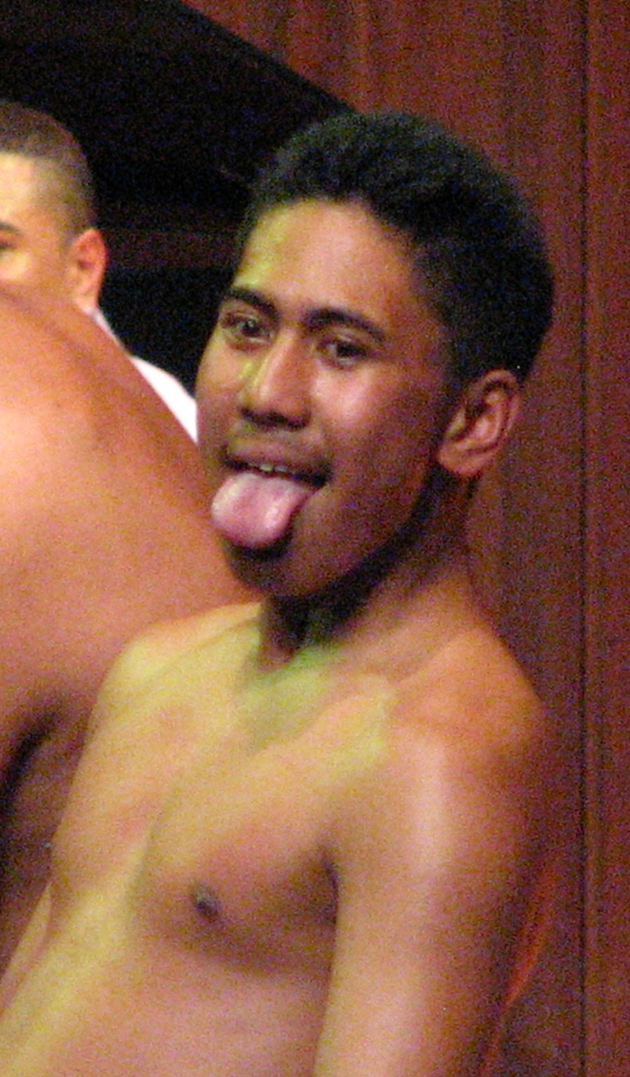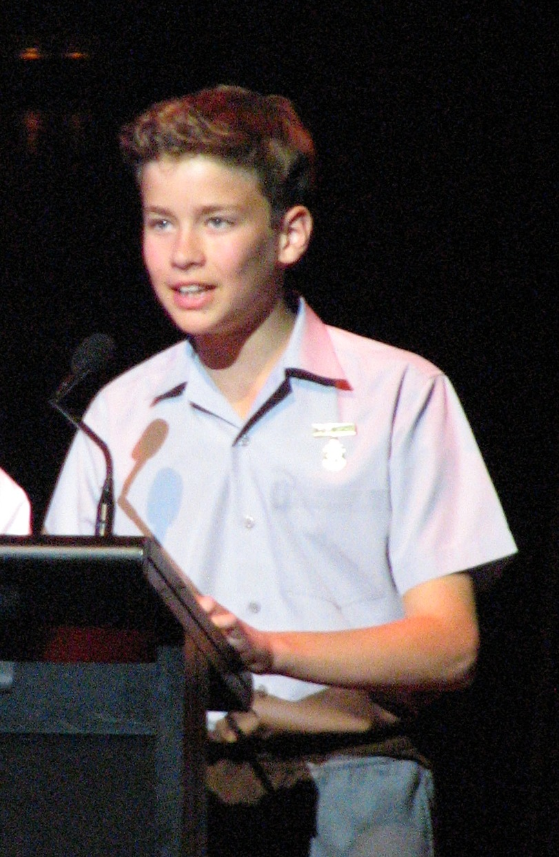

Draw - Saturday 21st August 2010

U6 finished for 2010

U7 WHITE finished for 2010

U7 RED finished for 2010

U8 WHITE finished for 2010

U8 RED President’s Cup semi vs St Bernadettes Castle Hill 9.00am Kick off at Everley 2
Help with set up at 8.00am

Final at 11.00am for winning sides at Everley 3

U10 WHITE President’s Cup semi vs Newington Gunners 10.00am Kick off at Everley 2
Help with set up at 9.00am

Final at 12.00pm for winning sides at Everley 2

U10 RED finished for 2010

U11 finished for 2010

U12 finished for 2010

U13 finished for 2010

U15 finished for 2010

U16 finished for 2010

Raahauge Cup North Div. finished for 2010

Raahauge Cup First Div. Res. Grade GRAND FINAL vs St Anthony/St Pauls at Walshaw (Hector Rd., Bass Hill) 1.00pm Kickoff (meet at Walshaw at 12.15pm)

____________________________________________________________________________________

