OTB 24/10

www.mccredie.org.au/soccer
Club Secretary – Greg 9682 7779 President – Peter 9632 9203

RESULTS from Saturday 28th August 2010

U6 vs Finished for the season
U7 RED vs Finished for the season
U7 WHITE vs Finished for the season

U8 RED SEMI vs St Bernadettes Castle Hill T 1 – 1 (won 3-2 on goal kicks)
Today we played the semi final against St Bernadettes and had a draw. We kept the defence strong as much as we could and just kept attacking and attacking, missing heaps of goal opportunities. After fulltime we managed to win the game in extra time by the total number of goal kicks.
Goal scorer – Joe Azzi 1

U8 RED FINAL vs Lidcombe Churches 0 – 1
The grand final was played against Lidcombe. They had the team working really hard to score a goal against us and they did. They were the better side but we didn't give up and kept our heads up and said there is always next year. Boys chins up, 1 for all and all for 1. We are the team that no body will forget.

U8 WHITE vs Finished for the season
U10 RED vs Finished for the season

U10 WHITE SEMI vs Newington Gunners 1 – 2
A really tight game. We dominated the first half territorially, but didn’t create too many scoring chances all the same. In the second half Newington broke through from midfield twice and scored two. The guys didn’t give up though and scored soon after. Unfortunately time ran out. Rusheel was very strong up front holding the ball and looking for support. His second half goal was really well finished. Biyan had a great game in defence, making some great tackles and clearances.
Goal scorer – Rusheel Raj 1

U11 vs Finished for the season
U12 vs Finished for the season
U13 vs Finished for the season
U15 vs Finished for the season
U16 vs Finished for the season
RC North FIRSTS vs Finished for the season

RC 1 RESERVES FINAL vs St Anthonys/St Pauls 3 – 1
2 reports for the same match? Yes – and it deserves it!
From the captain-
As expected with any grand final both teams played a strong and competitive match. First half we had the wind and despite having plenty of opportunities we were only 1 up at half time. The second half they came out strong and equalised with a cracking shot which still needed major assistance from the wind to beat Luk – who got a hit to the head for his efforts from the chasing player. There was an intense 10 minutes where they threw everything at us but we held them out. We then managed to raise it a notch and started hitting them on the counter. Dylan did brilliantly to get to a through-ball/cross before the keeper and headed it in to give us the lead. They once again threw everything at us but once more this meant there was more room on our counters and Cuong got his second to seal the result with 15 minutes left. We would like to thank the great supporters who attended, Carlos & Tito for playing for us and Tommy for the great celebration afterwards. Well done boys
And from the sideline crowd -
With a strong wind behind them in the first half it was very important that McCredie were up at half time. For 40 minutes it was nil all until a well taken corner from Tito found Cuong and then the net. The crowd went nuts! The wind seemed even stronger early in the second half, clearances weren’t going far, neither were goal kicks and it was hard work. The forwards were getting cold and not seeing much ball. Inevitably St Anthonys found a goal with a driving shot from distance with a cyclone behind it carrying it goal wards. At this stage it would have been easy to give up and think the task was too big against the gale. But the wind shifted from a southerly to an easterly at about the same time a free kick found a flying Dylan’s head over a flailing keeper. We were 2 – 1 up and very excited! There was still plenty of time until a solo run from Cuong, who had an outstanding game, found him in space behind the backs and a very clever dink into the left corner of the net put our guys 3-1 up and sent the big crowd delirious! Congratulations boys on a great result. Great to see such tremendous support from family, friends, first graders, junior players and past players. Great atmosphere, great result.
Goal scorers –Cuong Lo 2, Dylan Trevor 1

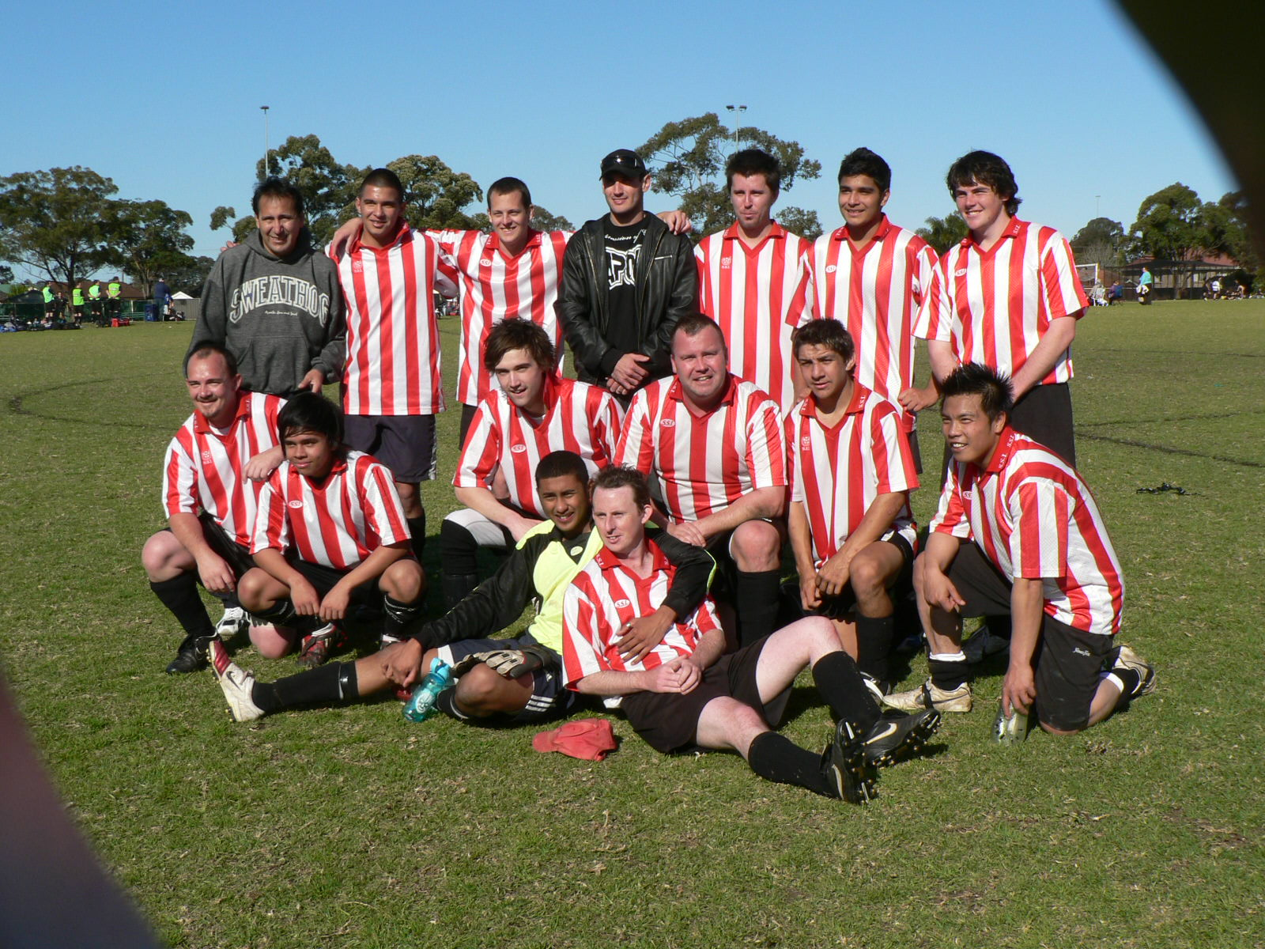

Presentation

The annual presentation day will be held on October 24th at 11.45am in the McCredie Uniting Church Hall.
486 Guildford Rd., Guildford.
There will be a sausage sizzle held afterwards and all players will receive a free sausage and drink.
Additional sausages and drinks will be available for purchase
There will also be a raffle held on the day.

The Annual General Meeting will occur 2 weeks later, Thursday 4th November at 7.30pm at the McCredie Uniting Church. All registered players over 18, financial members and coaches, managers and life members are entitled to vote and be elected to positions. Consider how you may wish to assist for season 2011 or talk to a committee member to discuss further.

