www.mccredie.org.au/soccer OTB 25/09

Club Secretary – Greg 9682 7779 President – Peter 9632 9203

Interested in sponsoring a team or advertising in this newsletter? – call one of the above numbers.



RESULTS from Saturday 29th August 2009

U6 six a side R1 vs OLOR/St Angelas Kellyville 0 – 4

six a side R2 vs St Bernadettes Castle Hill 0 – 1
We started the day quite anxiously, thinking that we may have had to begin the knockout with 4 players only. Luckily, two U7 players were seconded to us. Moses Masima and Aaron Batth immediately gelled with the team and they all wove a wonderful tapestry of good sportsmanship, team spirit and gusto. Although we lost both games we stood our ground firmly and fought to the last minute. Congrats to all the boys who showed up on the day, being John Luke El-Rahi, brothers Anthony and Abraham Tannous and Dean Simidis. Thank you also to the ring-ins Moses and Aaron. They each deserve man of the match.

U7 RED six a side R1 vs Lidcombe Churches Blue 4 – 1
Goal scorers – Yasir Jamil 2, Kenneth Tong 1, Jamal Swalah 1

six a side R2 vs Guildford McCredie White 1 – 3
Goal scorer – Yusuf Jamil 1

U7 WHITE six a side R1 vs OLQP Falcons 1 - 0
Goal scorer – Tam Do 1

six a side R2 vs Guildford McCredie Red 3 – 1
Goal scorers – Willy List 2, Tam Do 1

six a side SEMI vs Guildford McCredie Black 0 – 3

We had a great day today. All the boys were very excited. It took us some time to warm up in the first game, but by the second, we were back on track and had a ripper. We fought hard against the Blacks in our 3rd game and the boys should be very proud of themselves our defence was brilliant. Thanks for all the parents that helped on the day and throughout the year.

U7 BLACK six a side R1 vs Lidcombe Churches Gold 1 – 0
Goal scorer – Joe Azzi 1

six a side R2 vs OLOR Kellyville 5 – 0
Goal scorers – Joe Azzi 2, Qais Sungkar 2, Nedim Fazlic 1

six a side SEMI vs Guildford McCredie White 4 – 0
Goal scorers – Joe Azzi 2, Qais Sungkar 2

six a side FINAL vs Lidcombe Churches Gold 0 – 0 (loss 0 – 1 on goal kicks)

This was the day we have been waiting for the whole season. We started off very slow but still won our first game against Lidcombe by only 1-0. Everyone was still sleepy and tired but we still kept up our level of play. We had to wait 2 hours for our next game where we actually rained the goals in and walked away with a 5-0 win. We had trouble trying to keep the boys still and steady for our next game. After winning 4-0 againts McCredie u7 whites the boys just let go and wasted all their energy running around and playing kiss and catch with the girls. The moment came where we played Lidcombe in the grand finals. The game was full of excitment and with us attacking but missing heaps of goals. We went into extra time and golden goal, but there was still no goal from either team and goal kicks and corners were still equal! So we had extra extra time and golden anything! Unfortunately Lidcombe won the game with a goal kick. We still showed our sportsmanship and cheered for Lidcombe. Well done boys we all played an outstanding game so let’s keep our heads up, train harder to return back in 2010's 6 a side comp paying it all back in doubles.

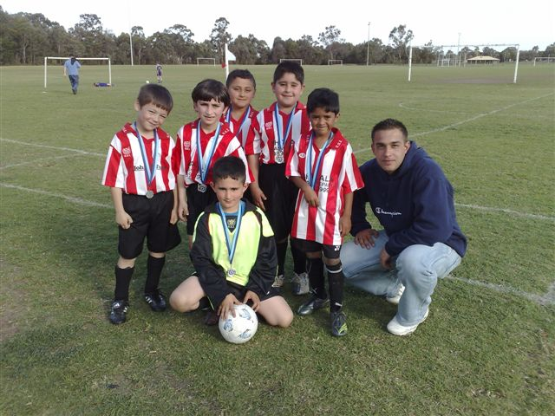
Under 7 Black

U9 President’s Cup semi vs Newington Gunners 1 – 1 (won 1 – 0 on corners)
What a match it had it’s highs & it had it’s lows. Both teams struggled through the oppositions half to obtain possession and at times it was difficult but the team never gave up the fight. It was still 1 – 1 at full time and even after extra time it was still a draw this shows how close this game was. Well done boys you did what you had to do to get through to the next round. Excellent games from Ehren, Alibaset and Kabin.
Goal scorer – Rusheel Raj 1

U9 President’s Cup final vs OLQP Falcons (Q) 0 – 1
Well done team you gave it all you had left and unfortunately it just wasn’t enough on the day. Can’t single any one player out, as the whole team should be commended on a job well done. By sticking together for next year, watch out competition, 2010 is ours.

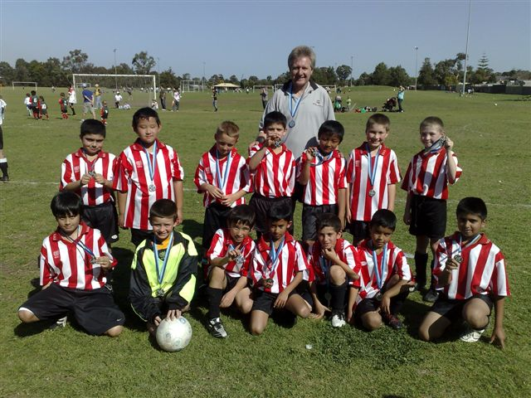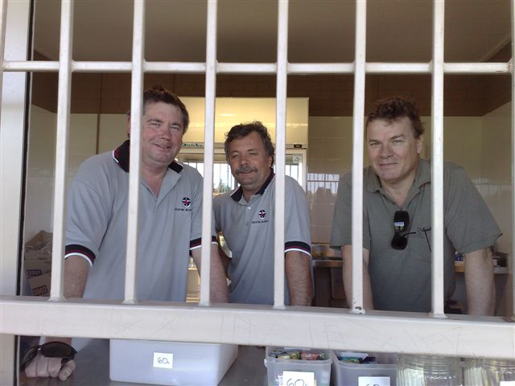

Under 9s 3 members of the club committee –
where they should be – behind bars!

GUILDFORD McCREDIE UNITING
SOCCER CLUB

ANNUAL PRESENTATION DAY
Sunday 25th October 2009

11.15am Presentation
12.00pm BBQ Lunch
McCredie Memorial Uniting Church
486 Guildford Rd., Guildford
Cnr Guildford & Chetwynd Rds
Guildford

There will be a church service at 10am and all are invited
(no matter what your religion!!)
McCredie Church proudly supports the Soccer Club & this is the Club’s
opportunity to thank the Church.
Free BBQ for all registered players – non players may purchase sausages

