OTB 4/12
Club Secretary – Greg 9682 7779 President – Peter 9632 9203

Interested in sponsoring a team or advertising in this newsletter? – call one of the above numbers.

www.mccredie.org.au/soccer
Bouncing emails
If you are not receiving this newsletter by email, you have either not provided us with your email address or the address you gave us was wrong or hard to read. Please email gmusoccer@optusnet.com.au to receive this newsletter by email – save paper and get the news first!
____________________________________________________________________________________________
The following players are still yet to provide a copy of their birth certificate/passport/driver’s licence: Dimo Dimo, Zachary Shamsin, Alexander and Christopher Fares, Fouad Ayoub, Joshua Paseka, Yar Deng, Tatiana Tannous, Sabit Tas, Aluel Angok, Ebonnee Barker, Katrina Howard, Mika Oo, Nada Darwish, Sarah Dubois, Sarah Irving. Please give to your manager this week.
_______________________________________________________________________________________________________
RESULTS - 31st March 2012

U6 Red vs St Bernadettes Castle Hill Lions 6 – 0
What a season starter! Ali was on fire from the get go,scoring 4 goals with the help of Talal (who left a trail of damage requiring first aid)across both halves. Hannah after many attempts was able to land a goal in second half and Josh struck a goal out of the blue in the final moments. Zachary backed up in defence and didn't allow the opposition to get through and Zachariah had alot of spare time in goals to practice defending them.Our new comer Richie is showing all the signs of having a great oncoming season.Well done team!!!! Goal scorers – Ali Fahme 4, Hanna Galeb 1, Josh Depares 1

U6 White vs St Bernadettes Castle Hill Tigers 7 - 1
Today was the beginning of a new adventure for all parents and children involved with this team. All except one player has today played their first official game for the club. A wonderful effort displayed by all players in achieving a first up win. From the kick off, Guildford McCredie attacked the ball at all times and set their sights in getting the white round ball into the back of the net. The first goal came within the first few minutes from Daniel Kvesic after some wonderful lead up work from the whole team. Not long after this the second goal to find its way into the back of the net came via a wonderful left foot strike by Sebastian Kerr. The game continued along from one end of the field to the other with most of the play being in the oppositions’ half. The third goal came just before half time from Daniel Kvesic after lead up work from the whole team. The second half started like the first half, from a kick off. Guildford McCredie dominated the second half with the same style of play as the first half. The team would move the ball from one end of the field to the other creating opportunities for each other. The fourth goal of the game came from Kassem Abbas and not long after followed by another goal from Daniel Kvesic. St Bernadettes’ was able to score a goal after some smart play by them. Guildford McCredie regrouped after this lapse and scored two more goals through Kassem Abbas and Daniel Kvesic achieving a great win in our first outing.
Goal scorers: Daniel Kvesic 4, Kassem Abbas 2, Sebastian Kerr 1

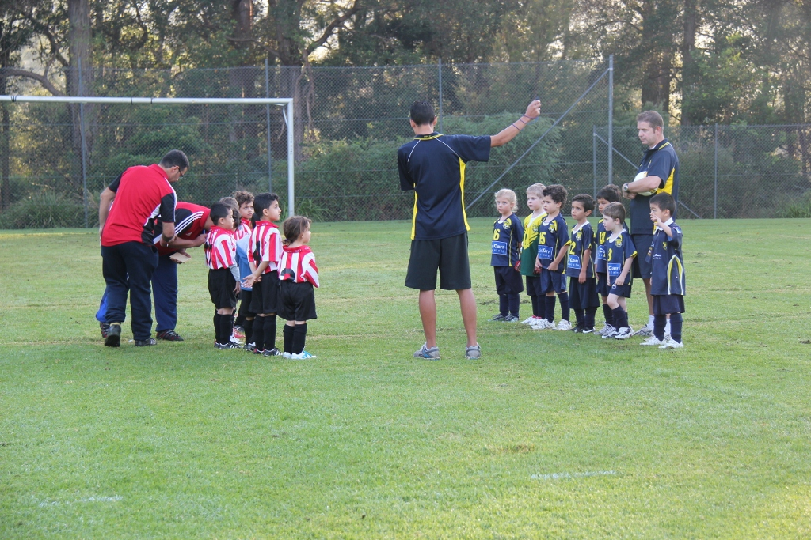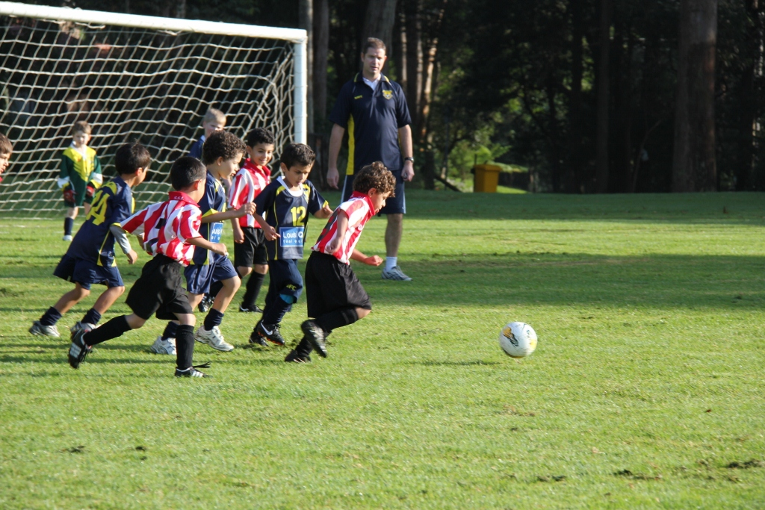

U6 Black vs Hills Spirit Blue 5 - 1
What a fantastic game with McCredie winning 5 – 1. Anthony played goalie first half and managed to stop a few attempted goals. Hassan played goalie in the 2nd half. All players had a turn to play and rest. Team played with enthusiasm and excitement. The excitement also flowed through to the parents who attended. A big thank you to all parents who came along and made our team complete. The team came home learning what to do when the coach (Robert) calls. Credit should also go to Wayne French who came along to the game to help out. Thank you Wayne.
Goal Scorers – Joey Farah 2, Ali Hamdan 1, Joshua Paseka 1, own goal 1

U7 vs St Bernadettes Castle Hill Tigers 6 - 1
The boys were on fire. Non stop action from the beginning of the game. Our little players felt more confident on the field, they knew where to stand and what to do. It's was a good kick into the season. Keep it up boys!
Goal scorers - Matthew Youssef 3, Mustafa El Bizri 2, Baran Tas 1

U8 RED vs Lidcombe Churches 6 - 4
Great start to the season guys. We started off strong with 2 goals but went to sleep a little before half time. Second half went out strong again and put away a couple more goals before Lidcombe struck back. But to our credit we finished off well and came away with a well deserved win. We are starting to learn to keep position but we need to keep practicing. Well played all and keep up the good work. Player of the match went to Gregory Farah.
Goal scorers – Anthony Tannous 3, Christian Frangie 2, Aaran Batth 1.

U8 WHITE vs Wentworthville Uniting 1 - 6
The game got off to a great start with some individual play from Mustapha scoring within the first few minutes running from his goal area to the other end placing the ball into the back of the net for a one nil lead. Unfortunately this was the only joy in the scoring department. The players all tried their best considering the hot conditions they were playing in. The goal keepers played well considering the score line. Izabella Sultana made a break down the side line in the second half which would have certainly boosted her confidence, considering this is her first year at soccer. Mustafa worked tirelessly all over the park causing some concern for this reporter when he came off the field feeling nauseas. Wentworthville Uniting were a better team on the day and deserving winners. Both teams had no reserves and the heat of the day didn’t help.
Goal scorer – Mustapha Fahme 1

U9 vs Wentworthville Uniting 7 - 0
Greaaaaaaaaaat start to the season...the boys had a little bit of a slow start but once they realised what’s going on they became unstoppable with one goal after the other. Every player started defending and chasing the ball and that’s how we dominated the ball most of the time. We scored 7 magnificent goals. Our player of the match went to MOUNIR who gave in 100%.
Goal scorers – Yel Chan 3, Christian Frangie 2, Mounir Hadid 1, John Luke El Rahi 1

U10 vs OLQP Falcons L 7 - 0
We started the season with a little stress but it turned out good at the end. We started with 6 players then had 2 arriving late. Our opponent was happy to see us with less players at the start keeping their hopes up but the end results made them not too happy. Each of our players were marking 2 players and they did a great job. Joe, Yusuf and Qais created excellent opportunities to score. Mr Elzain and Ahmet kept the defence so strong which had a great impact on the opponent by clearing all their through balls. Good job boys. Saf and Josh kept the midfield tight and showed good team work. Charlie and Yunus kept possession really well. Boys you all played excellent football. This really proved that we can play as a team. Good jobs boys. Man of the match - Andrew Elzain
Goal scorers - Joe Azzi 3, Yusuf Jamil 2, Qais Sungkar 1, Safwan Hamdan 1

U11 trial vs Lidcombe Churches 2 – 2
Today was a game where we had enough chances to win but missed the target or kicked it straight to the keeper. We dominated for a lot of the game and started to look for each other and pass the ball around. Jasper was strong at the back in his first game for the club. Chan and Tong formed a good combination in the centre of midfield while Ferdinando and Antoinne held the position well up front and were threatening. A solid result today, let's start the competition off with a win on the 14th April now.

U12 trial vs Lidcombe Churches 5 - 2
We had a 1-0 win in extra time in last year’s grand final against Lidcombe, so this game was a good indicator of how our preseason training is going. Most signs are good for the competition start on the 14th. The two goals conceded is of some concern but Mohammed’s, Ronan’s and Kabin’s play certainly isn’t of any concern. They were all outstanding today. Kabin will play a lot more centre half this year and Mohammed and Ali will play a lot more attacking. Mohamed’s goal after 15 seconds of the match was an outstanding finish. Bring on the challengers!

U14 No game Saturday so this report is from last week’s trial game
trial vs Penrith FC 0 – 2
The state of the field was a far cry from the waterlogged mush of last week, so it gave our team plenty of opportunity to run. We were up against a first division team in Penrith, and after their quick goal minutes into the first half it looked as if things could become ugly. However with good goal keeping and a great team performance by everyone across the field, we were able to keep up with them. We went further behind in the second half from a lucky kick, but did not give up. No special mentions today, but an excellent start from a team of different age groups against a quality opposition. The team should improve greatly once the summer rust has worn off. Coach Darren was extremely pleased with the performance and we look forward to his safe return from holidays.

Ladies trial 1 24/3 vs Penrith FC
It’s very exciting that McCredie has our first Ladies team in 2012. Less exciting is that Penrith decided to send their division 1 team for our first game. The girls battled hard and didn’t give in. Genell grabbed a goal which gives us reason to be confident for games against teams in our own division. Sarah was fantastic at sweeper and Nada and Elise went well all game.

Ladies trial2 1/4 vs Ermington United
The good news – Genell scored 3, Sarah I is a genuine talent in goals or at sweeper and today’s trial provided us with the opportunity to discover her versatility and we continue to be pretty good on the ball with Elise, Katrina and Hendrika all showing some nice skills and team work. Unfortunately today also saw us play with just 9 and then additionally injuries to both Laura and Sarah R are worrying. Hopefully by the comp start on Sunday 15th everybody will be fit and available and we’ll be able to put it all together.

RC N vs Zimwarriors
Unfortunately a mix up at Association level with ID cards left the RCN unable to take the field today. Rest assured guys – club management is not happy and will follow up with vigour. To have such a strong team, ready and keen to take the field on day 1, and then not be allowed to do so, despite making all cut offs etc is unacceptable. Leave this one with me.

_________________________________________________________________________________

Referee’s Course – Free

(held at Association Offices 3/9 Chester Hill Rd., Chester Hill 7pm)

Anybody over 14 years welcome. Courses include lectures and exam.

Next dates: 19th /24th April Lecture 19th Exam 24th

Draw - Saturday 14th April 2012

Gala Day for teams under 6, 7, 8, 9, 10 (Everley Park, Everley Rd., South Granville)
Please be aware that teams will play numerous games on the one day – until they lose or win the trophy.
The following games are Round 1 only

U6 Red Round 1 vs winner of St Col/Hills Spirit W at Everley (mini 4) (Everley Rd., South Granville)
9.30am Kickoff (meet at Everley at 9.00am)

U6 White Round 1 vs winner of SBFC/OLQP at Everley (mini 1) (Everley Rd., South Granville)
9.30am Kickoff (meet at Everley at 9.00am)

U6 Black Round 1 vs Hills Spirit Red at Everley (mini1) (Everley Rd., South Granville)
8.00am Kickoff (meet at Everley at 7.30am)

U7 Round 1 vs SBFC All Stars at Everley (mini 2) (Everley Rd., South Granville)
8.45am Kickoff (meet at Everley at 8.15am)

U8 Red Round 1 vs Hills Spirit Red at Everley 1 (Everley Rd., South Granville)
11.00am Kickoff (meet at Everley at 10.30am)

U8 White Round 1 vs Lidcombe Churches at Everley 1 (Everley Rd., South Granville)
11.00am Kickoff (meet at Everley at 10.30am)

U9 Round 1 vs SBFC Tigers at Everley 1 (Everley Rd., South Granville)
12.00pm Kickoff (meet at Everley at 11.30am)

U10 Round 1 vs Wentworthville Uniting at Everley 2 (Everley Rd., South Granville)
2.00pm Kickoff (meet at Everley at 1.30pm)
_______________________________________________

U11 vs Pendle Hill Tigers at Everley 2 (Everley Rd., South Granville)

8.30am Kickoff (meet at Everley at 8.00am) (set up field)

U12 vs Bye

U14 vs North Rocks at Everley 2 (Everley Rd., South Granville)

10.45am Kickoff (meet at Everley at 10.15am)

Raahauge Cup North Div.

Reserves vs Kings Old Boys at Homelands (Homelands Ave., Telopea)
1.15pm Kick off
Firsts vs Epping Church of Christ at Homelands (Homelands Ave., Telopea) 3.15pm Kick off
(Meet at Homelands at 12.45pm)

Sunday 15th April 2012

All Age Ladies vs Ermington United at Fred Catterson (Catterson Drive, Castle Hill)
1.15pm Kick off (meet at Fred Catterson at 12.45pm)

Wednesday 18th April 2012

Raahauge Cup North Div.

Firsts vs Zimwarriors at Jones 1 (Banks St., Merrylands) 7.00pm Kick off (Meet at Jones at 6.30pm) (time to be confirmed)

Club jackets are available.
Kids sizes are $30 and adult sizes are $65.
See Greg or check the canteen at Everley

