OTB 6/11

Club Secretary – Greg 9682 7779 President – Peter 9632 9203

Interested in sponsoring a team or advertising in this newsletter? – call one of the above numbers.

www.mccredie.org.au/soccer

THIS WEEK

* Raffle Books will be distributed – every player will receive a booklet containing 10 tickets. Each ticket is $1 each. Please sell these tickets and return the money by the 18th May when the raffle will be drawn. Prizes include a Hamper, picnic and household wares and large stuffed toys (12 prizes in all)

* Lapathon sponsorship forms – The lapathon will take place on Wednesday 18th May, in place of training that week. Each player is asked to find some sponsors. On the night we will begin at 5.30 and conclude at 6.30pm, there will be a barbecue running, the raffle will be drawn and prizes will be awarded at the end of the season for most laps and most money raised. The form can be found in this newsletter.

* Photo order forms will be distributed – Information about prices is contained in this newsletter. Every child is required to be in their team photo. If you would like to purchase a photo, payment must be made to your team manager before the photo is taken. Your team manager will have an order form and payments can be made to them from this week.

* Our fingers are crossed that this weather will change! – Please ensure that you are aware of what happens when it rains. Unless you have a confrmation from your manager that games or training are off, please arrive on time. Decisions on training cannot be made until 3pm that afternoon when council advises us and until Friday evening for Saturday matches. As soon as I know I email all managers and coaches, all players for whom I have emails and I put a message on the website.

Round 4: 30th April 2011

All games were washed out.

Under 12 and 13 games will be replayed on Monday 13th June (Queen’s Birthday Long Weekend)

No information has been received on whether or not the other matches will be replayed.

PHOTOS

Club photos have been booked for the following dates. I will remind teams closer to the date and distribute prices.

Saturday 7th May 2011

U6 9am photo

U8 10.15 photo

U9 WHITE 9.15am photo

U11 11.15am photo

U12 10.30am photo

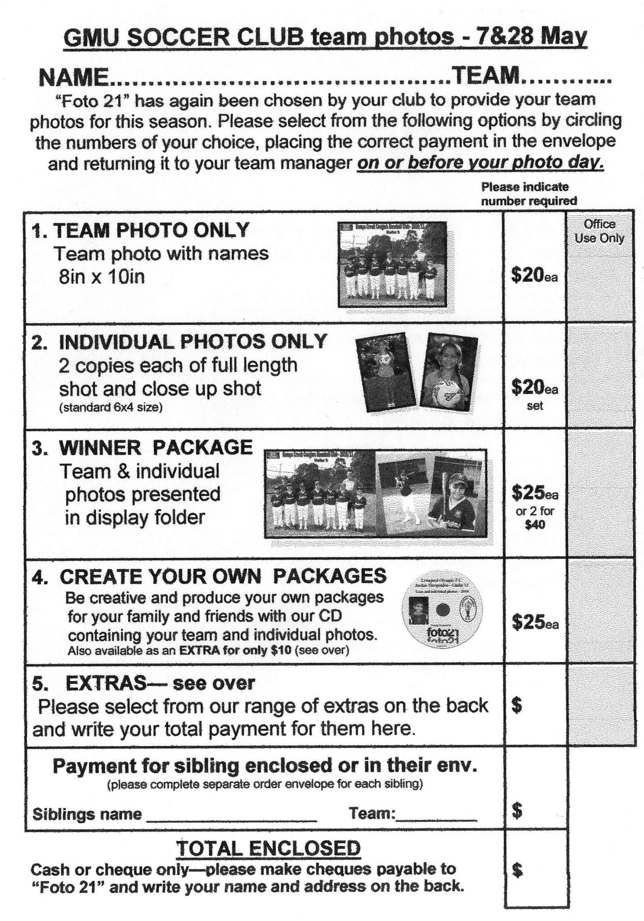

Photos - Saturday 28th May 2011

U7 RED 10.15am photo

U7 WHITE 9.15am photo

U9 RED 10.30am photo

U10 11.15am photo

U13 11.00am photo

Raahauge Cup First Div. 3pm photo

Draw - Saturday 7th May 2011

U6 vs OLOR/St Angelas Kellyville White at Everley (mini) (Everley Rd., South Granville)

10.00am Kickoff (meet at Everley at 9.30am) (dismantle field)

U7 RED vs OLQP Falcons B at Everley (mini) (Everley Rd., South Granville)

9.00am Kickoff (meet at Everley at 8.30am) (set up field)

U7 WHITE vs OLOR/St Angelas Kellyville Red at Kellyville 1 (Memorial Ave., Kellyville)

9.00am Kickoff (meet at Kellyville at 8.30am)

U8 vs St Bernadettes Castle Hill T at Everley 2 (Everley Rd., South Granville)

11.00am Kickoff (meet at Everley at 10.30am) (dismantle field)

U9 RED vs Newington Gunners at Wilson (Newington Rd., Silverwater)

10.10am Kickoff (meet at Wilson at 9.40am)

U9 WHITE vs St Bernadettes Castle Hill L at Everley 2 (Everley Rd., South Granville)

10.00am Kickoff (meet at Everley at 9.30am) (set up field)

U10 vs Lidcombe Churches at Phillips 1 (Martin St., Lidcombe)

11.00am Kickoff (meet at Phillips at 10.30am)

U11 vs St Bernadettes Castle Hill at Everley 1 (Everley Rd., South Granville)

12.00pm Kickoff (meet at Everley at 11.30am) (dismantle field)

U12 vs Pendle Hill Tigers at Everley 1 (Everley Rd., South Granville)

11.00am Kickoff (meet at Everley at 10.30am) (set up field)

U13 vs North Rocks at North Rocks (North Rocks Rd)
10.30am Kick off (meet at North Rocks at 10.00am)

Raahauge Cup First Div. vs Castle Hill Baptist at Excelsior 1 (Excelsior Ave., Castle Hill)

(Reserves Kick off at 1.30pm, Firsts at 3.15pm) (Meet at Excelsior at 1.00pm)
LAPATHON

Sponsorship form

Wednesday 18th May,2011

Name | Telephone number | Amount per lap or flat donation | Total donation
Total amount collected

It is expected that players under 13 years will complete not more than 25 laps.

