www.mccredie.org.au/soccer OTB 7/09

Club Secretary – Greg 9682 7779 President – Peter 9632 9203

Interested in sponsoring a team or advertising in this newsletter? – call one of the above numbers.

Our Club photos have been booked for Saturdays 9th May and 27th June.

Please choose which package you would like to purchase and pay your team manager this week.

Teams being photographed on the 9/5/09 are U6, U7W, U8, U10, U14, U16, RCN, RC1 1sts and res.

Thanks,

Greg
___________________________________________________________________________________________

RESULTS from Saturday 25th April 2009

RC North FIRSTS vs St Patricks Strathfield 5 – 3
Man of the match - Marcos Yalan
Goal scorers – (a Fill in from Coptic United reserves) 4, Antonio De Apolinacio 1

RC 1 RESERVES vs Carlingford Uniting 0 – 8
Not much to say about today but it was a bit of a disaster. Not many players had the knowledge for today’s game which gave the opposition a field day. The only player that did really well was Wayne. Keep turning up boys and keep trying.

RC 1 FIRSTS vs Carlingford Uniting 1 – 2
With players injured and away we couldn’t put 2 passes together and it seemed like the team didn’t want to be there. The opposition were nothing special but they got 2 early goals in the 1st half and we had nothing to throw back at them. Down to 10 men in the second we got 1 back somehow but we ran out of time. Not a good effort boys. To much sulking and not enough commitment to be in 1st division. Only Wayne and Volkan put in some effort today so guys if you have other things to do on a Saturday don’t waste my time. Pick it up for next week, as that team that beat us must be 1 of the weakest in the comp.
Goal scorer – Rick White 1
Premier RESERVES vs Blacktown Reformed 3 – 2
We started on fire and were 2-0 up quickly. The score at that stage could have been anything. But we stopped passing and started kicking it and therefore, stopped scoring. We gave them a freebie before half time and they earnt another, leaving the game as an arm wrestle for the last 30 minutes. I don’t quite know how it happened but Lam’s ball to Mirwais and Mirwais’ incredible shot from an incredible angle, gave us a great win. Very satisfying, but it needs to be said, that our opposition were a team of gentlemen and the game led to a very enjoyable afternoon.
Goal scorers – Greg Wark 2, Mirwais Waseeq 1

Premier League FIRSTS vs Blacktown Reformed 3 – 3
After 15 minutes we were 0-3 down and worried how many they might put on us. They did have the wind but the game was looking pretty bleak. After regrouping for the last 20 minutes and starting to dominate we pulled one back and Pece and Kuag showed a glimpse of what they are capable of. In the second half it was all us and our halves and forwards started to run rampant. There was still the odd scare behind but Blacktown really had no answer to Kuag. A draw, but we went home a lot happier than they would have.
Goal scorers – Pece Kotevski 2, Kuag Reec 1

RESULTS from Sunday 26th April 2009

U11 vs Auburn District 0 – 3
A tough game against a good team and we put in a valiant effort today. It could have been different if we were not 2 down at the break. We had some good chances in the second half and we tried so hard to break Auburn down but it was not to be. The back four were outstanding and fought off the opposition all game. Arthur and Emily tried really hard and Pete and Todd worked tirelessly up front. If we keep up the good work results will change for us. Player of The Match - Sam Killick.

U12 vs Pendle Hill Tigers 4 – 1
We were a bit nervous going in to today, as our opposition won 12-1 last week. We scored early but gave them a gift goal straight afterwards. As the game went on though , Alan’s tight marking on their forward and Shayan’s support of the backs from the halves really started to wear them down. Daniel was able to profit from the work behind him and scored 2 goals. Yasir also did well earning us a penalty which Wil converted. Well done boys.
Goal scorers – Daniel Jabou 2, William Wark 1, own goal 1

U13 vs Castle Hill United 9 – 2
Todays's play was like 2 sides of a coin. First half - no positional play, defence and substandard ball control, conceding 2 goals to the opposition. In the 2nd half the team listened to the coach and manager and played like the well-trained team they can be, scoring 9 goals. Highlights were from Jordan, showing excellent defensive play and exceptional attacking, producing 3 goals. Also Hassan worked the full match in forwards and fullbacks showing he can be an exciting and skilful player. Lastly, Rohit is improving with good positional play and better ball control when kicking. These 3 are our MVP's for the week. Good second half boys!
Goal scorers – Jordan Sarmento 3, Ahmad Momand 2, Jeremy Gonzales 2, Dean Docker 1, Wasim Baqaie 1

U14 vs Kellyville Kolts 5 – 3
An exciting game to watch, with some very impressive goal scoring and defending. Everyone played a whole lot better this week. If we can just put more effort into training, and getting to the game on time, we could give this division a real shake. Great goals to Junior, David, Barkhard, and an own goal off a great cross by Jason. Man of the Match - Mark.
Goal scorers – Junior Clark 2, David Youssef 1, Barkhad Farah-Bare 1, own goal 1

U15 vs Toongabbie 5 – 4
Plenty of entertainment for the fans since it went down to the last whistle. No communication with team mates, sloppy defensive play, rushing our tackles, soft passing, lack of discipline and wasted opportunities in front of goal meant this could have easily been a loss for us. We are much better than this. That said it was a determined effort from the boys to stick with it. They listened at half time and began to focus on our defence which was improved compared to the first half. We cannot afford to let in 4 goals each match. We have ridden our luck too much this season and it’s only the 2nd match. Great matches from Hayden, Eloy, Liam, Deniz (up to the incident) and Sunday.
Goal scorers – Mohammed Rahimi 2, Sunday Achiek 2, Trung Nguyen 1

U16 vs Greystanes 0 – 6
Our opposition today won division 1 last year and showed us why. They got to the ball first and had us chasing them all day. Anthony had a good game in the midfield and shut down some of their opportunities. Adem also played well out on the right and was unlucky not to score a late goal. We just have to get to the ball first and look for the pass rather than trying to beat three players, if we do this boys we will complete a lot more.

Our Club photos have been booked for Saturdays 9th May and 27th June.

Please choose which package you would like to purchase and pay your team manager this week.

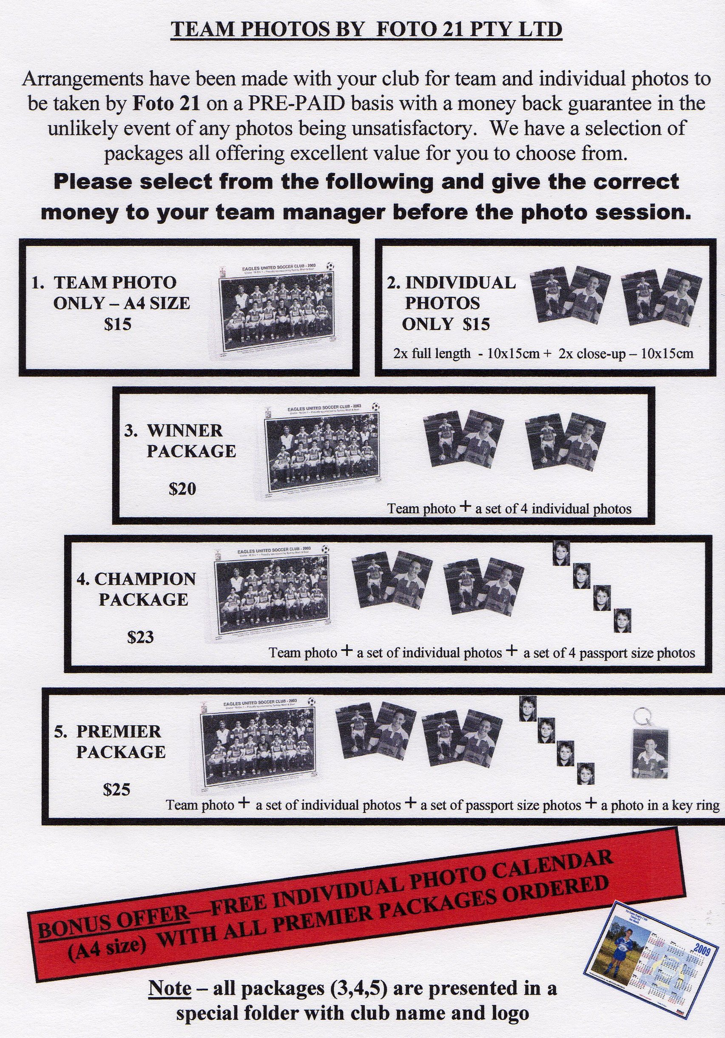

DRAW – Saturday 2nd May 2009

U6 vs OLQP Falcons M at Everley (mini) (Everley Rd., South Granville)

9.00am Kickoff (meet at Everley at 8.30am) (set up & dismantle mini field)

U7 WHITE vs OLQP Falcons L at Daniel 2 (Daniel St., Greystanes) 9.00am Kickoff (meet at Daniel at 8.30am)

U7 RED vs Wentworthville Uniting at Freame 2 (Rees St., Mays Hill)

11.00am Kickoff (meet at Freame at 10.30am)

U8 vs St Bernadettes Castle Hill L at Excelsior 1 (Excelsior Ave., Castle Hill)

9.00am Kickoff (meet at Excelsior at 8.30am)

U9 vs OLOR/St Angelas Kellyville W at Everley 1 (Everley Rd., South Granville)

11.00am Kickoff (meet at Everley at 10.30am) (set up field)

U10 vs OLOR/St Angelas Kellyville R at Everley 1 (Everley Rd., South Granville)

12.00pm Kickoff (meet at Everley at 11.30am)

U11 vs Winston Hills Bears at Everley 2 (Everley Rd., South Granville)

1.00pm Kickoff (meet at Everley at 12.30am) (Dismantle field)

U12 vs Kellyville Kolts at Everley 2 (Everley Rd., South Granville)

8.30am Kickoff (meet at Everley at 8.00am) (set up field)

U13 vs Toongabbie at Everley 2 (Everley Rd., South Granville)

11.05am Kickoff (meet at Everley at 10.30am)

U14 vs Baulkham Hills Sports at Everley 2 (Everley Rd., South Granville)

9.45am Kickoff (meet at Everley at 9.15am)

U15 vs Baulkham Hills Sports at Ted Horwood 4 (Park Rd., Baulkham Hills)

11.30am Kickoff (meet at Ted Horwood at 11.00am)

U16 vs Wenty Waratah at Ted Burge 2 (Centenary Rd., South Wentworthville)

11.40am Kickoff (meet at Ted Burge at 11.10am)

Raahauge Cup North Div. vs St Columbas Castle Hill at Excelsior 2 (Excelsior Ave., Castle Hill)

3.15pm Kickoff (meet at Excelsior at 2.45pm)

Raahauge Cup First Div. vs St Patricks Strathfield at Everley 1 (Everley Rd., South Granville)

(Reserves Kick off at 1.30pm, Firsts at 3.15pm) (Meet at Everley at 1.00pm)

Premier League vs St Patricks Strathfield at Powell Creek 1 (Victoria Ave., Concord West)

(Reserves Kick off at 1.30pm, Firsts at 3.15pm) (Meet at Powell at 1.00pm)

