OTB 7/10

The Website has had a makeover! Check it out - www.mccredie.org.au/soccer

Club Secretary – Greg 9682 7779 President – Peter 9632 9203

Interested in sponsoring a team or advertising in this newsletter? – call one of the above numbers.

PHOTOS

The following teams have team photos this Saturday.

U6, U7 RED, U8 WHITE, U10 WHITE, U10 RED, U11, U12, U16, Raahauge Cup North Div.
(The rest will be taken on 31st July)

Please adhere strictly to the timetable so that all teams can be photographed on time. One late player will mess up the team photo. You must attend the photo even if you do not intend to buy one.

Goal keeper training this week

Tom is offering specialist goal keeper training on occasional Tuesday evenings. The next session will be on Tuesday the 27th at 5.30pm. (no charge of course)
___________________________________________________________________________________________
All draws are now posted and can be accessed via our website
Under 6 – 10 and seniors click on NSWCFA link and follow links to draws.
Under 11 – 16 click on GDSFA link and follow link to ‘competitions’ and draw.

All junior players should now have their training shirts. See your manager if you missed out.

Condensed Ref Lecture on this Thurs 29 April with Ref test the following Thur 6 May – Assoc. office – Chester Hill – 7pm
_______________________________________________________________________________________________________
RESULTS from Saturday 24th April 2010
U6 vs Newington Gunners R 9 – 0
Awesome! another victory for the under 6's this weekend with an amazing 9-0 win against a great side Newington Gunners.
Man of the match awarded to Ben Hardy for an outstanding game on both attack and defence.Great goals by Aaron Bath and Fady Fouzia supported by an excellent team effort. Well done under 6's,keep up the good work. Under 6's would like to thank the Newington Gunners for an excellent game. Goal scorers – Aaron Baath, Fady Addoug.

U7 RED vs Newington Gunners R 4 – 1
The early start seemed to get the better of us; we struggled at first, against what seemed to be a super sized bunch of boys but it didn't take long before our boys found their rhythm. As we went to the break we were losing 1-0. Our start to the second half was a bit more promising, as we were constantly attacking their goals, then finally scored 4, while keeping the Gunners scoreless in the second half. Our Man of the match went to Jacob, for playing an exceptional game. Excellent game boys, keep up the good work! Goal scorers – Shaleen Nagar 1, Abraham Tannous 1, Anthony Tannous 1, Christian Frangie 1
U7 WHITE vs Wentworthville Uniting 0 – 6
Today the under 7 whites, ran, kicked, threw the ball in, stopped the ball going in the goal and had some scored against them.
Mario, Louie and Oliver worked in the goal and in defence, and pursued Wentworthville in our half of the field. Ryan, Lachlan, Mosese and Abdullah, covered off the centre and forward position trying to run the ball wide to push the it into Wentworthville’s half. We all learnt some more skills in this game, and had some fun MVP Abdullah for good runs up the side and getting into the game.

U8 RED vs OLQP Falcons P 9 – 1
Another well played game. We played our usual relaxed calm game at Everley. We need the passing to happen more regularly as we sometimes struggle at defence when 1 player tries to pass all 9 and loses the ball at half way. Overall we had a wonderful game. It was unfortunate that we had a penalty against us where 1 goal was scored into the McCredie nets. Peter had a terrific game and Herbert did a great job in chasing the opposition in defence to clear it away from the danger Zone. Welcome back Ken and Andrew from their little break. Man of the match: Peter Doumit
Goal scorers – Joe Azzi 4, Qais Sungkar 3, Nedim Fazlic 1, Joshua Elkerr 1

U8 WHITE vs St Bernadettes Castle Hill L 2 – 3
Well, our first loss of the season and very hard felt. The score doesn't show our resolve. We fought hard all game and were unfortunate not to win. Our back line was like a brick wall. Milos blocked so many opportunities for the opposition, and Jackson had his best game of the year running at anything, kicking the ball away with a massive boot which won him player of the match. Elias as well played with all his heart today which was great to see, this won him a special mention. Willy was all over the paddock and with the help of Yusuf scored a great goal. We were only pulled up once today for off-side which is a great improvement from last week - well done boys. Viththegan again tried hard and seems to have found his the right position and is doing great. Tam worked hard in the centre with Arber, and together work great. Sorry to Ahmet we lost - we can't win every game champ! Player of the match - Jackson Hunt. Goal scorers – Will List 1, Yusuf Jamil 1
U10 RED vs Newington Gunners 0 – 2
Every week we keep improving and every week we get closer to that elusive win. We had enough chances today but just couldn't finish. We are starting to hold our formation better now and were able to stretch our opposition today. Mohammad and Matthew had good games in goal. Marc-Anthony and Alex were strong at the back and Jehad, Antoine and Dominic made good runs from midfield. Keep up the work at training boys and a win is coming.

U10 WHITE vs Lidcombe Churches 3 – 3
What a game. We passed well to each other and got into position for most of the game and we were leading 3 – 1 with only 5 minutes to go. We had a few lapses and probably thought we had it in the bag and Lidcombe came back with 2 quick goals to even the score. Ronan and Ehren were on fire today they passed, kicked and defended better than, they have ever done before, well done guys. Ronan and Ehren both earned themselves the man of the match awards.
Goal scorer – Rusheel Raj 3

U11 vs Wenty Waratah 2 – 5
Started good and had a lot of chances. Scored within 10 minutes but the team eased off, resulting in a 2-5 loss. There were a lot of chances, and effort put in. Johnny had a few chances hitting the upright in the 2nd half; Joseph missed a few chances as well as Azal. It was bad luck for our team. The defence was doing a good job out the back Tommy saving some great shots, Andrew covering for Lazar in some situations, Lazar holding the line steady, Wesley Kane and Gavin good marking and pressure against opposition. They were confident they were going to win the game. Still played a good game guys. Next weeks a new week we will start fresh and gain back our winning streak. Player of the match: Gavin Weatherby
Goal scorers - Azal Mekhaeel 1, John Kazzi 1

U12 vs Kellyville Kolts 2 – 0
We headed to Kellyville to face the pace setters of the comp without our captain and sweeper Aiden, but it was worth the trip. We were out of sorts early on but Brandon made the save of the year diving at the striker’s feet and that changed the game. We did it tough as they are a solid team that had us wonder pressure but our make shift defence held firm. John scored his first goal for us in 5 years with our team with a shot from outside the box and we settled down. The second half was similar to the first but we took our chances again with Sajad slotting home when he broke clear. Jahid, Suri, Jason and John were great and we deserved the 3 points from a very gritty display against a good team but it was Brandon’s day. All his hard work is paying off and he is an excellent keeper. Player of the match – Brandon Hamlin.
Goal scorers – John Youssef 1, Sajad Saifi 1

U13 vs Kellyville Kolts 7 – 1
A pleasing return to form with much improved defence and, in the second half, attack. Early on we played like millionaires, lots of chances, very few conversions and seemingly, little care. The coach was getting frustrated and then when Kellyville scored from appalling defence, the team seemed to respond. In the second half we took our chances and tightened up at the back. EJ looked more confident, and Mahammad finished some nice goals. Today’s players of the match though were Wil, who kept them out at one end and banged in 2 at the other, Kerem who simplified his game this week and proved a great support to the players around him and Abulfazel who was outstanding at centre midfield. A special thank you to Rony this week and Joey last week for their support of the team even though unwell and able to play – great stuff.
Goal scorers – Mahammad Abdul Hamid 3, William Wark 2, Abulfazel Ahmadi 2

U15 vs Auburn FC 2 – 11
It is very difficult to describe this game. The score by no means represented the game and the performance of the two sides. Yes, we were out-played, and yes, we made mistakes, but we also made our chances. Auburn simply scored from just about every chance they had. Something we just have not been able to do. In the second half, we were behind and decided to take some chances that didn't pay off. With our heads down, we failed to stay in position and gave them way too much possession. If we are to improve, we must play the full 70 minutes, regardless of the score. We have to hold our defensive lines and pass pass pass! Emmanuel’s effort in goal was exceptional, even though the score doesn't reflect this. There were two diving saves that were truly sensational. Once again, the effort of everyone on the team was great, although I feel much of it was wasted chasing the ball, when all we need to do is control it. More training and preparation is obviously needed.
Congratulations on great goals from Kameel and Junior. Man of the match - Emmanual Eid.
Goal scorers – Junior Clark 1, Kameel Andraos 1

U16 vs Bye

RC North FIRSTS vs Penrith Churches 0 – 4

RC 1 RESERVES vs Chester Hill Sports B 3 – 1
A tough & exciting match which was expected from the top 2 teams so far this season. The match was very competitive from start to finish with the defence of both sides shutting down numerous attacks due to the quick pace & passing in the game. Nathan got an early goal but they responded straight afterwards. Amarvir’s goal had us all on our feet as it took forever to dribble across the line. After that the game turned into a duel of endurance with us not being helped by receiving a number of injuries from their ‘solid’ tackles. We had some good efforts from the free kicks and were unfortunate to hit a number of posts. Late in the second half Nathan got his second which took the wind out of the opposition. Great game and effort by all the boys.
Goal scorers – Nathan Stafford 2, Amarvir Singh 1

RC 1 FIRSTS vs Chester Hill Sports B 1 – 5
If only we played the full match like we did in the first 20 minutes. Despite a penalty for their player tripping over the ball we fought back and equalised. We dropped our heads and they got another 2. We settled down and began to pass the ball around only to be reduced to 10 men with 30 minutes to go. At that stage it could have turned real ugly for us against the top team but the boys focused and started playing good soccer again.
Goal scorer – Lam Nguyen 1

Package 1 = $15
Package 2 = $15
Package 3 = $20
Package 4 = $25 (price change from the list that follows)
Package 5 = $30
There is also a new Digital package available for $30

I will attempt to get an up to date flier attached and upload it here on Tuesday.

Managers will need to collect envelopes from me at training and collect all payments BEFORE the photos are taken.

(sorry for the short notice, but we have lots of teams at home this week)

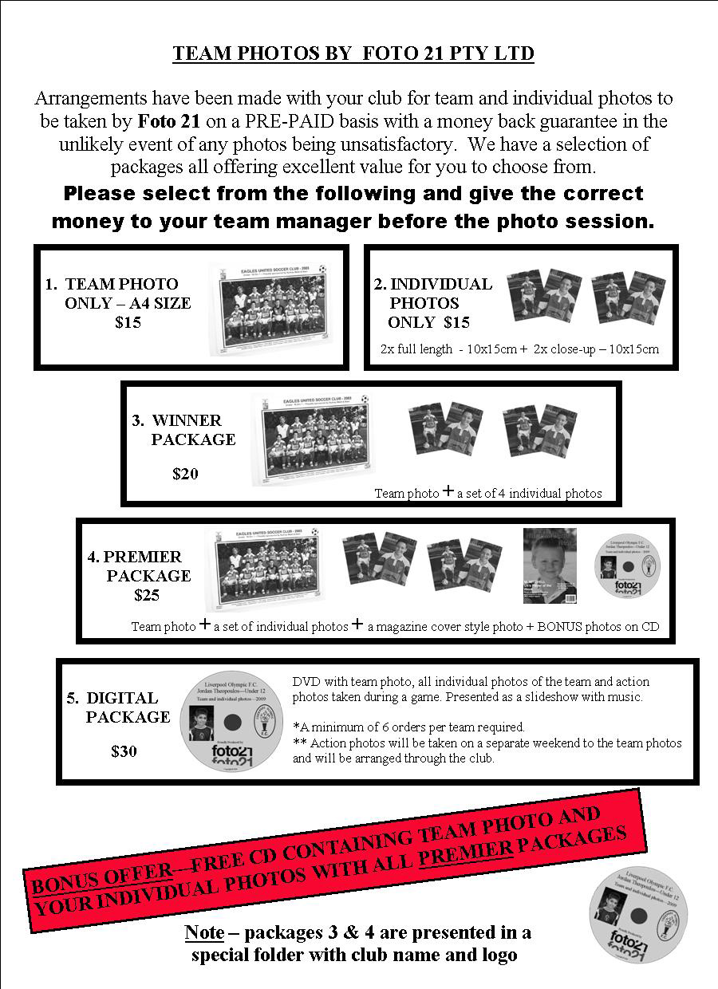

Draw - Saturday 1st May 2010

U6 vs Auburn FC A at Everley mini (Everley Rd., South Granville)
11.00am Kickoff (meet at Everley at 10.00am for team photo)(dismantle field)

U7 WHITE vs Newington Gunners at Wilson (Newington Rd., Silverwater)

9.00am Kickoff (meet at Wilson at 8.30am)

U7 RED vs Lidcombe Churches at Everley mini (Everley Rd., South Granville)

10.00am Kickoff (meet at Everley at 9.00am for team photo) (set up field)

U8 WHITE vs St Bernadettes Castle Hill T at Everley 2 (Everley Rd., South Granville)

10.00am Kickoff (meet at Everley at 9.15am for team photos) (set up & dismantle field)

U8 RED vs Lidcombe Churches at Wilson (Newington Rd., Silverwater)

11.00am Kickoff (meet at Wilson at 10.30am)

U10 WHITE vs OLOR Kellyville Green at Everley 1 (Everley Rd., South Granville)

11.00am Kickoff (meet at Everley at 10.15am for team photo)

U10 RED vs Wentworthville Uniting at Everley 1 (Everley Rd., South Granville)

12.00pm Kickoff (meet at Everley at 11.15am for team photo)

U11 vs Pendle Hill at Everley 1 (Everley Rd., South Granville)

9.00am Kickoff (meet at Everley at 8.15am for team photo) (set up field)

U12 vs Toongabbie at Everley 2 (Everley Rd., South Granville)

12.00pm Kickoff (meet at Everley at 11.00am for team photo) (set up & dismantle field

U13 vs Bye

U15 vs Bye

U16 vs Guildford County at Everley 1 (Everley Rd., South Granville)

10.30am Kickoff (meet at Everley at 9.30am for team photo)

Raahauge Cup North Div. vs Wentworthville Uniting at Everley 1 (Everley Rd., South Granville) 3.15pm Kick off (meet at Everley at 2.45pm) (dismantle field)

Raahauge Cup First Div. vs Greystanes Churches at Birrong 3 (Cnr Woods & Wellington, Birrong)

(Reserves Kick off at 1.30pm Firsts at 3.15pm) (Meet at Birrong at 1pm)

