www.mccredie.org.au/soccer OTB 8/09

Club Secretary – Greg 9682 7779 President – Peter 9632 9203

Interested in sponsoring a team or advertising in this newsletter? – call one of the above numbers.

CLUB PHOTOS THIS WEEK

FOR

U6, U7W, U8, U10, U14, U16, RCN, RC1 1sts and res.

Please choose which package you would like to purchase and pay your team manager this week.

All photos must be paid for before the photo is taken. If you do not want to buy a photo you still need to have your child in the team photograph as part of the team.

This Saturday 9th May the club will be having a barbeque at Woolworths Granville.
We will also be selling Krispy Kremes at Woolworths for Mother’s Day. Cheaper than the shop and cheaper than a cake for Mother’s Day – and your club will benefit.

After soccer – drop in – have a sausage – buy a couple of boxes and do some shoppin. Your Mum and club will love you!

Congratulations to Mohammad Rahimi and Tom List who were both successful in their referees examinations last week. We will shortly see them in the middle in ref’s gear, blowing their whistles and grooming their seeing eye dogs! Be kind all! ___________________________________________________________________________________________

Committee meeting this Thursday 7th May at the church – 7pm start.
___________________________________________________________________________________________

The church has some termite problems – that’s bad! But – the termites have brought Phyl out of spongemaking retirement – that’s good! Phyl will be baking in the last week of May, if you would like to order a $5.50 sponge please let me know by Wednesday 20th May.

I have had some enquiries about club jackets – let me know if you are interested in purchasing one so I can make an order in the next week or so.

We still have adult size club polo shirts available for $40
___________________________________________________________________________________________
RESULTS from Saturday 2nd May 2009

U6 vs OLQP Falcons 0 - 7
Not one of our best games. We were short on reserves and just couldn’t keep up with the other team. Some good passing and team work by everyone. Our player of the match award went to Dean.

U7 RED vs Wentworthville Uniting No report

U7 WHITE vs OLQP Falcons 11 – 0
The best performance by the boys since coming together, We passed and moved, tackled strongly, ran into space, held our positions and never gave up. Will, Tam and Milos scored goal after goal but were never greedy and passed when they could have scored. Arber was brilliant today, tackling and chasing and scored a lovely goal and celebrated accordingly. Jackson was dynamic today and played his best game ever. A great team performance. Player of the Match – Jackson Hunt.
Goal scorers – Will List 3, Tam Do 3, Milos Mijatovic 3, Jackson Hunt 1, Arber Zenelaj 1

U8 vs St Bernadettes Castle Hill L 3 - 1
A great start with 8 players on the field this morning. We held opposition back really well. Most of the first 10 minutes was played in Guildford’s half but not long after 3 fresh legs came onto the field and Mershad, Nedim and Anthony made a big difference. We ended 1-1 at half time which was not too bad on a big field. Second half was played much better with Mershad on the wing and his crosses to Joe and Qais which gave us the opportunity to score 2 more goals which made us walk away with a 3-1 against Castle Hill. Our defence needs to be more aware of the game of play and need to be at the ball first to be able to clear it away before the opposition. Great pressure was shown by Nedim and Robert and great control by Andrew speaking to his defence to move up at attack and drop back at defence. Great game everyone keep it up. Man of the match- Mershad Atai
Goal Scorers – Joe Azzi 2, Qais Sungkar 1

U9 vs OLOR/St Angelas Kellyville W 3 - 1
What a game! It was hard to pick out a few boys this week, they all played excellent. The passing to each other was great and led to most of our goals – the first one a great pass from Ehren to Rusheel stands out. Huge kicks from our backs kept the opposition chasing the ball back in their own half for most of the game. We are starting to gel together as a team and understand the importance of passing the ball. Ronan Galeb had a huge game and never gave up the fight for the ball and earned himself the Man of the Match award.
Goal scorers – Rusheel Raj 2, Ali Hawchar 1

U10 vs OLOR/St Angelas Kellyville R 2 - 3
The U10s are really coming together they are starting to work as a team and it’s showing .Congratulation to Mohammed with 2 excellent goals .Very hard to pick player of the match this week ,but went to Emir, he was just unstoppable on the field well done. Goal scorer – Mohammed Al-Naji 2

U11 vs Winston Hills Bears 1 – 3
We left the field feeling very hollow today because of what might have been. Playing the Competition leaders is never easy and we found ourselves 3 down after 10 minutes. We could have been forgiven for dropping our bundle but this team has wonderful spirit and we lifted our effort and the game changed. Our back 4 tightened up and turned the opposition away time after time and our attack gained strength and we started running strongly. The second half was terrific if not disappointing. We missed 2 one on ones with the keeper, Emily hit the post, and we put 2 past the posts. Arbin slotted home from close range and Winston Hills could not stop our charge but we ran out of time. We can compete at this level and with some luck we will start getting the results we deserve. Player of the Match – Cameron Hunt
Goal Scorer – Arbin Zenelaj 1

U12 vs Kellyville Kolts 2 - 0
The team is starting to settle into the year and seemed to take to the field much more confidently today. A couple of positional changes saw us able to build more attacks and control more of the play. Joey up front was a revelation. He had maybe his best game ever and was clearly the best player in our team today. Joey’s willingness to look for his team mates when he had the ball was the big difference and he set up the first goal with a great pass and deservedly scored the second goal himself.
Goal scorers – Daniel Jabou 1, Joey Nader 1

U13 vs Toongabbie 3 – 1
The boys win today is an encouraging sign that the team is moulding together with the new comers this year. Several players are rising to the new challenge. Some of today’s highlights Ahmad consistently engaged the opposition when they had the ball. Jacob and Mustafa displaying strong kicks defending our half. Hassan and Dean ran down Toongabbie when they broke through the fullbacks. Wasim and Jackson skilled moves up the sides from a defensive position to enable the team to attack Toongabbie’s goal. Jeremy excellent work setting up the strikers to shoot at goal, Ashim and Alisena have improved each week we play. Well done Boys. Mirwais the boys are starting to pickup some of the skills you are teaching them. MVP's Jackson, Jeremy, Wasim. Goal scorers – Jeremy Gonzales 2, Jordan Sarmento 1

U14 vs Baulkham Hills Sports 0 - 4
Unfortunately, the score by no means represents the game. Our finishing just wasn't up to scratch, and our mid-field looked tired and were continually caught out of position. Luck also seemed to fail us this week. On the bright side, we were still chasing that ellusive goal all the way to the end. We can use this game as the measure of where we need to be in this competition. Good work boys. Man of the Match - David Youssef

U15 vs Baulkham Hills Sports 8 - 1
Played on the narrowest field I have ever seen. There was 1 metre between the edge of the 18 and the sideline. This really cramped our style and for the first quarter it was ugly soccer with everyone stuck in the midfield centre circle. Once we stopped playing their way and started spreading out we created the space that gave us the opportunities in front of goal. Our midfield and forwards shared the shots on goal which was good practice. Well played everyone. We just need to work on getting there early. Goal scorers – Mohammed Rahimi 4, Antony Vojvoda 3, Trung Nguyen 1

U16 vs Wenty Waratah 0 - 1
We only had the bare 11 today with a few players unable to make it. Unfortunate to not come away with at least a point with the goal deciding the game being a little controversial. Amarvir was a strong fill in goalkeeper and pulled off many saves. Unlucky not to score today with Mustafa, Adam and Hideki all having chances. There were patches of improved soccer today with us starting to pass the ball more instead of trying to beat three players, much better to watch.

RC North FIRSTS vs St Columbas Castle Hill 3 - 6
Man of the match – Antonio De Apolinacio Goal scorer – Raphael Aleman 2, Antonio De Apolinacio 1

RC 1 RESERVES vs St Patricks Strathfield 0 - 2
A much better effort this week but still no points. A couple of mistakes gave the opposition 2 weak goals but keep putting it in boys and it shouldn’t be too long until we get a point. Man of the match Maldoon Tofele.

RC 1 FIRSTS vs St Patricks Strathfield 0 - 3
No effort, no goals, no chance, no good.

Premier RESERVES vs St Patricks Strathfield 2 - 3
But for a fifteen minute period when we were dreadful and conceded 2, we were clearly the better side today. That said St Pats are a pretty fair side, so we weren’t beaten by plonkers. I dare say we will see these guys a few more times this year.
Goal scorers – Lam Nguyen 1, John Dor Achiek 1

Premier League FIRSTS vs St Patricks Strathfield 1 – 3
Lots of things need to change but winning the toss is not the least of them! Running head long into a gale first half meant we were struggling from the start. Pece spent most of his time working very hard in midfield and Booph did a stirling job on one of the better strikers we have played against yet – keeping him from shooting. They scored twice in that half from corners and one of those goals was 30 seconds from half time – which was a tragedy. We hit back early in the second half through Phil Chan (who for 11 years he has been scoring 1 goal a year – do we leave him off from now on?) but their 3rd, through a very unlucky deflection falling to the feet of a very appreciative striker – killed us. Phil Chan and Mirwais were outstanding. Goal scorer – Phil Chan 1
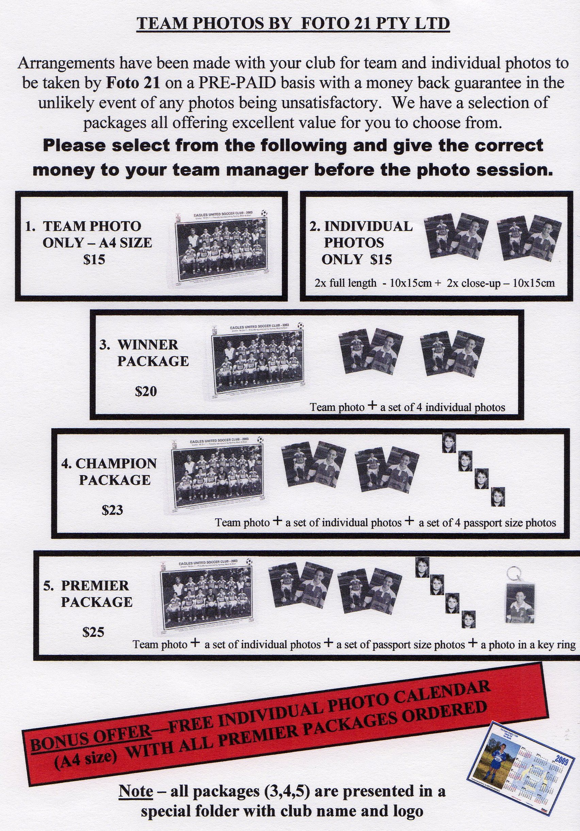

DRAW – Saturday 9th May 2009

U6 vs OLQP Falcons R at Everley (mini) (Everley Rd., South Granville)

10.00am Kickoff (meet at Everley at 9.10am FOR TEAM PHOTO)

U7 WHITE vs St Bernadettes Castle Hill L at Everley (mini) (Everley Rd., South Granville)

9.00am Kickoff (meet at Everley at 8.20am FOR TEAM PHOTO)

U7 RED vs Bye

U8 vs St Matthews Baulkham Hills at Everley 1 (Everley Rd., South Granville)

9.00am Kickoff (meet at Everley at 8.10am FOR TEAM PHOTO)

U9 vs OLQP Falcons P at Everley 1 (Everley Rd., South Granville)

11.00am Kickoff (meet at Everley at 10.30am)

U10 vs St Bernadettes Castle Hill E at Everley 1 (Everley Rd., South Granville)

12.00pm Kickoff (meet at Everley at 11.00am FOR TEAM PHOTO)

U11 vs Bye

U12 vs Parramatta City at Eric Primrose 2 (John St., Rydalmere)

11.45am Kickoff (meet at Eric Primrose at 11.15am)

U13 vs St Johns Auburn at Webbs Avenue 1 (Webbs Ave., Auburn)

11.30am Kickoff (meet at Webbs at 11.00am)

U14 vs St Johns Auburn at Everley 2 (Everley Rd., South Granville)

9.45am Kickoff (meet at Everley at 8.45am FOR TEAM PHOTO)

U15 vs Dundas United at Curtis Oval 2 (Yates Ave., Dundas)

11.25am Kickoff (meet at Curtis at 11.00am)

U16 vs Baulkham Hills Sports at Everley 2 (Everley Rd., South Granville)

12.15am Kickoff (meet at Everley at 11.15am FOR TEAM PHOTO)

Raahauge Cup North Div. vs Penrith Churches at Everley 3 (Everley Rd., South Granville)

3.15pm Kickoff (meet at Everley at 2.30pm FOR TEAM PHOTO) Dismantle field

Raahauge Cup First Div. vs Greystanes Churches at Everley 1 (Everley Rd., South Granville)

(Reserves Kick off at 1.30pm, Firsts at 3.15pm)

(Reserves Meet at Everley at 1.00pm FOR TEAM PHOTO)(Firsts Meet at Everley at 2.45pm FOR TEAM PHOTO)

Premier League vs Chester Hill Sports at Walshaw 2 (Hector St., Bass Hill)

(Reserves Kick off at 1.30pm, Firsts at 3.15pm) (Meet at Walshaw at 1.00pm)

