OTB 9/11

Club Secretary – Greg 9682 7779 President – Peter 9632 9203

Interested in sponsoring a team or advertising in this newsletter? – call one of the above numbers.

www.mccredie.org.au/soccer

Committee Meeting – Tuesday 31st May 7.00 pm

Coaches and Managers Meeting – Tuesday 31st May 7.30 pm
__________________________________________________
Club Photos –
Club photos have been booked and the remaining team’s photos will be on the 28th May.

Photos - Saturday 28th May 2011

U6 8.30am photo

U7 RED 10.15am photo

U7 WHITE 9.15am photo
U9 WHITE 10.00am photo
U9 RED 10.30am photo
U10 11.15am photo

U13 11.00am photo

Raahauge Cup First Div. 3pm photo

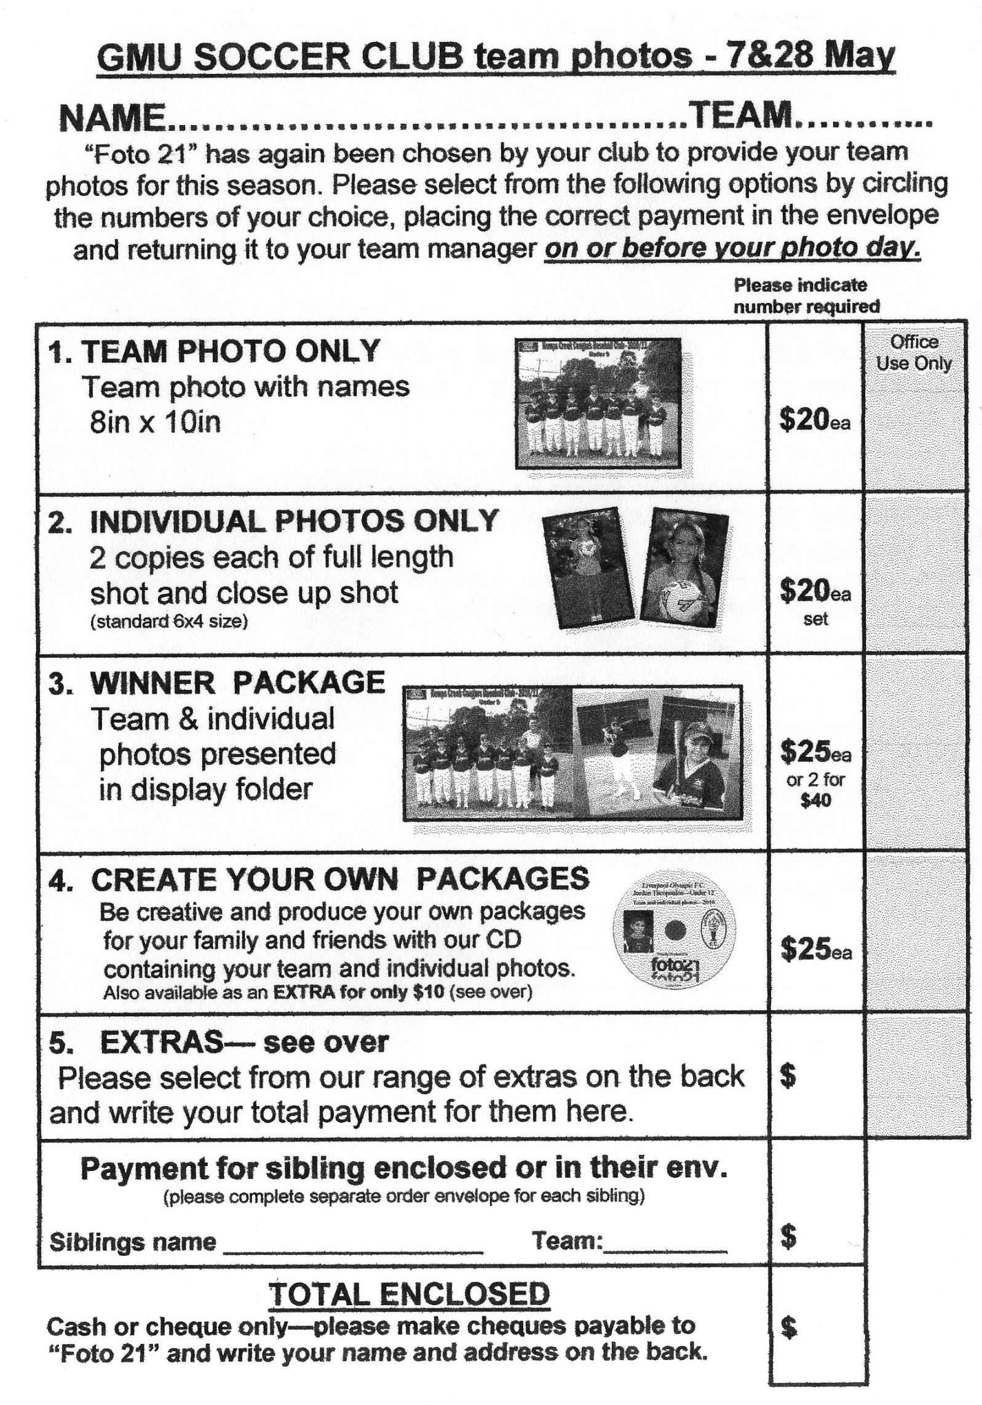

RESULTS for Round 7: 21st May 2011

U6 vs OLOR/St Angelas Kellyville G 5 – 1
After many attempts at kicking at goal Samuel and Hannah found Kellyville’s defence hard to get through, but, Kaaappppowww! Samuel managed to get 2 in with the help of the team before half time. Our defence Matthew and Victor did not let the ball pass them. Diego and Talal kept the opposition spinning with their crazy ball skills. Ali had amazing cross kicks and throw- ins, while Mylan feeling lonely at goals did a lot of hard work when she got on field. Congratulations!!!
Goal scorers – Samuel Kidane 3, Victor Doueihi 1, own goal 1

U7 RED vs OLOR/St Angelas Kellyville B 7 – 5
Great game today with the kids really starting to play well in both attack and defence. Awesome goal keeping by Bailey and Rahul kept the other team to 5 goals, it may seem a lot but could have been much more than that. Anthony and Aaron scored 3 goals each and Abraham also scored 1, which was part of the reason Abraham was awarded the Encouragement Award, while Joel’s continuous efforts as sweeper earnt him the Man of The Match Award.
Goal scorers – Anthony Tannous 3, Aaron Batth 3, Abraham Tannous 1

U7 WHITE vs OLQP Falcons W 2 – 3
We played very well in the first half of the game but unfortunately we had no reserves so by 2nd half our kids were tired and this was an advantage to the opposition and they managed to get their 3rd goal past us. Ajuet received the encouragement award.
Goal scorer – Mustapha Fahme 2

U8 vs Newington Gunners 3 – 0
We started the game with the sun in our eyes, which made the first half difficult with several goal attempts missed.
We dominated possession, but lapses in our positional play gave opportunity for the Gunners to break down the sides. Our most improved players: John- Luke did an excellent job as fullback in the first half and attacking in the Gunners half in the second , William our other most improved worked in the halves and forwards, passed the ball through the pack so our strikers could attempt goal and played goalie in the second where it was a bit quiet and Ryan, our Man of Match, either running the back row or forward is mastering the game by improved ball control in the forwards or steering our backline to terminate the Gunner’s attacks, well done.
Goal scorers - Yel Chan 2, Christian Frangie 1

U9 RED vs St Bernadettes Castle Hill T 4 – 2
A great game was played walking away with a 4-2 win. The game started very fast with lots of pressure coming from both teams. Joe scored a wonderful goal but things were still stressful. It was 1-1 at half time and the coach made some re-arrangements. A great goal came from Qais which relieved the coach. Another goal came from Josh with his driving free kick which relieved everyone. Another goal against us made things tight but with Christian’s help, Qais scored the 4th goal which made the coach proud. Boys we played as a team in the 2nd half and all we passed well and applied pressure. Keep it up. A big thank you to Christian who was the highlight of the whole game. Man of the match: Christian Frangie
Goal scorers – Qais Sungkar 2, Joe Azzi 1, Joshua Elkerr 1

U9 WHITE vs Newington Gunners 4 – 0
Tough game today, we had many chances in the first half but only managing 1. Alex and Kenny played great today working hard and tackling strongly. Jackson and Milos kept things under control at the back. We found our feet in the second half with Will and Yusuf scoring nice goals. Elias played well and Arber was everywhere. Good effort guys. Player of the Match - Milos
Goal scorers - Will List 3, Yusuf Jamil 1,

U10 vs OLOR/St Angelas Kellyville 3 – 0
A big turn around this week from the previous two. We looked a lot more solid today at the back and some of our attacking moves started to come off. Another big thank you to Yel this week for filling in again, and he didn’t look out of place. Chan dropped back into the midfield and controlled a lot of the play from there and earned himself man of the match. Deng and Kayra were strong at the back today shutting down a lot of the opposition’s attack. Antoine made some good breakaways and was unlucky not to score. Chris and Ashley were good out wide in midfield today setting up a lot of through balls.
Goal scorers – Chan Chan 2, Ryan Carder 1

U11 vs Newington Gunners 4 – 0
A really well crafted win against a pretty reasonable opposition. Our control of the ball and sensible passing was a feature of our match, particularly the first half. Kabin had an excellent match, and with Matty, controlled the left side of the park. On the right Chrissie was playing well and made some nice runs down the wings. Salem and Alibaset are a very formidable combination in the centre of the field and Joel is really taking charge of the back now. Well played all.
A quick reminder that this week we will train on TUESDAY at 5pm Not Wednesday
Goal scorers – Rusheel Raj 2, Alibaset Zafari 1, Salem Boustany 1

U12 vs St Michaels Baulkham Hills 3 – 1
Today’s game wasn’t a pretty game to watch, very, very messy, I have seen bowls of pasta that looked more organised,. The only person that I could say was in the right position all the time was Lazar our goalie. The other team had a few chances, but the only goal they where able to score was off a penalty . On a good note our team won the game, from some quite nice goals. Tawab with 2 goals proved today that the first few free kicks he scored off in previous games were not just lucky shots. These are his specialties with another great 18’yard free kick, on target and into the back of the net. Taha was the other goal scorer with another nicely placed goal right of keeper. The mess made everyone’s job on the team a lot harder and the score line also reflected this mess today. Our Man of the Match today was Tawab and the Most improved Player Micshang you showed good intensity, but please watch those slide tackles.
Goal scorers – Tawab Taufiq 2, Taha Housaini 1

U13 vs Lidcombe Waratah Black 0 – 1
Disappointing not for the score but we lacked determination. We only started to play in the last 15 minutes. Lidcombe were more desperate and more committed and we did not get it right many times. Stars were few but Emily, Josh, Cameron and Brandon did well. Player of the week - Emily Perera

RC 1 RESERVES vs Chester Hill Sports 1 – 4
Let in two goals early in the first half but came back and contained them after that. Second half looked promising especially after Pece combined well with Nath who finished nicely. Unfortunately, we then went down a player and with the extra man we weren’t able to hold them out.
Goal scorer – Nathan Garcia 1

RC 1 FIRSTS vs Chester Hill Sports 0 - 4
First twenty minutes we went out and played to our strengths as a team and were rewarded with some great opportunities we were unfortunate not to capitalise from. Then we failed to clear a corner after a great block by Wayne. They then managed to grab a second while we were recovering from them converting from there first half chance after we had the majority of the play. Injuries, frustration with refereeing, meant our mentality suffered and the result reflects this. We need to stick to the plan for more than 20 minutes. Everyone trying to push forward gave them the space to come back at us.

Lapathon

Team | Player with most laps | Number of laps | Total laps for team
U6 | Samuel Kidane | 15 | 67
U7 RED | Joel Carder  Aaran Batth | 18 | 95
U7 WHITE | Mustapha Fahme | 16 | 59
U8 | Yel Chan | 25 | 182
U9 RED | Andrew Ibraheem | 21 | 133
U9 WHITE | Yusuf Jamil | 20 | 163
U10 | Chan Chan | 23 | 98
U11 | Joel Booker  Alibaset Zafari | 25  25 | 215
U12 | John Kazzi  Wesam Chami | 23  23 | 159
U13 | Peter Yousef | 26 | 218
Guests  U13  U14 | Arbin Zenelaj  William Wark | 28  25

Draw - Saturday 28th May 2011

U6 vs OLQP Falcons at Everley (mini) (Everley Rd., South Granville)

9.00am Kickoff (meet at Everley at 8.30am for team photo) (set up field)

U7 RED vs OLOR/St Angelas Kellyville W at Everley (mini) (Everley Rd., South Granville)

11.00am Kickoff (meet at Everley at 10.15am for team photo) (dismantle field)

U7 WHITE vs OLQP Falcons T at Everley (mini) (Everley Rd., South Granville)

10.00am Kickoff (meet at Everley at 9.15am for team photo)

U8 vs OLOR/St Angelas Kellyville W at Everley 2 (Everley Rd., South Granville)

10.00am Kickoff (meet at Everley at 9.30am) (set up field)

U9 RED vs McCredie White at Everley 2 (Everley Rd., South Granville)

11.00am Kickoff (meet at Everley at 10.30am for team photo)

U9 WHITE vs McCredie Red at Everley 2 (Everley Rd., South Granville)

11.00am Kickoff (meet at Everley at 10.00am for team photo) (dismantle field)

U10 vs St Bernadettes Castle Hill L at Everley 1 (Everley Rd., South Granville)

12.00pm Kickoff (meet at Everley at 11.15am for team photo) (set up field)

U11 vs OLQP Falcons A at Daniel Street 1 (Daniel St., Greystanes)

12.00pm Kickoff (meet at Daniel at 11.30am)

U12 vs Winston Hills Bears at McCoy (McCoy St., Toongabbie)

9.30am Kick off (meet at McCoy at 9.00am)

U13 vs Greystanes at Everley 2 (Everley Rd., South Granville)

12.00pm Kickoff (meet at Everley at 11.00am for team photo)

(set up and dismantle field)

Raahauge Cup First Div. vs Parramatta Salvation Army at Everley 1 (Everley Rd., South Granville)

(Reserves Kick off at 1.30pm, Firsts at 3.15pm) (Meet at Everley at 1.00pm)

Team photo at 3.00pm (dismantle field)

____________________________________________________________________________________

Sunday 29th May 2011

Kings Sevens -

Under 13s to meet at The Kings School at 7.45am
(The Kings School – Pennant Hills Rd., North Parramatta enter school and follow signs.

