OTB 11/13

Club Secretary – Greg 9682 7779 President – Peter 9632 9203

Interested in sponsoring a team or advertising in this newsletter? – call one of the above numbers.

LAPATHON

A big thank you to everyone for your support for last week’s lapathon. At this stage we have raised over $1000 in sponsorship but there are a few teams and a few individuals who are still collecting. Please do this as quickly as possible and return to Greg.
____________________________________________________________________________________________________
Six a side this weekend!
The Annual six a side is on this weekend. Managers please confirm your teams this week. Most teams will split in two for the day to ensure as many children as possible can participate.
Please ensure your manager knows if you will be away. If you or your child are playing, please ensure that you are at the ground on time (parking will be a problem so allow plenty of time).
We have a proud history at this event (check this link! http://mccredie.nfshost.com/soccer/historical/sixasidewinners.xls ) so enjoy it and Good Luck!
_____________________________________________________________________________________________________
Goal keeper training continues this week
Goal keeper training from 5pm until 5.30pm at Granville Park.

_____________________________________________________________________________________________________
RESULTS – 1st and 2nd June 2013

U6 Red vs St Bernadettes Castle Hill 11 - 1
Spectacular effort from all the reds today. Jack started in goals while Fayez and Charbel made all the breaks and kept the ball in the oppositions half. Charbel and Gerri scored 2 goals each before half time and we only let one ball through, making it 4-1 going into the break. Simon took aver as goalie for the 2nd half and we saw Jack score 2 goals in the first few minutes. Jack & Ahoi &Ali were passing well which saw us score 5 more goals during the second half. Simon made some great saves and Thomas backed him up. An amazing game in which the boys saw just how well things can go when we use the skills we learn in training. Man of the match Fayez.
Goal scorers: Jack Whale 6, Gerardo Cavasinni 3, Charbel Estephane 2.

U6 White vs OLQP Falcons White 2 – 1
It was the first day of winter today and it seemed as if our players wanted to go into hibernation for the winter season. Last time we played OLQP Falcons white in round one we won comfortably 7 goals to nil. Today we struggled but did enough to win the game. The team obviously missed Kilarney Lavender, the giant defender with the big clearance kicks. We made it hard for ourselves by missing many opportunities at goal and by missing tackles. Mohammad played well today taking on the role that Kilarney would normally have played. Mohammad was good in defence and fortunately on target scoring two goals. Yak was great in goals making two great saves that would have normally produced goals. Hendrix played well beating the defence line on occasions. Little Diego played well in defence but missed Kilarney helping him out. Sarah is improving every week gaining a little bit of confidence each game. Lucy tried hard but it wasn’t her day today, as her legs did not seem to want to run. Yar shows improvement every week and today was no exception. Yar also played well as goal keeper in the second half. Adeng, the goal scoring machine wasn’t on her game today. Adeng tried hard all game, playing goal keeper for part of the first half and then in the forwards.
Goal scorer - Mohammad Ziyan 2

U7 Red vs St Bernadettes Castle Hill Lions 6 - 2
Today our coach had to referee, so the boys relied on themselves as well as the parents. Joey showed us today that his mind is back on the game scoring 5 goals effortlessly. Zachary was goalie first half sharing the position with Anthony. Zachary also scored his first goal for the season. Sayed almost scored a goal but missed than Joey made sure Sayed efforts weren't lost by shooting the ball through the goal posts. Kareem played up front as well as defence. Joshua, Mark-Antony and Ali all played really well as midfielders. Great game play today boys. Man of the match Sayed Dahdah
Goal scorers – Joey Farah 5, Zachary Shamsin 1

U7 White vs Lidcombe Churches 3 – 1
From the start, the Lidcombe Church team looked like they were on fire. They were quick on their feet, tough with their bodies and also feisty with their words about the challenge. But our team were not fazed. After a bye last week, we were ready for a challenge and from the start every team member played well. Our opponents saw this and brought out their secret weapon...and what looked like a giant on the field compared to all the other kids. It was confirmed that their secret giant was in fact a player from one of their older teams. Although this gave them an unfair advantage, this did not impact the game played by our boys and girls and they were determined to defeat their opponents and this they did! Foaud was player of the game playing well on the field in the first half and making a few spectacular goal saves in the second. It was a beautiful morning.
Goals: Ali Fahme 2, Dimo Dimo 1

U8 vs St Bernadettes Castle Hill Eagles 0 - 2
Man of the match – Tamir Moghayda

U9 vs St Bernadettes Castle Hill Tigers 4 - 1
Mustapha started our game today scoring our first goal in the first minute of the game, not long after that he scored again, and again and again!! Second half of the game Mase nearly scored, but unfortunately missed, better luck next time, although he played really well. The team played really well today, good on you kids, keep up the good work! Max played really well today, also had good efforts from Izabella and Gregory.
Goal Scorer - Mustapha Fahme 4

U10 vs St Bernadettes Castle Hill Eagles 1 - 1
Today’s game was a bit sad, we seemed to struggle with form. The first half was a ordinary. We tried and tried but were unable to do anything. Late in the first half the opposition busted through our defence and scored. We kept fighting all game and with no reserves we battled all the way to the end, midway through the second half we finally scored of some real nice play. Full time we were locked in at 1 all..
Player of the match-Will
Goal scorers: Mounir Hadid 1

U11 vs Bye

U12 vs Kellyville Kolts White 0 - 5
The early kick-off time for today’s game didn’t agree with some of our players and we played slowly. We allowed Kellyville to win every 50/50 ball and get to loose possession first. Harrison was good in goals in the second half and kept the score down as it could’ve been a little worse. Cameron and Sarah chased hard in the middle trying to shut down the opposition’s space. We have to get to the ball first in every game if we want to control the game. We will work hard at training and try and get back some form.

U13 vs Castle Hill United Black 3 – 2
This was a fabulous effort. We were missing plenty of players and had to borrow from the 12s but the effort the boys gave was sensational. This was a dangerous game, playing away, low on numbers and against a side we struggled against last round. But Mujtaba was on fire from the start and the team work through the midfield was the best of the year. Up front Ali, Matthew and Luke worked hard and kept testing the Castle Hill defence, whilst Joel and Serge were rock solid at the back. Happy coach ☺
Goal scorers – Matthew Richards 1, Luke Fernandes 1, own goal 1

U15 vs Pendle Hill Tigers 1 – 1
I don't know who ran over the black cat, but whoever it was: go and get a four leaf clover! Despite the scrappy play on both sides, we seemed to have the edge for most of the game, even though we weren't playing as well as we could have. There was great work in defence with some heart-in-the-mouth last minute saves by all of the backs as well as Vehid in goals. There were some great moments in attack too, our only score coming early in the second half from great work by John Kazzi on the right to set up Will in the square. Unfortunately our run of bad luck continued, as soon after that a half-saved, deflected ball only just clipped the inside of the goal post and trickled over the line before our backs or keeper could get to it. From there we couldn't break through and the game ended in a stalemate, even though we were able to put attacking and defensive pressure on the other team. Even though this wasn't our best performance, there were some glimpses of good play with occasional long passes through opening up their defence, and gutsy work at the back when they looked as if they would score. Best of all, we were a lot more committed to regaining the lost ball, with some long, hard chasing to put pressure on and win it back. A lot to work on at training, and we need to be more awake once the starting whistle blows. Nevertheless, another entertaining game.
Goal scorer: Will Booker 1

Ladies vs Winston Hills Bears White washed out

RC1 White Reserves vs McCredie Red 0 – 1
No report

RC1 White Firsts vs McCredie Red 1 - 4
No report Goal scorer: ?

RC1 Red Reserves vs McCredie White 1 – 0
Solid. Daniel and Mehmet worked hard in the middle and from this the team took control of the game. Darren was safe as houses in goals, while Phil and his backs cleaned up everything that came their way. Mick and Jeff kept their defence busy, but it was a great effort from An that finally brought us a goal. While we couldn't advance our lead, we kept control of the game and played strong across the park. We do need to look at our attacking options out wide so that we can then create space in the middle for our strikers.
Goal Scorer: Duy An Dao

RC1 Red Firsts vs McCredieWhite 4 – 1
From the start we took the game to our opposition, putting on a great display of teamwork and commitment. The first 30 minutes were ours, and through some great work by Adem, Caner and Virinder, we were 2 up. Then our opposition set a trap and we fell in. Luckily half time came and we could re-group. The second half saw us settle down and regain control of the game. While Darren was required to come up with some great saves, the backs defended solidly all match. A great effort from Daniel and Dany backing up, as well as Mehmet who came up with a great strike for a well-deserved goal.
Goal Scorers: Virinder Chaggar 3, Mehmet Biber 1

The U16 Kings Sevens Champions receive their medallions last weekend.

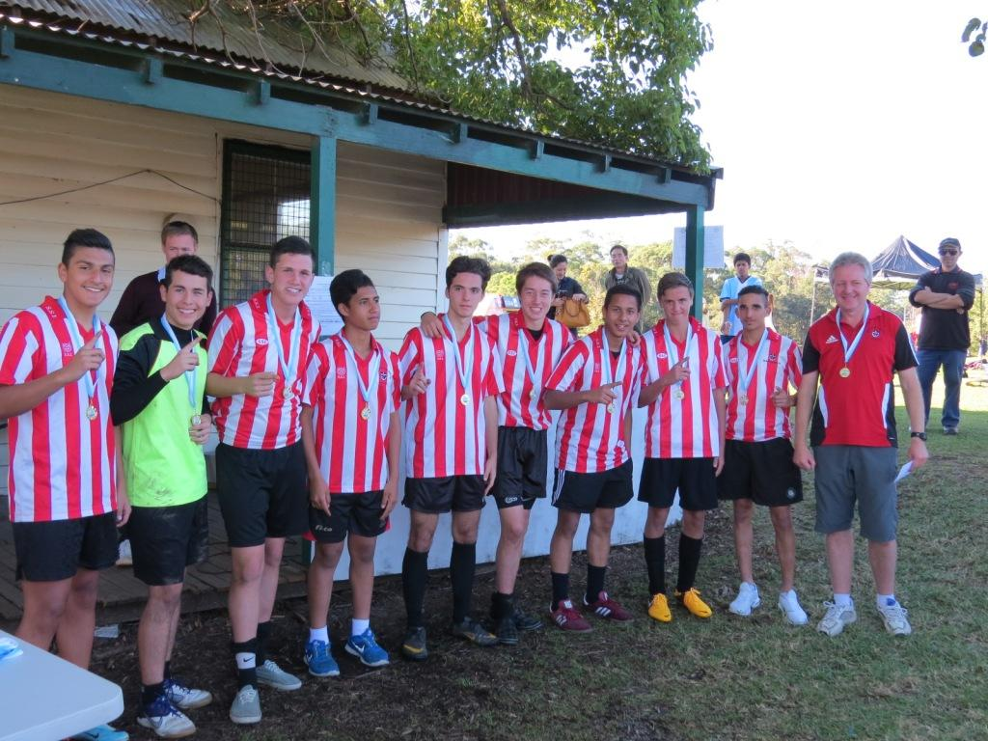

Saturday 8th June 2013
ANNUAL Six a side Tournament – all matches at Everley Park

U6 Red Meet at Everley Park at 9.30am

U6 White Meet at Everley Park at 9.30am

U7 Red Meet at Everley Park at 8.30am

U7 White Meet at Everley Park at 8.30am

U8 Red & Grey Meet at Everley Park at 8.30am

U9 Red & Grey Meet at Everley Park at 9.30am

U10 Red & Grey Meet at Everley Park at 9.00am

U11 Red & Grey Meet at Everley Park at 9.30am

U12 vs North Rocks at Princes 2 (Princes Rd., Auburn)
9.40am Kickoff (meet at Princes at 9.10am)

& U12 six a side Red & Grey Meet at Everley Park at 11.00am

U13 vs Regents Park at Princes 2 (Princes Rd., Auburn)
8.30am Kickoff (meet at Princes at 8.00am)

U15 vs Winston Hills at Princes 2 (Princes Rd., Auburn)
10.50am Kickoff (meet at Princes at 10.20am)

Sunday 9th June 2013

Ladies vs Lidcombe Waratah at Guildford Park (Marian St., Guildford)
1.00pm Kickoff (meet at Guildford at 12.30pm)

Monday 10th June 2013
ANNUAL Six a side Tournament – all matches at Everley Park

U13 Red & Grey Meet at Everley Park at 8.30am

U15 Red & Black Meet at Everley Park at 11.30am

Raahauge Cup Red (six a side – Red & Green) (Meet at Everley Park at 9.00am)

Raahauge Cup White (six a side – White & Blue) (Meet at Everley Park at 9.00am)

Ladies (six a side – Red & White) (Meet at Everley Park at 10.00am)

Over 35s Meet at Everley Park at 9.30am

Tuesday 11th June 2013

State Cup RC Red vs Chester Hill Sports at Jones (Banks St., Merrylands)
7.30pm Kickoff (meet at Jones at 7.00pm) (set up field)

Wednesday 12th June 2013

State Cup RC White Firsts vs Coptic United at Jones (Banks St., Merrylands)
8.30pm Kickoff (meet at Jones at 8.00pm) (dismantle field)

