OTB 12/13

Club Secretary – Greg 9682 7779 President – Peter 9632 9203

Interested in sponsoring a team or advertising in this newsletter? – call one of the above numbers.

_____________________________________________________________________________________________________
Goal keeper training from 5pm until 5.30pm at Granville Park, Wednesdays.
_____________________________________________________________________________________________________

The six a side for 2013 was a tremendous event only possible through the support of so many. Thank you to the NSWCFA for putting the event on, thank you to all the players, parents and coaches. We had so many club members who went above and beyond the call of duty to ensure all went well. Dorothy and Peter worked tirelessly all weekend as did Frank. Frank realizing on Monday afternoon why they call it a “long” weekend! Ian Warwick, Peter Sultana, Darren McGuire and Megan Warwick all helped out wherever required. Thank you all.

Results wise, things were looking pretty good after we grabbed the 7s and later the 11s. But unfortunately the number of runners up medallions we sport as a club now is nice, but a bit frustrating. We contested all finals bar one on Saturday winning two, and on Monday three finals in a row we led with a few minutes to go, only to lose – the 13, 15s and A grade men. The A grade was particularly heartbreaking with one decision in our favour really hurting us – advantage it was not!

A number of people have provided me photos of the weekend and you will find some of them on the website.

RESULTS – 8th, 9th & 10th June 2013

Six a side results

U6 Red
Round 1 vs Guildford McCredie White 0 – 4
Round 2 vs St Columbas Castle Hill 9 – 0
Goal scorers: Jack Whale 7, Charbel Estephane 2
Round 3 vs OLQP Falcons 2 – 3
Goal scorers: Jack Whale 2
Round 4 vs Guildford McCredie White 2 – 2 (lost on corners)
Goal scorers: Ahoi Ahoi 1, own goal 1
We played really hard today and everyone had fun. We started the 6 aside comp, playing against the GM whites,with 5 players and were down 4-0 at the half time switch. Ali then arrived and we kept the opposition away but our disappointing start saw us lose our first game 4-0. We then played St Columbus and with team work a super effort from Charbel and great passing we won 9-0, Jack Scoring 7 (including an incredible curved ball that scored from a corner) and Charbel 2, the boys were elated and excited to play again.
Third game was against OLQP who had been dominating the other teams all morning. This team was a little rougher than we were used to, but we played really well, Ahoi was incredible in goals and fayez kept attacking to the end. Unfortunately we lost 3-2. (Jack scored 2) In our last game for the day our boys had only a five minute rest before their tired legs again faced the U6whites. It was nail biting, Ahoi and Wek taking the ball forward while Ali and Fayez continued to tackle and pass the ball, jack played well in defense, holding out the incredible attack of the whites striker. The game was tied 2 all, but was won by the whites on a corners count 3-2. Ahoi scored 1, and the 2nd goal was an own goal. Congratulations to the U6 whites for playing so well!
U6 White RUNNERS UP
Today’s six a side competition was played on a glorious winter’s day which allowed for all teams involved showing the spectators on hand some wonderful football.
Round 1 vs Guildford McCredie Red 4 – 0
Goal scorer – Adeng Yelchan 4
Round 2 vs OLQP Falcons 0 – 3
Round 3 vs St Columbas Castle Hill won on forfeit
Round 3 vs Guildford McCredie Red 2 - 2
This game was a lot closer than our first encounter during the day. At full time the scores were level 2 goals apiece, but fortunately the team prevailed, going through to the final due to a higher corners count.
Goal scorer – Adeng Yelchan 2
FINAL vs OLQP Falcons Blue 2 – 3
The team put in a wonderful effort to unfortunately go down 3 goals to 2. The players involved today were Adeng Yelchan, Hendrix Pinto-Elliott, Kilarney Lavender, Lucy Sultana, Muhammad Ziyan, Yak Majock and Yar Deng. All these players put in a great effort today. Thank you to the players and parents in supporting me and helping organize the team throughout the day for without your assistance it would not have happen as smoothly as it did.
Goal scorer – Adeng Yelchan 2

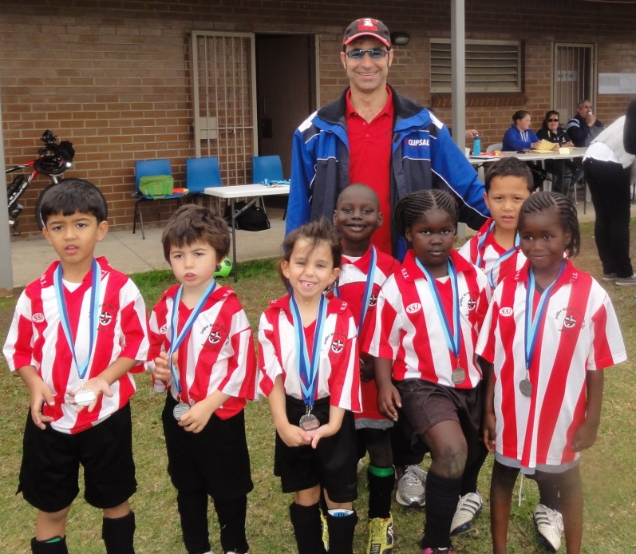
Under 6 White – runners up
U7 Red
Both games were lost, the first, on the number of goal kicks. The team played with enthusiasm and eagerness. They seemed a little lost about the rules of kicking the ball over the back line but it didn't stop them from enjoying themselves.

Round 1 vs OLQP Falcons 1–1 (lost on goal kicks)
Goal scorer – own goal
Round 2 vs Wentworthville Uniting 0-1

U7 White 2013 CHAMPIONS
It was great entertainment, bonus to win it. We've got a little champion team.
Round 1 vs Kings White 8-0
Goal scorers: Ali Fahme 3, Dimo Dimo 2, Sebastian Kerr 1, Dylan Lu 1, Fouad Ayoub 1
Round 2 vs Bye
Round 3 vs Hills Spirit 6-0
Goal scorers: Ali Fahme 3, Dimo Dimo 2, Daniel Kvesic 1
Final vs Wentworthville Uniting 1-0
Goal scorer – Ali Fahme 1
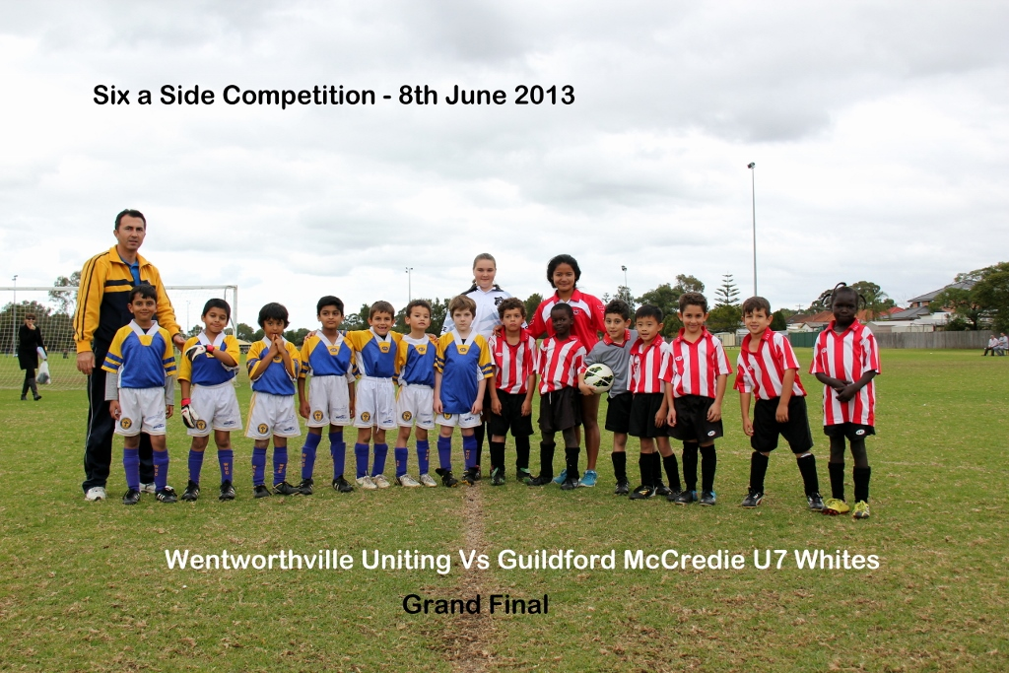

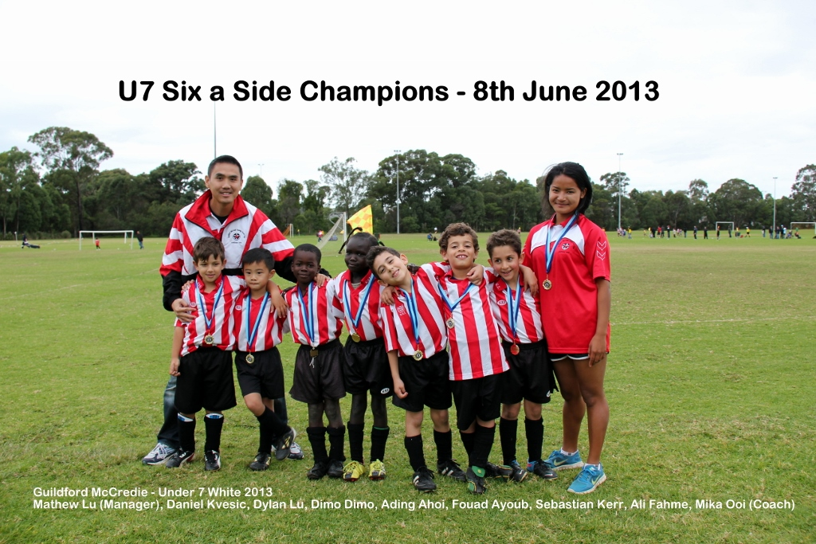

U8 Grey
Round 1 vs Lidcombe Churches 0 - 2
Round 2 vs Guildford McCredie Red 1 – 4
Goal scorer: Baris Ozkartal 1

Under 8 Red RUNNERS UP
Round 1 vs Lidcombe Churches 2 – 0
Goal scorers:
Round 2 vs Guildford McCredie Grey 4 – 1
Goal scorers:
FINAL vs Hills Spirit Blue 1 – 2
Goal scorer:
Every year the six a side knock out brings us a new challenge. Today was for many of our little players a chance to shine. Playing in a small team of six gave each member of the team the responsibility to push his team forward and try to win the game. Under 8 grey played from their heart today. Baris scored his first goal, Woody as keeper was at his best today, Tamer Charbel and Armin along with Austin did not give up and played beautifully. The under 8 reds went on to be runners up on the day. Congratulation to the under 8 players for their play and the beautiful team spirit that they showed on the gala day today. Soccer is a team game and we definitly are a hell of a team!!!!
Keep it up boys.

Under 8 Runners up

U9 Grey
Round 1 vs Hills Spirit Black 0 - 5
Round 2 vs Hills Spirit Blue 0 - 9

U9 Red
Round 1 vs Hills Black 4 - 0
Goal Scorers: Mustapha Fahme 2, Michael Barakat 1, Aaron Batth 1
Round 2 vs Lidcombe Churches 1 - 0
Goal Scorer: Mustapha Fahme 1
Round 3 vs Hills Spirit Blue 1 - 2
Goal Scorer: Aaran Batth 1

U10 Grey
Round 1 vs Prospect United 0 – 4
Round 2 vs Hills White 2 – 5
Goal scorers: Elias Matta 1, Christopher Germanos 1

The U10 grey team, Christopher, Deng, Elias, Joel, Peter & Salvator, put in a great effort & though we ended on the wrong side of the ledger in both games, we played with plenty of spirit, had some fun & scored a couple of goals as well. Each of the players had a turn at either striker, midfield or back. Goalie duties were shared too by Elias, Peter, Christopher & Joel. Our first match was against the eventual competition winners, Prospect U10. This was a tough match. Prospect were just too good, but we didn't stop trying. In the first half the boys were a bit at sea, but eventually found their feet to put in a strong effort. Great tenacity was shown in chasing our opponents down & forcing them towards the corners. Our goalies also put in a great display with Peter's effort in the second half particularly commendable.
The next match was against Hills White. Yet another tough match. After Hills had scored two quick goals, we replied with one by Elias, before Hills got another so we were down 3- 1 at half time. Christopher got another goal after the restart, making it 3 - 2, before Hills managed a couple more goals.

U10 Red Runners Up
Round 1 vs Wentworthville Uniting 3 - 0
Goal scorers: Mounir Hadid 2, Christian Frangie 1
Round 2 vs St Bernadettes Castle Hill 3 - 0
Goal scorers: Christian Frangie 2, John Luke El Rahi 1
Final vs Prospect United 0 - 3

U11 Grey
Round 1 vs Bye
Round 2 vs Guildford McCredie Red 5 – 4
Goal scorers: Charlie Malkoun 1, Yunus Jamil 1, Ahmet Keskinkilic 1, Jude Wall 1
Round 3 vs OLQP Falcons 0 - 3

Under 11 Red CHAMPIONS
Round 1 vs Lidcombe Churches 8 – 0
Goal scorers: Yusuf Jamil 4, Qais Sungkar 2, Nedim Fazlic 2
Round 2 vs Guildford McCredie Grey 4 – 5
Goal scorers: Nedim Fazlic 2, Yusuf Jamil 1, Joey Azzi 1
Round 3 vs Wentworthville Uniting 4 – 4 (won on goal kicks)
Goal scorers: Qais Sungkar 2, Nedim Fazlic 1, Joey Azzi 1
FINAL vs OLQP Falcons 5 – 0
Goal scorers: Qais Sungkar 3, Nedim Fazlic 2
A great day where the boys cheered each other on, prevailed in a tough semi final and defended our championship.
Under 12 Grey
Round 1 v Kings Old Boys 0 – 5
Round 2 v Lidcombe Churches Blue 0 – 7

Under 12 Red RUNNERS UP
Round 1 v Lidcombe Churches Blue 5 – 0
Goal scorers: Deng Deng 2, Luke Fernandes 1, Ahmad Saad Ekdawy 1, Ali Alsaadi 1
Round 2 v Lidcombe Churches Gold 0 - 1
Round 3 v Lidcombe Churches Blue 4 – 1
Goal scorers: Luke Fernandes 2, Deng Deng 2
Final v Lidcombe Churches Gold 0 – 1

U13 Red
Round 1 vs Wentworthville Uniting 4 – 0
Goal scorers – Salem Boustany 2, Rusheel Raj 2
Round 2 vs Bye
Round 3 vs Lidcombe Churches Gold 1 – 3
Goal scorer – Salem Boustany 1

U13 Grey
Round 1 vs Lidcombe Churches Blue 4 – 0
Goal scorer – Matthew Richards 4
Round 2 vs Lidcombe Churches Gold 2 – 3
Goal scorers – Kabin Rana 1, Jacob Mitwali 1
Round 3 vs Lidcombe Churches Blue 6 – 1
Goal scorers – Jacob Mitwali 4, Matthew Richards 2
FINAL vs Lidcombe Churches Gold 1 – 3
Goal scorer – Matthew Richards 1
Not quite the results we were after but the boys all tried really hard, supported each other and did their best.

U15 Red
(Hassan El Hallak, Brandon Hamlin, Cameron Hunt, Joseph Markovic, Peter Youssef, Kane Carder, Emily Pereira)
Round 1 Vs Wentworthville Uniting 1 – 0
Round 2 Vs Lidcombe Churches Blue 4 – 2
Semi-Final Vs Lidcombe Churches Gold 1 – 2
Goal Scorers: Cameron Hunt, Peter Youssef, Kane Carder

U15 Grey
(Vehid Dupovac, Jason Tran, Joshua McGuire, John Youssef, Will Booker, John Kazzi)
Round 1 Vs Bye
Round 2 Vs Wentworthville Uniting 9 – 0
Semi-Final Vs Lidcombe Churches Blue 8 – 0
Final Vs Lidcombe Churches Gold 2 – 2 (Lost on corners)
Goal Scorers: Jason Tran, Joshua McGuire, John Youssef, Will Booker. John Kazzi
A great chance for the team to be reunited with a few old faces and go out and have some fun. We were very unlucky not to have an all McCredie final, and even unluckier to lose out on corners after being up 2 – 0. Well done to all who played, you were all great.

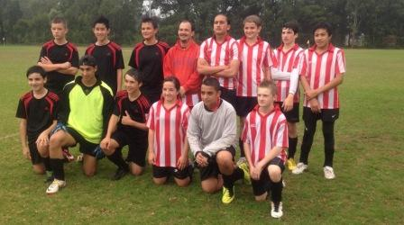
Under 15 Red & Grey (Runners up 2013 six a side)

Ladies Red
Round 1 vs St Barnabas Broadway B 0 - 1
Round 2 vs Merrylands SFC 0 - 4

Ladies White
Round 1 vs St Barnabas Broadway A 1 – 2
Goal scorer – Laura Burden 1
Round 2 vs St Barnabas Broadway C lost
Something a bit different and a bit of fun. Unfortunately we couldn’t get a win but it was nice to play some different girls and everybody enjoyed spending a day with each other.

AAM White
Round 1 vs St Barnabas Broadway A lost
Round 2 B vs Wentworthville Uniting Gold won
Round 3 B vs Lidcombe Churches lost

AAM Blue
Round 1 vs Zim Warriors won
Round 2 A vs Wentworthville Uniting White won
Round 3 A vs Guildford McCredie Uniting Red 0 - 1

AAM Green
(Luke Roumanos, Jason Stephenson, Daniel Lapinskas, Mehmet Biber, An Dao, Jeff Eker)
Round 1 vs Lidcombe Churches 1 – 0
Goal scorer – Anh Dao 1
Round 2 A vs Wentworthville Uniting D 2 - 0
Goal scorers – An Dao 1, Jeff Eker 1
Round 3 A vs St Barnabas Broadway A 0 – 4

AAM Red
(Darren Warren, John Zhou, Kyle Sharwood, Wil Wark, Mohammed Shukar, Adem Stevens, Caner Temel)
Round 1 vs Wentworthville Uniting Blue 3 – 0
Goal scorers – Wil Wark 2, Adem Stevens 1
Round 2 A vs Coptic United A 3 – 3 (won on goal kicks)
Goal scorers – Mohamed Shukur 1, Adem Stevens 1, Wil Wark 1
Round 3 A vs Guildford McCredie Uniting Blue 1 – 0
Goal scorer – Wil Wark 1
A Grade FINAL vs St Barnabas Broadway A 1 - 1 (lost on corners)
Goal scorers – Wil Wark 1

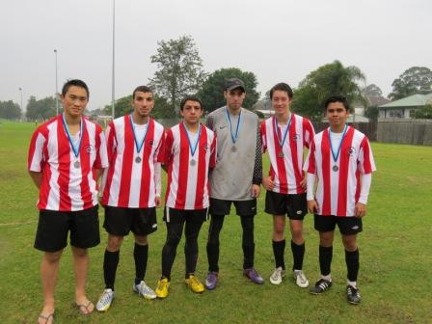

O35s
(Tim Booker, Phil Chan, Peter Sultana, Moises Palacios, Tito Carlos, Hakan Mete, Adam Spears)
Round 1 vs Zim Warriors 9 – 0
Goal scorers – Adam Spears 8, Hakan Mete 1
Round 2 vs Hills Spirit 0 – 3
Round 3 vs NSWCFA Allstars 8 - 0
Goal scorers – Adam Spears 7, Phil Chan 1
FINAL vs Hills Spirit 0 – 4
A very proud band of weekend warriors!

A great effort by all involved. The guys played some great soccer, taking control of their games and dictating play through most matches. All 3 RC Red teams (Red, Green and O35) looked capable of taking the finals, but it just wasn’t to be.


Over 35 runners up – 2013 six a side

Competition Round match results

U 12 vs North Rocks 2 – 0
It’s been a little while since we last got the full 3 points but we had been building towards it and today we were able to take advantage of our chances and get a much deserved win. Ryan and Harry shared the keeping responsibilities today and did really well keeping a clean sheet. Ahmad and Jasper were strong in the center of defence supported well by Nicholas and Peter. Mika was putting his body on the line in midfield and made some important interceptions. Luke, Ali, Ashley and Deng all looked threatening up front. A good result, we now need to build on it over the coming weeks. Goal scorers – Deng Deng 1, Luke Fernandes 1

U13 vs Regents Park 5 – 0
Want a fantastic match. Up against third placed Regents Park, this was a danger game. The boys played their finest game of the year though and trounced the poor Regents Park kids. Regents Park attack well and defend less well. Our defence took up the challenge though with man of the match, Daniel Wark dominating his forward opponents regularly picking their pockets and redistributing the ball back to our halves. Matthew’s striking up front was sublime missing no opportunities and scoring some belters. Keep up this play boys and we will test every side we play. Goal scorers – Matthew Richards 5

U15 vs Winston Hills Bears 1 – 3
Our eleven players out there gave 110% all game. We were up against it with no reserves and an opposition seeming to rotate their players at will - it was so annoying that we couldn't! We started well and even managed to score against tough defence, but were gradually worn down. Of their three goals, one was undefendable, but the other two came from opportunities that we couldn't cut off in time. Our goal came early and even seemed to surprise Hassan. There was great attacking work up front and an excellent finish. As the game wore on we tired and started losing ground to our fresher opponents. Despite our players not having anything left, they kept going until the end and we were so unlucky not to get some goals back later in the second half. The score doesn't reflect how well the team played - as a team, and with fantastic commitment to each other. Goal scorer: Hassan El Hallak 1

Ladies vs Lidcombe Waratah 1 – 4
The good news? We won the second half 1 – 0 with a concerted display of getting to the ball first, determined running and tackling and a solid defensive effort. Elise was player of the match with an awesome match of tackling and passing. Mo and Ania also played well today. You don’t want the bad news – it’s awful.
Goal scorer – Sarah Rebenko 1

Tuesday 11th June 2013

State Cup RC Red vs Chester Hill Sports at Jones (Banks St., Merrylands)
7.00pm Kickoff (meet at Jones at 6.30pm) (set up field)

Wednesday 12th June 2013

State Cup RC White Firsts vs Coptic United at Jones (Banks St., Merrylands)
8.00pm Kickoff (meet at Jones at 7.30pm) (dismantle field)

Saturday 15th June 2013

U6 Red vs Hills Spirit Red at Everley (mini) (Everley Rd., South Granville)
10.00am Kickoff (meet at Everley at 9.30am) (dismantle field)

U6 White vs St Bernadettes Castle Hill Lions at Eric Mobbs 1 (Excelsior Ave., Castle Hill)
10.00am Kickoff (meet at Eric Mobbs at 9.30am)

U7 Red vs St Columbas Castle Hill at Everley (mini) (Everley Rd., South Granville)
9.00am Kickoff (meet at Everley at 8.30am) (set up field)

U7 White vs Hills Spirit Black at Kellyville 3 (Memorial Ave., Kellyville)
9.00am Kickoff (meet at Kellyville at 8.30am)

U8 vs Hills Spirit Red at Everley 2 (Everley Rd., South Granville)
9.00am Kickoff (meet at Everley at 8.30am) (set up field)

U9 vs Hills Spirit White at Everley 2 (Everley Rd., South Granville)
10.00am Kickoff (meet at Everley at 9.30am) (dismantle field)

U10 vs Hills Spirit White at Kellyville 1 (Memorial Ave., Kellyville)
12.00pm Kickoff (meet at Kellyville at 11.30am)

U11 vs St Columbas Castle Hill at Eric Mobbs 2 (Excelsior Ave., Castle Hill)
11.00am Kickoff (meet at Eric Mobbs at 10.30am)

U12 vs Castle Hill United at Fred Caterson 3 (Caterson Dve, Castle Hill)
10.45am Kickoff (meet at Catterson at 10.15am)

U13 vs Rouse Hill Rams at Commercial Road 1 (Commercial Rd., Kellyville)
11.30am Kickoff (meet at Commercial at 11.00am)

U15 vs Ermington United at George Kendall 2 (Trumble St., Ermington)
11.30am Kickoff (meet at Kendall at 11.00am)

Raahauge Cup Red vs St Matthews Baulkham Hills at Everley 1 (Everley Rd., South Granville)
(Reserves Kick off at 1.15 pm Firsts at 3.15pm) (meet at Everley at 12.45pm) (set up & dismantle field)

Raahauge Cup White vs Castle Hill Baptist at Eric Mobbs 1 (Excelsior Ave., Castle Hill)
(Reserves Kick off at 1.15 pm Firsts at 3.15pm) (meet at Everley at 12.45pm)

Sunday 16th June 2013

Ladies vs Holroyd Rangers at Max Ruddock 2 (Romulus St., Winston Hills)
1.00pm Kickoff (meet at Max Ruddock at 12.15pm for TEAM PHOTO)

Wednesday 19th June 2013

Ladies catch up match vs Winston Hills Black at Phillips 2 (Martin Street, Lidcombe)
7.00pm Kickoff (meet at Phillips at 6.30pm) (set up & dismantle field)

