OTB 21/13 Club Secretary – Greg 9682 7779 President – Peter 9632 9203

A Proud day for McCredie!

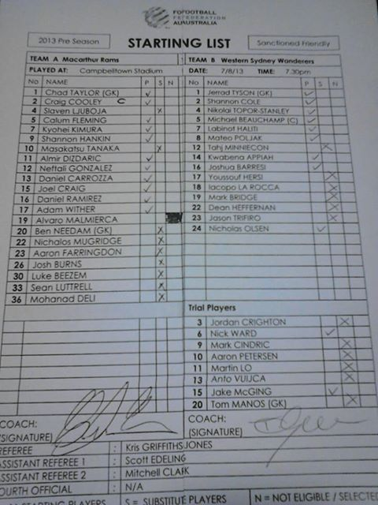

This is a picture of the team sheet for the Western Sydney Wanderers in their trial last week against Macarthur Rams.

So what? I hear you say.

Well look carefully, not only is Shannon Cole (who we know played Churches soccer for Yaralla as a kid and has played for Australia) on the team, but look further down the list.

Mark Cindric started his soccer career with, you guessed it GUILDFORD MCCREDIE, and Martin Lo not only started his career with GUILDFORD MCCREDIE, he was playing All Age for our team last season (at the age of 14)! What? you missed watching him at Everley last year? Now you will have to pay to see him!

His brother Tony, also a McCredie boy and also with us last year – ran out this time last year with Sydney FC.

RESULTS – 10th & 11th August 2013
U6 Red vs Hills Spirit Red 4 - 0
By far one of the best games of our season. The team work from all players was outstanding. Ahoi, Jack and Charbel were all so close to scoring during the first five minutes, missing "by that much" until Ahoi converted a chance for our first goal. Fayez was fantastic in goals in the first half and was all over the ball, giving the opposition no chance to score from any loose balls. Ahoi scored again shortly before half time with Wek as his wingman to make it 2-0 at the break. Millen was player of the match for the second week in a row due to some wonderful kicking and really chasing the ball. Charbel was brilliant the whole game, really getting into the fray. Then came Gerri who came out of the second half break like he'd eaten a whole box of weetbix washed down with some red cordial! He and Jack made a brilliant team, taking the ball to the goal and always looking for the cross to the centre. Gerri converted the opportunities twice to make it 4-0. I think all the parents and the coach were ready to do cartwheels after the match - not just because we came away with a win - but because we really played as a team today. Well done to everyone.
Goal scorers: Ahoi Ahoi 2, Gerardo Cavasinni 2

U6 White vs St Bernadettes Castle Hill 7 - 1
Goal scorers: Adeng Yelchan 4, Kilarney Lavender 3

U7 Red vs St Columbas Castle Hill 1 - 3
The boys had a good game today. Despite being short if players, they still managed to put up a fight. Joey had 5 attempted goals that just didn't make it in the goals. Mark-Antony and Joshua shared the goalies position today. Sayed had lots of tumbles but still managed to get back up. Anthony showed us today what he is made of!! Keep up the good work boys it was a good game! Man of match Sayed Dahdah
Goal scorer: Joey Farah 1

U7 White vs Hills Spirit Black 7 - 4
First Half: It started off as a pretty tight game with each side scoring alternate goals and our opponents getting first points. Not shortly after their 1st goal Dylan managed to capitalise on a corner kick set up by Ali to level the scoreline. The Hills Spirit recaptured the lead from a big kick from their big boy, kicking a big one right over Fouad our goalie's head. Our boys and girls knew we needed to dig deep if we were to maintain our unbeaten record for the whole season...and dig deep they did, where Achel levelled the score 2 all by being at the right place at the right time and then Ali seeing us take the lead for the first time, heading into half time 3-2.
Second half: After being powered up with fresh oranges, our kids were unforgiving in the second half. Maybe it was their way of reminding their opponents that this was their house and you don't mess with the mighty McCredie's in their house. Fouad the punisher, came out of goals and punished them with 2 punishing goals and was punishing with his punishing defensive tackles. Ali-tastic was simply fantastic with two more goal-tastic goals. Mc-Adam and Ading-ding, played great supporting roles along with our effervescent Sir-Bazzy in a well orchestrated final 20 mins. Despite the Hills getting 2 cheap goals by harrasing our sweet Achel in a rare appearance at goals, our little champions remain undefeated and were happy little vegimite's in the end. We fist pumped our "TEAMWORK" motto twice and the job was done. See you next week.
Goals: Ali Fahme3, Fouad Ayoub 2, Dylan Lu 1, Achel Majok 1

U8 vs 1 – 2
No report Goal scorer – Matthew Youssef 1

U9 vs Hills Spirit Blue 0 - 2
Unfortunately we lost today.

U10 vs Wentworthville Uniting 1 - 0
Wenty had the better of field position in the first half, but our defence held them at bay. When we did get in their half, Wenty's swarming defence thawed our plays. So it was locked at 0-0 at half-time.
In the second half a lot of the field was covered in both defence & attack. Christian's goal after a good break from halfway put us in front. Wenty kept up their attack only to be denied again by some good defence. Yilmaz had a solid game in both defence & attack. A hard fought win by the boys. Man of the Match: Yilmaz Temel
Goal scorers: Christian Frangie 1

U11 vs Lidcombe Churches 6 – 0
Today we were back at Everley where we took on OLQP reds where our boys took the honors 7 - 0 Great defence at the back by Joshua and Andrew Ibraheem was rewarded by great goals by Nadim (3), Yusuf (2) and Qais. Good to see the boys getting back on track.
Goal scorers: Nedim Fazlic 3, Yusuf Jamil 2, Qais Sungkar 1

U12 vs Kellyville Kolts White 3 - 3
Our last game of the season today and we were playing against a team who were pushing for a top four position. Our players really played well and if we had have showed this kind of determination and teamwork throughout the year we would have finished a lot higher on the table. Deng, Jasper, Nicholas, Peter and Mika all worked really hard at the back to limit Kellyville’s chances. Ashley, Ali, Ahmad, Ferdinando and Sarah all played really well in the mid-field to set Luke up with breaks and goal chances which he was able to finish off on a couple opportunities.
Goal scorers: Luke Fernandes 2, Ferdinando Cavasinni 1

U13 vs Rouse Hill Rams 2 - 3
Defensively not good enough and wasteful up front. The midfield was strong, the goals we scored were good and we hit the post with 5 seconds remaining – so we played poorly and still nearly kept second place. But we didn’t keep it, drop to 4th and now need to win the last 3 games of the year starting with our semi next week against Regents Park. We can definitely do it.
Goal scorers: Jacob Mitwali 1, Salem Boustany 1

U15 vs Pendle Hill Tigers 2 - 3
Memo to self: in the off season either (1) invent a new style of match ball that favours our shots on goal (perhaps magnetising the net and ball when we are in attack), or (2) take up golf (scratch that....it's too frustrating!). The last game of the season wasn't a great result, but it was a great effort and deserved at least a draw. We started slowly and they got the jump on us with three quick goals. We managed to get one back before the half time break through some strong work up front in attack. We were the better team in the second half, but just couldn't find the back of the net. Finally, our hard work was rewarded and the second goal came with a flourish. Unfortunately we couldn't create a third or fourth. It was a great game nonetheless, and everyone showed their courage and hard work to try and make the ending a fairytale for our long-suffering coach. Thank you to Darren for all your efforts this year, and to all of the players: Emir, Will, Kane, Vehid, Hamze, Hassan, John K, Josip, Joshua, Surammay, Emily, Adam, James, Jason and John Y. We didn't get as far as we would have liked, but you all played well and showed that you were capable of matching it with any of the other teams, even those who were much taller and faster. Thank you all for a great, entertaining season and see you at presentation night!
Goal scorer: John Kazzi 2, Kane Carder (Yahoo! We all knew it was coming!)

Ladies vs Holroyd Rangers 0 – 6
There are plenty of legitimate excuses but I will concentrate on a phenomenal effort today from Sarah Huynh who was outstanding! Never stopped trying in a difficult match and then as a reward for her effort, got thrown into an unfamiliar role by her coach, where she continued to toil tirelessly and shine! She was enthusiastically supported by Ania and Laura and Sarah R and Elise played bravely although both were badly hampered by injury. Great to have a support crew today of girls on crutches!

RC1 Red Reserves vs Castle Hill Baptist 0 - 6

RC1 Red Firsts vs Castle Hill Baptist 2 - 3
Goal Scorers: Antony Vojvoda 2

RC1 White Reserves vs Greystanes Churches 0 - 4

RC1 White Firsts vs Lidcombe Churches

MARCONI STADIUM for NSWCFA Grand Final Day!

MARCONI STADIUM has been selected to host all the junior President’s Cup and senior Grand Final games on Saturday 31 August 2013.
This will be a tremendous occasion for our association. Imagine the thrill of playing the most important game of the season in front of grandstands built for 12,000 fans!
There will be eight first-grade games on the main stadium field starting at 8:30am and finishing under lights at night. Two other fields in the complex will be used for other games and team warm-ups.
All players, parents and friends are encouraged to make a day of this. Club Marconi has first-rate facilities for players and spectators, as well as an excellent bistro and restaurant and the usual club attractions. There is ample free all-day parking available.
Marconi Stadium is located at 121–133 Prairie Vale Rd, Bossley Park.
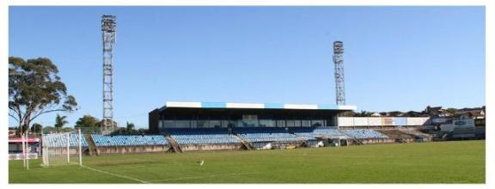
Saturday 17th August 2013

U6 Red vs Hills Spirit Blue at Everley mini (Everley Rd., South Granville)
9.00am Kickoff (meet at Everley at 8.30am) (set up & dismantle field)

U6 White vs Hills Spirit White at Kellyville (Memorial Ave., Kellyville)
10.00am Kickoff (meet at Kellyville at 9.30am)

U7 Red vs Bye

U7 White vs St Bernadettes Castle Hill Tigers at Eric Mobbs 1 (Excelsior Ave., Castle Hill)
10.00am Kick off (meet at Eric Mobbs at 9.30am)

U8 vs OLQP Falcons White at Daniel (Daniel St., Greystanes)
9.00am Kickoff (meet at Daniel at 8.30am)

U9 vs Wentworthville Uniting Blue at Freame (Rees St., Mays Hill)
10.00am Kickoff (meet at Freame at 9.30am)

U10 vs Hills Spirit Blue at Kellyville (Memorial Ave., Kellyville)
11.00am Kickoff (meet at Kellyville at 10.30am)

U11 vs OLQP Falcons at Everley 3 (Everley Rd., South Granville)
4.00pm Kickoff (meet at Everley at 3.30pm) (dismantle field)

U12 finished for 2013

U13 SEMI FINAL vs Regents Park at Webbs Ave 2 (Webbs Avenue, Auburn) 8.30am kick off (meet at Webbs Ave at 8.00am)

U15 finished for 2013

Raahauge Cup Red Reserves semi final

vs Castle Hill Baptist at Eric Mobbs 2 (Excelsior Ave., Castle Hill)
1.00pm Kick off (meet at Eric Mobbs at 12.30pm)

RC Red Firsts finished for 2013

RC White Firsts and Reserves finished for 2013

Sunday 18th August 2013

Ladies vs Ermington United at Guildford Park 2 (Marian St., Guildford)
1.00pm Kickoff (meet at Guildford at 12.30pm)

