OTB 24/13 Club Secretary – Greg 9682 7779 President – Peter 9632 9203

The final newsletter for 2013.

Thanks everyone for a fantastic season. Thanks to the coaches and managers, players and parents. The season finished with a great day at Marconi Stadium yesterday for the President’s Cup and Raahauge Cup Grand finals. Unfortunately our 10s and 11s finished second (the 11s losing on count back on corners – so close!), but in McCredie’s final game of the year, our RC1 Reserves won 2-1 over Castle Hill in a close contest. A great result.

For those that then hung around for the RC1 final and the Premier League Grand finals they were treated to two of the most exciting games they could have watched.

In the RC 1 final Lidcombe were 3-0 up over Zimwarriors after 15 minutes (something our boys may remember doing to them last year). Lidcombe got to 4-1 up before Zim stormed home to even it up at 4-4 by full time. At the end of extra time it was still 4 all, so it was off to penalties. The grand stand in the main stadium was going off! Zim prevailed and claimed their club’s first Raahauge Cup, coming back successfully from 1 – 4 down, a tremendous effort.

In Premier League, Greystanes (runners up in 2012) and Wentworthville (surprise finalists) took to the field – neither club having won the Premier League trophy in the Association’s 93 years. It was a very even game until after half time when Greystanes started to take control. Greystanes grabbed the lead through their NSW City representative striker and the crowd started to think Wenty’s fairytale could be over. Wenty had other ideas when from nowhere, their own representative midfielder took a searing run down the left, beat two and finished a beautiful goal. Again the crowd went nuts in a packed grand stand. Again we had extra time. Wenty’s fairytale wasn’t over yet and it is Greystanes who still don’t have a PL trophy, as Wenty’s buildup down the left and a nice cross found their exciting right midfielder for a clinical finish. The crowd went off again – fortunately covering Keith’s attempt at announcing the goal scorer’s name!

A great finish to a terrific season for the Association.

See you all at the Presentation in November.

RESULTS – 27th, 28th, 31st August 2013

U8 semi vs Hills Spirit Blue 0 - 2

U9 semi vs Hills Spirit Blue 0 - 2
Unfortunately the season has come to an end for us, it was good to have made it this far, our team have come a long way. Hills Spirit played a tough opposition, we tried, our team kept pushing but unfortunately we could not defeat this team. Mase played really well today as he always does, Mustapha tried scoring with no luck.
Even though we lost the kids gave it their best and had fun, it was nice to see improvement from Max and Atem.
Congrats on making it to the semi's hopefully next year we'll go through to the finals!

U10 semi vs Wentworthville Uniting 2 – 0
Goal scorers – Mounir Hadid 1, Christian Frangie 1

U10 Grand final vs Hills Spirit White 1 – 3
The boys, Shaleen goalie, fullbacks Ryan, Peter, William, Joel & Salvator, halves Elias, John-Luke, Christopher & Deng with forwards Mounir & Christian, played their heart out but it was Hills day today. Great team effort, all playing together as a unit with a single purpose. Hills scored first but we didn't give up until the final whistle. Christian's goal was well deserved after a combination of pressure & skill. Special thanks to Aaran Batth & Mustapha Fahme who helped out off the bench & our wounded warrior Yilmaz again for his enthusiasm & team spirit.
Goal scorer - Christian Frangie 1

U11 semi vs Wentworthville Uniting 3 - 0

U11 Grand final vs Kings Old Boys 0 – 0 (lost on corners 1 – 2)
Well grand final day didn't work out the way we wished after a great season where we went down by the slimmest of margins losing on corner kicks. I'd like to thank the under 11 team for a great season and to the parents who all chipped in with jersey washing, supplying oranges at half time and supplying me with pens! Also to Sam who has done so much for the boys in coaching them along the season. Well done again lads and I hope you all have a great summer and come back again in 2014 to have another crack at the title.

RC Red Reserves Grand final vs Castle Hill Baptist 2 – 1
Goal scorers – Wil Wark 1, Adem Stevens 1
.

All the finals results can be found on our website by clicking on the ‘records’ page.

http://mccredie.nfshost.com/soccer/historical/index.html

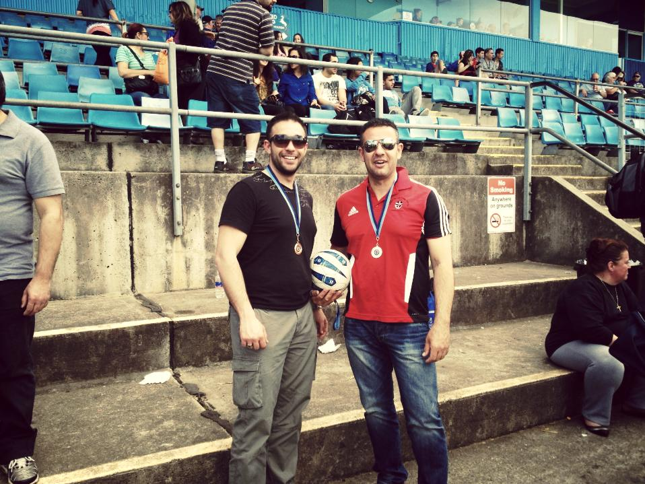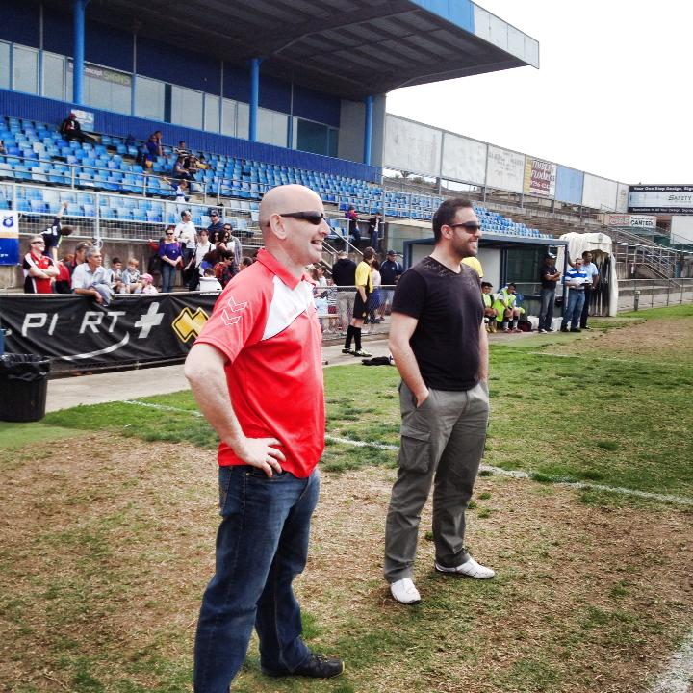

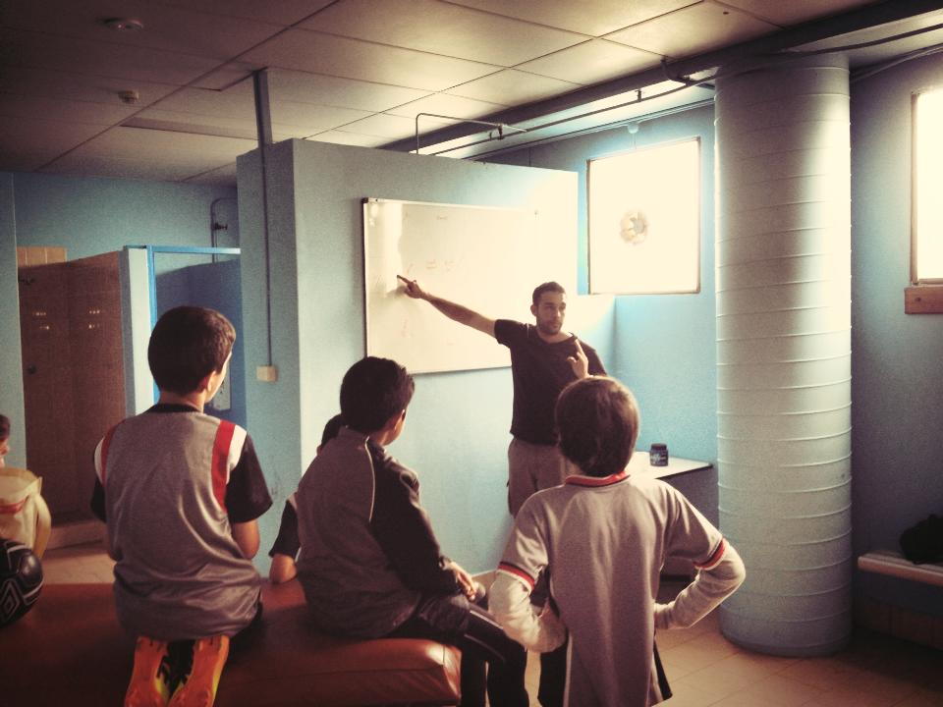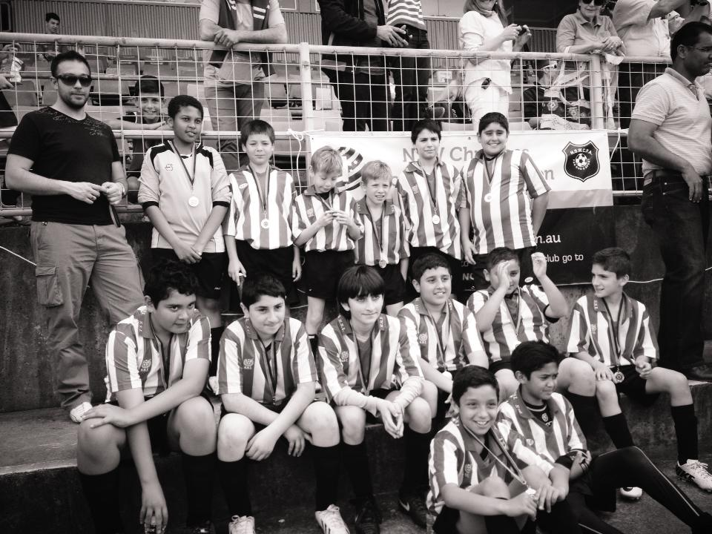

Pre game maths lesson

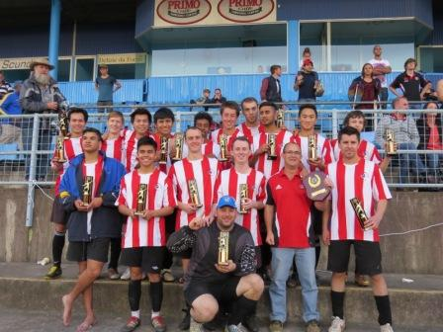

GUILDFORD McCREDIE UNITING
SOCCER CLUB

ANNUAL PRESENTATION DAY

Friday 1st November 2013

Commencing at 6.30pm
at
McCredie Memorial Uniting Church Hall
486 Guildford Rd., Guildford
Cnr Guildford & Chetwynd Rds., Guildford

Presentation of trophies

Sausage sizzle

Raffle
_____________________________________________________
Notice of Annual General Meeting – Thursday 7th November
7.30pm McCredie Uniting Church

