OTB 6/13

Club Secretary – Greg 9682 7779 President – Peter 9632 9203

Interested in sponsoring a team or advertising in this newsletter? – call one of the above numbers.
_____________________________________________________________________________________________________
Goal keeper training
From this Wednesday there will be goal keeper training from 5pm until 5.30pm at Granville Park.

Dates for this year’s CLUB PHOTOS

4th May @ Everley

6 White
7 White
10
11

Ladies photos TBA

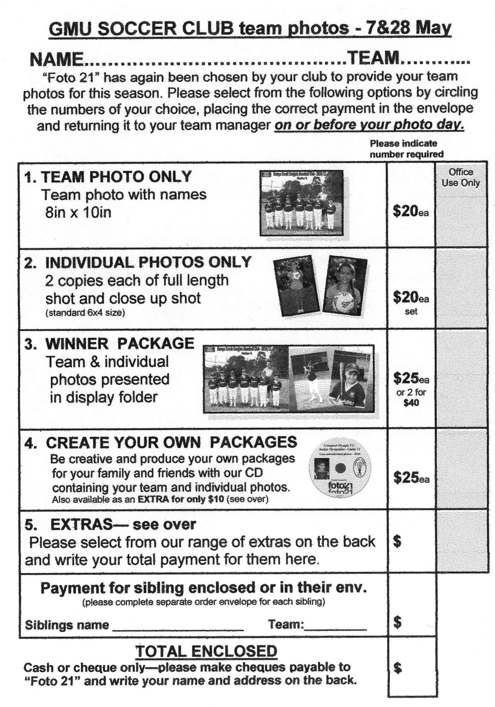

25th May @ Everley
6 Red
7 Red
8
9
12
13
15
RC Red
RC White

May 4th & 25th

For club photos ALL players need to be at the ground 1 hour before kick off to allow the photos to be taken on time.
No T shirts under jerseys, no stripes on socks or shorts, all players to be present whether or not they are purchasing photos.
If photos are being purchased money needs to be with your manager BEFORE the photo is taken.
______________________________________________________________________________________________
LAPATHON – the annual club lapathon, our major fundraiser for the year will be held on Wednesday May 22nd. Details next newsletter.

RESULTS – 27th and 28th April 2013

U6 Red vs Hills Spirit Blue 2 – 1
With only 3 players one minute before kick off, it looked like we would have to forfeit. However our 4th arrived just in time and we were able to play. Two players down coach and parents prepared for the worst, but the reds showed incredible stamina and determination. Jack, Charbel, Gerri & Fayez kept the opposition at bay and only let one in. Ahoi arrived on the scene and scored our first goal. One all at The half time break and our little guys were exhausted. Team work saw Jack score the only second half goal. The reds came away with an inspiring 2-1 win despite the odds being against them. Well done Jack, Ahoi, Charbel, Gerri and Fayez.
Goal scorers – Ahoi Ahoi 1, John Whale 1

U6 White vs Hills Spirit White 2 - 2
A great result achieved by our little team of warriors with only six players during the whole macth. A outstanding performance by Adeng, Diego, Hendrix, Kilarney, Sarah and Yar. They manage to draw the match 5 min before the it ended.
Goal Score Kilarney Lavender 2

U7 Red vs Bye

U7 White vs St Bernadettes Castle Hill Eagles 3 – 1
On this beautiful Saturday morning compared to the cold and wet one last week, the team travelled to Castle Hill to play on possibly the largest mini field in the competition. We started with just six players, against a full strength Tigers outfit. There was a lot of running on this field with our boys and 1 girl, holding the opposition in their half for most of the time. Daniel and Dylan starred in the first half by giving the team great support. Ading shows each week she isn't afraid of getting into the thick of the action with the boys and takes every opportunity to put in some good kicks up field. Dylan was able to get some space in the latter part of the first half to give the team a 1-0 lead into half-time. The Calvary (ok just Fouad) arrived in time for the start of the second half, helping relieve Adam after a good effort playing non-stop for the first 20. Ading went into goals and the Tigers took advantage early, levelling the game 1-1. Things started looking like it was getting tight and luckily we had some fresh legs from Fouad to help keep the team moving forward. Sebastian came out of goals and made some good solo runs, but still needs to learn to pass. Daniel continued his great game from the first half helping do all the little things that often gets overlooked. These are the little things that then gives opportunities to players like Ali to capitalise with 2 late goals to claim a good hard fought win. It was a great way to finish a wonderful autumn morning with Daniel Kvesic taking out the teams Player of the Week Medal.
Goal Scorers: Ali Fahme 2, Dylan Lu 1

U8 vs St Columbas Castle Hill 2 – 1
No report
Goal scorers – Mohamed Matar 1, Mustafa Elbrizi

U9 vs Hills Spirit Red 9 - 0
What a great game the U9's played today, within the first few minutes of the game Mustapha nearly scored our first goal, but soon after his first attempt Aaran scored and what a goal it was! Not long after our first goal Michael came through with our second and that too was a beautiful goal. Our boys were playing as a team today, finally!!! It paid off as they just kept bringing those goals through... Mustapha had so many attempted goals then finally by second half he came through as John passed him the ball and he scored! Soon after that he put in another. Ajuet played the best I've ever seen him play, Kiir was unbelievable in goal's he stopped 3 goals that I thought no one could stop, so he received the award this week as it was well deserved! Gregory lined the ball up which gave Mase the chance to score and he did, soon after, Gregory scored his first goal for the club, 2 minutes later he scored his second, keep it up! We were all so proud of the team today, they played the best they've ever played, thanks to our coach George!
Goal Scorers- Mustapha Fahme 2, Gregory Farah 2, Aaran Batth 2, Michael Barakat 2, Mase Swalah McDahrou 1,

U10 vs St Bernadettes Castle Hill Eagles 2 – 1
What a contrast to last week. Instead of cold & wet it was hot & sunny.
This was a tough match against a strong opponent. In the first half, whilst we had the majority of field position in their half, it was proving difficult to score. Finally a St Bernadette's error gave us a free kick in front of goal. Christian stuck the ball well only to have the keeper push it away, it was then that Mounir swooped in from right of goal to strike the ball past the keeper for our first goal. More shots on goal from Shaleen, John-Luke & Joel as well as Christian & Mounir went tantalisingly close to scoring but no more goals. As half time was approaching & seemingly against the run of play St Bernadette's scored an equaliser. In the second half the game was a bit more even in terms of field position. However the passing game was much improved over the first half. Deng after a good goal kick from Elias, passed the ball to Christian on the left hand side of goal. St Bernadette’s keeper came out to try & shut down play, only to see the ball sail over his head & into the back of the net from Christian's shot. Peter & Christopher tried hard in the midfield supporting our strikers. Yilmaz, when not defending, made a couple of nice breaks down field. Joel also was tenacious in defence. The backs Ryan, Viththegan & William again defended well & shut down most opposition raids. Ryan's kicks often re leaving defensive pressure. Elias played goalie for us today often turning around the opposition with his goal kicks. A good defensive effort generally. A good win. Man of the Match Elias Matta.
Goal scorers: Christian Frangie 1, Mounir Hadid 1

U11 vs Hills Spirit White 6 - 1
Well it was great to get back on the paddock this week after the disappointing wash out last week and the boys didn't let us down with a 6 - 1 win over a spirited hills outfit ( pardon the pun !! ) We started well with great defence by Ahmed, Joshua, Charles and Andrew I and Angus rewarded it with a cracking goal in the first 10 min. After that the floodgates opened with goals from Yusuf, Joshua and a hat trick to Nedim sealing the victory. It was another fine performance by this well drilled team. Special thanks to Gloria for supplying the oranges
Goal scorers – Nedim Fazlic 3, Yusuf Jamil 1, Joshua Elkerr 1, Angus Wall 1
U12 vs Guildford County 0 - 7
We had a couple of key positional players missing today through sickness but we were still good enough to get a better result than the final scoreline. Unfortunately some players tried to do it all themselves without passing and kept being caught out of position when they lost the ball, when we work as a team we will get a much better result against an opposition like we played today. Harrison made some really good saves in the second half in goals. Ashley, Peter, Nicholas and Mika never gave up and saved a couple of chances that would have seen the scoreline be even greater. We need to remember how to play like a team before next week and everyone get involved not sit back and wait for someone else to make it happen.

U13 vs Rouse Hill Rams 2 – 2
At times it seemed we weren’t playing very well but I think that was more that our opposition today were pretty strong and in the end a 2-2 draw is probably a pretty good result. In the first half Jesse was tested in goals and made a couple of important 1 on 1 saves. Joel was also kept busy at sweeper. As the game progressed though we were required to do less defending and maintained some good attacks. Our hitting back from Rouse Hill’s second goal was a very pleasing example of our team’s willingness to fight back and our refusal to give up.
Goal scorers – Matthew Richards 1, Salem Boustany 1

U13 washout replay vs Regents Park 4 - 4
6 goals in two days, and only 2 points to show for it, is a bit disappointing. Clearly when you score 4 and don’t win there are significant defensive problems. We struggled early against their quick skilful forwards and only when Jesse was put on their key striker did the flood gates close somewhat. A bit too much standing around hoping someone else deals with the problem today. Up front and in the midfield things were better – we did score 4 times after all. Matthew finished nicely but Jacob’s goal was an absolute belter. Need to start scoring more goals than our opponents boys.
Goal scorers – Matthew Richards 3, Jacob Mitwali 1.

U15 vs Baulkham Hills Sports 7 – 2
Well, we won. We shouldn't have, but we did. With only 8 players they were first to the ball, they had unmarked players, they had space. We......stopped.....watched.....and played with the ball. 2 nil down at half time against 8 players was embarrassing. In the 2nd half we used our possession a little bit better and scored some goals. It was a day where most players seemed content to watch the ball, and then take a moment or two to reflect if the ball might come to them. If you want to win a game, you need to be involved! A positive which I want everyone to focus on was our passing. Now if we can move to the ball first, get some quick passes moving forward, and a strong finish...wow. Hassan, Joshua, Surammay and Willem played strongly, but Player of the Match was John Kazzi for some great finishes to team build-ups as well as some superb individual efforts, a great striker's game. (Training is now Tuesday 6.00-7.00pm and Wednesday 5.30-7.00pm)
Goal Scorer: John Kazzi 7

Ladies vs Holroyd Rangers 2 – 3
Severely undermanned with regular centre half, striker and left back missing, no subs and 3 sick ladies playing this was a tough ask. The fact that we got so close is very encouraging. In fact we could easily have won but for some problems with finishing. Ania was amazing today, as was Sarah Rebenko. Sarah was unstoppable as she weaved in and out of the opposition in the second half. Next week the cavalry will be arriving in the form of returning players from holidays – and we should get back to our winning ways.
Goal scorer – Sarah Rebenko 2

RC1 White Reserves vs Greystanes Churches 2 – 2
I felt we were in control for most of the game but fell apart at the end and conceded two. We need to work on our structure at training. We're playing better each week at least.
Goal scorers – Jack Knight 1, Christopher Nakat 1

RC1 White Firsts vs Lidcombe Churches 0 – 5
Despite playing against quality opposition, I feel we let ourselves down. The only way to rectify this is by showing up at training and actually putting in the effort needed. Special mention to Matt in goals for keeping the score down with a handful of saves.

RC1 Red Reserves vs Castle Hill Baptist 2- 2
Points lost unfortunately. We were the better team but we just did not convert our chances. We can use the heat, the disjointed team due to people being away & timetable clashes but we know they are only excuses for 2 points lost today. We sat back, were lose with our passing and did not compete for the 50/50 balls. We played the game knowing we were the better team but expecting someone else to win it for us. Congratulations to Mic for his first competition goal ☺
Goal Scorers: – Jeff Eker 1, Michael Di Marti 1

RC1 Red Firsts vs Castle Hill Baptist 3 - 2
With a number of first graders unavailable we didn’t need any other distractions but as with reserve grade late attendance and lack of preparation meant we didn’t start the match well. Losing some players within the first 15 minutes meant we spent most of the first half reshuffling. It took us a while to find any sort of rhythm even if it wasn’t ours. The match was more of an endurance fight than a soccer match. Solid tackles, very quick counters, hot day with both teams doubling up and a ref who preferred to play the advantage really didn’t suit us but at least we kept our heads. We came out in the second half with a better idea of the conditions and got an early goal to put us back in the lead. We then allowed them back into it but only for a short while before we sealed the result. Nick was great as sweeper and Eloy made some fantastic tackles in the second with Virinder getting his touch back in front of goals. Well done everyone as it was a match won by heart more than anything else.
Goal Scorers: – Virinder Chaggar 2, Caner Temel 1
Saturday 4th May 2013

U6 Red vs OLQP Falcons Blue at Daniel 2 (Daniel St., Greystanes)
10.00am Kickoff (meet at Daniel at 9.30am)

U6 White vs OLQP Falcons Green at Everley (mini) (Everley Rd., South Granville)
10.00am Kickoff (meet at Everley at 9.15am FOR PHOTO)(dismantle field)

U7 Red vs Hills Spirit Red at Kellyville 3B (Memorial Ave., Kellyville)
8.00am Kickoff (meet at Kellyville at 7.30am)

U7 White vs Wentworthville Uniting at Everley (mini) (Everley Rd., South Granville)
9.00am Kickoff (meet at Everley at 8.15am FOR PHOTO) (set up field)

U8 vs Hills Spirit Green at Kellyville 3 (Memorial Ave., Kellyville)
10.00am Kickoff (meet at Kellyville at 9.30am)

U9 vs Hills Spirit Black at Eric Mobbs 2 (Excelsior Ave., Castle Hill)
10.00am Kickoff (meet at Eric Mobbs at 9.30am)

U10 vs Hills Spirit White at Everley 1 (Everley Rd., South Granville)
10.00am Kickoff (meet at Everley at 9.00am for PHOTO) (set up field)

U11 vs Kings Old Boys at Everley 1 (Everley Rd., South Granville)
12.00pm Kickoff (meet at Everley at 11.00am for PHOTO)

U12 vs Winston Hills Bears at McCoy Park (McCoy st., Toongabbie)
8.30am Kickoff (meet at McCoy at 8.00am)

U13 vs Castle Hill United White at Fred Catterson 4 (Catterson Dve., Castle Hill)
11.30am Kickoff (meet at Catterson at 11.00am)

U15 vs Granville Kewpies at Colquhoun (Lackey St., Granville)
8.30am Kickoff (meet at Colquhoun at 8.00am)

Raahauge Cup Red

Reserves vs Greystanes Churches

Firsts vs Lidcombe Churches at Everley 1 (Everley Rd., South Granville)
(Reserves Kick off at 1.15 pm Firsts at 3.15pm) (meet at Everley at 12.45pm) (dismantle field)

Raahauge Cup White

Reserves vs Macarthur Wasps

Firsts vs Zimwarriors at Everley 2 (Everley Rd., South Granville)
(Reserves Kick off at 1.15 pm Firsts at 3.15pm) (meet at Everley at 12.45pm) (set up & dismantle field)

Sunday 28th April 2013

Ladies vs Winston Hills White at Rydalmere 1 (South St., Rydalmere)
11.10 am Kickoff (meet at Rydalmere at 10.30am)

