OTB 9/13

Club Secretary – Greg 9682 7779 President – Peter 9632 9203

Interested in sponsoring a team or advertising in this newsletter? – call one of the above numbers.
_____________________________________________________________________________________________________
Goal keeper training continues this week
Goal keeper training from 5pm until 5.30pm at Granville Park.
_______________________________________________________________________________________________________
Coaches and Managers Meeting – Monday May 20th 7.30pm 486 Guildford Rd., Guildford
All coaches and Managers are requested to attend.

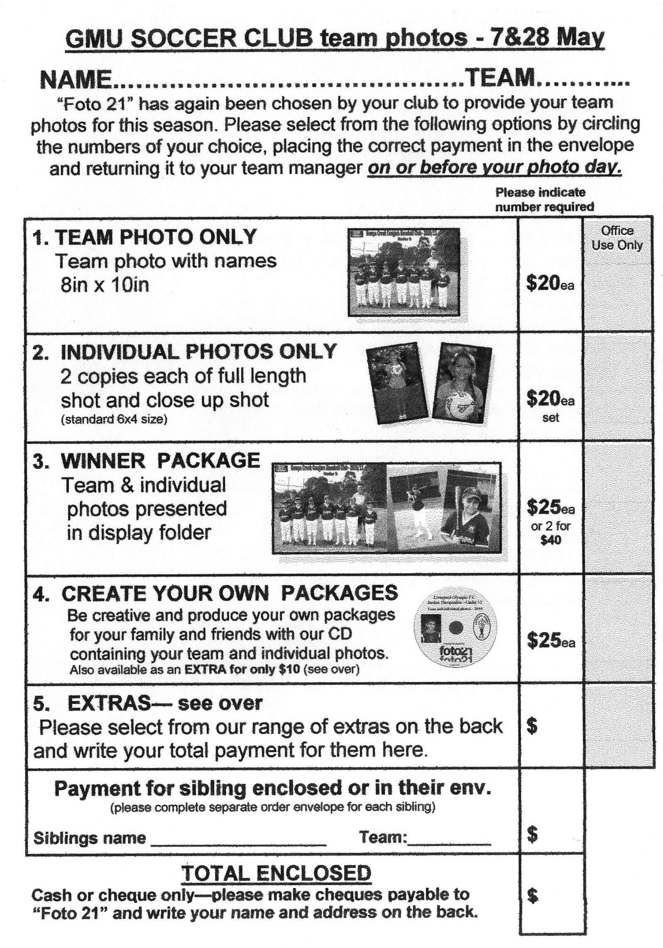
May 25th

For club photos ALL players need to be at the ground 1 hour before kick off to allow the photos to be taken on time.
No T shirts under jerseys, no stripes on socks or shorts, all players to be present whether or not they are purchasing photos.
If photos are being purchased money needs to be with your manager BEFORE the photo is taken.
LAPATHON – the annual club lapathon, our major fundraiser for the year will be held on Wednesday May 29th .

LAPATHON

Sponsorship form

Wednesday 29th May, 2013

Name | Telephone number | Amount per lap  or the sponsor may choose to donate a total amount. | Total donation
Total amount collected

It is expected that players under 13 years will complete not more than 25 laps

RESULTS – 18th & 19th May 2013

U6 Red vs St Bernadettes Castle Hill Eagles 2 - 0
As a few players were unable to make it and what seemed like a pretty big "mini field", it seemed as though we were up against the odds from the start. However the team exceeded all expectations and took the opposition by surprise when Ahoi scored our first goal in the first few minutes. Gerri flew up the field for a second goal soon after. The opposition tried to get past but only managed a few breaks that they were unable to convert to goals due to some amazing defense by guildford reds. Jack and Ahoi worked well together and it was great to see all the boys pass the ball more and work together.
Gerri got man of the match.
Goal scorers – Ahoi Ahoi 1, Garardo Cavasinni 1

U6 White vs Bye

U7 Red vs Hills Spirit Blue 1 - 2
The boys played some good defence today. They missed a few kicks and forgot to pass to each other but never left sight of the ball. Anthony and Zachary played goalies and saved some good shots. Joey ran the field a few times all the way to the goals to just miss out. He finally scored in second half. Kareem played good defence with big kicks. Sayed. Ali, Joshua and Mark- Antony all defended the goals and tried their best. Good game play but better luck next time! Man of the match goes to Zachary.
Goal scorer - Joey Farah 1

U7 White vs Hills Spirit White 9 - 1
Despite missing our 2 star players from last week (Adam and Fouad) due to illness, the U7 White's continued their dominating run by comfortably beating the Hills Spirit White 9-1, who were galant in defeat, shaking hands and finishing the game in good spirits. Dimo continued his punishing game by getting 2 really early goals but what really stood out today was his focus on our "TEAMWORK" motto, which earnt him player of the week. Each and every member of the team are beginning to work together better and helping each other out and for all the parents and coach this is great to see. Ali was also outstanding with 5 great goals and excellent defence. After a brief stint in goals in the first half Sebastian helped his team all around the field and was able to reward himself with 2 of his own goals; he was very happy too. Clearly a leader in the team Sebastian just needs to win over his team mates by helping others play better too and I can see that he is moving in the right direction to do that. It was great to see Daniel back, although still not 100% recovering from an infected toe. Daniel and Dylan are 2 players in our team whose first instinct is to pass, I think we need a different training technique for these two.
Its only a matter of time before our 2girls Ading and Achel score their first goals for the season with some missed opportunities this game.
GO UNDER 7 WHITES!
Goal scorers: Ali Fahme 5, Sebastion Kerr 2, Dimo Dimo 2

U8 vs OLQP Falcons Blue 2 - 1
And here's another winning game! At first it seemed that our boys weren't focused on their positions and not playing very well but I think it was more that our opposition were strong in their defense and fast, still we won 2-1 and it’s a score that was well earned. In the first half the opposition scored their only goal and not long after that Matthew scored our first one and the battle began. The boys never gave up we saw a very good tries from each and every player till the last 3 minutes of the game when victor rewarded it with the winning goal! Victor was also tenacious in defense and earned the man of the match today. A good defensive effort from Austin, Woody and the goal keepers Mohammed and Baris, strikers and midfielders tamir Mustafa charbel baran And samuel, Played very good to. A good effort, a good win! Well done boys.
Scorers Matthew Youssef 1, victor Doueihi 1
U9 vs OLQP Falcons Blue 7 - 0
Wow what a game our kids played today, they were on fire. Aaran scored our first goal today, with Michael's help. Ajuet was playing great, he received the award today as his defence skills and passing were fantastic! Aaran scored 3 goals today, he was great, he played well both halves of the game.
Mustapha scored a great goal in second half. Thanks to Angela for getting gloves for Kiir, cause he was so enthusiastic to dive on the ball and wear them in... Overall a great game, it's so good to see the team have improved so much! Keep it up!!!
Goal Scorers, Aaran Batth 3, Mustapha Fahme 2, Michael Barakat 1, Mase Swalah McDahrou 1

U10 vs Wentworthville Uniting 0 - 0
Today’s game was pretty sad, we lacked enthusiasm from the start which made it hard for us to keep control of the ball. We also lacked in our usual atticking style which left us defending our goals for the whole first half. The game was still scoreless by half time. The second half was a little better but not by much and I was starting to wonder where my team has gone. We attacked the oppositions goals a few times, but unable to score. I hope my Mighty 10s find their way back soon!!!!!!
U11 vs St Bernadettes Castle Hill 7 - 0
Today we were back at Everley park to take on St Bernadettes Castle Hill ad our boys continued their winning ways with a 7 - 0 win. Again we were slow out of the blocks but after Yusuf opened the scoring in the 12th min the boys started to pass well and got into their groove. Joey hit a hatrick while Nedim got two and Qais hit a great free kick to cement this team at the top. The only blemish on the days play were two yellow cards handed out to Qais and Jude. Overall a good day for Guildford McCredie
Scorers: Joe Azzi 3, Nedim Fazlic 2, Yusuf Jamil 1, Qais Sungkar 1

U12 vs Kellyville Kolts Black 1 - 1
We are starting to play like a team and have begun looking for each other on the field starting to string together some passes and hold possession for longer periods of play. Jasper was really good in goals making some good saves. Deng worked really hard through the middle of the park. Luke and Ferdinando always looked threatening up front while Mika, Peter, Nicholas and Ahmed all worked tirelessly at the back.
Goal scorers – Ali Al Saadi 1

U13 vs Granville Rage 0 - 4
Our first loss for 2013 but we did it properly! We came out really well after a good warm up. Having 15 players warming up at 8.30am certainly helped. Unfortunately after dominating the early passages Granville broke free and finished a pretty spectacular goal. We dusted ourselves off and got back into it only to see Granville again rob us of possession and do it again. Beofre half time we hit the post but that was as close as we got. In the second half more of the same, a hard fought match, and then a freakishly well taken free kick smashed into the back of our net. We are 0 – 3 down and we haven’t done a lot wrong. The 4th goal was soft and I would be pretty disappointed if that was the winning goal – but it obviously wasn’t. We have some work to do, because Granville are strong, but we have 7 weeks to prepare. The boys actually played OK and Matty, Daniel and Mujtaba had strong games, Joel and Kabin were terrific, Salem did well in the middle and Ali had plenty of ball.

U15 vs Guildford County 1 - 3
On behalf of the supporters who were there I would like to say that you all played well and that the score doesn't reflect your efforts. As a team, I thought it was another fantastic effort - there are still some things to work on but the ideas and plays that you all attempted were as good as any other team I have seen this year. Keep up the hard work! Now the report. It was a much closer contest than the score suggests, there was a lot of end-to-end play and we were really unlucky to not get a few more in the net from a few different players. They overpowered us on corners, and were more physical when going for the ball, but our defence and attack for the most part was up to the challenge. We were evenly matched at half time with one goal apiece, then in the second half they stepped up a notch and we dropped off a little. If last year is anything to go by, we will come back harder and fitter and I think we will get them next time we play. A great effort and another game for your supporters to be proud of. For those of you in the club who haven't seen us play yet, and you want to see some exciting football, come and watch us (just pick a good day when we are playing well!). There is never a dull moment!
Goal scorers: John Kazzi 1

Ladies vs Wenty Waratah 2 – 4 (when the game was abandoned)
A really disorganised start for a few reasons meant our usual line up was disrupted and first half as a result pretty awful. Stupid mistakes, players not warmed up and little cohesion saw us behind 1 – 3 at half time despite scoring in the first 3 minutes. We came out firing in the second half scoring straight away but again turned our minds off and conceded another straight back. A possibly serious knee injury then stopped the game in it’s tracks in the 47th minute and that was it for the afternoon. Hopefully Tess will be fine (or at least mendable) and that we will be more switched on when the replay happens.
Goal scorer – Genell Hunt 2

RC1 White Reserves vs Epping Church of Christ 3 - 1
A hard fought game, one we should have wrapped up early, but regardless, we stuck tight and got the 3 points. We're play out from the back much better and our central players are using their brains. One thing I want to see more of, is an early release. We get caught too many times messing around with the ball at our feet. Fuad, strong at the back, Mick and Fawzi, smart in the middle and Robbo was excellent in goals.
Goal scorers: Jack Knight 2, Mark Patterson 1

RC1 White Firsts vs Epping Church of Christ 1 - 2
A few crucial lineup changes before kick off hindered us. At times we can play great football, we have the talent across the pitch, but today we looked lost at times. Instead of playing to feet and moving into space, we lumped the football up time after time, surrendering possession.
Needless to say, we recuperated and looked the better side when we used the full width of the pitch, without actually being in front. Chetcuti, Mitch and Devita played well together, our front trio were unlucky not to bang in a few more. ANOTHER penalty miss hurt us, but we got one back with a cool finish from Moz. With the last play of the game, we conceded a soft goal from a corner, courtesy of some slack marking. A disappointing result, considering the high we were on after leveling. See you all Tuesday.
Goal: Aaron Morris 1

RC1 Red Reserves vs Bye

RC1 Red Firsts vs Strathfield Prestige 3 – 5
Such a shame. A team bristling with talent and skill, yet a lack discipline from some players infects the team and results in a game where those involved are embarressed by the performance. A few players need to take a good long look at themselves and decide whether they are there to play a team sport, or just use the occasion to show how infantile they can be. As for the game, for the 30 minutes that we played soccer it was sharp, controlled and effective. We looked good and controlled the game. For the rest of the game, our opposition didn't win, we lost. Please, think about what you intend to do before turning up next week.
Goal Scorers: Caner Temel 1, Daniel Santo 1, Virinder Chaggar 1
Wednesday 22nd May 2013

State Cup RC White Reserves vs Coptic United at Jones (Banks St., Merrylands)
8.30pm Kickoff (meet at Jones at 8.00pm) (dismantle field)

Saturday 25th May 2013

U6 Red vs Wentworthville Uniting Blue at Everley (mini) (Everley Rd., South Granville)
10.00am Kickoff (meet at Everley at 9.15am FOR PHOTO) (dismantle field)

U6 White vs Wentworthville Uniting at Freame (Rees St., Mays Hill)

9.00am Kickoff (meet at Freame at 8.30am)

U7 Red vs Kings Old Boys at Everley (mini) (Everley Rd., South Granville)
9.00am Kickoff (meet at Everley at 8.15am FOR PHOTO) (set up field)

U7 White vs Bye

U8 vs Hills Spirit Blue at Everley 2 (Everley Rd., South Granville)
9.00am Kickoff (meet at Everley at 8.30am FOR PHOTO) (set up field)

U9 vs Hills Spirit Blue at Everley 2 (Everley Rd., South Granville)
10.00am Kickoff (meet at Everley at 9.00am FOR PHOTO) (dismantle field)

U10 vs Hills Spirit Blue at Kellyville (Memorial Ave., Kellyville)

12.00pm Kickoff (meet at Kellyville at 11.30am)

U11 vs OLQP Falcons Red at Daniel (Daniel St., Greystanes)

11.00am Kickoff (meet at Daniel at 10.30am)

U12 vs Rydalmere FC at Everley 1 (Everley Rd., South Granville)
9.40am Kickoff (meet at Everley at 8.30am FOR PHOTO)

U13 vs Auburn FC at Everley 1 (Everley Rd., South Granville)
8.30am Kickoff (meet at Everley at 8.00am FOR PHOTO) (set up field)

U15 vs Castle Hill United at Everley 1 (Everley Rd., South Granville)
10.50am Kickoff (meet at Everley at 9.55am FOR PHOTO) (dismantle field)

Raahauge Cup Red vs Epping Church of Christ at Everley 2 (Everley Rd., South Granville)
(Reserves Kick off at 1.15 pm Firsts at 3.15pm) (meet at Everley at 12.45pm) (set up & dismantle field)
PHOTO AT 2.45pm

Raahauge Cup White vs St Matthews Baulkham Hills at Everley 1 (Everley Rd., South Granville)
(Reserves Kick off at 1.15 pm Firsts at 3.15pm) (meet at Everley at 12.45pm) (dismantle field)
PHOTO AT 3.00PM

Sunday 26th May 2013

U11/12, 13, 15, 16 Kings Sevens Tournament Required players will be notified.
Meet at the Kings School, off Pennant Hills Rd, North Parramatta at 7.45am

Ladies vs Wentworthville Uniting at Freame (Rees St., Mays Hill)
1.00 pm Kickoff (meet at Freame at 12.30pm)

Tuesday 28th May 2013

State Cup RC Red vs Chester Hill Sports at Jones (Banks St., Merrylands)
7.30pm Kickoff (meet at Jones at 7.00pm) (set up field)

