OTB 11/14

Club Secretary – Greg 9682 7779 President – Peter 9632 9203

Interested in sponsoring a team or advertising in this newsletter? – call one of the above numbers.
_____________________________________________________________________________________________________

LAPATHON

THIS WEEK IS LAPATHON. All teams need to be at Granville Park on Wednesday at 6.45pm ready for a 7pm start.

Remember to collect your sponsorship – this is the club’s major fundraiser for the year.

LAPATHON

Sponsorship form

Wednesday 11th June, 2014

Name | Telephone number | Amount per lap  or the sponsor may choose to donate a total amount. | Total donation
Total amount collected

It is expected that players under 13 years will complete not more than 25 laps

CALENDAR

Lapathon –Wednesday 11th June 5.45pm – 7.00pm ALL TEAMS

Zone rep trials – Under 8, 9, 10, 11, 12, 13 June 10 and 12 –

Trials for South Zone will be held on the following dates
Under 11,12,13s Thursday 12th June 2014 at 5.30pm for 6pm start
Under 8,9,10 MOVED TO Tuesday 17th June 2014 at 5.30pm for 6pm start
The initial trial for South Zone will be held at Phillips Park (Nicholas St) Lidcombe.
To trial for South Zone, please turn up to Phillip Park on the scheduled trial night.

Players trialling must be available for all of the following games Games will be held on:

Wed 25/06/2014 – Eric Mobbs Reserve, Castle Hill
Wed 16/07/2014 – Freame & Jones
Wed 23/07/2014 – Phillips
Game times: 6pm – Under 8 & 10
7pm – Under 9 & 11
8pm - Under 12 & 13

Cost $30 – includes jersey, shorts and socks to keep

Managers please follow these birth certificates up this week – we do not want to have to stop players playing until we have them – but it is now May!

Abbas Al-Kaabi
Rehab Shabir
Ahoi Ahoi
Hassan Al Shamariy
Jeffrey Farah
Ringo Ajang
Akot Akot

________________________________________________________________________________________________________________

2014 National Titles Player Trial dates

To be held at Jones Park, Banks St, Merrylands West

Under 14 Boys – 1st & 2nd July, 6pm

Under 16 Boys – 23rd & 25th June, 7pm

Under 18 Boys – 23rd & 25th June, 7pm

Under 23 / Youth Men’s – 24th June & 1st July, 7pm

Over 35s Men’s – 9th July, 7pm

Senior Men’s - 24th June & 1st July, 7pm

Under 16 Girls – 8th July, 5.30pm

Senior Ladies – 8th July, 7pm

Nomination forms can be downloaded from http://www.nswcfa.com.au/
Knockout RESULTS – this week

U8 Red FINAL vs Kings Old Boys 0 – 6
Very good game played tonight. They played with all their might despite the fact that we had no reserves. In our eyes they are the winners. Good on ya u8 red!!

U11 FINAL vs Hills Spirit White 3 - 0
What a game, with us overpowering Hills White towards the end to ensure a well deserved win. The cut & thrust of the game was almost unbearable to watch as both teams tested each other’s defences. Just before half time Christian chipped over the top of Hills backs. Mounir got a good bounce & ran nicely onto the ball to shoot a nice goal. After half-time the game continued as a tug of war until finally Hills ran out of puff. Another nice goal to Mounir put us comfortably in front, before Christian scored after a nice left cross from Elias our left mid-fielder. There were many other highlights with some good long kicks from Shaleen, Ryan & Peter turning defence into offence. The other backs, James, Adhel, William & Joel combined well to stuff out raids & ensure a clean sheet. The other mid-fielders, John-Luke, Yilmaz, Geetansh, Deng & Christopher, helped hold the line & service our forwards well. Goalie duties were shared by Peter & Joel. A good team effort & sweet victory to claim the silverware. Well done Team.
Goal scorers- Mounir Hadid 2, Christian Frangie 1

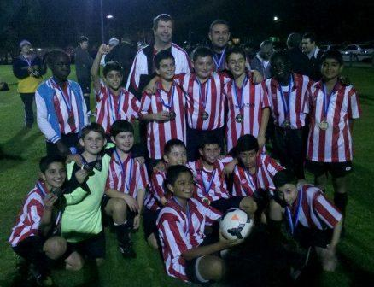

U12 FINAL vs Wentworthville Uniting 0 – 1
This game had to be the best the boys have played (so far). Missing 5 players that night, Christian, John Luke, Shaleen and Joel really stepped up with their contribution to the game, it allowed it to be one great game. Every single person played their position well. Both teams were in full control throughout the whole game. We managed to score two goals during the game, all by Christian. However, Wentworthville also bounced back with two, which then led to extra time. With great defence from both teams, we had to go to a penalty shoot out. Qais and Christian got one each and Andrew who played our goalie, was able to save 2 from 3, which gave us the win! It was such a great game to watch. Well done to all the boys Goal scorers – Christian Frangie 3, Qais Sungkar 2
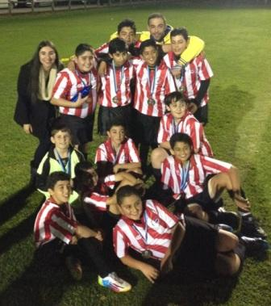

U13 FINAL vs Kings Old Boys 0 – 6
Unfortunately the team went down 6-0 to Kings Old Boys in the grand final of the knockout competition.
Boys & girls tried hard but could not match the discipline & skills of the opposition. Great effort from all players especially Peter, Nicholas & Sarah. Sarah played midfield first half & was there helping the defence & moving up when we had chances, Nicholas held his ground strongly & surprised me with few sliding tackles in perfect timing & Peter was great as he played his roles perfectly, he was switched from right wing to stopper & played it well. I cant not mention the effort from Mika, Ahmed, Cameron & Richard who was our goal keeper most of the game & did well saving few shots including a rocket from mid range late in second half. Man of the match was Peter for his great effort in defence. After the match there was medals & presentation for both teams, team captain Adut congratulated KOB on their wining & thanked referees & officials for their support & presented KOB with the winners medals & our team received runners up medals from KOB captain.

B Grade Mens FINAL vs Coptic United 1 – 1 lost on penalty shootout
Goal scorer – Mohammed Shukur 1

RESULTS – 7th, 8th and 9th June

Six a side results

U6 Red
Round 1 vs St Columbas Castle Hill won
Round 2 vs Bye
Round 3 vs OLQP Falcons Red won
FINAL vs St Columbas Castle Hill lost

U6 White
Round 1 vs OLQP Falcons 4 - 3
Goal scorers – Dut Atak 2, Andrew Sleiman 1, Omar Elbizri 1
Round 2 vs St Columbas Castle Hill 3 - 4
Goal scorer – Dut Atak 2

Kids tried their best, playing really well but in the end the better team won and we went out of the competition!!
Great job team, better luck next time!

U7 Red
Round 1 vs OLQP Falcons Orange won
Round 2 vs Wentworthville Uniting Gold won
Round 3 vs OLQP Falcons Yellow lost

U7 White
Round 1 vs Lidcombe Churches lost
Round 2 vs OLQP Falcons Yellow lost

U8 White
Game 1 vs Canterbury 0-2
Game 2 vs Bye
Game 3 vs Lidcombe 2-1 (in extra time)
Game 4 vs Canterbury 0-7
Long day good effort by the kids, beaten on the day by a very strong team of talented kids. Adam, Ali, Daniel, Dylan, Fouad, Owen and Sebastian all contributed strongly today and should be very proud of their efforts.

U8 Red
Round 1 vs Kings Old Boys 2 – 2 (lost on corners)
Goal scorer – Joey Farah 2
Round 2 vs Canterbury 0 - 6

U9
Red
Round 1 vs Wentworthville Uniting lost
Round 2 vs Lidcombe Churches lost

Grey
Round 1 vs St Bernadettes Castle Hill lost
Round 2 vs Wentworthville Uniting lost

U10
Grey
Round 1 vs Hills Spirit Blue 0-3
Round 2 vs OLQP Falcons 1-4
Goal scorer- Mustapha Fahme 1

Red
Round 1 vs Lidcombe Churches Gold 0 - 2
Round 2 vs Hills Spirit Blue 0-12

It was unfortunate for us that we weren't able to win today, but it was still a very enjoyable day, the kids had lots of fun. From both teams today our star players were Mary, Aaran, Michael and John. They all pushed themselves beyond the limit! Thanks to Christopher from U11 for helping out and a big thanks to Lamar who is in U6 she played so well considering the age gap, good on you Lamar. Good try to the kids, better luck next time! I thought Lamar looked so cute on the big field so I've included a pic.
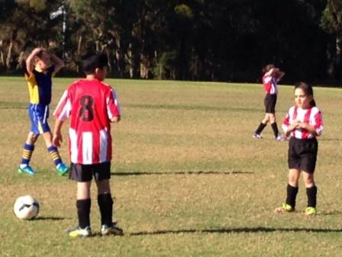

U11 Grey
Round 1 vs Earlwood Wanderers 0 – 7
Round 2 vs Prospect United 1 – 2
Goal scorer – Geetansh Kaushal 1

The U11 grey team, Geetansh, Deng, William, James, Peter & Yilmaz, put in a great effort & though we ended on the wrong side of the ledger in both games, we played with plenty of spirit & had some fun. Each of the players had a turn at a variety of positions. Our first match was against Earlwood. This was a tough match. Earlwood were just to good, but we didn't stop trying. The boys were a bit at sea, but ran themselves ragged trying to stem the flow. The next match against Prospect was another tough match. After Prospect had scored first we didn't give up. Eventually after some sustained pressure we got a penalty in the box. Geetansh slotted a nice goal to get us back to level pegging. Unfortunately we also gave away a penalty in the box just before full time. Prospect duly converted, making the final score Prospect 2 - Guildford Grey 1.

U11 Red
Round 1 vs Lidcombe Churches won
Round 2 vs Wentworthville Uniting lost

U12
Long and exhausting day we had but it was all worth it in the end. Our team was split into two, u12s Grey and u12s Red.

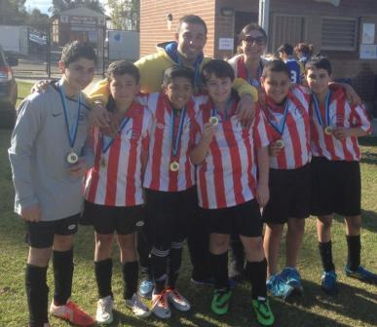

Grey
Round 1 vs Lidcombe Churches Yellow 0 – 8
U12s grey- Rough start for the boys, with only 4 players on the field, it allowed the opposition to dominate and score 8 goals. On top of that the boys seemed to be half asleep.
Round 2 vs Lidcombe Churches Blue 4 - 1
Second game,- We were able to have Hassan finally join us!. A great performance by them during this game. We had Hassan and Jeffrey score their first goal of the season and Ahmet was able to score two, which allowed us a spot in the semi final.
Goal scorers – Ahmet Keskinkilic 2, Hassan Al Shamariy 1, Jeffrey Farah 1
Round 3 vs Guildford McCredie Red 1 - 3
Goal scorer – Ahmet Keskinkilic 1

Red
Round 1 vs Kings Old Boys 4 - 0
Goal scorer – Ferdinando Cavasinni 2, Andrew Ibraheem 1, Qais Sungkar 1
Round 2 vs St Columbas Castle Hill 3 - 1
Goal scorers – Ferdinando Cavasinni 2, Qais Sungkar 1
Round 3 vs Guildford McCredie Grey 3 - 1
We had both our teams verse each other in the semi final. Not only was it a great game to watch, but it was great to see the support the boys showed to one another. We had Qais, Ferdinando and Chris score, from the Reds. However, they gave an opportunity for Ahmet to score. which closed it off 3-1. knocking out Greys and placing the Reds in the final.
Goal scorers – Qais Sungkar 1, Chris Abosh 1, Ferdinando Cavasinni 1
Final vs Wentworthville Uniting 2 - 1
Grand final- Using up all their energy throughout the day, the boys looked tired. They weren't chasing the ball, nor had any control of the ball. They gradually got back into the game, and were able to score the first goal. However, Wentworthville also scored, which created more pressure for the boys. A penalty kick by Qais won us the game.
Great work to ALL the boys who played today.
Goal scorer – Qais Sungkar 2

U13
Both the Reds and the Greys played 4 games each. No report

U14

Red
Round 1 vs Lidcombe Churches Blue 3 - 0
Goal scorers – Jacob Mitwali 2, Salem Boustany 1
Round 2 vs Merrylands SFC White 5 - 0
Goal scorers – Jacob Mitwali 2, Salem Boustany 1, Daniel Wark 1, Kabin Rana 1
Round 3 vs Lidcombe Churches Gold 1 – 2
Goal scorer – Jacob Mitwali 1

Grey
Round 1 vs Merrylands SFC Black lost
Round 2 vs Lidcombe Churches Gold lost

U16
Grey
(Vehid, Josip, Alexia, Joshua, Dusan and Brandon)
Round 1 vs Castle Hill Rockets 0 - 3
Round 2 vs Wentworthville Uniting 0 - 3

Red
(Will, Hussan, Jason, John, Kane, Peter, Dusan)
Round 1 vs Lidcombe Churches Gold 2 - 2 (Lost on corners)
Goal scorers: Kane Carder 1, Peter Youssef 1
Round 2 vs Castle Hill Rockets 3 - 0
Goal scorers: Kane Carder 2, Willem Booker 1
Round 3 vs Wentworthville Uniting 1 – 3
Goal scorer – Peter Youssef 1
First up, very disappointed with those that didn’t show up, you let your team mates down. You can sleep in next Saturday too, we’ll be fine.
To everyone else, well done. The Grey team had only 4 players to begin with and were always short, but put in a super huge effort. They led in both games (on corners) before not having enough players wore them down and the opposition scored. Alexia was great, always getting involved and shutting down chances. The Reds put in a good effort, but we either rushed our scoring opportunities or we tried to take it all the way past the keeper. It was pleasing to be in the semi-final but we were just a bit flat on the day. It was good to see Kane scoring some goals again.
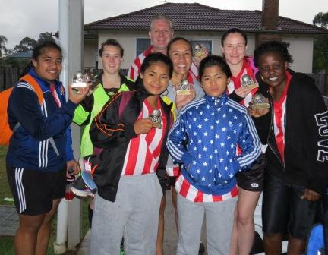
AAL
White
Round 1 vs St Barnabas Broadway 2 lost
Round 2 vs Merrylands SFC lost

Red
Round 1 vs Wentworthville Uniting 7 – 0
Goal scorers – Taufa Kivalu 4, Mika Oo 2, Genell Hunt 1
Round 2 vs St Barnabas Broadway 2 6 – 0
Goal scorers – Mika Oo 4, Taufa Kivalu 2
Round 3 vs Bye
FINAL vs Merrylands SFC 2 – 1
Goal scorer – Taufa Kivalu 2

How good are we! Awesome display and great reward for a team that has been getting better and better for 3 years. We were behind in the final all the way, conceding the first goal, goal kicks and corners. We came back to score the equaliser in the first half and then a tense battle ensued with us still behind on count back. With a minute to go on the clock Mika timed a perfect pass to Taufa who beat two and slammed the winner. Merrylands are on top of Div 2 in the comp, played div 1 last year and won this tournament last year. Genell, Taufa, Mika, Chantelle, Laura, Nyanut and Sarah I are awesome. Congratulations girls.

O35
Round 1 vs Zim Warriors 3 – 1
Goal scorers – Greg Wark 1, Hakan Mete 1, Luke Roumanos 1
Round 2 vs Hills Spirit 0 – 1
Round 3 vs Wentworthville Uniting 7 - 0
Goal scorers – Greg Wark 3, Hakan Mete 2, Phil Chan 1, Tito Jimenez 1
FINAL vs Hills Spirit 0 - 1

Fabulous to be able to get some current warriors and past team mates together to have some fun – in the pouring rain! We won two games easily and lost 2 very narrowly. Luke Roumanos was awesome in goals – one of the best players of the day from any team. Phil Chan never stopped running when I first played with him 17 years ago – nothing has changed. Hakan Mete always listens carefully , nods, and proceeds to do his own thing. It’s invariably brilliant so all’s good! And how brilliant was the striker (in the easy games anyway) – who now won’t be able to walk for a week.

AAM
Red
Round 1 vs St Barnabas Broadway 2 3 - 0
Goal scorers – Mick Massih 2, Mohamed Al Delaimy 1
Round 2 vs Merrylands SFC L 3 - 0
Goal scorers – Wil 2, Mick Massih 1
Round 3 vs Wentworthville Uniting White 2 – 2 (lost on corners)
Goal scorers – Adem Stevens 1, Wil 1

White
Round 1 vs Coptic United B 0 – 6
Round 2 vs Wentworthville Uniting Gold lost

Daniel Lapinskas did an amazing job pulling the boys together on the morning – 10 minutes before round 1!. Kyle, Darren, Daniel, and welcoming back Tim and Jesse (and a ring in). Great job.

Green
Round 1 vs Coptic United A lost
Round 2 vs St Barnabas Broadway lost

If it wasn’t for drawing the eventual champions in round 1, pretty sure these guys would have gone all the way! Great effort Andy and the boys.

Competition matches Saturday 7th/Sunday 8th

U14 vs Castle Hill United 3 - 1
Goal scorer: Matthew Richards 3

U16 vs Lidcombe Waratah 2 – 4
Not much to say here. Yet another game that we let go. Looked the better side for most of the game, but we panicked at both ends. 2 soft goals to them and numerous opportunities we didn’t put away. That will be the difference in making the semi-finals.
Goal Scorers: Vehid Dupovac 1, Willem Booker 1

Ladies vs Pendle Hill Tigers 2 – 1
We scored in the opening minutes and it could have been (should have been?) straight forward, but we let them back in later in the first half. Happily we struck straight back so the pressure didn’t build on us, but not scoring in the second half despite having all of the field position was a bit frustrating. As I said to one of our spectators today though, it’s better being frustrated at 2-1 up than being frustrated and being behind. Moana had her game of the year today, Nyanut continued her good form and Ania was on fire early.
Goal scorers – Laura Burden 1, Mika Oo 1

Saturday 14th June 2014

U6 Red vs St Bernadettes Castle Hill Lions at Everley (mini) (Everley Rd., South Granville)
9.00am Kickoff (meet at Everley at 8.30am)

U6 White vs OLQP Falcons Green at Everley (mini) (Everley Rd., South Granville)
10.00am Kickoff (meet at Everley at 9.30am)

U7 Red vs Hills Spirit Red at Everley (mini) (Everley Rd., South Granville)
8.00am Kickoff (meet at Everley at7.30am) (set up field)

U7 White vs Hills Spirit Blue at Everley (mini) (Everley Rd., South Granville)
11.00am Kickoff (meet at Everley at 10.30am) (dismantle field)

U8 Red vs OLQP Falcons Red at Daniel (Daniel St., Greystanes)
9.00am Kickoff (meet at Daniel at 8.30am)

U8 White vs Kings Old Boys at Eric Mobbs 2 (Excelsior Ave., Castle Hill)
10.00am Kickoff (meet at Excelsior at 9.30am)

U9 vs Hills Spirit Green at Kellyville (Memorial Ave., Kellyville)
9.00am Kickoff (meet at Kellyville at 8.30am)

U10 vs Lidcombe Churches at Everley 1 (Everley Rd., South Granville)
9.00am Kickoff (meet at Everley at 8.30am) (set up field)

U11 vs Hills Spirit 12s at Kellyville (Memorial Ave., Kellyville)
12.00pm Kickoff (meet at Kellyville at 11.30am)

U12 vs Lidcombe Churches at Phillips 1 (Martin St., Lidcombe)
12.00pm Kickoff (meet at Phillips at 11.30am)

U13 vs St Columbas Castle Hill at Everley 1 (Everley Rd., South Granville)
10.00am Kickoff (meet at Everley at 9.30am) (dismantle field)

U14 vs Merrylands SFC Black at Merrylands 2 (Cnr Merrylands Rd & Burnett St., Merrylands)
9.40am Kickoff (meet at Merrylands at 9.00am)

U16 vs Castle Hill RSL at Eric Mobbs 4 (Excelsior Ave., Castle Hill)
11.30am Kickoff (meet at Eric Mobbs at 11.00am)

Raahauge Cup vs Castle Hill Baptist at Eric Mobbs 1 (Excelsior Ave., Castle Hill)

Reserves kick off at 1.15pm Firsts at 3.15pm (Meet at Excelsior at 12.45pm)

Sunday 15th June 2014

U14 vs Pendle Hill Tigers at Binalong (Binalong Rd., Old Toongabbie)
10.30am Kickoff (meet at Binalong at 9.15am)

All Age Ladies vs North Rocks at Ted Horwood 2 (cnr Renown & Park Rds., Baulkham Hills)
1.00pm kick off (Meet at Ted Horwood at 12.15pm)

Monday 16th June 2014

Raahauge Cup catchup vs St Barnabas Broadway at Jones 1 (Banks St., Merrylands)
Reserves kick off at 6.30pm Firsts at 8.00pm (Meet at Jones at 6pm) (set up & dismantle field)

