OTB 1/14

Club Secretary – Greg 9682 7779 President – Peter 9632 9203

Interested in sponsoring a team or advertising in this newsletter? – call one of the above numbers.

WELCOME TO THE 2014 SEASON!
During the season, draws, results, newsletters and links will be available on the website.

www.mccredie.org.au/soccer

It’s now time to bring in your proof of age (birth certificate or passport if you are new to our club)
These should be given to Greg, Carolynne or the canteen ASAP.

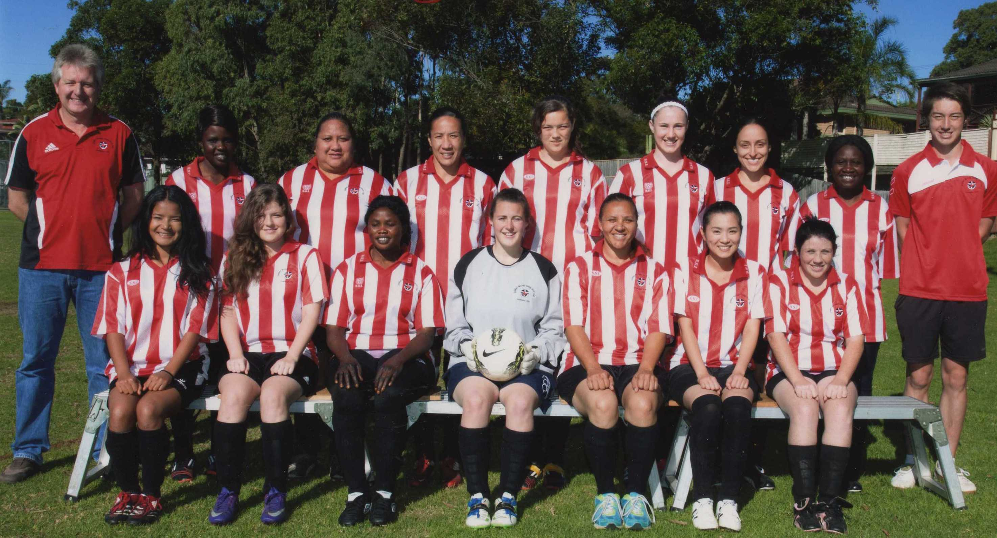
Above: Our 2013 All Age Ladies
Below: The under 8s celebrate their knockout competition win in 2013



IMPORTANT NOTICES
- If for any reason your child is unable to play or attend training you MUST inform your coach or manager AS SOON AS POSSIBLE.

- If you have questions regarding your team ask your manager.

- If it is raining on a Saturday morning call the team manager to see if the game is on. Most often games will still be on so do not just stay at home, you will be letting your child's team down!!!

- Please assist the coach and manager, they are working unpaid for your child. There may be nets to put up or pull down, corner posts to stick in, players to be picked up (particularly if a parent has more than one child playing in different teams) or shirts to wash.

- This Club, the NSW Churches Football Association and Granville District SFA have high expectations of our parents and players. Please support our teams, but no abuse of players or officials will be tolerated and bans or fines could result.

Greg Wark – Secretary 9682 7779

RAIN – WHAT TO DO

It’s raining, it’s Saturday!! Is the game on??

Your manager will know if the game is on, give them a call. Very rarely is a decision made before Friday evening. If I have not called your manager, the game is on, even if it is raining!

Most often games will still be on so do not just stay at home, you will be letting your child's team down!!!

It’s raining and it’s training tonight!! Is training on??

Coaches and managers call the wet weather line 9294 8586. If the ground is closed you cannot train, even if it’s not raining!! Parents and players call the manager or coach.
___________________________________________________________________________________________

Referees Courses - Free
(held at Association Offices 3/9 Chester Hill Rd., Chester Hill 7pm)
Anybody over 14 years welcome. Courses include lecture and exam on the one night.
Next dates: Weds 19/ 3

Vale Caner Temel
During the off season McCredie lost a valued member of our soccer family with the passing of Caner Temel. Caner was one of our foundation members being a part of our inaugural under 8 team in 1999. Caner played junior soccer with us each year through to under 17s. When he was an under 16 Caner began playing senior football with McCredie on Saturday afternoons, graduating to the first XI when he was just an under 17. Caner played a number of seasons of senior soccer, returning to us after a break last year. Caner was highly respected by his team mates and opponents, skilful and reliable, the rock around whom strong teams were built. As Caner's coach from under 8s through into seniors I can honestly say I cannot ever remember Caner causing any trouble for team mates, his coach, the referee or his opposition (except with the ball!). Caner played in many very successful teams winning junior & senior competitions and being part of the A Grade six a side team who were runners up last season. The reason for much of this success is quite simply, because he was in the team.

Caner was junior player of the year in 2000, age player of the year 1999/2003/2005, coached a junior team in 2007, achieved his 10 year service medallion in 2008, runner up senior player of the year 2009, won 5 premierships and scored 207 goals for the club.

Caner's family continue to support our club and our thoughts are with them all. Caner will be sadly missed.

For McCredie's round 1 matches each team will wear black arm bands to honour the memory of our footballing friend.

Team Coaches and Managers contact details
TEAM |  |  | Phone | Mobile | Training
U6 RED | Emma Ali | Manager |  | 0412 492 779 | Wednesday 5.00pm
U6 RED | Andy | Coach
U6 WHITE | Sue Sleiman | Manager |  | 0406 727 199 | Wednesday 5.30pm
U6 WHITE | Mika Oo | Coach | 9885 0960 | 0431 750 204
U7 RED | Need a volunteer | Manager |  | 0413 511 377 | Wednesday 6.00pm
U7 RED | Marco Cavasinni | Coach | 9681 1459 | 0409 457 403
U7 WHITE | Peter Sultana | Manager | 9760 1176 | 0413 318 962 | Wednesday 6.00pm
U7 WHITE | Charles Abdulahad | Coach | 9885 0956 | 0452 477 478
U8 RED | Salma Germanos | Manager | 9885 0673 | 0415 137 733 | Wednesday 5.30pm
U8 RED | Robert French/  Sarah Dubois | Coach | 9892 1428 | 0412 762 373  0435 820 232
U8 WHITE | Mathew Lu | Manager |  | 0402 872 478 | Wednesday 5.30pm
U8 WHITE | Mathew Lu | Coach |  | 0402 872 478
U9 | Vera Doueihi | Manager | 8720 2902 | 0439 063 155 | Wednesday 6pm
U9 | Bilal Elbizri | Coach |  | 0405 789 464
U10 | Mary Ayoub | Manager | 9897 2671 | 0414 665 054 | Tuesday & Wednesday 6.00pm
U10 | George Helou | Coach |  | 0416 619 515
U11 | Stephen Durbidge | Manager | 9721 3391 | 0418 962 893 | Tuesday & Wednesday 6.00pm
U11 | Hamid Frangie | Coach | 9637 2299 | 0405 351 515
U12 | Need a volunteer | Manager |  |  | Wednesday 6.30pm
U12 | Serhat (Sam) Tuzcuoglu | Coach | 9702 0197 | 0401 066 911
U13 | Mary Carr | Manager | 8006 5201 | 0402 407 015 | Wednesday 5.00pm
U13 | George Ayoub | Coach | 8720 2313 | 0410 587 285
U14 | Tim Booker | Manager | 9632 8545 | 0425 369 138 | Wednesday 5.15pm
U14 | Greg Wark | Coach | 9682 7779
U16 | Anita Tran | Manager | 9726 5803 | 0431 690 663 | Tuesday 6.00pm &
U16 | Darren McGuire | Coach |  | 0418 253 651 | Wednesday 5.30pm
RC 1st Div | Philip Rafter | Manager | 9688 2478 | 0414 461 371 | Wednesday 7pm
RC 1st Div | Christian Diaz | Coach | 9731 0535 | 0404 027 698
LADIES | Hendrika Sharwood | Manager |  | 0420 831 960 | Wednesday 6.45pm
LADIES | Greg Wark | Coach | 9682 7779

If for any reason you or your child is unable to play
you must ring your team manager ASAP
(who will relay this information to the coach).
________________________________________________________________________________
If you have not yet supplied a copy of your child’s birth certificate or passport, please forward to your manager THIS WEEK. Your child cannot play until all requirements are met.

All new players and under 8s will also need to email a photo to gmusoccer@optusnet.com.au for their ID card. The photo does not need to be a passport photo but does need to be a clear photo of the head.

For the trial matches the grounds will be prepared on Friday afternoon 21st March from 3.30pm.
Please come down to Merrylands HS to assist if you can, bring a lawn mower or just your enthusiasm.
TRIAL MATCHES

FULL UNIFORM IS REQUIRED FOR TRIAL MATCHES
Socks will be available at the trials for $12 a pair. A limited supply of shorts ($28) will also be available.

From 7.30am both Saturdays the fields need to be set up as does the canteen. Help in the canteen, cooking sausages and serving would also be appreciated Thanks.

Saturday 22nd March 2014

U6 Red vs Wentworthville Uniting Blue at Merrylands HS 3 (Bristol St., Merrylands)
8.30am Kickoff (meet at Merrylands HS 8.00am)

U6 White vs Wentworthville Uniting Gold at Merrylands HS 3 (Bristol St., Merrylands)
9.15am Kickoff (meet at Merrylands HS 8.45am)

U7 Red vs Wentworthville Uniting Blue at Merrylands HS 3 (Bristol St., Merrylands)
9.50am Kickoff (meet at Merrylands HS 9.20am)

U7 White vs Wentworthville Uniting Gold at Merrylands HS 3 (Bristol St., Merrylands)
10.50 am Kickoff (meet at Merrylands HS 10.20am)

U8 Red vs Wentworthville Uniting at Merrylands HS 1 (Bristol St., Merrylands)
10.45 am Kickoff (meet at Merrylands HS 10.15am)

U8 White vs St Columbas Castle Hill at Merrylands HS 1 (Bristol St., Merrylands)
12.30pm Kickoff (meet at Merrylands HS 12.00pm)

U9 vs Wentworthville Uniting at Merrylands HS 1 (Bristol St., Merrylands)
11.45am Kickoff (meet at Merrylands HS 11.15am)

U10 vs Wentworthville Uniting at Merrylands HS 2 (Bristol St., Merrylands)
8.30am Kickoff (meet at Merrylands HS 8.00am)

U11 vs Wentworthville Uniting Blue at Merrylands HS 1 (Bristol St., Merrylands)
9.30am Kickoff (meet at Merrylands HS 9.00am)

U12 vs St Michaels Baulkham Hills 13/4 at Merrylands HS 1 (Bristol St., Merrylands)
1.15pm Kickoff (meet at Merrylands HS 12.45pm)

U13 vs St Columbas Castle Hill at Merrylands HS 2 (Bristol St., Merrylands)
9.30am Kickoff (meet at Merrylands HS 9.00am)

U14 vs Wentworthville Uniting at Merrylands HS 2 (Bristol St., Merrylands)
12.15pm Kickoff (meet at Merrylands HS 11.45am)

U16 vs Wentworthville Uniting 15 at Merrylands HS 2 (Bristol St., Merrylands)
10.45am Kickoff (meet at Merrylands HS 10.15am)

Raahauge Cup 1 vs Wentworthville Uniting at Merrylands HS 2 (Bristol St., Merrylands)
(Reserves Kick off at 1.30pm Firsts at 3.15pm) (Meet at Merrylands HS at 1.00pm)

Sunday 23rd March 2014

All Age Ladies vs Wentworthville Uniting at Merrylands HS 2 (Bristol St., Merrylands)
1.30pm Kickoff (meet at Merrylands HS 1.00pm)
FULL UNIFORM IS REQUIRED FOR TRIAL MATCHES
Socks will be available at the trials for $12 a pair. A limited supply of shorts ($28) will also be available.

From 7.30am on both Saturdays the fields need to be set up as does the canteen. Help in the canteen, cooking sausages and serving would also be appreciated Thanks.

Saturday 29th March 2014

U6 Red vs St Columbas Castle Hill at Merrylands HS 3 (Bristol St., Merrylands)
9.15am Kickoff (meet at Merrylands HS 8.45am)

U6 White vs Wentworthville Uniting Blue at Merrylands HS 3 (Bristol St., Merrylands)
9.50am Kickoff (meet at Merrylands HS 9.20am)

U7 Red vs Wentworthville Uniting Gold at Merrylands HS 3 (Bristol St., Merrylands)
11.30am Kickoff (meet at Merrylands HS 11.00am)

U7 White vs Wentworthville Uniting Blue at Merrylands HS 3 (Bristol St., Merrylands)
10.50am Kickoff (meet at Merrylands HS 10.20am)

U8 Red vs St Columbas Castle Hill at Merrylands HS 1 (Bristol St., Merrylands)
11.30am Kickoff (meet at Merrylands HS 11.00am)

U8 White vs Wentworthville Uniting at Merrylands HS 1 (Bristol St., Merrylands)
10.30am Kickoff (meet at Merrylands HS 10.00am)

U9 vs Lidcombe Churches at Merrylands HS 1 (Bristol St., Merrylands)
8.30pm Kickoff (meet at Merrylands HS 8.00am)

U10 vs Lidcombe Churches at Merrylands HS 2 (Bristol St., Merrylands)
8.15am Kickoff (meet at Merrylands HS 7.45am)

U11 vs Wentworthville Uniting Gold at Merrylands HS 2 (Bristol St., Merrylands)
10.25am Kickoff (meet at Merrylands HS 9.55am)

U12 vs Wentworthville Uniting at Merrylands HS 2 (Bristol St., Merrylands)
11.15am Kickoff (meet at Merrylands HS 10.45am)

U13 vs St Michaels Baulkham Hills at Merrylands HS 1 (Bristol St., Merrylands)
2.00pm Kickoff (meet at Merrylands HS 1.30pm)

U14 vs Granville Waratah at Merrylands HS 2 (Bristol St., Merrylands)
12.15pm Kickoff (meet at Merrylands HS 11.45am)

U16 vs Pendle Hill Tigers at Merrylands HS 4 (Bristol St., Merrylands)
10.30am Kickoff (meet at Merrylands HS 10.00am)

Raahauge Cup 1 Reserves vs Wentworthville Uniting RC1

Firsts vs Norwest Cougars at Merrylands HS 4 (Bristol St., Merrylands)
(Reserves Kick off at 1.45pm Firsts at 3.30pm) (Meet at Merrylands HS at 12.45pm)

Sunday 30th March 2014

All Age Ladies vs Pendle Hill at Merrylands HS 2 (Bristol St., Merrylands)
3.00pm Kickoff (meet at Merrylands HS 2.30pm)

