OTB 18/14

Club Secretary – Greg 9682 7779 President – Peter 9632 9203

Interested in sponsoring a team or advertising in this newsletter? – call one of the above numbers.

All the National Titles squads are now announced and can be found at www.nswcfa.com.au

Congratulations to McCredie players Kabin Rana (14s), Matthew Richards (14s), Willem Booker (16s), Alan Trad (16s), William Wark (18s), Adem Stevens (23s), Mohammed Al Delaimi (23s), Mick Massih (23s), Genell Hunt (AAL), Mika Oo (AAL), Taufa Kivalu (AAL), Mohammed Rahimi (AAM) and Thuzar Oo (U16 Girls) on their selections.

The event will be held in Sydney from September 28 to October 1st. Please make sure you get down at some time to check games out. Volunteers are also being sought. Would you like to help?
Visit www.nsw.cfa.com.au for information on how to volunteer.

LAPATHON

Sponsorship form - Wednesday 30th July, 2014

All players required at Granville Park at 5.45pm

Name | Telephone number | Amount per lap  or the sponsor may choose to donate a total amount. | Total donation
Total amount collected

It is expected that players under 13 years will complete not more than 25 laps

RESULTS – 26th and 27th July 2014

U6 Red vs St Bernadettes Castle Hill Washed out

U6 White vs Wentworthville Uniting Gold 4 - 1
Today we had a hard game,kids were playing good but couldn't finish the task to score few more goals,with no reserve ,most of the players were tired.we need to work on passing the ball to each other and on defence!!hope next week we will do better.
Goal scorers – Dut Atak 2, Joe Douehi 1

U7 Red vs St Bernadettes Castle Hill Washed out

U7 White vs Hills Spirit White Washed out

U8 White vs Lidcombe Churches 2 - 1
Great commitment from the team's parents today, given the rainy start to the morning, missing only Adam due to illness. It was a must win game and the kids played well. Ali was on fire today taking control of the game up front and supported well by the rest of the team. First half we had so many chances, with Fouad first then Ali hitting the back of the net to give us the early lead. Kassem was excellent in goals stopping what would have normally been easy goals. Without that effort we could have been 2-3 down at half time. Lidcombe came back as expected in the second and attacked hard with raid after raid, then Hissham their star striker managed to convert a breakaway run. We defended well, but there were definitely heart stopping moments with broken play and the ball loose in our goal area on many occasions which could have easily just gone in. But to our kids credit they defended the second half very well and pulled off a gutsy win.
Goal scorers: Fouad Ayoub 1, Ali Fahme 1

U8 Red vs Wentworthville Uniting lost on forfeit

U9 vs Hills Spirit Red 1 - 2
Under the pouring rain we played. The team tried their best but it wasn't enough. Their passes were better and their strikes stronger! Hard luck but lots to learn from.
Scorer: Mohamed Mattar 1
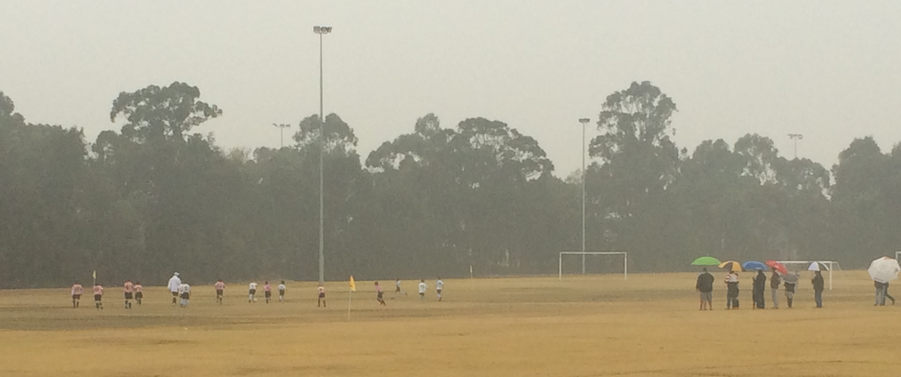

Under 9s in action. (Notice how the photographer appears to be under shelter!)

U10 vs Hills Spirit White 3 - 0
It was nice to win today in the wet weather. Mustapha scored our first goal in the first 2 min of the game. Thanks to Josh and Joey for helping out today, Joey played really well almost scoring. Mary scored our second goal, so well done. Aaran played really well today, great defence, lines up the goal and almost scoring, so Aaran is our man of the match today. Second half Mustapha scored again., so it was nice walking away with a 3-0 win.
Goal scorers – Mustapha Fahme 2, Mary Ning 1

U11 vs Wentworthville Uniting 3 - 0
Our passing generally hit the intended target, which meant we retained possession, field position & comfortably controlled the game. Christian was goalie today but still managed to score our first goal after several earlier shots by Monir & Christopher were stopped by Wenty Gold's goalie. Joel goal was after a nice cross by John - Luke who was put into some space by Yilmaz. Elias scored after some nice play on the left by Deng & Geetansh. Shaleen, Ryan & William at the back were solid & passed nicely between themselves & to the midfield. Man of the Match: Christian Frangie
Goal Scorers: Christian Frangie 1, Joel Carder 1, Elias Matta 1

U12 vs Bye

U13 vs Lidcombe Churches 0 – 1
The under 13 lost 0-1 to Lidcombe at our home ground Everley. We had to ask the help of the under 10's because we have few players away & others or injured or was too cold for them to play. So a massive thanks first to May, Mustafa, Adam & Gregory from the under 10 who helped us today & lets be honest they where great on the field. We tried hard but just fell short as we could not create the right chances to score, Ali took it on his shoulder to be the midfielder & assist the defence. Peter, Sarah Alex & Adam (under 10) were tested in many ways, they managed to block the attacks & keep Richard's net clean except for 1 & that was the only scoring attack in the game. Ryan, Nicholas, Cameron & with the help of Mustafa & Gregory helped creating few chances for the attack but was not finished right. The attack with Mary (under 10), Ringo tried hard, Mary was a fighter, she really put her body on the line, size or age did not scare her, she fought & she won possession for the team many times & that earned her the man (lady) of the match so very well done Mary. Must mention the effort of Ali, Peter & Ryan in this game, & also Cameron's game is improving by passing & positioning.
U14 vs Lidcombe Waratah washed out

U16 vs Winston Hills Bears washed out

RC1 Reserves vs Bye

RC1 Firsts vs Strathfield Prestige 3 - 0
Slow match. Only 1 nil up at half-time and were lucky that they didn’t equalise straight after the kick-off. At least that prompted us to lift a gear.
Goal Scorers: - Wil Wark 2, Mohammed Shukur 1, Mohamed Rahimi 1

Ladies vs Auburn FC 2 - 1
We didn’t play badly today by any means but we only scored 2 and Auburn only had 9 players, so something was amiss. It was hot, but it was just as hot for them. Perhaps a little complacent? Not sure – anyway it’s nice to win even after not playing our best. Laura again shone at the back as did Sarah. Chantelle keeps getting better, Mika played well and Elise had a strong game.
Goal scorers: Genell Hunt 1, Taufa Kivalu 1

Saturday 2nd August 2014

U6 Red vs Hills Spirit Blue at Everley (mini) (Everley Rd., South Granville)
8.00am Kickoff (meet at Everley at 7.30am) (set up field)

U6 White vs St Columbas Castle Hill at Everley (mini) (Everley Rd., South Granville)
9.00am Kickoff (meet at Everley at 8.30am)

U7 Red vs Lidcombe Churches Blue at Everley (mini) (Everley Rd., South Granville)
10.00am Kickoff (meet at Everley at 9.30am)

U7 White vs OLQP Falcons Green at Everley (mini) (Everley Rd., South Granville)
11.00am Kickoff (meet at Everley at 10.30am) (dismantle field)

U8 Red vs St Columbas Castle Hill at Everley 2 (Everley Rd., South Granville)
9.00am Kickoff (meet at Everley at 8.30am)

U8 White vs Wentworthville Uniting at Everley 2 (Everley Rd., South Granville)
10.00am Kickoff (meet at Everley at 9.30am) (dismantle field)

U9 vs Hills Spirit Green at Everley 2 (Everley Rd., South Granville)
8.00am Kickoff (meet at Everley at 7.30am) (set up field)

U10 vs Lidcombe Churches at Phillips 1 (Martin Street, Lidcombe)
10.00am Kickoff (meet at Phillips at 9.30am)

U11 vs OLQP Falcons Red at Everley 2 (Everley Rd., South Granville)
11.00am Kickoff (meet at Everley at 10.30am) (set up field)

U12 vs Lidcombe Churches at Everley 2 (Everley Rd., South Granville)
12.00pm Kickoff (meet at Everley at 11.30am) (dismantle field)

U13 vs St Columbas Castle Hill at Eric Mobbs 2 (Excelsior Ave., Castle Hill)
10.00am Kickoff (meet at Eric Mobbs at 9.30am)

U14 vs Merrylands SFC White at Everley 1 (Everley Rd., South Granville)
9.00am Kickoff (meet at Everley at 8.15am)

U16 vs Castle Hill United at Everley 1 (Everley Rd., South Granville)
10.15am Kickoff (meet at Everley at 9.45am) (dismantle field)

Raahauge Cup vs St Barnabas Broadway at Tempe 6 (Bay St., Turnoff from Princes Hwy, Tempe) Reserves kick off at 1.15pm Firsts at 3.15pm (Meet at Tempe at 12.45pm)

Sunday 3rd August 2014

All Age Ladies vs Wentworthville Uniting at Bernie Mullane 2 (Marella Ave., Kellyville)
1pm kick off (meet at Bernie Mullane at 12pm for PHOTO)

