OTB 20/14

Club Secretary – Greg 9682 7779 President – Peter 9632 9203

Interested in sponsoring a team or advertising in this newsletter? – call one of the above numbers.

Lapathon update

Total sponsorship received to date = $1101.65

If you are yet to return your sponsorship please do so as soon as possible to your team manager.

Flashback – and what they are up to now
Thought I might share this. The following photo is a McCredie junior team from 2009 (U12)

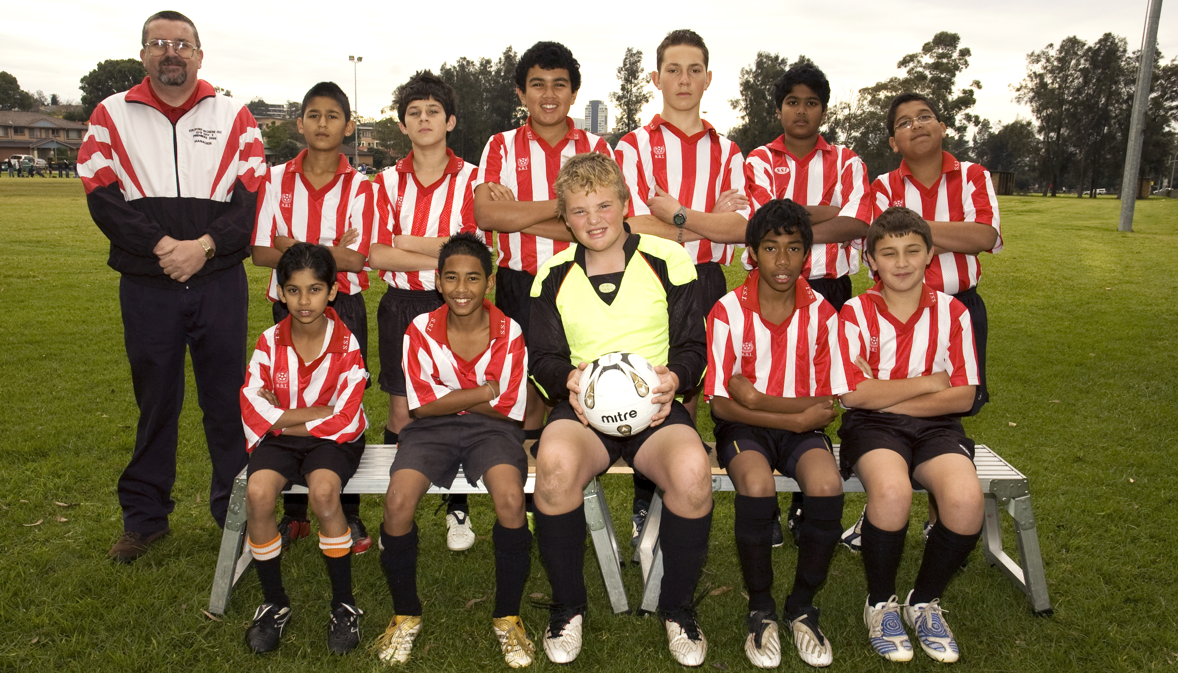

These guys are doing their HSC or first year post school - but was this our cleverest team ever? They now boast boys aspiring to be a physio, studying to be a doctor, a lawyer and a dentist as well as the photographer on the following youtube video featuring another McCredie junior from the team one year older. https://www.youtube.com/watch?v=BstpPX52JNI&feature=youtu.be
Going well guys – keep it up!

RESULTS – 9th & 10th August 2014

U6 Red vs
Our kids played so well today. They all had some great kicks and dribbling of the ball. We didn’t let the other team make it to our goal! Fantastic defence. Patrick is man of the match as he played so well.
Goal scorers – Wek Deng 4, Adhar Yaac 3
U6 White vs Hills Spirit White 6 - 0
Today our team had the best game ever. Everyone scored and the parents were over the moon. Good job my little machines so proud of you!
Goal scorers: Dut Atak 1, Badih Ayoub 1, Omar Elbizri 1, Lamar Fahme 1, Joseph Douehi 1, Nour Matar 1
U7 Red vs Bye

U7 White vs Hills Spirit Blue 0 - 11
Unfortunately the score line reflects the difference between the two teams, but it does not reflect the efforts that the five players that played today put in against a very good team playing with reserves. Adam and Christian shared the goal keeping duties, but probably wished that they were somewhere else today. They both made some good saves but were not able to stop all the shots on goal. When not playing in goals, Christian tried his best playing in defence with help from Isaiah. Isaiah made some great clearing kicks in defence and assisted Lucy, Jonathan and Adam with the very few attacking raids that the team had. Lucy tried very hard today making some dribbling runs along the side line and beating some of the defence at times to create what little chances the team had. Johnathan and Adam tried to assist Lucy in attack but were also unable to break the defence of Hills Spirit. Better luck next week and hoping those that are sick recover in time to play. Hills Spirit only had one more player on the field than our team, but that one player on the field and their fresh reserves must have seemed like two teams to the players that played for Guildford today. For the parents of the two players who did not show up or contact the manager today to let him know of your child’s unavailability, you let the team down.

U8 White vs St Columbas Castle Hill 1 - 1
Our kids played their hearts out and were the better team on the day but it wasn't meant to be. Ali played a sensational game! Getting a goal mid way through the first half and our team just kept troubling their goal line again and again but missed our chances to seal the game. All our kids today, Fouad, Owen, Jack, Sebastian, Kassem, Dylan, Daniel, Adam & Ali have improved through the season and play with a great sense of mateship which is lovely to watch. It was nice to have had Ryan Lu from U6 help out in today’s game also. We were about 5 mins from full time and the game within our grasp, but a broken passage of play saw the opponents get a cheap goal. Without much time left we pressured hard to win it back however the full time whistle came and it was a lucky escape for the undefeated All Saints who are table leaders but were today facing a much improved and resilient team of kids who believe in themselves and each other that they can beat any team now. 1 game left in the season and a must win to make the finals. Go team!
Goal Scorers: Ali Fahme 1

U8 Red vs Kings Old Boys 2 - 9
Today Yasmin saved 13 goals and Joey would of scored 4 more goals if they went in. In the first 30 seconds of starting Joey almost scored but the goalie caught the ball. Our opponents played smart today they had high kicks into the goals. Our teams effort was great today. They played really well and never gave up. Keep up the good work team. Player of match Yasmin
Goal scorer – Joey Farah 2

U9 vs OLQP Falcons 4 - 0
One for all and all for one!!! That was our game today. The team was playing in such a harmony and making the right passing to the right player and scoring. Getting toward the end of the season after hard training, listening to coach’s instructions and believing in team efforts we have surely come a long way. It was an awesome game!
Goal scorers: Charbel Chehab 2, Mohamed Mattar 2
U10 vs St Bernadettes Castle Hill won on forfeit
U11 vs Kings Old Boys 0 - 0
This week, we again dominated field position & possession, with Kings rarely in our half of the field. However, just like last week we again failed to convert this dominance into any goals on the scoreboard. On a positive note, Kings did not score any goals, so our defence was better this week. Lets hope in next week's final round game we remember how to get the ball into the back of our opponent's net & get back into the winners' circle.

U12 vs McCredie 13s 2 – 1
Today we versed our u13s. It was great to get another win but also great to see how much the boys have improved with their passing and with controlling the ball. Joe scored us two amazing goals and Johnny saved us many attempted goals. Great effort to both teams.
Goal scorer – Joe Azzi 2

U13 vs McCredie 12s 1 – 2
Tough game for our team but they played well & they showed they can be up there with the top teams when they put their mind into it. Scoring first but could not hold on then falling 2 - 1 at full time, the score does not reflect the reality of the match with many wasted chances & hitting the cross bar. The whole team played well & I am proud of them all from Mika the goalie to Ryan & Cameron in the attack, good defence line & was strong the whole game was also backing up the midfield. The midfielders were running non stop & they were the creating a chance after another until we won a free kick & Ahmad made sure the ball went straight to the net to open the score for our team. The defence was the back bone of our team this match & Richard played a huge game he was a solid rock in defence & sending supply of long distance balls to our stickers & wingers which helped in winning possession & taking the danger to the other side of the field & that's why he was named our man of the match.
Goal scorer – Ahmad Saad Ekdawy 1

U14 catch up vs Lidcombe Waratah 1 - 3
Did we deserve to win – no. But we didn’t deserve the two decisions that cost us two goals either. We have been struggling for form there is no doubt but we are the same players that went through the first round losing just the first and last games. We are a quality side that have beaten or at least drawn with two of the other sides who we will play in the semis. We can do this! Nice to get Matt back on the score sheet tonight through sheer persistence.
Goal scorer – Matthew Richards 1

U14 vs Granville Waratah 0 – 2
This game looked very familiar to the last time we played these guys. They dominated possession and scored early. They continued to dominate but couldn’t score again until the last few minutes. In the mean time both teams hit the woodwork but unlike last time, we didn’t score more goals than them. Let’s see if we can in two weeks when we meet again in the semi.
Kabin added real punch to the midfield today, Daniel marked well and Matt McGuire played strongly on the left. Vernon though led the way with his never say die running, determination to get to the ball and consistent effort throughout the match.

U16 vs Lidcombe Churches 0 - 0
Lidcombe were out today for a big win so they could regain 1st position on the ladder, but we had other ideas. We took the game to them from the start, passing and supporting each other, probing into their backs looking for opportunities. We had a number of close shots and we should have had 2 penalties awarded to us for hand ball, but the referee was oblivious. Our intensity was so great that Lidcombe didn’t even get a shot on goal in the first half. We continued in the second half the same as the first, but just couldn’t put one away. Then the last 20 minutes saw Lidcombe lift and throw everything they had at us, but the backs held firm while Hamze put his body on the line to pull off the save of the year. We nearly had them a couple of times on the counter, with Emir, Alan, Will and Dusan all coming oh-so-close to scoring, but no goals. We deserved a win, but can’t be unhappy with the draw. Why did we wait until the end of the season to show that we can actually play some good football?

RC1 Reserves vs Wentworthville Uniting Blue 8 – 1
Final competition match before semi-finals. Unfortunately, we didn’t retain our 2nd place spot but positive finish to the season.
Goal Scorers: - Jeff Eker 4, An Dao 1, Dany Badoui 1, Adem Stevens 1, Wil Wark 1

RC1 Firsts vs Wentworthville Uniting Blue 12 – 2
Nice fun game to finish the competition part of the season. 1st v. 2nd (us) next week so will need to lift a gear.
Goal Scorers: - Mick Massih 3, Mohammed Al Delaimi 3, Jeff Eker 3, Daniel Richardson 1, Nic Stamos 1, Wil Wark 1

Ladies vs Winston Hills 2 – 0
Today’s win was really pleasing as we played so well! Everybody really lifted and it has us very excited for the semis. Ania, Elise, Chantelle and Nyanut had particularly strong games – but it’s really hard to single people out in a performance which was as flawless as we get. Great effort girls!
Goal scorers – Taufa Kivalu 1, Mika Oo 1

Tuesday 12th August 2014

U16 vs Winston Hills at Masonic Schools 1 (Seven Hills Rd., Winston Hills)
7.00pm Kickoff (meet at Winston Hills at 6.30pm)

Saturday 9th August 2014

U6 Red vs OLQP Falcons Blue at Everley mini (Everley Rd., South Granville)
8.00am Kickoff (meet at Everley at 7.30am) (set up field)

U6 White vs Hills Spirit Red at Everley mini (Everley Rd., South Granville)
8.50am Kickoff (meet at Everley at 8.20am)

U7 Red vs Kings Old Boys at Everley mini (Everley Rd., South Granville)
10.00am Kickoff (meet at Everley at 9.30am)

U7 White vs OLQP Falcons Yellow at Everley mini (Everley Rd., South Granville)
11.00am Kickoff (meet at Everley at 10.30am) (dismantle field)

U8 Red vs OLQP Falcons Red at Everley 2 (Everley Rd., South Granville)
9.00am Kickoff (meet at Everley at 8.30am) (set up field)

U8 White vs Kings Old Boys at Everley 2 (Everley Rd., South Granville)
10.00am Kickoff (meet at Everley at 9.30am)

U9 vs St Bernadettes Castle Hill Eagles at Everley 2 (Everley Rd., South Granville)
11.00am Kickoff (meet at Everley at 10.30am) (dismantle field)

U10 vs OLQP Falcons Blue at Daniel (Daniel St., Greystanes)
10.00am Kickoff (meet at Daniel at 9.30am)

U11 vs Hills Spirit at Everley 1 (Everley Rd., South Granville)
12.00pm Kickoff (meet at Everley at 11.30am) (dismantle field)

U12 vs Hills Spirit at Kellyville (Memorial Ave., Kellyville)
11.00am Kickoff (meet at Kellyville at 10.30am)

U13 vs Kings Old Boys at Homelands (Homelands Ave., Telopea)
9.00am Kickoff (meet at Homelands at 8.30am)

U14 vs Castle Hill United at Everley 1 (Everley Rd., South Granville)
9.00am Kickoff (meet at Everley at 8.15am) (set up field)

U16 vs Lidcombe Waratah at Everley 1 (Everley Rd., South Granville)
10.15am Kickoff (meet at Everley at 9.45am)

Raahauge Cup Reserves Elimination semi final vs South Hurstville Uniting 1pm Kick off – Walshaw (Hector Rd., Bass Hill)

Raahauge Cup Firsts Major Semi Final vs South Hurstville Uniting 3.00pm kick off Walshaw (Hector Rd., Bass Hill)

Sunday 17th August 2014

All Age Ladies vs Pendle Hill at Max Ruddock 1 (Romulus St., Winston Hills)
1pm kick off (meet at Max Ruddock at 12.15pm)

