OTB 23/14

Club Secretary – Greg 9682 7779 President – Peter 9632 9203

Interested in sponsoring a team or advertising in this newsletter? – call one of the above numbers.


GUILDFORD McCREDIE UNITING
SOCCER CLUB

ANNUAL PRESENTATION DAY

Friday 7th November 2014

Commencing at 6.30pm
at
McCredie Memorial Uniting Church Hall
486 Guildford Rd., Guildford
Cnr Guildford & Chetwynd Rds., Guildford

Presentation of trophies

Sausage sizzle

_____________________________________________________
Notice of Annual General Meeting – Thursday 14th November
7.30pm McCredie Uniting Church

National Titles – Volunteers Sought
Why not come and volunteer at the 2014 National Titles. NSWCFA seek your assistance to be involved with making the National Football Titles a big success.
Over 38 teams from across Australia and New Zealand will come together at Narrabeen Sport & Recreation camp . Opening Ceremony and Church Service are on Sunday 28th, Competition starts on Monday 29th September and concludes on 1st October, 2014
Volunteers are need in all areas to help make this event “the best ever”. A stylish Volunteers’ shirt will be provided.
Come for a couple of hours or a couple of days, we would love to have your help.
If you can help out please contact secretary@nswcfa.com.au
Volunteer form download
_________________________________________________________________________________________________
REMINDER

Coaches and Managers – please remember to return your gear, provide your end of season report and let the secretary know your trophy winners this week. Thanks.

RESULTS – 30th August 2014

U6 Red season finished

U6 White season finished

U7 Red season finished

U7 White season finished

U8 White season finished

U8 Red season finished

U9 Grand final vs Lidcombe Churches 0 – 1 (golden goal extra time)

U10 season finished

U11 season finished

U12 Grand final vs Kings Old Boys 0 – 1
With a fantastic atmosphere, the ground and stadium in perfect condition and a big crowd the boys took on the minor premiers Kings Old Boys. It was a tough contest and required hard work in defence, but we were the first to threaten the goals with Charles smashing the underside of the crossbar only to see the ball go down and then out. Was it in? Was it out? Nobody really knew and without crossbar cam still nobody really knows. Kings were able to find the goal once unfortunately and despite a magnificent game from Charles, incredible keeping from Jonny and especially terrific efforts from Josh, Qais, Shaleen, Anthony, Ferdinando and Andrew we were unable to come up with one of own. Bad luck guys – great effort.
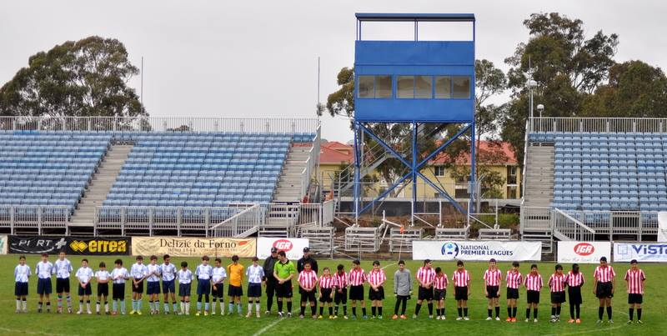

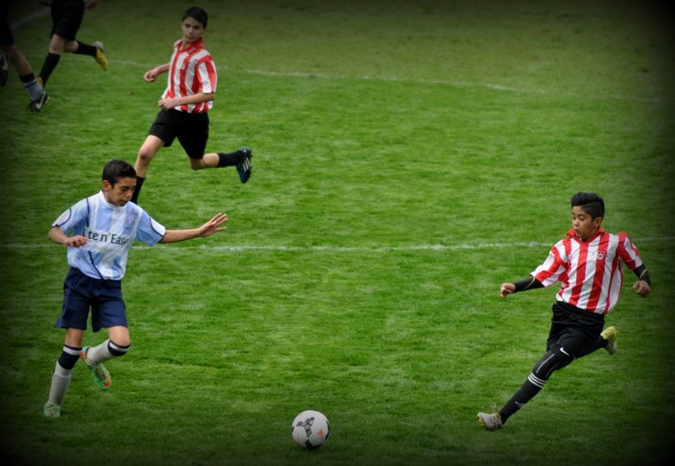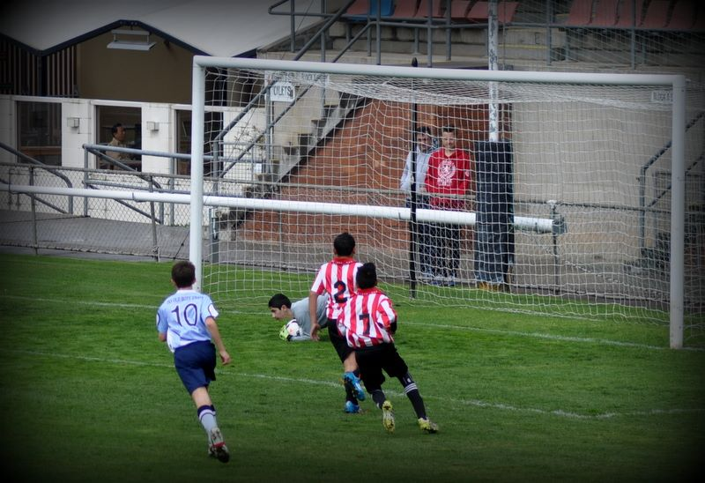

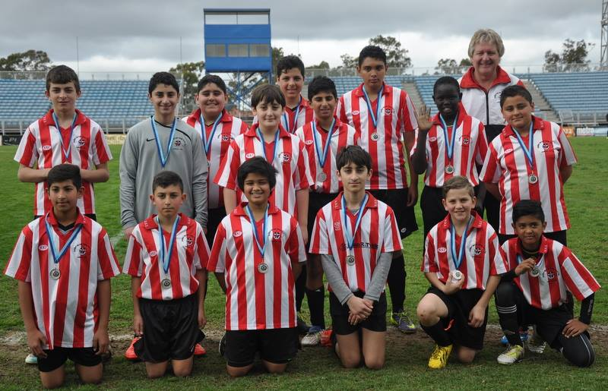

U13 season finished

U14 semi vs Merrylands SFC Black 2 – 3
Merrylands were the undefeated competition minor premiers having conceded just 6 goals all year. How do you reckon they were feeing at half time in this sudden death semi at 2-0 down! That’s what happened as the team stuck strictly to the plan of fill the midfield, strengthen the defence, mark tight and release the striker on the counter. We felt very clever when in the 4th minute we won a corner and Jake finished a perfect header from Kabin’s perfect cross. It got better, 10 minutes later Matt hit the goal of the year from 25 metres, smashing the ball into the net like a tracer bullet – the keeper didn’t move. Half time 2-0 up. We knew there was still plenty to do but with an effective game plan we didn’t change a thing. Merrylands are a quality side and they found some ways to score. Firstly a corner – as we had done, was headed home. Next a striker slipped through, and finally, in the second minute of added time, a dribbling midfielder earned a penalty. So close! Our team was magnificent, we had gone closer than any other team to beating them, and finished the season with one of our best performances. Can’t be disappointed by that.
Goal scorers – Jacob Mitwali 1, Matthew Richards 1.

U16 season finished
RC1 Reserves season finished

RC1 Firsts Grand final vs Miranda Congregational 3 – 0

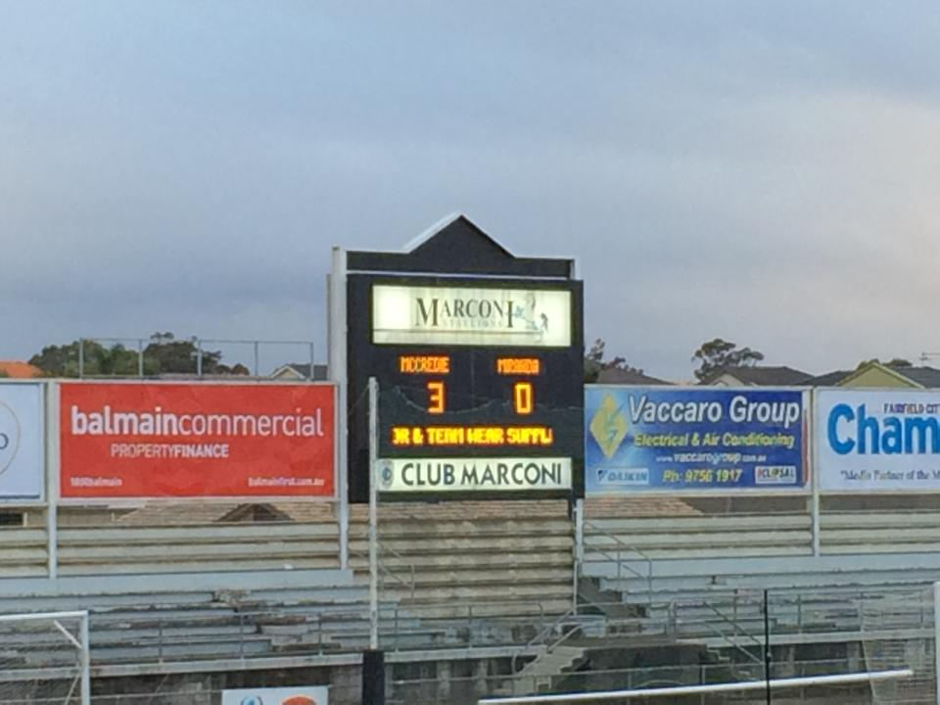

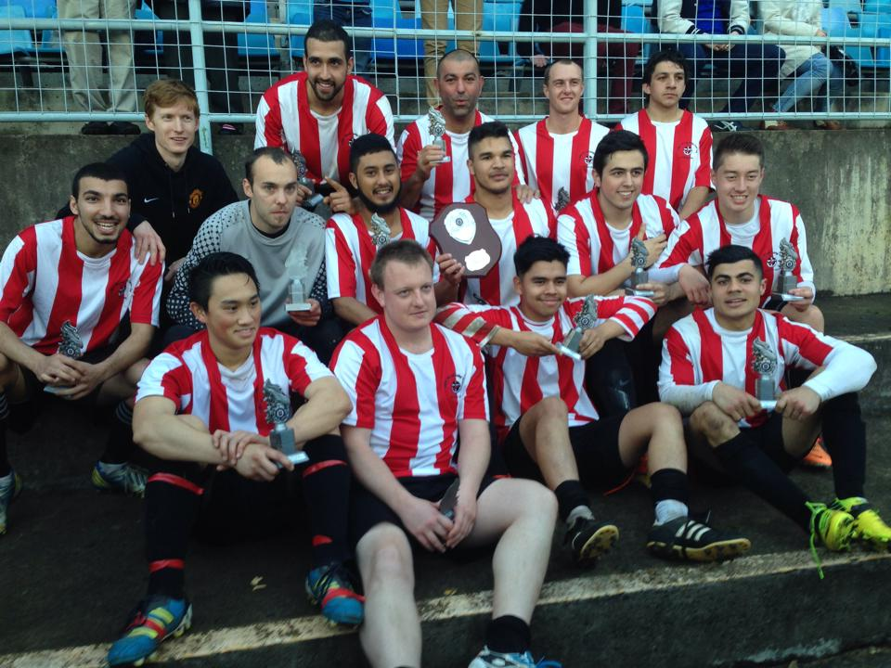

Goal scorers – Daniel Richardson 1, William Wark 1, Mohamed Al Delaimi 1

Ladies Grand final next week

Sunday 7th September 2014

All Age Ladies Grand final vs North Rocks at Webbs Ave 3 (Webbs Ave., Auburn)
12.30pm Kick off (Meet at Webbs Ave at 11.45am)

