OTB 7/14

Club Secretary – Greg 9682 7779 President – Peter 9632 9203

Interested in sponsoring a team or advertising in this newsletter? – call one of the above numbers.
_____________________________________________________________________________________________________

A big couple of weeks ahead for the club

Calendar

Committee Meeting - Thursday 15th May 7pm Church Hall 486 Guildford Rd Guildford

Coaches Managers meeting - Thursday 15th May 7.30pm Church Hall 486 Guildford Rd Guildford

Club Photos - Saturdays 17th and 24th May – see below for which teams on which week and the back page for times

Kings Sevens – Under 12s, 13s, 14s, 16s, U18s Sunday May 25th at the Kings School

Annual six a side – Saturday June 7th U6 – U12, Monday June 9th U13, 14, 16, AAM, AAL, O35 at Everley Park

Lapathon – POSTPONED TO Wednesday 11th June 5.45pm – 7.00pm ALL TEAMS

_____________________________________________________________________________________________________

Club Photos will be taken on Saturdays 17th and 24th May

Photos need to be paid for before the photos are taken – please pay your team manager.

17th – Under 8 reds, 8 whites, 9s, 10s, 11s, 14s, 16s, RC

24th – Under 6 reds, 6 whites, 7 Reds, 7 Whites, 12s, 13s.

AAL – TBA

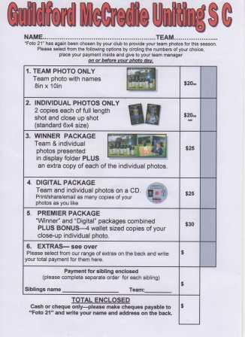

We do not seem to have copies of the following birth certificates. If your name is here please forward a copy of your birth certificate, passport or citizenship paper to your team manager this week.

Abbas Al-Kaabi
Rehab Shabir
Ahoi Ahoi
Hassan Al Shamariy
Jeffrey Farah
Ringo Ajang
Akot Akot

________________________________________________________________________________________________________________

RESULTS – 10th and 11th May 2014

U6 Red vs Hills Spirit Blue 9 - 0
What a fantastic game under 6 red! I’m so proud of these little guys and girls. They’re such good kids an so caring for each other. Patrick, Wek an Adhar were on a roll today with 3 goals to Patrick , 1 goal to Wek and a whopping 5 Goals to Adhar great job guys. Fantastic defence to Talitha, Keeyan and Adam in setting up the goals. Player of the match goes to Patrick!!!
Keep up the great effort
Goal scorers – Adhar Yaac 5, Patrick Matta 3 , Wek Deng 1

U6 White vs St Columbas Castle Hill 3 - 0
What a game today!! Everyone gave their best in playing, lots of improving at passing the ball to each other it was great team work, which led us to win today 3/0.
Goal scorers – Dut Atak 2, Joseph Doueihi 1

U7 Red vs St Bernadettes Castle Hill 7 - 2
Nothing much to say but fantastic. The boys once again showed tactics we use at training on the park. Zain again was strong at the back Gerri, Ali and Ahoi just too quick up front and Fayez, Yusef, Simon and Thomas way too strong in the centre but a stand out performance today was from Angelo with some great shots and a few goals to his name. All I can say is bring it on.Goals Ahoi 4 Angelo 2 Gerardo 1. Man of the match Fayez
Goal scorers Ahoi Ahoi 4, Angelo Guidone 2, Gerardo Cavasinni 1

U7 White vs St Bernadettes Castle Hill 2 - 1
After three losses in consecutive weeks the team today came away with their second win of the season. The game against St Bernadette’s Tigers today showed how well the young boys and girls in the team can play. The two goal keepers today, Moustafa in the first half and Adam in the second half made some great saves and kept us in the game. The defensive players, Christian and Isaiah kept holding out the attacking plays by St Bernadettes. Isaiah playing as the last line of defence made numerous clearance kicks halting St Bernadette’s momentum and swaying it back into Guildford’s favour. The midfield, wingers and forwards made up of Sarah, Jonathan, Solange, Yar, Lucy and Muhammad gave their all in attack. Many chances were created but only two chances were converted into goals and fortunately these were enough to provide us with a win. This game and win was dedicated to all the soccer mums of the team. Hoping you all have a wonderful mother’s day.
Goal scorer: Muhammad Ziyan 2

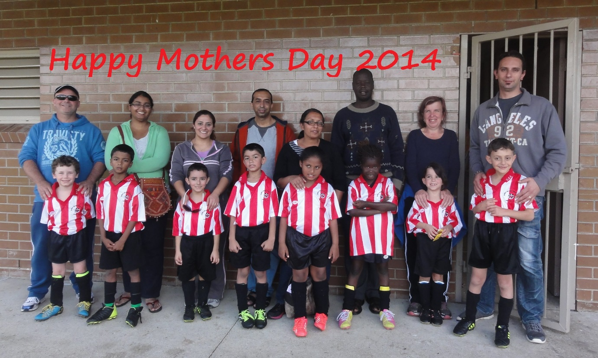

U8 White vs St Bernadettes Castle Hill Lions 4 - 3
Good to see most of us at the game today. It was a beautiful sunny morning and our kids played much better today. Signs of the kids starting to be aware of the passing game. Defenders stayed in defence and all fought hard for the ball. We could have easily been up by much more than 2-1 at half time but the Lions played really good defence. Our 2 Striking Mantis' Fouad and Ali got another goal each in the second half and Owen was unlucky not to have finished off a really good break, and played hard all day all over the park earning him player of the match. 4-2 up with moments to go our kids did get tired letting the Lions in with another simple goal. We focus on fitness, so this tells me we're not training hard enough on it. Get ready kids for training!
Goal scorers: Ali Fahme 2, Fouad Ayoub 2



U8 Red vs Lidcombe Churches 1 - 6
You could see the determination on our players’ faces. They so badly wanted the ball. They tried so hard to put into practice what they were taught at training but for some odd reason bad habits are hard to break. You can always count on Kareem to save the ball when our opponents run with the ball to score. He saved a few with his mighty kicks which scored him man of the match. Well done Kareem!
Yasmin & George both played goalie. The score would of been 9-1 but they both saved 2 goals each. Anthony tried so hard to play his position while Joshua & Mark played good defence. Elisa & Aluel had all eyes on the ball. You could see they were hunger for the ball! Ibrahim showed good team spirit by passing to his team players and trying to get the ball out to the sides. Joey managed to score our only goal. Well done team. Man of the match Kareem
Goal scorer – Joey Farah 1

U9 vs Wentworthville Uniting 0 - 2
First loss of the season. Grrrrrr! It doesn't feel good. The boys also didn't like the idea and picked themselves up in the second half, put more pressure on their defence and stopped the opposition from scoring any more goals. Hard luck team! But am sure we learned a lot from this game and always remember "SPREAD OUT".

U10 vs Wentworthville Uniting 0 - 7
What is my excuse today for our loss? Unfortunately we only have 11 players at the moment, so it's very hard for our team not having any subs when all the other teams have 16 players! Our team did play well, John impressed us all with this awesome pass, he managed to get past the opposition, who mind you is twice his size! Adrian has been playing really well, keep it up. Adam plays well every week, good work. Michael played in goals for a while today, he stopped some goals. We really need to push harder so hopefully we will have a win next week.

U11 vs St Bernadettes Castle Hill 4 - 1
We scored early, after a nice right cross from John-Luke, found Shaleen in clear space for him to strike a nice goal. After an innocuous St Bernadette's goal kick & seemingly against the run of play St Bernadette's scored an equaliser.
As half-time approached Shaleen put through a nice ball to the left of goal for Christian to run onto & score. In second half our passing game was better. John-Luke crossed to Mounir who was blocked from taking a shot, so passed nicely to Christian who then scored. Our final goal was a true team effort. The backs combined to get the ball to Geetansh, who took the ball down the left side of the field, he then fed a nice ball to Christian who passed neatly to Mounir in some space. Mounir then dribbled past the goalie, but his shot hit the post & rebounded out to the right to John-Luke who calmly slotted home the goal. Elias as goalie, along with the backs & halves, Deng, Ryan, Joel, Peter, Yilmaz, Christopher, James & William put in a solid effort. Overall a pleasing result with the team trying their best. A good win. Man of the Match Shaleen Nagar. Goal scorers: Christian Frangie 2, John Luke El Rahi 1, Shaleen Nagar 1

U12 vs Wentworthville Uniting 2 - 4
Poor start to the game. The boys heads just weren't screwed on today. The opposition took control from the minute we started and scoring three goals in the first half. Kicking was poor and there was no communication between the players. Second half was much better, with Joe scoring us our first goal of the game. There was more involvement from Chris, Ahmet and Charles, also a few goal attempts by Ferdinando. Finally, we were able to get another goal by Joe, making it 2-3. However, the Wentworthville came back with a finishing goal, leaving it 4-2. It was definitely a tough game today. We also had our goal scorer Joe hurt towards the end of the game. Hope you get better Joey! Goal scorers: Joey Azzi 2

U13 vs Hills Spirit 3 - 0
It was team work, discipline and the “ I will” attitude that brought our U13’s 3 points on Saturday, defeating the Hills Spirits 3-0 at Everley. Ahmed scored first from outside the box while supporting the attack & finished the first half 1-0. Second half boys and girls kept the pressure on the Hills and their reward was two long range goals. First by Ryan who connected his left foot to the ball and send it hugging the net, then Ahmed again, support the attack, got the loose ball and chipped the keeper from almost halfway! All the team was great, the defence was awake and strong lead by Jasper who kept Mika safe while goalie the first half. Midfield were great with a magic touch from Ryan and all the line. Attack never stopped by Antoine and Adut they both kept the threat real and close to the Hills’ box. The most improved player this game was Nicholas who had a great game in the midfield and also had a few shots on target.
Man of the match is Ahmed.
Goal Scorers: Ahmad Saad Ekdawy 2, Ryan Carder 1

U14 vs Rydalmere 3 - 2
Matt’s finishing was on today and suddenly the game seemed much easier. We quickly shot out to a 2 – 0 lead before Rydalmere could regroup, but by the time they had scored a catch up goal Matt was well rested and he struck again. The game then drifted a bit until the final 10 where we took complete control only to concede a soft break away goal in the final seconds which was frustrating. Serge supported well up front, Akot had his strongest game of the year, Salem was strong in goals, Biyan, Joel and Kabin played well and Rusheel was outstanding with his calmness on the ball earning him player of the match.
Goal scorer: Matthew Richards 3

U16 vs Merrylands SFC 2 - 5
Goal scorer – Emir Biber 2

RC1 Reserves vs St Columbas Castle Hill 3 - 0
While this would never be described as a stellar performance it was a great result especially with us missing so many players. We showed our squad depth today and we pulled together for each other. Even though everyone did great Andy and An deserve special mention.
Goal Scorers: - Mic Di Marti 1, Duy An Dao 1, Jeff Eker 1

RC1 Firsts vs St Columbas Castle Hill 4 - 2
Missing 7 players against a team that was in Premier League last year we expected a tougher test against a team that was also competing for a top 4 spot this season. That said we went behind first but this proved a wake up call. We finally started playing it on the ground and using our speed out wide and it didn't take long for us to get back on top. We were unfortunate to lose our sweeper for the second match but the team pulled together and we saw the remainder of the game out.
Goal Scorers: Mohammed Shukur 1, Adem Stevens 2, Wil Wark 1

Ladies vs Ermington United 3 – 1
A nice way for our ladies to celebrate Mother’s Day. We got off to a nice start with some persistence from Chantelle and an opportunistic finish from Taufa. Unfortunately we let them back in and were locked at 1-1 at half time. The second half started well though with Taufa cracking a 25 metre drive into the net and then a very neat pass from Laura found Rana for a delicious first time finish. Mo and Sarah I defended well but it was Chantelle’s 100% effort that saw her win many more balls than she had any right to win and therefpre take our player of the match award.
Goal scorers – Taufa Kivalu 2, Rana Karakus 1
Thursday 15th May 2014

B Grade Knockout

Raahauge Cup 1 vs Wentworthville Uniting Gold at Jones 1 (Banks St., Merrylands)
7.00pm Kickoff (meet at Jones at 6.30pm) (set up field)

Saturday 17th May 2014

U6 Red vs OLQP Falcons Red at Daniel (mini 2) (Daniel Street, Greystanes)
10.00am Kickoff (meet at Daniel at 9.30am)

U6 White vs Hills Spirit White at Kellyville (Memorial Ave., Kellyville)
11.00am Kickoff (meet at Kellyville at 10.30am)

U7 Red vs Lidcombe Churches Blue at Phillips (Martin Street, Lidcombe)
10.00am Kickoff (meet at Phillips at 9.30am)

U7 White vs Wentworthville Uniting Gold at Freame (mini) (Rees St., Mays Hill)
9.00am Kickoff (meet at Freame at 8.30am)

U8 Red vs Wentworthville Uniting at Everley 2 (Everley Rd., South Granville)
9.00am Kickoff (meet at Everley at 8.15am FOR TEAM PHOTO) (set up field)

U8 White vs Lidcombe Churches at Everley 2 (Everley Rd., South Granville)
10.00am Kickoff (meet at Everley at 9.00am FOR TEAM PHOTO)

U9 vs OLQP Falcons Red at Everley 2 (Everley Rd., South Granville)
11.00am Kickoff (meet at Everley at 10.15am for TEAM PHOTO) (dismantle field)

U10 vs Hills Spirit Blue at Everley 3 (Everley Rd., South Granville)
12pm Kickoff (meet at Everley at 11.00AM FOR TEAM PHOTO) (dismantle field)

U11 vs Wentworthville Uniting Gold at Everley 3 (Everley Rd., South Granville)
11.00am Kickoff (meet at Everley at 10.00AM FOR TEAM PHOTO) (set up field)

U12 vs St Columbas Castle Hill at Eric Mobbs 2 (Excelsior Ave., Castle Hill)
11.00am Kickoff (meet at Eric Mobbs at 10.30am)

U13 vs bye

U14 vs Lidcombe Waratah at Everley 1 (Everley Rd., South Granville)
9.00am Kickoff (meet at Everley at 8.00am FOR TEAM PHOTO) (set up field)

U16 vs Winston Hills Bears at Everley 1 (Everley Rd., South Granville)
10.15am Kickoff (meet at Everley at 9.15AM FOR TEAM PHOTO)

Raahauge Cup 1 vs Miranda Congregational at Everley 1 (Everley Rd., South Granville)

(Reserves Kick off at 1.15pm Firsts at 3.15pm) (Meet at Everley at 12.45pm) (SQUAD PHOTO AT 3.00pm)

Sunday 18th May 2014

All Age Ladies vs Auburn FC at Webbs Avenue (Webbs Ave., Auburn)
1.00pm kick off (Meet at Webbs at 12.15pm)

