OTB 8/14

Club Secretary – Greg 9682 7779 President – Peter 9632 9203

Interested in sponsoring a team or advertising in this newsletter? – call one of the above numbers.
_____________________________________________________________________________________________________

Please be aware that this week’s lapathon has been POSTPONED – it will now take place on June 11.

It was postponed due to the first round of junior knockouts – please check the back page carefully as a number of teams have midweek games under lights this week.

Upcoming dates

Calendar

Club Photos - Saturdays 24th May – see the back page for times

Kings Sevens – Under 12s, 13s, 14s, 16s, U18s Sunday May 25th at the Kings School

Annual six a side – Saturday June 7th U6 – U12, Monday June 9th U13, 14, 16, AAM, AAL, O35 at Everley Park

Lapathon – POSTPONED TO Wednesday 11th June 5.45pm – 7.00pm ALL TEAMS

Zone rep trials – Under 8, 9, 10, 11, 12, 13 June 10 and 12 – see your coach for details.

_____________________________________________________________________________________________________

Club Photos will be taken this Saturday 24th May for the Under 6 reds, 6 whites, 7 Reds, 7 Whites, 12s, 13s.

Photos need to be paid for before the photos are taken – please pay your team manager.

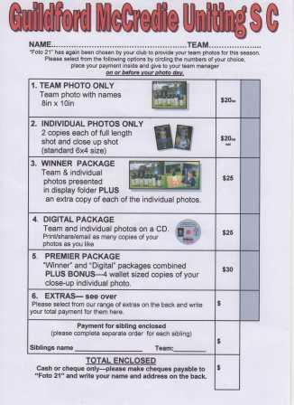

Managers please follow these birth certificates up this week – we do not want to have to stop players playing until we have them – but it is now May!

Abbas Al-Kaabi
Rehab Shabir
Ahoi Ahoi
Hassan Al Shamariy
Jeffrey Farah
Ringo Ajang
Akot Akot

________________________________________________________________________________________________________________

RESULTS – 17th and 18th May 2014

U6 Red vs OLQP Falcons Blue 9 - 3
We had a much tougher game this week, even though our scoreline shows a comfortable win. The OLQP team had a good number of shots at our goal, scoring a few times. But we managed to keep their score low with some great goal-keeping and a few fantastic saves by Wek, Patrick, Ater and Talitha. There was also some great defending by Keeyan who manages to stop a lot of balls getting through, and Patrick, Wek and Adhar were strong in chasing back to defend. Adhar, Patrick and Wek scored some fantastic goals, sometimes with persistence when the defence was tough, but other times with some very accurate shooting. Great game team!
Goal scorers: Adhar Yaat 4, Patrick Matta 3, Wek Deng 2.

U6 White vs Hills Spirit White 10 - 0
Another week and another awesome win! The kids played really well today! Passing the ball to each other, strong defence that made it impossible for the other team to score! The team was on fire. No one wanted to sit on the side and rest. Great work under 6 white. Very proud of every and each one of you. Keep up the good work!
Goal scorers – Dut Atak 7, Joseph Doueihi 3

U7 Red vs Lidcombe Churches 6 - 0
A scrappy game today however the boys had it all under control and they all played well. That pretty much sums it up. Well done to everyone. Man of the match Ali.
Goal scorers: Ali Saad Ekdawy 4, Gerardo Cavasinni 2

U7 White vs Wentworthville Uniting Gold 1 - 1
Well what game today from Guildford under 7's White! We were up against the same team that pummelled us 10-0 in our first trial game. After going behind early the team showed how far they have come along by playing excellent team football to come back and score before halftime. Once again our goal scoring machine Mohammed on the score sheet. Through some excellent defence by Isiah and Christian and some great go forward by Lucy and Solange and being supported by Johnny, Sarah and Yar we were incredibly unlucky not to score 2 more goals. Adam was especially good as goalkeeper. All in all a fantastic effort to draw 1-1 in the end, Considering Mustafa didn't play because he was sick.
Goal scorer: Muhammad Ziyan 1

U8 White vs Lidcombe Churches 3 - 4
We played well but couldn't make it back after going into the half down 0-2. An easy goal at the start for their Godzilla striker took us by surprise. His size and speed also stopped many of our breaks throughout the game. We were a much smaller team and got pushed around the park a bit. However our kids played very well with Ali, Fouad and Owen each getting a goal in the second half. Dylan was great today chasing down everything and passed the ball to his teammates who were free to finish the job. The strong effort earnt him player of the match. I was disappointed we lost but it was a good tough game and the kids enjoyed it.
Goal scorers: Ali Fahme 1, Fouad Ayoub 1, Owen Thai 1.

U8 Red vs Wentworthville Uniting 0 - 2
Positions! Positions! Positions! The team must learn to stay in their positions. They need to understand if they stay in position they won't be taking the ball of each other and they won't exhaust themselves from running after the ball. George and Yasmin played goalie today. They managed to save a few goals. George saved the first goal by using his leg. Great save George! By the time first half was over the score was 0-0. We were really excited at this stage. The team was running but not getting. Second half Joey managed to almost score two goals but somehow would trip over in front of the goals. Better luck next time Joey! Mark showed good sportsmanship which scored him man of the match. Good work Mark! The rest of the team played really good defence but must remember to stay in their position. Man of the match – Mark-Anthony Chehade

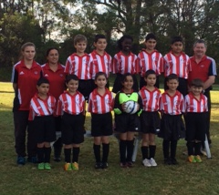

U9 vs OLQP Falcons Red 2 - 0
It was such a pleasure to watch today's game. Full of energy, fighting for their ball and leading to the win. Most of the players showed big improvement in their soccer skills which is the result of hard training and commitment on a weekly basis. Hats off to Abuk and Tamir who were on fire today and got us all impressed by their defence and running skills. Well done boys and girl. Wish you all the best in the knock out game this Wednesday.
Goal scorer: Mohammed Mattar 2

U10 vs Hills Spirit Blue 0 – 5
It was a tough game today playing against such a strong opposition. Our team didn't play their best first half of the game letting 4 goals slip past them. Mary played well, playing great defence, she also runs very fast allowing her to get to the ball first. Second half our kids did play better only allowing 1 goal to get past them. Aaran almost scored last 5 min of the game, it would've been nice but it was unlucky...
We are still going to hold our heads up high and keep trying. We did have fun dismantling the field so I've included a pic for Toufic!

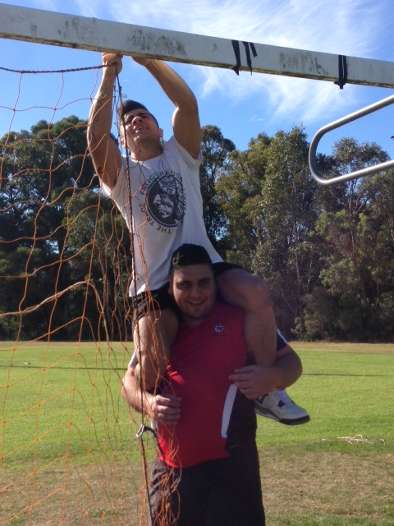

U11 vs Wentworthville Uniting Gold 12 - 0
Today our game was a pleasure to watch, not just because of the scoreline, but the way the whole team contributed to the win by playing their role to the best of their ability. The list of goal scorers is a testimony to the opportunities created, built on a strong defence to enable multiple raids. Those who did not score, Adhel, James, Ryan, Joel, Christopher, Geetansh, Elias & Shaleen, equally contributed to the resounding win. The crosses from the left or right of goal generally found an eager player in position to have a shot. The backs and goalie always returned the ball quickly to the mid-fielders thus ensuring most of the play was in front of Wenty's goal. Well done team, kept up the good work. Man of the Match: Peter Germanos
Goal scorers: Goal scorers:, Mounir Hadid 4, Peter Germanos 2, Christian Frangie 2, John-Luke El-Rahi1, Deng Aguok 1, William Durbidge 1, Yilmaz Temel 1

U12 vs St Columbas Castle Hill 1 - 1
Outstanding effort from our boys today!. Once again we did not have a full team, with only 10 players and no reserves , they were able to allow only one goal from Castle Hill.Each player performed very well in their positions. Our defender Andrew was fully focused,he was able to get back every ball that came his way and with his big kicks, gave us a greater chance to score. Great work by Charles and Ferdinando, they did not give up through out the whole game, they had great control of the ball and were able to set up goals. Great contribution to Chris, Salvator, Hassan, Jeffrey and Ahmet. Also, great work by our goalie Jonny. After missing a few opportunities, our striker Qauis was finally able to score, leaving it 1-1.Man of the match went to Charles, for once again, proving he can play his position very well.
I just want to say thank you to the parents who have been coming every week and showing full support.
Goal scorer: Qais Sungkar 1

U13 vs Bye

U14 vs Lidcombe Waratah 2 - 2
Matt’s in a rich vein of form at the moment firing off two goals against the competition’s leaders in the first 5 minutes. A fantastic start. The team was really up for the match with enthusiastic tackling from Daniel and Rusheel and clever team work from Serge (player of the match) and Jake. Missing our regular sweeper, Kabin really stepped up and Thuzar continues to impress with her commitment to heading the ball clear and challenging for everything. We probably tried to keep our lead rather than extend it and when they scored their first, panic set in a little. To concede a second goal in two weeks in the final minute is a problem. When we start to panic we watch the ball and try to get to it, rather than concentrating on the player we have been marking all match. Both those goals fell to unmarked players in the forward line. Must mark up. Not a disastrous result though, just a bit disappointing given the position we had been in.
Goal scorer: Matthew Richards 2

U16 vs Winston Hills 1 - 0
What a huge improvement in our attitude from last week. By getting to the ball first we totally shut Winston Hills out of the game. All of the backs played well, giving our 3 goalkeepers very little to do all game. Alan and Will were strong in the middle, setting up plenty of opportunities. Unfortunately, most of our forwards didn’t show the same fight as the backs and mids in wanting to get possession and get the ball in the back of the net. Our attempts on goal were meek and embarrassing. Luckily, a great run from Dusan found a determined John, who slotted home our lone goal. A big improvement in the forwards is required as we play 3 of the top teams in the coming weeks.
Goal Scorer: John Youssef 1

RC1 Reserves vs Miranda Congregational 1 - 1
We dropped 2 points even if it was against quality opposition. We were ahead and with 5 minutes to go they equalised. We were unlucky with the bounce of the ball for their equaliser with it ricocheting of a few legs & knees before it landed at an opposition players feet. He still had work to do and we didn’t shut down his attempt due to tired legs.
Goal Scorers: - Jeff Eker 1

RC1 Firsts vs Miranda Congregational 5 - 0
We decimated them in the first half but in saying that it still took the first 15 minutes for us to play to our strengths. Once we did that we scored 5 in the first half and were devastating going forward starting with our backline. Second half we still dominated possession and created chances but as the opposition came out in the second half with an axe to grind it was hard to play the same quick football which carved them up in the first half. Stand out performance by Adem who was at the heart of everything; at one stage he stopped an attempt at our 6 yard box, helped bring the ball up in a quick counterattack, drew the defender in to lay off the ball for a simple finish inside the opposition’s 18 yard box.
Goal scorers: - Adem Stevens 1, Antony Vojvoda 1, Mohammed Shukur 1, Mick Massih 1, Wil Wark 1

Ladies vs Auburn FC 1 - 1
2 more dropped points unfortunately, but we didn’t play poorly. I have seen us play poorly – but this wasn’t it! We held our position well, looked to pass the ball, worked hard and defended against a pretty good forward. At half time it was 0-0 and we were still feeling confident. Attacking was difficult today with a tightly packed defensive line but some neat passing between Laura, Nyunut and Taufa saw Taufa in space and a rocket shot into the back of the net. Unfortunately about 15 minutes later they caught us on the break and finished their opportunity. Both sides missed a couple but to be honest there were few clear chances for either side. Nyunut takes player of the match today. Well played girls.
Goal scorer – Taufa Kivalu 1

Tuesday 20th May 2014 Knockout semis

U8 White Knockout semi vs Kings Old Boys at Eric Mobbs 2 (Excelsior Ave., Castle Hill)
6.30pm Kickoff (meet at Eric Mobbs at 6.00pm)

U10 vs Lidcombe Churches at Jones 1 (Banks St., Merrylands)
7.00pm Kickoff (meet at Jones at 6.30pm)

Wednesday 21st May 2014 Knockout semis

U8 Red Knockout vs Lidcombe Churches at Phillips 2 (Martin St., Lidcombe)
6.00pm Kickoff (meet at Phillips at 5.30pm)

U9 Knockout vs Lidcombe Churches at Phillips (Martin St., Lidcombe)
7.00pm Kickoff (meet at Phillips at 6.30pm)

U11 vs Hills Spirit Blue at Jones 1 (Banks St., Merrylands)
6.00pm Kickoff (meet at Jones at 5.30pm)

Raahauge Cup 1 B Grade vs Kings Old Boys at Jones 2 (Banks St., Merrylands)
8.00pm Kickoff (meet at Jones at 7.30pm) (dismantle field)

Saturday 24th May 2014

U6 Red vs OLQP Falcons Blue at Everley (mini) (Everley Rd., South Granville)
9.00am Kickoff (meet at Everley at 8.30am FOR TEAM PHOTO) (set up field)

U6 White vs Hills Spirit Red at Everley (mini) (Everley Rd., South Granville)
11.00am Kickoff (meet at Everley at 10.15AM FOR TEAM PHOTO)

U7 Red vs Bye (meet at Everley at 9.00AM FOR TEAM PHOTO)

U7 White vs Hills Spirit White at Everley (mini) (Everley Rd., South Granville)
10.00am Kickoff (meet at Everley at 9.15AM FOR TEAM PHOTO)

U8 Red vs St Columbas Castle Hill at Eric Mobbs 2 (Excelsior Ave., Castle Hill)
9.00am Kickoff (meet at Eric Mobbs at 8.30am)

U8 White vs Wentworthville Uniting at Freame (Rees St., Mays Hill)
9.00am Kickoff (meet at Freame at 8.30am)

U9 vs Lidcombe Churches at Phillips (Martin St., Lidcombe)
10.00am Kickoff (meet at Phillips at 9.30am)

U10 vs Hills Spirit Red at Everley 1 (Everley Rd., South Granville)
10.00am Kickoff (meet at Everley at 9.30am) (set up field)

U11 vs OLQP Falcons Red at Daniel 2 (Daniel St., Greystanes)
10.00am Kickoff (meet at Daniel at 9.30am)

U12 vs Kings Old Boys at Everley 3 (Everley Rd., South Granville)
12.00pm Kickoff (meet at Everley at 11.15AM FOR TEAM PHOTO) (set up field & dismantle field)

U13 vs Wentworthville Uniting at Everley 1 (Everley Rd., South Granville)
12.00pm Kickoff (meet at Everley at 11.00AM FOR TEAM PHOTO) (dismantle field)

U14 vs Merrylands SFC White at Merrylands 2 (Cnr Merrylands Rd & Burnett St., Merrylands)
11.00am Kickoff (meet at Merrylands at 10.15am)

U16 vs Castle Hill United at Fred Catterson 4 (Catterson Dve., Castle Hill)
1.15pm Kickoff (meet at Fred Catterson at 12.45pm)

Raahauge Cup 1 Reserves vs Bye

Firsts vs Strathfield Prestige at St Lukes (Gipps St., Concord)

3.15pm kick off (Meet at St Lukes at 2.45pm)

Sunday 25th May 2014

Kings Sevens Tournament

U12 U13 U14 U16 U18

Players selected to participate must be at The Kings School by 8am – It is very important that all players report on time.

Managers please ensure you have the player’s player ID cards.

All Age Ladies vs Wentworthville Uniting at North Rocks (cnr Farnell and North Rocks Rds)
1.00pm kick off (Meet at North Rocks at 12.15pm)

