OTB 9/14

Club Secretary – Greg 9682 7779 President – Peter 9632 9203

Interested in sponsoring a team or advertising in this newsletter? – call one of the above numbers.
_____________________________________________________________________________________________________

Upcoming dates

Calendar

Junior knockout matches continue this week for under 8 Red & Under 9

Annual six a side – Saturday June 7th U6 – U12, Monday June 9th U13, 14, 16, AAM, AAL, O35 at Everley Park

Lapathon – POSTPONED TO Wednesday 11th June 5.45pm – 7.00pm ALL TEAMS

Zone rep trials – Under 8, 9, 10, 11, 12, 13 June 10 and 12 – see your coach for details.

Managers please follow these birth certificates up this week – we do not want to have to stop players playing until we have them – but it is now May!

Abbas Al-Kaabi
Rehab Shabir
Ahoi Ahoi
Hassan Al Shamariy
Jeffrey Farah
Ringo Ajang
Akot Akot

________________________________________________________________________________________________________________

2014 National Titles Player Trial dates

To be held at Jones Park, Banks St, Merrylands West

Under 14 Boys – 1st & 2nd July, 6pm

Under 16 Boys – 23rd & 25th June, 7pm

Under 18 Boys – 23rd & 25th June, 7pm

Under 23 / Youth Men’s – 24th June & 1st July, 7pm

Over 35s Men’s – 9th July, 7pm

Senior Men’s - 24th June & 1st July, 7pm

Under 16 Girls – 8th July, 5.30pm

Senior Ladies – 8th July, 7pm
Knockout RESULTS – this week

U8 White vs Kings Old Boys lost

U10 vs Lidcombe Churches lost

RC B Grade Knockout vs Kings Old Boys 3 – 0
Goal scorers – Mohamed Al Delaimy 2, Antony Vojvoda 1

RESULTS – 24th and 25th May 2014

U6 Red vs OLQP Falcons Blue 0 - 2
I think our kids forgot to have their WeetBix this morning, The other team had a strong attack and kept us on the back foot. Man of the match goes to Wek as he played so well with great defence. Keeyan & Adam made some brilliant saves in the goals, Talitha, Rehab, Adhar and Patrick had some great kicks and fantastic defence. Well done guys and girls

U6 White vs Hills Spirit Red 4 - 1
Another game and another win! Today the game was awesome! We played against the only team that beat us before..so it was revenge time! The other team never gave up attacking us and trying to score...but we were better in defending our ground! All the kids played very good, we actually played like one team. They all showed lots of confidence and improvement. Well done team.
Goal scorers – Dut Atak 4

U7 Red vs Bye

U7 White vs Hills Spirit White 0 - 4
The team were outplayed in the first half with all 4 goals coming in this period. Hills Spirit had two superstars that outplayed our youngsters. In the second half we matched them and kept them scoreless. All the boys and girls tried their best against a team that has been together for three years and we have been together for this year only. Man of the match was Adam Harvey who kept a clean sheet in goals in the second half.

U8 White vs Wentworthville Uniting 2 - 0
Good hard match today with both teams not being able to hit the back of the net in the first half, although we did miss a few good chances by kicking the ball straight to the goalie. Early in the second half Ali gave the team the lead and our kids spent most of the second period in the Wenty's half. But again we found ways to miss many simple chances at goals. Adam played well today troubling their attacks through strong defence and getting the ball back to his team mates. Nearing the end Fouad sealed the match for us. Adam earnt player of the match.
Goal scorers: Ali Fahme 1, Fouad Ayoub 1

U8 Red vs St Columbas Castle Hill 0 - 4
Everyone played so hard today, with 7 only starting and only having 9 players on the day, as everyone seemed to be sick. We need to remember to play our positions, as we seem to be all over the place at times, and this might aid in us possibly winning a game. Yasmin saved several goals in the first half and Aluel almost soccer a few goals. Joshua and Ibby played great down the right side trying to get the ball up our end. Joey played goalie second half and save at least 5 goals, good job Joey! Matthew and John played great defence, good job guys. Kareem also played great defence as usual and George played excellent as midfield running non- stop even when he was tired and constantly fighting for the ball. Player of the match was George.

U9 vs Lidcombe Churches 1 - 5
At the end of the game, our boys didn't need to be told what went wrong In the game. They knew their mistakes and we're committed to make it up at the knock out next week.
Scorer: Mohammed Mattar 1
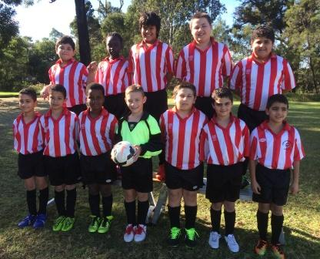

U10 vs Hills Spirit Red 0 – 3

U11 vs OLQP Falcons 2 - 1
Today was the top of the table clash, which was everything from a spectators point of view that you'd hope it would be, with us victorious in the end. Great play from both teams saw the ball rapidly shift from one end of the field to the other. Christian's first goal was after he got well clear of the defence & beat OLQP's goalie. Just before half-time we got a penalty in the box. Unfortunately Christian's shot went over the cross bar. The arm wrestle continued unabated after half-time, but some quick passing from the backs & mid-fielders got a nice ball through to Christian who raced towards goal with OLQP's defenders hot on his heels. Christian managed to get his shot off before they got to him, the shot beat the goalie into the back of the net. Then with only minutes remaining we gave away a penalty in the box, which OLQP duly converted. After the restart OLPQ pressed again only to be repelled by our stout defence. All players should be proud of their effort today, but, Joel our goalie was just outstanding. He stopped many OLQP raids with quick thinking; coming forward to shut-down attacks and displaying great reflexes by saving many goals on the goal line. Great game team! Man of the Match: Joel Carder
Goal scorers: Christian Frangie 2

U12 vs Kings Old Boys 1 - 1
A pleasant start to the game today. Each player played their role and controlled the ball. A firm pass by Qais gave Christian the opportunity to score the first goal. However, second half came and it seemed the boys had given up, playing far from their best, they looked tired and unfocused. It seemed we were trying to defend more then trying to attack. After a few attempts, Old Kings were able to get a goal. Great work by our goalie Johnny. Thank you to Christian for not only playing with us but for also giving us a goal.
Goal scorer: Christian Frangie 1

U13 vs Wentworthville Uniting 2 - 2
I can say we were unlucky to come out from this game with 1 point only from a draw but we were also lucky as Wentworthville had few good chances throughout the game as well. After having a week off (bye) the team's game was a little rusty but they got into it straight away after an early goal from Ringo & dominated the first 15 minutes of the first half. Then a couple of slips at the end of the first & early second half made the locals running hard to find the equaliser. Half way into the second half Ringo again finished a simple play that started with Ryan to Nicholas who passed to Ringo to beat a player then the keeper with a good safe shot. Antoine kept the opposition defence on their toes, also Richard & Ali who both maintained the high standard of goal keeping then playing in the field. Jasper, Sarah, Alex & Nicholas stood strong against the attacks, Adut, Mika, Pater & Ryan controlled the midfield & supported the defence & the attack & unlucky we did not score more & get the three points. Man of the match is the unstoppable Ringo.
Goal scorer: Ringo Ajang 2

U14 vs Merrylands SFC White 4 - 0
This was a strange one as the more hungry and fluid team found themselves down 2 – 0 at half time. In the second half we played better and deserved a couple more goals but we were never really 4 goals better than them. Really nice to see Akot finding form, the back of the net and the player of the match award and Salem’s save in the opening minute may well have changed the whole game for us. It was superb.
Goal scorers: Matthew Richards 2, Akot Akot 1, Kabin Rana 1

U16 vs Castle Hill United 2 - 5
From the first whistle we took it to Castle Hill, and we looked like a premiership winning team. We were pressuring their players and spoiling their attacks. We countered with some good passing and long balls to constantly turn them around. The good work paid off with Will scoring a long range goal that took their keeper by surprise, helped by some good pressure from Kane. 10 minutes later, quick thinking from Hussan, and some strong running from Alan, saw Alan break away from their defence before firing a superb goal into the back of the net. That was the first 25 minutes and we were 2-0 up. The rest of the game was garbage. Except for Dusan, our forwards were lazy, we started playing as individuals instead of as a team, and we stopped talking marking and wanting the ball. Need to get our heads right if we are to be a threat.
Goal Scorers: Alan Trad 1, Willem Booker 1

RC1 Reserves vs Bye

RC1 Firsts vs Strathfield Prestige won on forfeit
No ID cards, no play – McCredie win on forfeit.

Ladies vs Wentworthville Uniting 1 - 1
Goal scorer – Mika Oo 1

Sunday 25th May 2014

Kings Sevens Results

Under 12

vs Sydney Football Academy 0 – 0

vs Kenthurst 2 – 2
Goal scorers – Nedim Fazlic 1, Yusuf Jamil 1

vs Kings School 0 - 1

Under 13

Under 14
vs Kings School 0 – 0

vs Rouse Hill Rams 3 – 0
Goal scorers – Matthew Richards 2, Akot Akot 1
vs Merrylands SFC White 2 – 0
Goal scorers – Matthew Richards , Salem Boustany 1

SEMI vs Merrylands SFC Black 0 – 1

For the second year running we bowed out in the semi but this time it took a last minute goal. We were close boys as we watched the other semi go to penalties and then also the final. It was nice to see our play develop as the day went on and maybe watching the quality of the 18s helped. Akot was a revelation as he calmed things down and played some really nice passes. His goal was a beauty. Angui kept well, Matthew R ran himself into the ground and Salem battled through his injury to have his first game on the field for 3 weeks. Daniel, Matty M and Kabin worked hard in midfield and Joel and Rusheel were solid in the back. We conceded just one goal all day, a long range free kick in the final minute. Heartbreaking.

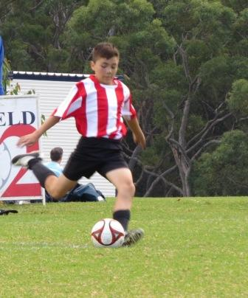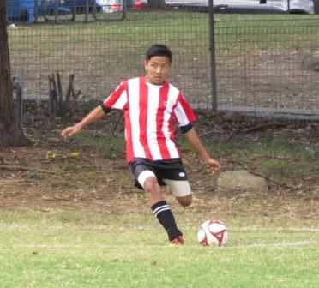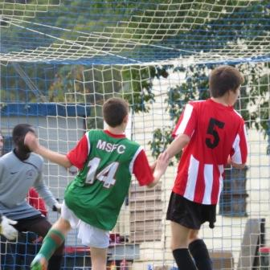

Under 14s in action

Under 16

vs Baulkham Hills Black 1 – 2
Goal scorer – Peter Youssef 1

vs Beacon Hill Yellow 2 – 3
Goal scorers – Alan Trad 1, Peter Youssef 1

vs Beacon Hill Blue 1 – 1
Goal scorer – Alan Trad 1

Semi vs Baulkham Hills Black 0 - 5

A super huge effort today to take on mostly Division 1 sides and push all of them to the last seconds of the game. We fought hard and never gave up, keeping the pressure on and being a chance to win every game. Sometimes our passing let us down, sometimes our marking, but we would scramble together and launch another attack, turning the game back in our favour. It was end to end play and never a moment to rest. By the time we reached the semi-final, there was nothing left in the tank. A good day where the team was praised by other coaches for their tenacity.

Under 18

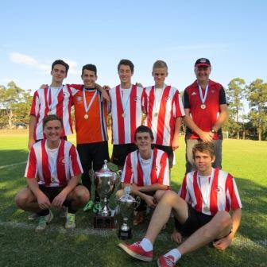

vs Kings School White 2 – 0
Goal scorer – Angus Chance 2

vs Castle Hill Rockets 2 – 0
Goal scorers – Angus Chance 1, Jason Cacharron 1

vs Kings School White 4 – 0
Goal scorers – Angus Chance 3, William Wark 1

vs Castle Hill Rockets 2 – 0
Goal scorers – William Wark 1, Angus Chance 1

SEMI vs Kings School Blue 2 – 0
Goal scorers – Angus Chance 2

FINAL vs Mt Colah 1 – 0
Goal scorer – Angus Chance 1

A triumphant day. We backed up our 14s and 16s wins with the major prize today the Open Trophy. We didn’t concede a goal all day, played some very attractive and patient football and did it all with no subs! Congratulations to Angus who scored 10 goals today, but it couldn’t have been done without the solid defence of James, Liam and Daniel and intelligent half play of Wil, Jason and Divan. A dominant performance – all the better because this side were all 16 and eligible for next year too! Really good that the 14s could watch, learn and reproduce each time they took the field.
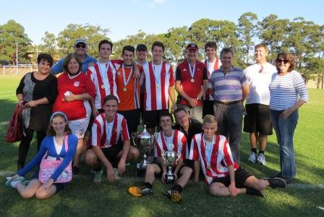

The annual family shot

Tuesday 27th May 2014 Knockout semis

U8 Red Knockout semi vs Lidcombe Churches at Phillips 2 (Martin St., Lidcombe)
6.00pm Kickoff (meet at Phillips at 5.30pm)

U9 Knockout vs Lidcombe Churches at Phillips (Martin St., Lidcombe)
7.00pm Kickoff (meet at Phillips at 6.30pm)

Saturday 31st May 2014

U6 Red vs Wentworthville Uniting Blue at Freame mini (Rees St., Mays Hill)
9.00am Kickoff (meet at Freame at 8.30am)

U6 White vs Wentworthville Uniting Gold at Freame mini (Rees St., Mays Hill)
10.00am Kickoff (meet at Freame at 9.30am)

U7 Red vs Kings Old Boys at Homelands Reserve (Homelands Ave., Telopea)
9.00am Kick off (meet at Homelands at 8.30am)

U7 White vs OLQP Falcons Green at Daniel Street (mini) (Daniel St., Greystanes)
10.00am Kickoff (meet at Daniel at 9.30am)

U8 Red vs Kings Old Boys at Everley 2 (Everley Rd., South Granville)
9.00am Kickoff (meet at Everley at 8.30am) (set up field)

U8 White vs St Columbas Castle Hill at Everley 2 (Everley Rd., South Granville)
10.00am Kickoff (meet at Everley at 9.30am) (dismantle field)

U9 vs Hills Spirit Red at Kellyville (Memorial Ave., Kellyville)
10.00am Kickoff (meet at Kellyville at 9.30am)

U10 vs Hills Spirit White at Kellyville (Memorial Ave., Kellyville)
12.00pm Kickoff (meet at Kellyville at 11.30am)

U11 vs Kings Old Boys at Everley 1 (Everley Rd., South Granville)
11.00am Kickoff (meet at Everley at 10.30am)

U12 vs Bye

U13 vs Lidcombe Churches at Phillips 1 (Martin St., Lidcombe)
12.00pm Kickoff (meet at Phillips at 11.30am)

U14 vs Granville Waratah at Everley 1 (Everley Rd., South Granville)
9.00am Kickoff (meet at Everley at 8.15am) (set up field)

U16 vs Lidcombe Churches at Everley 1 (Everley Rd., South Granville)
10.15am Kickoff (meet at Everley at 9.45am) (dismantle field)

Raahauge Cup 1 vs Wentworthville Uniting Blue at Freame (Rees St., Mays Hill)

(Reserves Kick off at 1.15pm Firsts at 3.15pm) (Meet at Freame at 12.45pm)

Sunday 1st June 2014

All Age Ladies vs Winston Hills at Ted Burge 2 (Centenary Rd., South Wentworthville)
12.30pm kick off (Meet at Ted Burge at 11.45am)

