OTB 10/15

Club Secretary – Greg 9682 7779 President – Peter 9632 9203

Interested in sponsoring a team or advertising in this newsletter? – call one of the above numbers.

www.mccredie.org.au/soccer Join our Facebook group

LAPATHON LAST WEEK

Age | Name | Highest number of laps
6 | Nour Eldine Matar | 20
7 | Adam Assan-Larry | 20
8 | Malachi Daniels | 18
9 | Saadallah Alameddine | 23
10 | Matthew Youssef | 20
11 | Aaran Batth | 25
12 | Ryan Booker | 26
13 | Nedim Fazlic | 23
14 | Peter Chehab, Ahmed Ekdawy | 28
15 | Daniel Wark | 30
15 Girls | Alexia Abou Hamad, Mary Ning | 24
16 | John Youssef | 25
17 | Micah Doughty | 24

Please return your lapathon money as quickly as possible to your team manager. Thanks for the wonderful support last week. I will let you know how much we raised shortly.

Coaches and managers meeting this Thursday
7.30pm Church Hall 486 Guildford Rd, Guildford

Important matters up for discussion include, six a side, Kings Sevens and the upcoming representative season.



CALENDAR OF UPCOMING EVENTS

May 28 Coaches and Managers Meeting 7.30pm Church Hall

May 30 Team photos for 6R, 7R, 8, 9R, 10R, 12R, 13, 15 Girls, 15s, CC, PL

June 6 Six a side Gala Day for 6s, 7s, 8s, 9s, 10s, 11s, 12s

June 8 Six a side Gala Day for 13s, 14s, 15s, 15 Girls, 17s, AAM, O35s

June 11 Zone rep trials for U8, U9, U10, U11, U12, U13, U14

June 14 Kings Sevens tournament (selected teams only)

June 22 & 29 National Titles Trials U16 Boys & U18 Boys (7pm) Jones Park

June 24 & July 7 National Titles Trials U16 Girls (5.30pm) & AAL (7pm) Freame Park

June 30 & July 7 National Titles Trials U23 & AAM (7pm) Jones Park

July 1 & 2 National Titles Trials U14 (6pm) Jones Park

To trial for National Titles (27/9 – 1/10/15) a nomination form must be completed prior to trialling (available at www.nswcfa.com.au)

STATE CUP RESULTS

Premier League vs Lidcombe RC Reserves 4 - 1
Goal Scorers: - M. Shukur 3, Amarvir 1

Premier Reserves vs St Barnabas Broadway 0 - 2
RESULTS – 23rd & 24th May 2015

U6 Red vs OLQP Falcons Green 11 - 1
Saturday morning turned out being sunny and dry. The kids recovered well from their little marathon, sorry lapathon. They put the pressure on right from the start with Nour scoring 1 of his 6 goals. Danielle was a hard worker today, always dribbling and stealing the ball. Izzac, Lamar, and Gethyn were like determined little bees chasing the honey pot. There were lots of clumping near the nets, which gave the opportunity for Jackson to nearly score twice. Malik cast his net wide and scooped the balls to dribble them to the other side to score 5 goals
Goal scorers – Nour Eldine Matar 6, Malik Daniels 5

U6 White vs Wentworthville Uniting 4 - 2
Another Saturday and get again more rain. It was a frosty start for our under 6's with a 8:00am start for our team photos. The boys looked great. Our line up included Charbel, Jonah, Alexander, John, Mikhail, Elias and Jeremiah. Our boys looked strong from the start we had many chances at goal but the goal keeper was too strong and kept them our for a while. A great play from a throw in saw a goal from Mikhail and we were up 1-0. Some great defending from our boys saw us keep the lead. Another strong set of moves and a great goal from Mikhail and it was 2-0. The boys were looking good but a mix up at goal saw an own goal and it was 2-1. Great defending from Alexander and Jonah saw us hold the lead and the first half finished 2-1. Second half and the boys were ready to go. Great passing by Charbel and a great goal from Jeremiah saw the boys up 3-1 but it wasn't over yet. Wentworthville were looking to come back and a great goal saw it at 3-2. But our boys kept on going and a great goal from Jonah saw the game finish at 4-2.
Goal scorers - Mikhail Khan 2, Jeremiah Elkadi 1, Jonah Botros 1

U7 Red vs Lidcombe Churches 10 - 3
Another great win for our team this week, 10-3. We had so many highlights today - players keeping their positions well, some great passing and tackling, a fantastic cross by Patrick from the corner, straight to Adhar in the middle to score a goal, and overall, the players learning to work together as a team. Lidcombe made some strong attacks which broke through our defence to score, so there's still lots of room for improvement for us. Still: well done team.
Goals: Adhar Yaac 5, Patrick Matta 3, Wek Deng 2.
U7 White vs Wentworthville Uniting Gold 7 - 1
After a cold and soggy start, the sun came out to shine on these little stars. It was great to see the team warming up and train together before the game even started. The game was “Nail-Biting” with some missed opportunity for goals. Mark did a great job as goal keeper, saving 6 potential goals the opposition could have scored. Sione and Ryan demonstrated great defending skills. Badih set the ball up extremely well for those goals. Laura did some big kicks. Bol, Andrew and Fateh supported their team mates with great effort. Dut worked his magic again to be the highest goal scorer.
Goal scorers: Dut Atak 5, Sione Tu’ifua 1, Ryan Lu 1

U8 vs OLQP Falcons Green 1 – 3
Another frustrating day for the team today all started with players not showing up and players arriving after the start of play and to top it off, a missed penalty opportunity. As I write every week the players that turn up give it their all and try really hard to achieve a favourable outcome, but this just seems so far away on cold early Saturday mornings. Lucy was chosen as the captain of the team for the day and she played well today making some dribbling runs and beating the defence at times. Lucy also had a chance to score but was unable to convert this chance. These efforts earned Lucy, best player in the first half. Lucy was supported well by Exodus who played his usual game of great running with the ball, defending well and providing the big kicks to clear the ball away from danger. This earned Exodus, best player in the second half. The rest of the team today made up of Ali, Ameera, Gerardo, Isaiah, Moustafa, Rhiannyn, Thomas and Simon supported each other well throughout the game. Gerardo as usual made some darting runs and was able to get a goal back to make the score line a little more respectable.
Goal scorer: Gerardo Cavasinni 1
U9 Red vs Lidcombe Churches Blue 0 - 12
Tough day at the office for our boys & girls. Never give up is the attitude & the rain soaked ground, playing short or the other team's quality play did not stop our kids from giving all what they have. They were beaten hard but they played harder. All the kids agreed to have more training sessions during the week to up their games so hats up for determination. We need to focus more on positioning & passing then we will be on the right track to play & win. Standouts for this game is the whole team, all players just refused to give up. Man of the Match for the second week is Zacheria who tried his best & challenged hard for every ball in his reach. We are having a training session on Tuesday at 5 pm, so please be there. Don't forget that next Saturday is our team photo, make sure to wear black shorts & black socks. Parents please fill up the form & bring it with you to next game at Everley, If you haven't received your team photo envelop please ask me on Wednesday.

U9 White vs Lidcombe Churches Gold 11 - 0
It was a good score today, however they didn't play very well as a team in the first half. Much better in the second. Understandably everyone was just keen to get on the scoreboard. Joey and Ali bagged 3 goals each with Joey playing a very supporting game earning him player of the week. It was really good to see all the kids getting into the action with Anthony narrowly missing 3 shots at goal, Jack had a couple of opportunities, so did Robert, Sebastian and Johnathan also coming close. Today's game also saw Owen scoring his first goal for the season and Dylan getting in on the action with 2 of his own, the first being a lollipop gift but some excellent ball skills and strong finishing kick to score his second goal. Fouad returning from sickness and lacking a bit of match fitness did a good job being in the right place at the right time and finishing off the opportunities presented getting 2 goals also. Strong performance on the scoreboard but a bit over enthusiastic today and not a lot of coordination, but who can blame them. Well done little champs.
Goal scorers: Joey Farah 3, Ali Fahme 3, Dylan Lu 2, Fouad Ayoub 2, Owen Thai 1

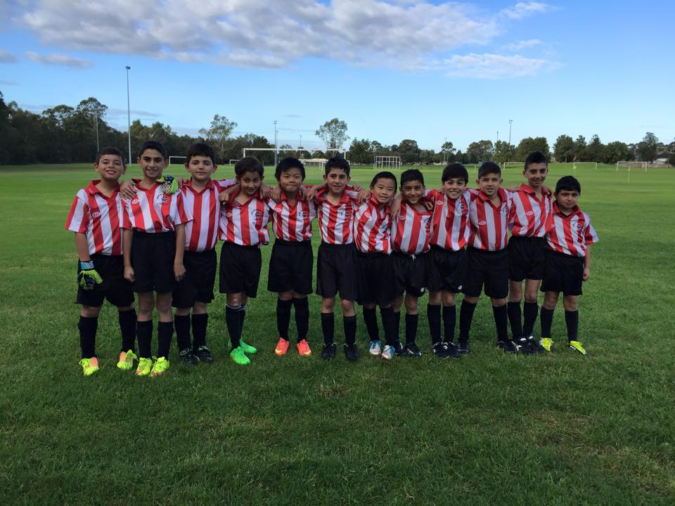

U10 Red vs Hills Spirit White 5 - 0
First I would like to congratulate Under 10 warriors for their outstanding run at the Lapathon on Wednesday night. Thank you for your support and your generous contribution to the only fundraising event of our club. most of the runners have smashed 18 to 20 laps, its just amazing. And it continued today at Kellyville. Another game another win. Good team effort, improved skills and perfect communication between the players led to a straight win. Well done Youssef on your first goal for this year. Moe and Mak you guys rock. as for you every single team member this win would never happen without your efforts in defence, wings and mid field. A win well deserved kids.
Goal scorers: Mohammed Mattar 2, Makuac Kuol 2, Youssef Maldini 1
U11 White vs Hills Spirit Red 2 - 3
A game that maybe we weren’t mentally prepared for due to the photos being taken. Nonetheless, it was an exciting one from the sidelines and we were unfortunate not to come out on top. We had several chances that left us wanting and unfortunately lost us the game. One thing I was happy with was the creation of those chances showing we are not far off being able to completely dominate games, which I think we can achieve. A great performance today by Achai, Aaran, Abdul, Kuach and Adam whom all were able to be effectively involved and have a positive impact on the game. There was one play whom both coaches were extremely happy with and that’s Ali. He has improved drastically and has showed us his willingness to get involved week in and week out. Man of the match to Ali and we want to see more of this motivation to improve from all the kids. Really proud of everyone today, but we need to be looking for the win in the remaining games. Also, thanks to the parent's who gave us a hand today setting up the fields, etc. we really appreciate your help! See you all on Wednesday.
Goal Scorers - Aaran Batth 1, Abdul Agha 1

U12 Red vs Bye

U12 White vs Wentworthville Uniting 1 - 3
Today's game was a slippery one and our boys forgot their defending skills. They had numerous attempts at goal shooting but somehow the goals went straight into the hands of the goalie. Our boys must remember to mark their opponent and work together. I really believe we have a great team that can succeed. Man of the match Geetansh
Goal scorer – Jayden Daily 1

U13 vs Bye

U14 vs OLQP Falcons 8 – 0
The boys played a bit soft but got away with the win. The boys need to learn to go in 100% all the time and play hard no matter if they are smaller than them. Man of the match went to jasper showing 100% all the time. And with a sweet goal
Goal scorers – Ahmed Ekdawy 3, Jakob Kaihea 1, Ryan Carder 1, Jasper Carr 1, Own goals 2
U15 Girls vs St Columbas Castle Hill 0 - 9
Great effort today ladies! Definitely one of our strongest games. Throughout the match we pushed up into our goal zone a lot and moved into new territories that called for new skills. We were attacking and defending better than other games. Today we demonstrated persistence, determination and consistency throughout the game (even with no subs & at one stage only 9 players on). All our training is paying off. Player of the match goes to our wonderful Goalie, Tahlia! Can't wait for next week :))

U15 vs Lidcombe Churches 4 - 1
We certainly recovered from a bad weekend last weekend and played the best match of the year in putting Lidcombe to the sword. Ali was on fire beating 3, 4 and 5 players at a time and finishing just about every chance he gets. The midfield worked better today and it was great seeing Mahdi and Tai hold possession and deliver the ball to team mates. Aiden bagged his first competition goal (boy he’s quick) and Jesse in a man of the match performance, passed well, moved everywhere and thought about his game, marking when required and heading the ball with ferocity. A great game all round which included the best team goal we have scored in our team’s 10 years.
Goal scorer – Ali Hawchar 2

U17 vs Lidcombe Waratah 1 – 5
Against a very good opposition, I thought the first 20 minutes of this match was our best performance so far this year. There was intensity and commitment, to the ball and to each other. We controlled the midfield. We were smart with the ball, and we built up our plays. Then we stopped. The midfield were covering other positions so we had no midfield. The opposition started building up pressure and we reverted to long ball attacks, but the ball kept coming straight back. Two soft goals hurt us, but we didn't improve and they put another one in before half time. After the break we were better, pulling a good goal back, but the opposition were just too good on the day. The coach has some thinking to do.
Goal scorer – Alan Trad
Over 35s vs Columna 1 – 5
Once again we struggled for numbers with us only just fielding 11 at kickoff. Thanks to Dany, Daniel, Mathew, Juan and Zeeshan for backing up and playing in both games this afternoon. Goal scorer – Aydin Tokdogan 1

Challenge Cup vs Kings Old Boys 2 – 7
This wasn't our afternoon! With only 9 players there at kick off we started out well but then Old Kings Boys soon dominated the first half. Getting our two goals in the 2nd half just came a bit too late for us.
Goal scorers: Edward Nehme 1, Goran Gesovski 1

Premier Reserves vs Coptic United 2 - 1
A battle between 1st & 2nd (us) and while it was not a flamboyant free flowing affair it was a contest between two competitive sides. Both sides fought hard but despite us being 2 nil up at half time they never stopped pushing us.
Goal Scorers: - Gerard McKeown 1, Mohammed Al Delaimi 1

Premier League vs Coptic United 2 - 4
Another frustrating result against the team coming first. We got an early goal but they equalized due to a very questionable linesman. We let our heads down and they got 2 more before half time. Second half we came out and contested better. We created a number of good opportunities especially in the second half and were unlucky not to have scored another. This was against the best team in the comp and we were their equal across the park.
Goal Scorers: - Reinaldo Capizzi 1, Mick Massih 1

Ladies vs Auburn FC 3 - 4
Playing the top team and 3 – 1 up and playing great football, things were looking very rosy. Unfortunately 10 minutes and really amazing soccer from our opposition, turned things around and despite getting the upper hand again in the last 15 minutes we were unable to score again. Elise is playing very very well at the moment, Natasha and Taufa controlled the midfield and Laura Herbert finished a nice striker’s goal. One of the best games we have played despite the result.
Goal scorers – Laura Herbert 2, Taufa Kivalu 1

Team photos this week. Your manager will distribute photo envelopes. Please pay for your photo before it is taken – either at training or before it is taken. Remember to bring the right money – we don’t have change.

Check times on the back of this newsletter – don’t let everyone down by being late.

Managers – please ensure no player wears anything under their jersey – no training shirts, singlets, skins etc for the photo.

Thursday 28th May 2015

State Cup Round 3 Premier League vs St Matthews Baulkham Hills at Jones 1 (Banks St., Merrylands)
8.00pm kick off (meet at Jones at 8.00pm) (dismantle field)

Saturday 30th May 2015

U6 Red vs St Bernadettes Castle Hill Tigers at Everley (mini) (Everley Rd., South Granville)
9.00am Kickoff (meet at Everley at 8.30am FOR PHOTO) (set up field)

U6 White vs Hills Spirit Red at Kellyville (Memorial Ave., Kellyville)
9.00am Kickoff (meet at Kellyville at 8.30am)

U7 Red vs St Bernadettes Castle Hill Lions at Everley (mini) (Everley Rd., South Granville)
9.50am Kickoff (meet at Everley at 9.00am FOR PHOTO) (dismantle field)

U7 White vs Hills Spirit Red at Kellyville (Memorial Ave., Kellyville)
9.50am Kickoff (meet at Kellyville at 9.20am)

U8 vs St Bernadettes Castle Hill at Everley 2 (Everley Rd., South Granville)
9.00am Kickoff (meet at Everley at 8.30 for PHOTO) (set up field)

U9 Red vs Wentworthville Uniting at Everley 2 (Everley Rd., South Granville)
10.00am Kickoff (meet at Everley at 9.15am FOR PHOTO) (dismantle field)

U9 White vs St Bernadettes Castle Hill Lions at Eric Mobbs SSG (Excelsior Ave., Castle Hill)
9.00am Kickoff (meet at Eric Mobbs at 8.30am)

U10 Red vs Hills Spirit Red at Everley 3 (Everley Rd., South Granville)
10.00am Kickoff (meet at Everley at 9.30am FOR PHOTO) (set up field)

U11 White vs Lidcombe Churches at Phillips 1 (Martin St., Lidcombe)
10.00am Kickoff (meet at Phillips at 9.30am)

U12 Red vs McCredie White at Everley 3 (Everley Rd., South Granville)
11.00am Kickoff (meet at Everley at 10.00am FOR PHOTO)

U12 White vs McCredie Red at Everley 3 (Everley Rd., South Granville)
11.00am Kickoff (meet at Everley at 10.30am) (wear grey shirts)

U13 vs McCredie Girls at Everley 3 (Everley Rd., South Granville)
12.00pm Kickoff (meet at Everley at 11.30am FOR PHOTO)

U14 vs Bye

U15 vs Castle Hill United at Everley 1 (Everley Rd., South Granville)
9.00am Kickoff (meet at Everley at 8.15am FOR PHOTO)

U15 Girls vs McCredie 13s at Everley 3 (Everley Rd., South Granville)
12.00pm Kickoff (meet at Everley at 11.15am FOR PHOTO) (wear red for photo/ grey for match)

U17 vs Wenty Waratah at Everley 1 (Everley Rd., South Granville)
10.30am Kickoff (meet at Everley at 10.00am)

Challenge Cup vs Gymea Baptist at Everley 3 (Everley Rd., South Granville)
(35s Kick off at 1.15pm Firsts at 3.15pm) (Meet at Everley at 12.45pm) (dismantle field)
PHOTO 2.45PM

Premier League vs Greystanes United at Everley 1 (Everley Rd., South Granville)
(Reserves Kick off at 1.15pm Firsts at 3.15pm) (Meet at Everley at 12.45pm) (dismantle field)
PHOTO 3pm

Sunday 31st May 2015

All Age Ladies vs Wenty Waratah at Fred Catterson 2 (Catterson Drive, Castle Hill)
3.00pm Kickoff (meet at Catterson at 2.15pm)

