OTB 13/15

Club Secretary – Greg 9682 7779 President – Peter 9632 9203

Interested in sponsoring a team or advertising in this newsletter? – call one of the above numbers.

www.mccredie.org.au/soccer Join our Facebook group

Please return any lap-a-thon money that hasn’t come in, this week.
Our total has now climbed to $3,936.20

CALENDAR OF UPCOMING EVENTS

June 17 Zone rep uniform fitting – 3/9 Chester Hill Rd., Chester Hill, between 6.30 and 8.30pm

June 22 & 29 National Titles Trials U16 Boys & U18 Boys (7pm) Jones Park

June 24 & July 2 National Titles Trials U16 Girls (5.30pm) & AAL (7pm) Freame Park

June 25 (Phillips Park) & July 16 (Jones/Freame Parks) Zone rep matches

June 30 & July 7 National Titles Trials U23 & AAM (7pm) Jones Park

July 1 & 2 National Titles Trials U14 (6pm) Jones Park

To trial for National Titles (27/9 – 1/10/15) a nomination form must be completed prior to trialling
(available at www.nswcfa.com.au)
Congratulations to the following players on their selection in the South Zone representative teams
U8 Zain Ali

U9 Dylan Lu, Sebastian Kerr, Yasmin Hasani, Joey Farah, Fouad Ayoub, Owen Thai, Ali Fahme

U10 Mustafa Elbizri, Abuk Yaac, Makuac Kuol, Charbel Chehab, Matthew Youssef, Mohammed Matar,
Samuel Kidane, Fraz Maqsoodi

U11 Mustapha Fahme, Christian Frangie, Aaran Batth, Abdul Agha, Mary Ning

U12 Jayden Daily, Krish Srestha, Ryan Booker, Deng Aguok, Geetansh Kaushal, Mounir Hadid, John-Luke El-Rahi

U13/14 Jakob Kaihea, Nedim Fazlic, Jasper Carr, Chloe Hildred, Charlene Muru-Tucker, Samuel Appiah,
Nicholas Azar, Qais Sungkar, Andrew Ibraheem

Full team lists are on the Association website – www.nswcfa.com.au

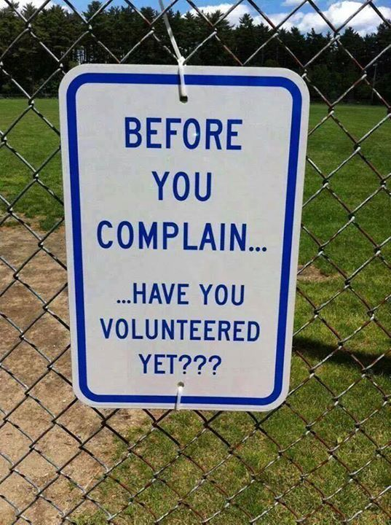

RESULTS – 13th and 14th June 2015

U6 Red vs OLQP Falcons Yellow 3 - 4
The team started off really well. There was lots of action on the opposition end of the field, however, the team couldn't get past the defenders. Malik finally scored a goal that bounced off the goalie. The players started to run out of steam during the match, but Jackson, Izaac, Matthew and Gethyn were still trying to block and tackle. Nour got his second wind and scored 1 of his 2 goals straight after the break. Danielle and Sunday were attacking really well, but were out maneuvered and outpaced by the opposition.
Goal scorers – Nour Eldine Matar 2, Malik Daniels 1

U6 White vs OLQP Falcons Blue 3 - 2
This round we played OLQP Blue at our home ground. For the first time we had all 10 players, this is amazing considering at one stage we only had 4 or 5 players at some games. Our line up included:
Muhammad Aeliya, Alexander Azar, John Barakat, Jonah Botros, Jeremiah Elkadi, Elias Hakimi, Muhammed Musab Hameed, Mikhail Khan, Deon Kumar, Charbel Nakhoul.
From the kick-off we definitely looked the stronger team. We were on fire from the go. I think all parents can agree we are much more organised and are passing the ball to each other much better. Wed plenty of subs so everyone had a go. We had some shots on goal but no on target. OLQ had a break but wonderful goal keeping by Musab kept the score 0-0. The first half was coming to an end and a quick sprint by Mikhail and some great moves by Jonah and Deon made way for a wonderful strike by Mikhail and we were up 1-0, and that was the end of the first half. A quick break and we were back on. Again we attacked from the word go and some wonderful passing from our boys saw Jeremiah score our second goal and it was 2-0, we looked to have the game under control. Some poor defending saw the other team get away and a mix up at goal saw the score at 2-1. Some great goal keeping by John kept them out and he made some wonderful saves, well done. Because of our large quantity of subs we always had fresh legs on the field and another quick get away by Charbel saw Mikhail up at goal with a few attempts at goal finally one found the make of the goal and it was 3-1, we looked to have the match under control, but the other team wasn't giving up and a great strike by their player saw it now at 3-2. We were getting nervous with the clock ticking away but the final blow of the whistle and the final score 3-2. What a wonderful with and a special big thank you to Elias's dad for fixing our jerseys, we looked great there on the field. Well done boys and keep up the good work. Man of the match Musab for his great goal keeping skills
Goal scorers: Mikhail Khan 2, Jeremiah Elkadi 1

U7 Red vs OLQP Falcons Red 5 – 1
Well played guys and girls. These little guys and girls always give it their best every week.
Goal scorers - Adhar Yaac 2, Pattrick Matta 2, Wek Deng 1
U7 White vs Kings Old Boys 7 - 0
A well deserved win today. The players had good defence strategies and worked together in setting up those goals. There was some fancy footwork near the goals with the Kings Old Boys putting in a good fight to help their goalie, and the 7 Whites did miss some opportunities but their persistence did pay off in the end. Mark and Laura both saved the ball as goalies, taking away any chance for the Kings Old Boys scoring. Ryan, Dut and Sione were super fast with the ball, getting it quickly to our end of the field. Badih, Bol, Andrew and Fateh got in some great kicks getting possession of the ball from the opposition. Great job 7 Whites.
Goal scorers: Sione Tu’ifua 3, Dut Atak 3, Ryan Lu 1

U8 vs OLQP Falcons Yellow 2 – 4
Goal scorer – Ali Ekdawy 2

U9 Red vs St Bernadettes Castle Hill Saints 0 – 2
Good effort today team! We limited the opposition to only two goals, we are continuing to make great improvements. Yasmin in goals was again a brick wall which the other team could not break through. Khareem was also very solid and a big reason why the other team found it hard to score goals. Big congratulations to Malachi who won man of the match who ran and worked hard all game, if the whole team could follow his example every week we will continue to make big improvements. Everyone should be happy with the way they played, if you compare the results from the beginning of the season up until now the team should be very proud with the progress we have made. Let's continue to train hard, listen to the coach, work together and most of all have fun and the results will reflect our commitment. Well done everyone!

U9 White vs Wentworthville Uniting 1 - 1
A game we should have won, could've lost, but frustratingly drew. Wentys had 1 chance at goal for the whole game in the first half and was able to convert it, bouncing off the post and going in. We totally dominated possession the whole game, but the Wenty's defence was rock solid, always kicking the ball out of play, which frustrated our team. We had over 20+ corners but couldn't convert. Ali's solo effort in counter attack levelled the score in the 2nd half. But it wasn't to be today. A good lesson mid way through the season.
Goal scorer: Ali Fahme 1

U10 Red vs Wentworthville Uniting 2 - 0
Today's game was a well deserved win for the Red. They managed to keep their goal clean by holding their positions and passing. I want to take this opportunity to congratulate one of our star players our only girl in the team Abuk Yaac for her outstanding performance and play at the six aside games last Saturday.
Abuk played really well and was an absolute asset for her team. Well done girl. Also I would like to wish the best of luck for all our players representing the club at the Zone rep. Make us proud boys and girl.
Scorers: Makuac Kuol 1, Matthew Youssef 1

U11 White vs Hills Spirit White 12 – 0
What a performance by everyone today! Great individual performances from many, but more importantly we actually played as a team today. It was good to see Duan and Mary hold our defences and not pushing too far forward. This has been something that’s really let us down in previous weeks. It really gave us more room and more options up front with Greg, Abdul and Aaran running the show! Aaran and Abdul in particular totally dominating. Aaran picked up man of the match today with a stellar performance in the heart of midfield working as a shield to the defence and scoring 3 vital goals. Special mention to Duan with an absolute defensive masterclass today stopping everything that came near him with a few tricks chucked in. He’s really been improving this year and it’s starting to show in his game.
Goal scorer – Abdul Agha 6, Aaran Batth 2, Gregory Farah 2, Mary Ning 1, own goal

U12 Red vs Lidcombe Churches 1 - 1
Today was upsetting to watch realising our boys' passing tactics to each other was all over the place. We did physically play better than the other team but little mistakes saw them score first before we got a corner chance and Christian passed brilliantly to Mustapha who happened to be standing in the right place at the right time to kick it right in the net sending the parents cheering loud. 2nd half we lacked chasing the ball even though we had many opportunities at goal which for some reason always ended up in the goalies hand , Christian took a long shot at goals and was so unfortunate to miss but we will have to blame that one on the wind ... More concentration on passing and chasing the ball once we kick it should see us play better games from now on ..Joel was rewarded man of the match for always trying his best and Jude played a fantastic game chasing the ball at every opportunity.
Goal scorer - Mustapha Fahme 1

U12 White vs Hills Spirit 0 - 2
The boys were very slow in there play today. They had fairy taps for passing and when they passed, it was to the wrong player!! They tried to work with each other and call for the ball which made their teamwork skills better. Better luck next time boys. Thank you Adam, Anthony and Abdul from u11 for helping out today.

U13 vs McCredie 14s 1 - 1
Goal scorer – Qais Sungkar 1

U14 vs McCredie 13s 1 - 1
The under 14s played the under 13s today. The under 13s went very defensive from the kick off. And we could not break down the defence . Second half the under 13s scored. The boys needed to lift to get the goal back. We did with a great run by Jakob. The boys started to play hard and wanted the win but it was too late. Both teams should meet again in the finals series. Man of the match went to Bilal
Goal scorer – Jacob Kaihea 1

U15 Girls vs Hills Spirit 0 - 5
We were unlucky today however, I'd like to applaud the 9 players that came today for carrying our team. Their consistency each week adds to the value of the team. Sulafa, destiny and Yasmine did absolutely amazing up front. Christine and Chloe made some important shots that kept the other team running. Hannah and Sarah used their defensive skills well. Sharlene owned her role as fullback, consistently doing her job for the team. Tahlia had a great game as goalie and later on up at the front. Superb effort ladies. A little disappointed with some of the girls who didn't attend today. I hope we have a full squad next week. Player of the week goes to our little pocket rocket, Yasmine :)

U15 vs Granville Waratah ground unplayable
This doesn’t happen in NSWCFA. If a game is affected by poor pitch condition it is moved to a different pitch. In GDSFA if a club closes a ground – you get a Sunday catch up. No prizes for guessing which works better.

U17 vs Granville Waratah ground unplayable

Over 35s vs St George Rowing 0 – 4
A very even match for around 75 minutes, unfortunately 3 very difficult shots to stop for our not so tall goal keeper (with a big heart) denied us from bringing home the 3 points. I would like to thanks Luke for run the line for the reserve grade

Challenge Cup vs St George Rowing 1 - 2
With only 7 players fresh and 5 reserve grade payers to start the match and with a previous lost match score of 5 - 0, it did not look good at all. It was a really difficult game since we have a lot of missing players from the 1st Grade team. During the whole match we showed a very solid defending and we slow the pace of the match against a Brazilian side that tried everything to take the lead on the score. A long pass found Aydin facing a slow defensive line and with a very clinical finish we took the lead 1 - 0. St George players could not believe what was happening, so they tried everything desperately looking for the equalizer. The great performance of our Goalkeeper Luke and our defensive line were able to control the desperate attacks of the opposition side. Unfortunately at 10 minutes from the end, the opposition got the equalizing goal and in the last second a perfect executed free kick gave the opposition the 3 points. The opposition celebrated this triumph like they won a final match of the competition. It worth to highlight that St George players recognized that it is was a very hard match and they show it with effusive shake of hands. I would like to thanks Tito for run the line for the 1st grade
Goal Scorer: Aydin Tokdogan

Premier Reserves vs Macarthur Wasps 3 – 1

Due to the previous rounds robbed result we were in 3rd place playing 2nd place at their home ground down in Campbelltown. We don’t travel well and this combined with uni exams and people still recovering from injury meant it was going to be a tough afternoon. We had a bare 11 there for kick-off and were feeling under pressure before we even kicked off. An early goal from James knocked some wind out of the opposition’s high pressing game and it lifted us. They equalised early in the second half but we came straight back at them and controlled the second half well.
Due to our win we have now regained our 1 point win over 2nd place. Congrats
Goal scorers - Mirwais Waseeq 1, John Zhou 1, James Rosandi 1

Premier League vs Macarthur Wasps 0 – 6
With so many people doubling up and having very little options for subs it was always going to be tough. The boys can be proud of their efforts and were unlucky in front of goals.

Ladies vs Winston Hills Bears 1 – 1
Far too many missed opportunities up front. We had all the field position but couldn’t convert our chances. The fact that we were 1 – 0 down at half time was very disappointing and did not reflect the game at all.
Goal scorer – Taufa Kivalu 1

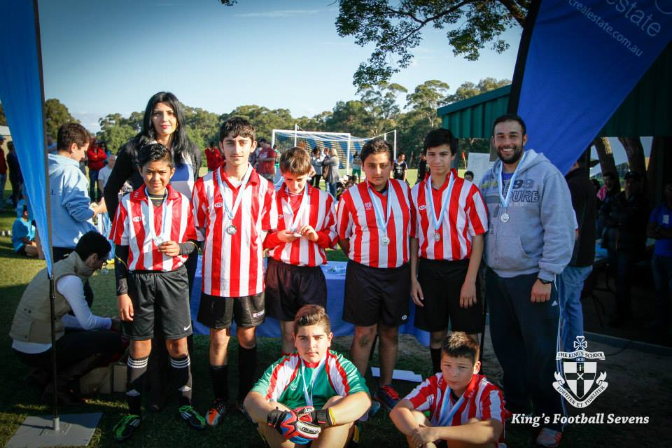

Under 13s – Kings Sevens Runners Up 2015

Kings Sevens – Sunday 14th

Under 12s

Won 1, drew 1, lost 1.
Goal scorer – Mounir Hadid 1

Under 13s – RUNNERS UP!

Won all 3 round games.

Semi vs Kellyville Kolts won on penalties

Final vs Expendables 0 - 1
Goal scorer – Joe Azzi 5, Nedim Fazlic 1

Under 15s

Game 1 vs Kings School Blue 0 - 1

Game 2 vs Kings School Blue 1 – 0
Goal scorer – Jacob Mitwali 1

Game 3 vs Merrylands SFC 0 - 3

Game 4 vs Football Development Academy 2 – 2
Goal scorer – Ali Hawchar 2

Semi vs Merrylands SFC 0 – 1

Early in the tournament we were pretty woeful, which was a shame as I believe we were the second best side and should have played the final. Our results though left us with a very difficult semi. Neither of the teams in the other semi beat us today. We did bring our A game though, and used it in the semi. In the semi we played with heart, defended well, marked up and managed to create a couple of real chances whilst restricting theirs. The goal they scored was a cracker.

Under 16s
Alan Trad, Hamze El Hallak, Hassan El Hallak, John Youssef, Josip Markovic, Kane Carder, Matthew McGuire.
Started impressively showing plenty of support and running, moving the ball about and trying to maintain possession. With no reserves, the team soon grew tired, and by the last game, energy levels were near zero. A good effort and well played against stronger opposition.
Goal Scorer: Hassan El Hallak
Under 17s
Ahmad Mahfoud, Anthony Gwee, Dusan Miljevic, Jason Tran, Joshua McGuire, Vehid Dupovac, Willem Booker.
A poor start was made through not listening to instructions, and the result, we got thumped in the first 2 matches. 2nd time round, we played smarter, and we looked like we had an idea of what we were supposed to do. Again, no reserves made it difficult, but a good learning experience against some tough opposition.
Goal Scorers: Ahmad Mahfoud, Willem Booker (2)

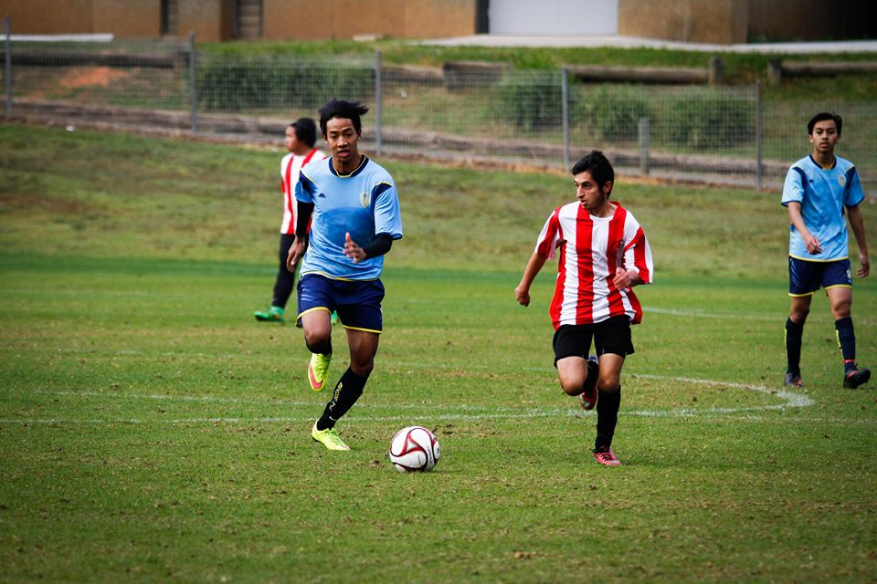

Kings Sevens action (above Ahmad 17s, below Hassan 16s, Dusan bottom pic)

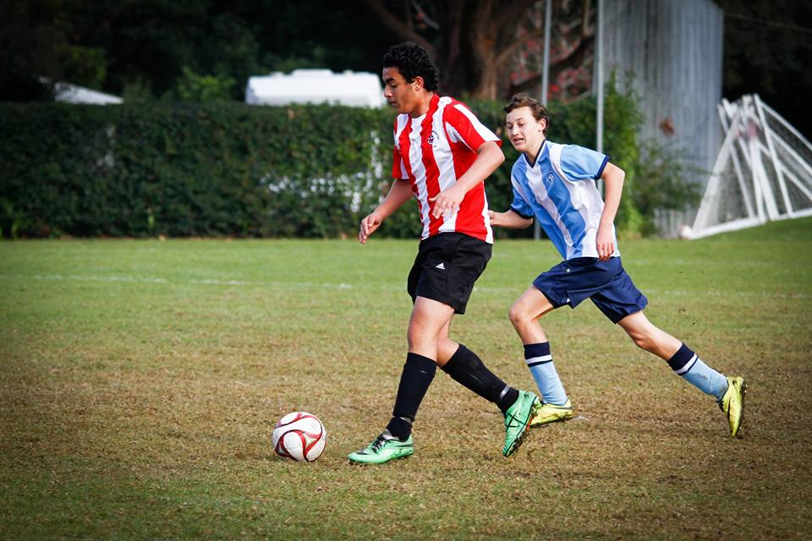
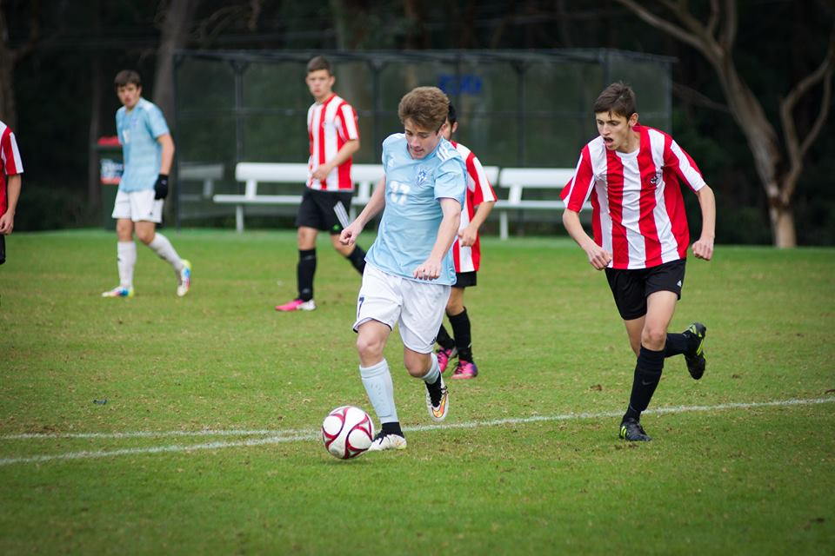

Wednesday 17th June 2015

All Age Ladies vs Wenty Waratah at Phillips Park (Martin St., Lidcombe)
7.30pm Kickoff (meet at Phillips at 7.00pm)

Saturday 20th June 2015

U6 Red vs St Columbas Castle Hill at Everley (mini) (Everley Rd., South Granville)
9.00am Kickoff (meet at Everley at 8.30am) (set up field)

U6 White vs OLQP Falcons Red at Daniel (mini) (Daniel St., Greystanes)
9.00am Kickoff (meet at Daniel at 8.30am)

U7 Red vs Wentworthville Uniting Blue at Everley (mini) (Everley Rd., South Granville)
9.50am Kickoff (meet at Everley at 9.20am) (dismantle field)

U7 White vs OLQP Falcons Blue at Daniel (mini) (Daniel St., Greystanes)
9.50am Kickoff (meet at Daniel at 9.20am)

U8 vs Wentworthville Uniting Gold at Everley 2 (Everley Rd., South Granville)
9.00am Kickoff (meet at Everley at 8.30am) (set up field)

U9 Red vs McCredie White at Everley 2 (Everley Rd., South Granville)
10.00am Kickoff (meet at Everley at 9.30am)

U9 White vs McCredie Red at Everley 2 (Everley Rd., South Granville)
10.00am Kickoff (meet at Everley at 9.30am) (dismantle field)

U10 Red vs Lidcombe Churches at Everley 3 (Everley Rd., South Granville)
10.00am Kickoff (meet at Everley at 9.30am) (set up field)

U11 White vs Wentworthville Uniting at Freame (Rees St., Mays Hill)
11.00am Kickoff (meet at Freame at 10.30am)

U12 Red vs Hills Spirit at Everley 3 (Everley Rd., South Granville)
11.00am Kickoff (meet at Everley at 10.30am)

U12 White vs St Bernadettes Castle Hill at Eric Mobbs 2 (Excelsior Ave., Castle Hill)
11.00am Kickoff (meet at Eric Mobbs at 10.30am)

U13 vs Lidcombe Churches at Phillips 1 (Martin St., Lidcombe)
12.00pm Kickoff (meet at Phillips at 11.30am)

U14 vs McCredie Girls at Everley 3 (Everley Rd., South Granville)
12.00pm Kickoff (meet at Everley at 11.30am)

U15 vs Pendle Hill Tigers at Everley 1 (Everley Rd., South Granville)
9.00am Kickoff (meet at Everley at 8.30am) (set up field)

U15 Girls vs McCredie 14s at Everley 3 (Everley Rd., South Granville)
12.00pm Kickoff (meet at Everley at 11.30am) (dismantle field)

U17 vs Castle Hill RSL at Everley 1 (Everley Rd., South Granville)
10.30am Kickoff (meet at Everley at 10.00am)

Challenge 35s vs Young Nak at Everley 3 (Everley Rd., South Granville)
1.15pm Kick off (Meet at Everley at 12.45pm)

Challenge Cup vs Living Grace at Everley 3 (Everley Rd., South Granville)
3.15pm kick off (Meet at Everley at 12.45pm) (dismantle field)

Premier League vs St Matthews Baulkham Hills at Everley 1 (Everley Rd., South Granville)
(Reserves Kick off at 1.15pm Firsts at 3.15pm) (Meet at Everley at 12.45pm) (dismantle field)

Sunday 21st June 2015

All Age Ladies vs Kellyville Kolts at Merrylands Park 2 (Burnett St., Merrylands)
1.00pm Kickoff (meet at Merrylands at 12.15pm)

