OTB 14/15

Club Secretary – Greg 9682 7779 President – Peter 9632 9203

Interested in sponsoring a team or advertising in this newsletter? – call one of the above numbers.

www.mccredie.org.au/soccer Join our Facebook group

CALENDAR OF UPCOMING EVENTS

June 22 & 29 National Titles Trials U16 Boys & U18 Boys (7pm) Jones Park

June 24 & July 2 National Titles Trials U16 Girls (5.30pm) & AAL (7pm) Freame Park

June 30 & July 7 National Titles Trials U23 & AAM (7pm) Jones Park

July 1 & 2 National Titles Trials U14 (6pm) Jones Park

To trial for National Titles (27/9 – 1/10/15) a nomination form must be completed prior to trialling (available at www.nswcfa.com.au)

National Titles start Trials this week
Don’t miss out on trying out
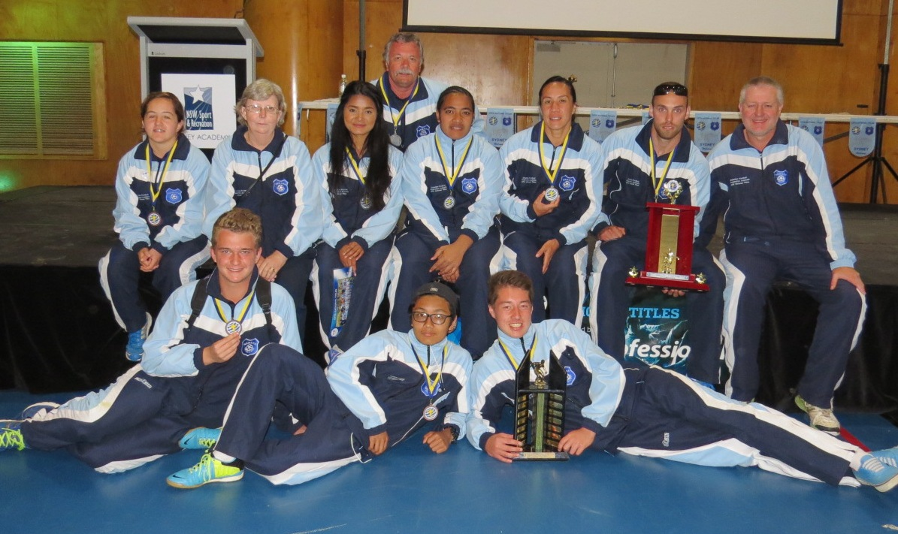
McCredie’s 2014 representatives

COMPETITION RESULTS – 17th June

Ladies Wednesday 17th vs Wenty Waratah 2 - 1
We were very fortunate to get this game in after 2 days of rain. We had a strong team on the park and took control of the game early. Unfortunately, before we had made the most of our dominance and scored a goal the other team got into the match and troubled our defence, who tonight seemed to have tremendous trouble clearing the ball. Taufa broke the deadlock after a well worked move with Natasha. We went into the break 1-0 up and were a different team in the second half. We again took control and a perfect pass found Megan who slammed it home, 2-0. We conceded one which was a shame but kept the win safe, through the efforts of the defenders like Sarah and Elise who had an outstanding game. The most significant thing may be an off the ball accident that saw Natasha find a divot in the pitch and as she later described her “ligaments have done the haka”. Out for the season. We wish her a speedy and full recovery.
Goal scorers – Taufa Kivalu 1, Megan Warwick 1

No matches were played on 20th or 21st following ground closures

The junior round will be replayed on July 4th and the Ladies round will not be replayed.

Please note – Under 15 and All Age Ladies Training will be on Tuesday this week

National Titles Trials start this week
Don’t miss out on trying out

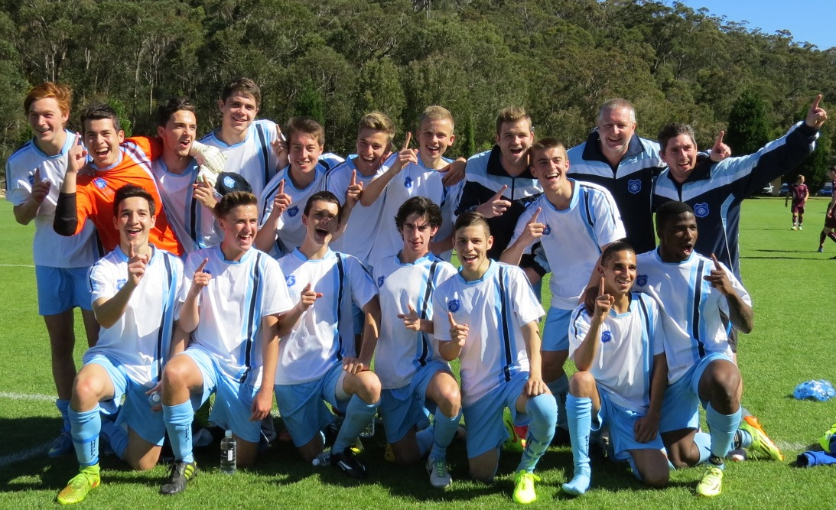

NSW City’s victorious U18s featuring McCredie player William Wark and former player Abdullah Conteh

Victorious over Victoria on penalties in the final

See the whole game at https://vimeo.com/107770566
Saturday 27th June 2015

U6 Red vs St Bernadettes Castle Hill Tigers at Eric Mobbs 1 (Excelsior Ave., Castle Hill)
9.00am Kickoff (meet at Eric Mobbs at 8.30am)

U6 White vs St Bernadettes Castle Hill Lions at Everley (mini) (Everley Rd., South Granville)
9.00am Kickoff (meet at Everley at 8.30am) (set up field)

U7 Red vs St Columbas Castle Hill at Eric Mobbs 1 (Excelsior Ave., Castle Hill)
10.00am Kickoff (meet at Eric Mobbs at 9.30am)

U7 White vs St Bernadettes Castle Hill Lions at Everley (mini) (Everley Rd., South Granville)
9.50am Kickoff (meet at Everley at 9.20am) (dismantle field)

U8 vs Wentworthville Uniting Blue at Freame (Rees St., Mays Hill)
9.00am Kickoff (meet at Freame at 8.30am)

U9 Red vs Hills Spirit Red at Kellyville (Memorial Ave., Kellyville)
11.00am Kickoff (meet at Kellyville at 10.30am)

U9 White vs Hills Spirit Green at Everley 2 (Everley Rd., South Granville)
9.00am Kickoff (meet at Everley at 8.30am) (set up & dismantle field)

U10 Red vs McCredie White at Everley 1 (Everley Rd., South Granville)
10.00am Kickoff (meet at Everley at 9.30am)

U11 White vs McCredie Red at Everley 1 (Everley Rd., South Granville)
10.00am Kickoff (meet at Everley at 9.30am) (set up field)

U12 Red vs Kings Old Boys at Homelands (Homelands Ave., Telopea)
12.00pm Kickoff (meet at Homelands at 11.30am)

U12 White vs Bye

U13 vs St Columbas Castle Hill at Everley 1 (Everley Rd., South Granville)
11.00am Kickoff (meet at Everley at 10.30am)

U14 vs Lidcombe Churches at Everley 1 (Everley Rd., South Granville)
12.00pm Kickoff (meet at Everley at 11.30am)

U15 vs Greystanes FC at Bathurst St 1 (Bathurst St., Greystanes)
11.15pm Kickoff (meet at Bathurst St at 10.30am)

U15 Girls vs OLQP Falcons at Daniel (Daniel St., Greystanes)
12.00pm Kickoff (meet at Eric Mobbs at 11.30am)

U17 vs Castle Hill United at Fred Catterson 4 (Catterson Dve., Castle Hill)
3.00pm Kickoff (meet at Fred Catterson 4 at 2.30pm)

Challenge Cup vs Hills Spirit at Kellyville (Memorial Ave., Kellyville)

(O35s Kick off at 1.15pm Firsts at 3.15pm) (Meet at Kellyville at 12.45pm)

Premier League vs Kings Old Boys at Homelands (Homelands Ave., Telopea)
(Reserves Kick off at 1.15pm Firsts at 3.15pm) (Meet at Homelands at 12.45pm)

Sunday 28th June 2015

All Age Ladies vs Castle Hill United White at Bernie Mullane 2 (Marella Ave., Kellyville)
3.00pm Kickoff (meet at Bernie Mullane at 2.15pm)

