OTB 15/15

Club Secretary – Greg 9682 7779 President – Peter 9632 9203

Interested in sponsoring a team or advertising in this newsletter? – call one of the above numbers.

www.mccredie.org.au/soccer Join our Facebook group

CALENDAR OF UPCOMING EVENTS

June 29 & July 15 National Titles Trials U16 Boys & U18 Boys (7pm) Jones Park

June 24 & July 2 National Titles Trials U16 Girls (5.30pm) & AAL (7pm) Freame Park

June 30 & July 7 National Titles Trials U23 & AAM (7pm) Jones Park

July 1 & 2 National Titles Trials U14 (6pm) Jones Park

To trial for National Titles (27/9 – 1/10/15) a nomination form must be completed prior to trialling (available at www.nswcfa.com.au)

National Titles Trials continue this week
Don’t miss out on trying out
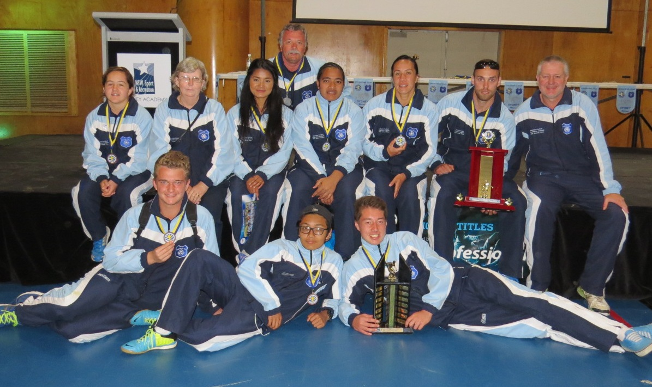
McCredie’s 2014 representatives
Zone Rep results Game 1 Thursday 25th June

McCredie is a member of the South Zone

Junior Zone Representative Competition 2015
UNDER 8 South Zone def North Zone 1 - 0
UNDER9 South Zone def North Zone 2 - 1
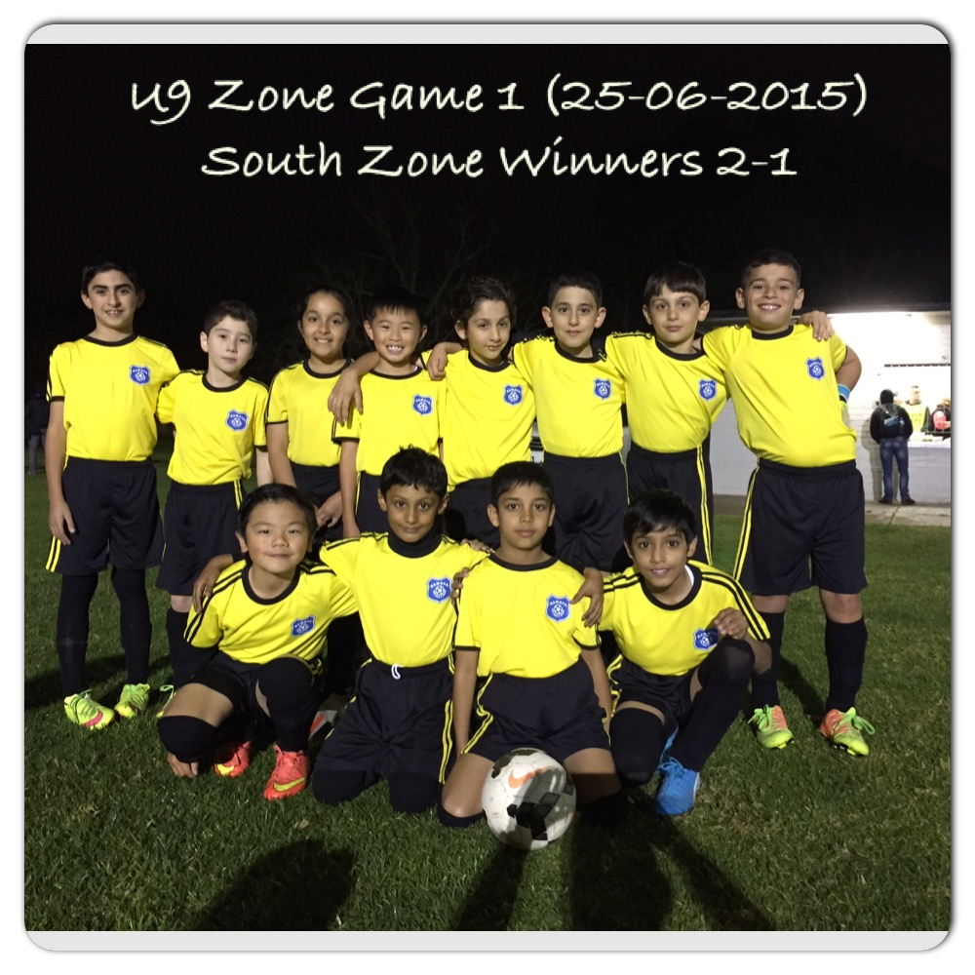
UNDER 10 South Zone drew North Zone 3 - 3
UNDER 11 South Zone def North Zone 3 - 2
UNDER 12 South Zone def North Zone 3 - 0
UNDER 13/14 South Zone def North Zone 5 - 0
Game 2 - Thursday 16/07/2015 – Freame & Jones Parks, Merrylands

RESULTS – 27th and 28th June 2015

U6 Red vs St Bernadettes Castle Hill Tigers

U6 White vs St Bernadettes Castle Hill Lions 7 - 1
This was a fantastic game and our boys looked so good. The start up for our team included Alexander Azar, Elias Hakimi, Deon Kumar, Mikhail Khan, Jeremiah Elkadi, John Barakat and Muhammed Aeliya. From the word go the boys were off and within minutes our first goal was scored by Mikhail. We were defending great and kept the attack up another quick goal by Mikhail and the score was now 2-0. We had Deon as a goal keeper and he made some great saves. Some great passing between Jeremiah and Mikhail saw another goal in and it was now 3-0. We had only 1 sub available so we were making some quick changes so all the boys could have some rest. A mix up at goal so the ball just pass the line and some technically the goal keeper was over the line so it was 3-1 at half time. The second half we started full ball and some great passing saw Jeremiah saw his first goal for the game and it was a great goal. We were playing so well with some great passing and defending. Alex and Deon kept them back and some terrific saves by John are awesome goal keeper kept it at 3-1, but we were not done there. Our super striker Mikhail scored again and again and again with the final score finishing at 7-1. Wow what are terrific effort from our boys they are playing so well. Great team effort guys keep up the good work.
Goal scorers - Mikhail Khan 6, Jeremiah Elkadi 1

U7 Red vs Lidcombe Churches 10 - 3
Another great game! FANTASTIC DEFENCE!! FANTASTIC ATTACK!! Our little boy's and girl's never give up and just enjoy themselves.
Goals: Adhar Yaac 3, Wek Deng 2.
U7 White vs St Bernadettes Castle Hill Lions 6 - 1
Great win by Under 7s White today. Everyone played a great game in attack and defence, setting up some great goals. Dut scored 5 goals and was a standout once again. Sione defended and ran strong, also getting in some great kicks. Mark did a great job as goal keeper in the first half and scored his first goal in second half. Bol also did a great job as goal keeper in the second half. Ryan made numerous runs down the side all game. Andrew and Ali defended well. All round a great team effort securing a good win for the team. Well done.
Goal scorers – Dut Atak 5, Mark Sorojevic 1

U8 vs Wentworthville Uniting Blue 0 – 3
The score line does not really reflect the way the team played today, considering that the team did not field a full side and the opposition had four reserves. Due to not having enough players the team was under the pump from the kick off and they endured a barrage of attacking play from Wenty for at least 13 minutes before a goal was conceded. Zain played a great game as the goal keeper in the first half with only one goal conceded in between making some great saves and frustrating the attacking side. The rest of the team basically played a completely defensive game while Ali tried his best playing upfront on his own. On many occasions Ali took on the defence and beat up to 4 players at a time but with no support the goal area was never really threatened.
In the second half Simon played goal keeper and Zain was to play up front with Ali to try and get an equalizer. Unfortunately this did not work as Wenty got two quick goals to skip to a three nil lead. Despite the score line and the frustration of not having enough players the team on field made up of Zain, Simon, Thomas, Isaiah, Exodus, Ali, Lucy and (Keeyan Ali, Under 6 player) gave it their all. As a manager you couldn’t ask for any more from the team today.

U9 Red vs Hills Spirit Red 0 - 5
Good effort today team against a very difficult opponent. We managed to limit them to much fewer goals than the first time we played them, so again we keep improving. Everyone worked hard, kept running and supported their team mates all across the park. If we keep coorporating as a team, passing to each other and communicating, the rest of the season looks promising. A big congratulations to Benjamin for man of the match, he played an outstanding game. Montell, you set the example by always running hard and also deserve special mention, in saying that, great job to the team for always giving their all. Better luck next week team!

U9 White vs Hills Spirit Green 2 - 0
We managed to field a team of 9 players a few minutes following kickoff. Our kids had many opportunities throughout the game, getting the ball on target but with no venom behind it and when it did have some pace their goalie stood up to the challenge and would have easily defended approximately 6+ shots. That goalie deserved a medal. But our kids ran their little hearts out and we could see they were tired on the field. With many of them backing up from Thursday's zone game, I guess it's somewhat understandable. Joey pocketed a goal in the first half and Ali capturing another in the second to give us the comfort lead which we held on to. Dylan was awarded player of the week, playing well across the park with some excellent solo runs, supporting passes and a few shots at goal (although all just missing the target). Jonathan did a great job in defence and midfield and continues to improve each week. Robert doing the same as he's getting more involved and getting some good clearing kicks to his teammates. Joshua coming back for his second game after surgery also played well in midfield and defence. Owen is a workhorse and always contributes solidly for the team at both ends of the park. And between Sebastian and Anthony in goals both kept a clean score sheet. An understandably tired performance, but they got the job done against a good opponent. Well done kids.
Goal scorers: Joey Farah 1, Ali Fahme 1

U10 Red vs McCredie White 0 - 2
U11 White vs McCredie Red 2 - 0
Another win and another impressive performance. It’s good to see we’ve started to gather some momentum and have improved from our first half of the season. We’re beginning to learn our roles and what it means to be a team. It was important to keep the clean sheet today and I was really happy with the defence today as we rarely were troubled. It was good to see that we played as a team even though a large majority of our team was away. Good to see us get a goal in the second half whilst being a man down playing only with 10 for a full half. We really took this game to the other team and didn’t really give them any chance to win the game! Well played kids and let’s keep it going for next week! Abdul picked up the man of the match for an awesome performance with plenty of skill being showcased. It was unfortunate he didn’t get a goal, but what an awesome little player he is to watch!
Goal Scorer - Aaran Batth 2

U12 Red vs Kings Old Boys 8 – 1
Goal scorers: Christian Frangie 2, Thyson Huynh 2, Mounir Hadid 1, Krish Srestha 1, Ryan Booker 1, Mustapha Fahme 1

U12 White vs Bye

U13 vs St Columbas Castle Hill 8 – 2
Goal scorers – Joe Azzi 5, Nedim Fazlic 3

U14 vs Lidcombe Churches 2 - 1
What a game by the under 14 today. We started slow and Lidcombe played smart they got a penalty but William pulled off a great save. I thought the boys would lift from that but we did not. We made 1 error in the back and they scored. Ahmed could of had 2 goals before half time but did not finish them. Second half started the boys started playing better William pulling off saves. Fred doing alot of talking. We made a little change to the line up by pushing Jasper into the midfield and moving Jakob into the back line. Jasper made a great run beating 5 players and then passing it to Ahmed that drilled it home. With 10min to go Ahmed got tackled from behind in the box and Jasper finished the resulting penalty. Man of the match - Jasper. I am very proud of the boys, still undefeated.
Goal scorers: Ahmed Saad Ekdawy 1, Jasper Carr 1

U15 Girls vs OLQP Falcons 4 - 0
We wonnnnnn! A well deserved win that showcased the sportsmanship, skill and determination of our girls. Everyone on the team had an input in today's game and together we came out on top! Player of the match goes to Sarah.
Goal Scorers: Sulafa Ageeb 1, Yasmine Hawat 1, Tahlia Hildred 1, Chloe Hildred 1

U15 vs Greystanes FC 3 - 1
Greystanes were on top but we beat them easily in round 1, so we were not sure what to expect. The first half though was all theirs as we were unable to get any traction in midfield and couldn’t string any passes together. Greystanes inability to score goals flattered us and when we made two positional shifts to gain the midfield, Ali and Jake combined beautifully to score just on half time and send us into the break even. The scoreboard was even but the match hadn’t been. The boys clicked better in the second half and took over the game. A well finished header from a corner and then an absolute cracker from Ali, again combining with Jake sealed the win. Special mention to Thomas today who had a tremendous impact in midfield when entering the game and was instrumental in shifting the momentum back our way – well done Thomas. Man of the match though was Salem – awesome in goals. Goal scorers – Ali Hawchar 2, Jacob Mitwali 1

U17 vs Castle Hill United 2 – 2
A very frustrated coach. We did enough to beat the opposition. Their first goal came after the ball was well and truly out, with everyone but the ball player stopping. Lesson, play the whistle. For their second goal, I still have no idea why, but they were awarded a free kick from which they scored. When questioned what the free was for, the referee said he wasn't sure, but he'd stopped play, so they could take a free? Sorry, I can't get a lesson from this except maybe we bring a referee to our games. Anyway, we did score two smacking goals, the first from Hassan who took a corner onto the chest, dropped the ball to his feet and smashed it passed the keeper. The second was an angled strike from Ahmad inside the back post, with Anthony charging into to make sure the ball was in the back of the net for the referee to see. For most of the game we played well, however we do need to be faster on the ball, and make the most of our chances. Everyone had good games, Dusan​ a master in the midfield, Emir solid in goals, and both Hamze and Kane having strong second halves
Goal Scorers: Ahmad Mahfoud, Hassan El Hallak

Over 35s vs Hills Spirit 2 - 8
It is a very frustrating to play a whole match with only 10 players and no reserves. There is no chance to run any game plan to come back on the score against a good opposition. I would like to thanks to those 10 players that probably do not want to remember this match again Goal Scorers: Borce Sugarevski, Pece Kotevski

Challenge Cup vs Hills Spirit 5 - 1
At the beginning of the match there were only 9 players to start the match with no substitution. Fortunately no more than 5 minutes another 3 players arrive and help us to complete the formation. The match was even until the 20th minute when our first goal was scored then we managed to score another 4 goals against not strong opposition. In this match we were very effective upfront. Well done guys and keep it up.
Goal Scorer: Jason Stephenson, Duy An Doa, Zia Rajabi, Jeff Eker and Santo Daneil

Premier Reserves vs Kings Old Boys 1 – 1
Disappointing result. It was first vs. last place and they brought us down to their level with the help of a small wet field. We were 1-0 up and they had a player sent off in the first half. We should have dominated the second half by playing smart and using the space but we didn't.
Goal scorer - Wil Wark 1

Premier League vs Kings Old Boys 2 - 1
Congratulations for the effort and determination. As with reserve grade they were not a pleasant opposition and the field didn't help. They pressed us hard, constantly niggling, verbally abusing and when that didn't work they resorted to roughhousing. But the boys held firm and finally got the win they deserved.
Goal Scorers: - William Wark 1, Ali Safdari 1

Ladies vs Castle Hill United White 0 – 2
Sometimes days like this happen: the stronger side loses; a big game goes the wrong way; passes don’t connect, mistakes occur and we can’t get our shots away. That’s football. When this occurs after a poor warm up, late arriving players and a small training turn out, we really haven’t given ourselves a fair chance.

National Titles Trials continue this week
Don’t miss out on trying out

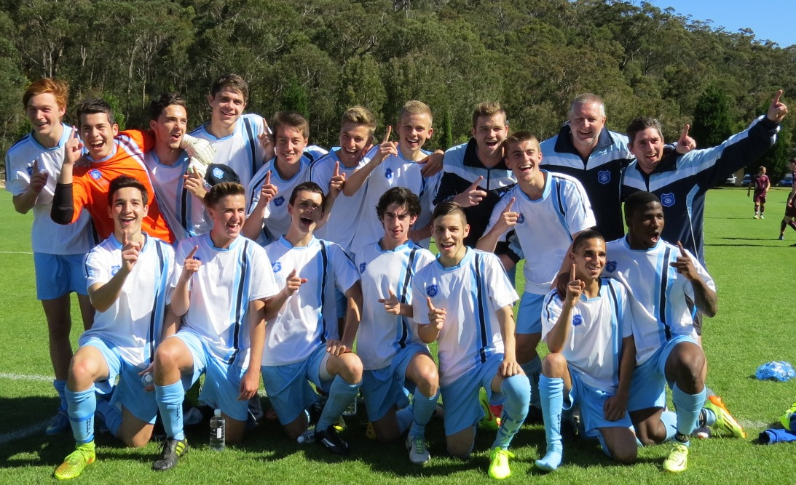

NSW City’s victorious U18s featuring McCredie player William Wark and former player Abdullah Conteh

Victorious over Victoria on penalties in the final

See the whole game at https://vimeo.com/107770566
Saturday 4th July 2015

U6 Red vs Bye

U6 White vs St Columbas Castle Hill at Eric Mobbs 1 (Excelsior Ave., Castle Hill)
10.45am Kickoff (meet at Eric Mobbs at at 10.15am)

U7 Red vs Wentworthville Uniting White at Everley (mini) (Everley Rd., South Granville)
9.50am Kickoff (meet at Everley at 9.20am) (set up & dismantle field)

U7 White vs Wentworthville Uniting Blue at Freame (mini) (Rees St., Mays Hill)
11.00am Kickoff (meet at Freame at 10.30am)

U8 vs Hills Spirit Blue Have Forfeited

U9 Red vs Hills Spirit Green at Everley 2 (Everley Rd., South Granville)
10.00am Kickoff (meet at Everley at 9.30am) (dismantle field)

U9 White vs Bye

U10 Red vs Hills Spirit White HAVE FORFEITED

U11 White vs Hills Spirit Red at Eric Mobbs 2 (Excelsior Ave., Castle Hill)
10.00am Kickoff (meet at Eric Mobbs at at 9.30am)

U12 Red vs St Bernadettes Castle Hill Eagles at Everley 3 (Everley Rd., South Granville)
11.00am Kickoff (meet at Everley at 10.30am)

U12 White vs Lidcombe Churches at Phillips 1 (Martin St., Lidcombe)
11.00am Kickoff (meet at Phillips at 10.30am)

U13 vs Hills Spirit at Eric Mobbs 2 (Excelsior Ave., Castle Hill)
12.00pm Kickoff (meet at Eric Mobbs at at 11.30am)

U14 vs St Columbas Castle Hill at Eric Mobbs 2 (Excelsior Ave., Castle Hill)
11.00am Kickoff (meet at Eric Mobbs at at 10.30am)

U15 vs Pendle Hill Tigers at Everley 1 (Everley Rd., South Granville)
9.00am Kickoff (meet at Everley at 8.15am)

U15 Girls vs Lidcombe Churches at Everley 3 (Everley Rd., South Granville)
12.00pm Kickoff (meet at Everley at 11.30am)

U17 vs Castle Hill RSL at Everley 1 (Everley Rd., South Granville)
10.30am Kickoff (meet at Everley at 10.00am)

Challenge 35s vs Wentworthville Uniting

Challenge Cup vs Parramatta Salvation Army at Everley 3 (Everley Rd., South Granville)

(O35s Kick off at 1.15pm Firsts at 3.15pm) (Meet at Kellyville at 12.45pm)

Premier League vs St Barnabas Broadway at Everley 1 (Everley Rd., South Granville)
(Reserves Kick off at 1.15pm Firsts at 3.15pm) (Meet at Everley at 12.45pm)

Sunday 5th July 2015

All Age Ladies vs Kellyville Kolts at Everley 1 (Everley Rd., South Granville)
3.00pm Kickoff (meet at Everley at 2.15pm)

