OTB 16/15

Club Secretary – Greg 9682 7779 President – Peter 9632 9203

Interested in sponsoring a team or advertising in this newsletter? – call one of the above numbers.

www.mccredie.org.au/soccer Join our Facebook group

CALENDAR OF UPCOMING EVENTS

July 7 National Titles Trials U23 & AAM (7pm) Jones Park

July 13 National Titles Trials AAL (7pm) Freame Park

July 15 National Titles Trials U16 Boys & U18 Boys (7pm) Jones Park

July 16 Game 2 Zone reps – Freame & Jones Parks, Merrylands

RESULTS – 4th & 5th July 2015

U6 Red vs Bye

U6 White vs St Columbas Castle Hill 7 – 2
Despite the shortage of players, four ‘Mighty Ducks’ (as coach referred to them) turned up for the match and played their exceptional best. The team supported each other and applied more complex strategies, resulting in their amazing victory. Deon multi-tasked by playing both on the field and as goalkeeper. His training has paid off, by demonstrating many times how to save goals like a pro. John strategically stepped into the huddle and was consistent in trying to get the ball away. He provided morale to his team with regular high-fives. Alex’s strategic kicks were powerful enough to get the ball away and even scoring a goal. He proved to be an asset to the team. From the sidelines, supporters could be heard throughout the game, “All the way, Jeremiah!” Jeremiah consistently took the book from one end of the field to the other and scored a total of 6 goals- his personal best this season. Even though the team was small in number, they were enormous in their effort today. Goal scorers – Jeremiah Elkadi 6, Alex Azar 1



U7 Red vs Wentworthville Uniting White 6 - 0
Great game! They had our kid's running off their feet but our kids never gave up. Omar played so well today scoring 3 goals well done Omar! Everyone else showed great defence and passing of the ball. Patrick never giving up an scoring 1 goal, and Wek scored 2 goals. Well done to Talitha as goalkeeper keeping those balls away. Keep up the excellent work boys and girls.
Goal scorers: Omar Elbizri 3, Wek Deng 2, Pattrick Matta 1
U7 White vs Wentworthville Uniting Blue 7 - 3
It was a very tough game with a good opposition. Even though we conceded an early goal, our team came back to win 7-3. With only one reserve, everyone played well. Dut was a standout, scoring six goals, with Sione scoring one. There was some great defending, even though the team were tired. Andrew almost scored a goal but a good save denied him that goal. Ryan and Mark made numerous runs up field and defended strongly. Sione was solid as a rock holding our defense together. Ali played second half as goalie and did well. Bol played well in the middle of the field, helping his team mates. Great win against a good team.
Goal scorers – Dut Atak 6, Sione Tu’ifua 1

U8 vs Hills Spirit Blue won on forfeit

U9 Red vs Hills Spirit Green 0 - 8
The score did not reflect on how we played today. Even though the opposition were much taller and bigger than us we still managed to make it a challenge for them to score. Amazing job to Elisa, Yasmin and Malachi for being man/woman of the match today, they played their best and deserve the title. Well done to the whole team for the hard work and for not giving up. Keep your heads up high as we can only get better from here.

U9 White vs Bye

U10 Red vs Hills Spirit White game postponed

U11 White vs Hills Spirit Red 0 - 7

U12 Red vs St Bernadettes Castle Hill Eagles 6 - 1
I thought today's game was just beautiful the boys played together as a whole team passing to one another especially down the sideline and finishing perfectly into the net . Krish was on the field today instead of between the post and he played the field like he owned it scoring two hectic goals, which earned him man of the match .Yilmaz Mustie and Aakrist played their positions right and were always on the ball Mounir and JohnLuke set up many goals booting it to Christian to finish , Christian as always spectacularly scored a long chip over the keeper . Deng Ryan Thyson and Elias were also on fire today playing the ball to one another and showing growth in play, Deng also had a shot at goals which was finished by the opposition ...special mention to our coach who always plays fairly by benching more players off the field so we could give the opposition a fair-go as they seemed to need all the help today ..I'm sure Joel was a bit bored playing keeper but I'm also sure he would've been ready to defend any ball coming his way .
Goal scorers: Christian Frangie 2, Krish Srestha 2, Ryan Booker 1, own goal 1

U12 White vs Lidcombe Churches 0 - 4
Boys played good today but not good enough to score. They had a few attempts at shooting but it just didn't happen!
Better luck next time boys. Man of the match Peter Germanos

U13 vs Hills Spirit 5 - 0
A great performance by the team today! They took full control of the game, might I add with just only 9 players. Qais scored 3 goals and Nedim scored one in the first half. 2nd half approached and we thought we get the defenders up front, which gave Salvator a chance to score finishing the game.
Goal scorers – Qais Sungkar 3, Nedim Fazlic 1, Salvator Angoang 1

U14 vs St Columbas Castle Hill 5 – 0
Goal scorers:

U15 Girls vs Lidcombe Churches 0 - 4

U15 vs Pendle Hill Tigers 3 – 0
We had two opportunities to score in the first 3 minutes and failed to finish. What should have been an easy match turned into an arm wrestle and Pendle Hill did a good job of making us work hard. At half time it was still nil all. In the second half we settled, grabbed two nicely finished goals and picked up an additional gimme late in the match. Jesse played well at the back and Thomas continued his good form in the midfield.
Goal scorers – Ali Hawchar 2, Rusheel Raj 1

U17 vs Castle Hill RSL 1 – 2
Disappointing not to walk away with at least a draw against the competition leaders. Unfortunately, in the first half we fell into the trap of a couple of passes, and then a long ball forward. NO!! This will rarely work with our team. Build it up and keep possession. They were 2-0 up at half time thanks to some good ball work by them, and poor positioning by us. In the second half we improved and started to treasure possession a bit more, passing to feet and supporting each other. Although we created multiple opportunities, we were only able to get one goal back. Anthony and Kane were strong all game and it was good to see Jason come back into a little bit of form. Against the best teams in the competition we need to start with our A-game.
Goal Scorer: Will Booker 1

Over 35s vs Wentworthville Uniting 2 - 2
Another day to forget, with only 10 players against the bottom team of the competition did not represent any challenge at all. Two early goals conceded in each half put a lot of pressure on our players to get level on the score. Though we had the possession of the ball during the whole match and plenty opportunities to score, we just were able to equalize the score with 2 minutes to go. Unfortunately Wayne French got a fractured shoulder almost at the end of the match, We wish him a soon recovery.
Goal Scorers: Mathew Lapinska 1, Zeeshan Mirza 1

Challenge Cup vs Parramatta Salvation Army 2 - 2
Two early goals on the match gives the composure to play our game. Having more controls of the ball allow us to create many opportunities to score but we were unable to do it so. Unfortunately the opposition manage to level the score, but we never stop looking for the winning goal. At the end an unsatisfactory feeling between the players for not getting the 3 points.
Goal Scorers: Aydin Tokdogan 1, Santo Daneil 1

Premier Reserves vs St Barnabas Broadway 3 - 4
Goal scorers – James Rosandi 2, William Wark 1

Premier League vs St Barnabas Broadway 1 - 7
Goal Scorers – Amarvir Singh 1

Ladies vs Kellyville Kolts 3 – 1
Last week we were late to the game and not ready when play started and paid the price. This week we were ready and our opposition weren’t. The 2 goals we scored early were the difference in the end – a lesson not lost on our team. But we had to take the chances early and Laura’s great run and cross for Taufa, Taufa’s charge through the middle and later Laura’s powerful run and finish were all goals of quality. Throughout the match Ania and Nyanut played well, Nyanut winning my player of the match award.
Goal scorers – Taufa Kivalu 2, Laura Herbert 1

National Titles Trials continue this week
Don’t miss out on trying out

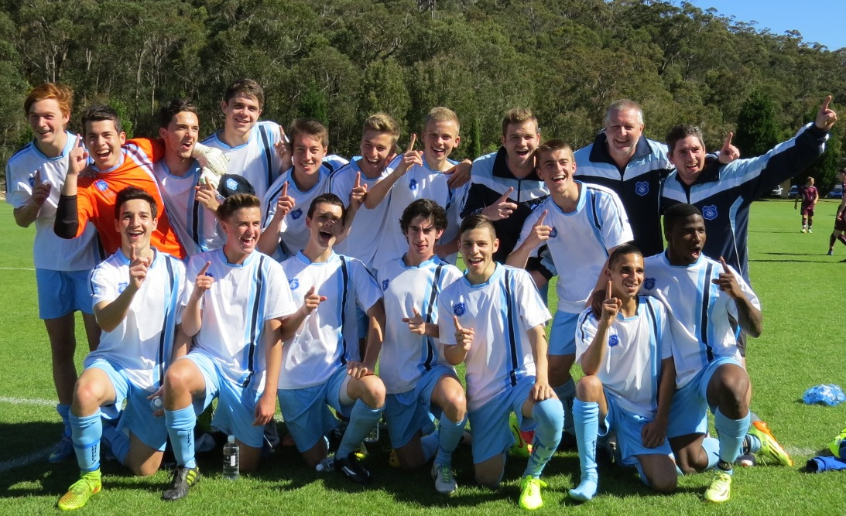

NSW City’s victorious U18s featuring McCredie player William Wark and former player Abdullah Conteh

Victorious over Victoria on penalties in the final

See the whole game at https://vimeo.com/107770566
Saturday 11th July 2015

U6 Red vs Wentworthville Uniting at Freame (Rees St., Mays Hill)
9.00am Kickoff (meet at Freame at 8.30am)

U6 White vs Bye

U7 Red vs Wentworthville Uniting Gold at Freame (Rees St., Mays Hill)
9.50am Kickoff (meet at Freame at 9.20am)

U7 White vs Wentworthville Uniting White at Everley (mini) (Everley Rd., South Granville)
9.50am Kickoff (meet at Everley at 9.20am) (set up & dismantle field)

U8 vs Hills Spirit White at Kellyville (Memorial Ave., Kellyville)
10.00am Kickoff (meet at Kellyville at 9.30am)

U9 Red vs Lidcombe Churches Gold at Phillips 2 (Memorial Ave., Kellyville)
9.00am Kickoff (meet at Kellyville at 8.30am)

U9 White vs Lidcombe Churches Blue at Everley 2 (Everley Rd., South Granville)
9.00am Kickoff (meet at Everley at 8.30am) (set up & dismantle field)

U10 Red vs Hills Spirit Red at Eric Mobbs 2 (Excelsior Ave., Castle Hill)
11.00am Kickoff (meet at Eric Mobbs at 10.30am)

U11 White vs Lidcombe Churches at Everley 3 (Everley Rd., South Granville)
9.00am Kickoff (meet at Everley at 8.30am) (set up field)

U12 Red vs Wentworthville Uniting at Freame (Rees St., Mays Hill)
12.00pm Kickoff (meet at Freame at 11.30am)

U12 White vs Kings Old Boys at Everley 3 (Everley Rd., South Granville)
10.00am Kickoff (meet at Everley at 9.30am)

U13 vs OLQP Falcons Red at Everley 3 (Everley Rd., South Granville)
11.00am Kickoff (meet at Everley at 10.30am)

U14 vs Hills Spirit at Everley 1 (Everley Rd., South Granville)
12.00pm Kickoff (meet at Everley at 11.30am)

U15 vs Regents Park at Everley 1 (Everley Rd., South Granville)
9.00am Kickoff (meet at Everley at 8.15am)

U15 Girls vs Bye

U17 vs Guildford County at Everley 1 (Everley Rd., South Granville)
10.30am Kickoff (meet at Everley at 10.00am)

Challenge Cup vs Bye

Premier League vs Wentworthville Uniting at Freame (Rees St., Mays Hill)
(Reserves Kick off at 1.15pm Firsts at 3.15pm) (Meet at Freame at 12.45pm)

Sunday 12th July 2015

U15 catchup vs Granville Waratah at Robin Thomas 1 (Macarthur St., Parramatta)
11.30am Kickoff (meet at Robin Thomas at 10.45am)

U17 catchup vs Granville Waratah at Robin Thomas 1 (Macarthur St., Parramatta)
1.15pm Kickoff (meet at Robin Thomas at 12.45am)

All Age Ladies vs Castle Hill United Black at Everley 1 (Everley Rd., South Granville)
3.00pm Kickoff (meet at Everley at 2.15pm) (dismantle field)

