OTB 17/15

Club Secretary – Greg 9682 7779 President – Peter 9632 9203

Interested in sponsoring a team or advertising in this newsletter? – call one of the above numbers.

www.mccredie.org.au/soccer Join our Facebook group

CALENDAR OF UPCOMING EVENTS

July 15 National Titles Trials AAL (7pm) Freame Park

July 15 National Titles Trials U16 Boys & U18 Boys (7pm) Jones Park

July 16 Game 2 Zone reps – Freame & Jones Parks, Merrylands

RESULTS – 4th & 5th July 2015

U6 Red vs Wentworthville Uniting 2 – 7
It was a slow start today as players were late getting to the game. Nour kicked things off nicely with 2 goals, however, he injured himself and couldn't continue to play. The team stepped up to the challenge with only 5 players. Izaac dribbled close to the goal many times. Danielle skillfully stole balls from opposing players. Matthew and Jackson tackled and defended with a passion. Gethyn had lots of opportunities to kick the ball. Everyone tried very hard and got to kick the balls lots. Good effort team.
Goal scorer: Nour Eldine Matar 2

U6 White vs Bye

U7 Red vs Wentworthville Uniting Gold 6 - 0
What a game! We were 3 player's down but our boys and girls played so well today. JOEY was unstoppable scoring 4 goals giving it all his best today. Adam had great passing and also scored a goal.
Talitha took the ball more than half the length of the field for her goal. Emily tried her best to attack the ball.
Omar and Keeyan provided good defence not letting the ball past them. Idin as goal keeper second half not letting any balls in. Well done everyone. Goal scorers: Joey Douehi 4, Adam Assan-Larry 1, Talitha Chung 1
U7 White vs Wentworthville Uniting White 4 - 2
We started the game with both sides being under strength, only 5 players to each team. However they both played their hardest. Badih scored a brilliant goal in the first half, doing a little victory jump! Sione, once again, was a great defense ensuring the ball rarely got past him and scoring a goal himself. Andrew did a great job saving the goals from the opposition and had some good kicks to his team. Ryan did great runs up the field and fought well for that ball. Mark scored two goals for the team, showing good control of the ball. Danielle joined the team in second half and showed good team work. Great win for our team!
Goal scorers – Mark Sorojevic 2, Sione Tu’ifua 1, Badih Ayoub 1

U8 vs Hills Spirit White 0 – 6
The team was out played today by a better side. Hills Spirit has some good players with speed and this was something that Guildford could not counter against. It was basically one way traffic as Guildford was unable to make any opportunities to threaten the score sheet. Gerardo, coming back from being on the side line for 4 weeks with a broken arm tried hard all game to move the ball forward and into the oppositions side of half way creating some half chances. The Guildford players that turned up for the game today, as usual tried their best. To the following players; Ameera, Gerardo, Zain, Simon, Thomas, Isaiah, Exodus, Rhiannyn and Lucy that consistently turn up week after week your efforts on the field are noticed. Your efforts are noticed by the coach, manager and the supporters that come to watch you play every week.
Injury update on Rhiannyn. Rhiannyn was treated with an ice pack to the injured right knee, treated for the knock to the head and was able to walk to the car. Rhiannyn’s parents’ caring words also helped heal the wounds.

U9 Red vs Lidcombe Churches Gold
Totally my mistake and I apologise. Please check the draw on the website each week as I can’t be trusted! Greg

U9 White vs Lidcombe Churches Blue 1 – 6
We were outplayed by a better team on the day. We had chances at goal and missed, they had chances and made them count. Our defence let us down. It was another important lesson to learn as we march toward the finals. Hopefully we'll see them again and having learnt from this experience, the kids will be motivated to reverse the result next time. Anthony played a great second half in goals making some excellent saves, earning him player of the week. The kids played a good game today and should hold their heads up high. We'll need to find that extra level in our game to step up. We didn't find it today and it showed on the scoreboard. Goal scorer: Joey Farah 1

U10 Red vs Hills Spirit Red 2 – 0
Goal scorer – Mohammed Matar 2

U11 White vs Lidcombe Churches 4 - 3
A much better effort today compared to last week. We showed what we can do when we play as a team. We all put in 100%, and our second half was one of the best I’ve seen all season against a quality opposition. If we show this same determination and commitment every week, teams will find it very hard to defeat us. A special mention to today’s player of the match, Izabella, who played fantastic in defence. Let’s keep the momentum going for next week.
Goal scorers: Abdul Agha 3, Aaran Batth 1

U12 Red vs Wentworthville Uniting 1 - 2
A soccer game worth watching ,there literally was 22 feisty kids on the field playing their heart out chasing after the ball . In the 1st half Thyson kept trying till he striked the ball right in but I think than our kids relaxed a bit and gave the opposition the chance to tie with us . Second half was pretty much the same every kid was hungry for the ball there was never a dull moment even from the side line .Johnluke and Christian made many breaks but were extremely unlucky to finish . Krish feistly Saved many goals but the opposition gave us a true run for our money and got lucky again in the 2nd half ..unlucky game but a true soccer game. Just a bit more team effort would see us play a much better game next time .
Goal scorer: Thyson Huynh 1

U12 White vs Kings Old Boys 4 - 1
Good playing today boys! You were focused and determined to win. You all played in position as well as playing in different positions. You talked to each other calling for the ball and the team spirit was very positive. Keep playing like you did today and I'm sure we will all enjoy the rest of the season. Man of the match Malou
Goal scorers – Jayden Daily 2, Garang Angui1, Peter Germanos 1,

U13 vs OLQP Falcons 16 - 0
This report will just be a list of who scored today. We had Joey Azzi score three goals, Nedim with three, Qais with three and Ferdi with three as well. Jeffrey for the first time, scored one goal, Andrew Ibraheem scored one too and Chris scored two goals. Hope that tells you how the game went. Well done team.
Goal scorers – Qais Sungkar 3, Nedim Fazlic 3, Joe Azzi 3, Chris Abosh 2, Andrew Ibraheem 1, Jeffrey Farah 1

U14 vs Hills Spirit 9 – 0
We won 9-0. The second goal was a nice little play and finished of with a nice header by Ryan .. It was a ‘kick to Ahmed and let him score’ kind of day with him scoring 6 goals. Boys need to start playing it around more. Man of match was Peter who played out of his skin.
Goal scorers: Ahmed Ekdawy 6, Ryan Carder 1, William Appiah 1, Jakob Kaihea 1

U15 Girls vs Bye

U15 vs Regents Park 1 – 5
Apart from Salem in goals, who was simply magnificent, we played poorly today. Not enough urgency to get to the ball and not enough common sense when we did have it. Goal scorer – Thomas Taouk 1

U17 vs Guildford County 7 - 0
Greedy McCredie. Playing against only 7 men, we should have listened to the coach and worked the ball more. Instead, we kept attacking the same area time after time. As a game, it was a bad training run. The positive is the 7 goals will help our goal difference.
Goal Scorers: Dusan Miljevic 3, Alan Trad 1, Anthony Gwee 1, Hassan El Hallak 1, Vehid Dupovac 1

Over 35s vs Bye

Challenge Cup vs Bye

Premier Reserves vs Wentworthville Uniting 3 - 1
Goal scorers – James Rosandi 1, Pece Kotevski 1, Mohammed Al Delaimi 1

Premier League vs Wentworthville Uniting 0 - 7

Ladies vs Castle Hill RSL Black 1 - 1
This was a really brave effort. Lots of girls away on hols, no subs, a couple of girls really sick and one really injured but everyone dug deep and we managed a draw with the team running second. Fantabulous. Only a penalty against us preveted us from taking all the points. Sarah Rebenko was fantastic, Natasha gave until she could give no more and Sarah Irving urged the team on with running and effort until the final whistle view. Laura Burden also played strongly all game and deserved her goal. Very proud coach.
Goal scorers – Laura Burden 1

National Titles Trials continue this week
Don’t miss out on trying out

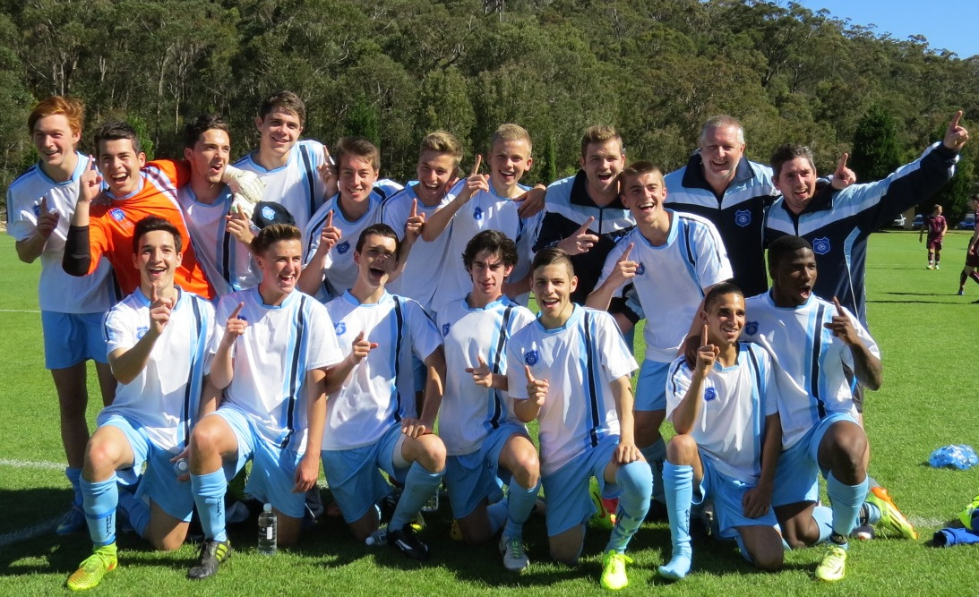

NSW City’s victorious U18s featuring McCredie player William Wark and former player Abdullah Conteh

Victorious over Victoria on penalties in the final

See the whole game at https://vimeo.com/107770566

2015 selections

Under 14, 16 girls and All Age Men teams were announced this week

For complete team lists visit the Association website www.nswcfa.com.au

Congratulations to Ahmed Ekdawy, Jacob Kaihea and Jasper Carr (U14s) and Sulafa Ageeb and Sharlene Muru Tucker (U16 girls) on their selection.

More teams will be announced this week.
Saturday 18th July 2015

U6 Red vs McCredie White at Everley (mini) (Everley Rd., South Granville)
9.00am Kickoff (meet at Everley at 8.30am)

U6 White vs McCredie Red at Everley (mini) (Everley Rd., South Granville)
9.00am Kickoff (meet at Everley at 8.30am) (set up field)

U7 Red vs McCredie White at Everley (mini) (Everley Rd., South Granville)
9.50am Kickoff (meet at Everley at 9.20am) (dismantle field)

U7 White vs McCredie Red at Everley (mini) (Everley Rd., South Granville)
9.50am Kickoff (meet at Everley at 9.20am)

U8 vs Hills Spirit Red at Everley 2 (Everley Rd., South Granville)
9.00am Kickoff (meet at Everley at 8.30am) (set up & dismantle field)

U9 Red vs Lidcombe Churches at Phillips 2 (Martin St., Lidcombe)
12.00pm Kickoff (meet at Phillips at 11.30am) (This is a change to what is on the website)

U9 White vs St Bernadettes Castle Hill at Eric Mobbs 2 (Excelsior Ave., Castle Hill)
9.00am Kickoff (meet at Eric Mobbs at at 8.30am)

U10 Red vs Wentworthville Uniting at Everley 1 (Everley Rd., South Granville)
10.00am Kickoff (meet at Everley at 9.30am) (set up field)

U11 White vs Hills Spirit White at Kellyville (Memorial Ave., Kellyville)
11.00am Kickoff (meet at Kellyville at 10.30am)

U12 Red vs Bye

U12 White vs Wentworthville Uniting at Freame (Rees St., Mays Hill)
10.00am Kickoff (meet at Freame at 9.30am)

U13 vs Bye

U14 vs OLQP Falcons at Daniel 1 (Daniel St., Greystanes)
11.00am Kickoff (meet at Daniel at 10.30am)

U15 vs Lidcombe Churches at Phillips 1 (Martin St., Lidcombe)
10.45am Kickoff (meet at Phillips at 10.00am)

U15 Girls vs St Columbas Castle Hill at Everley 3 (Everley Rd., South Granville)
11.00am Kickoff (meet at Everley at 10.30am) (set up field)

U17 vs Lidcombe Waratah at Coleman 2 (Georges Ave., Lidcombe)
1.15pm Kickoff (meet at Coleman at 12.45am)

Challenge 35s vs Kings Old Boys

Challenge Cup vs Columna at Everley 3 (Everley Rd., South Granville)

(O35s Kick off at 3.15pm Firsts at 1.15pm) (Meet at Everley at 12.45pm) (dismantle field)

Premier League vs Coptic United at Everley 1 (Everley Rd., South Granville)
(Reserves Kick off at 1.15pm Firsts at 3.15pm) (Meet at Everley at 12.45pm) (dismantle field)

Sunday 19th July 2015

U15 catchup vs Granville Waratah at Robin Thomas 1 (Macarthur St., Parramatta)
11.30am Kickoff (meet at Robin Thomas at 10.45am)

U17 catchup vs Granville Waratah at Robin Thomas 1 (Macarthur St., Parramatta)
1.15pm Kickoff (meet at Robin Thomas at 12.45am)

All Age Ladies vs Auburn FC at Webbs Ave 1 (Webbs Ave., Auburn)
1.00pm Kickoff (meet Webbs at 12.15pm)

