OTB 23/15

Club Secretary – Greg 9682 7779 President – Peter 9632 9203

Interested in sponsoring a team or advertising in this newsletter? – call one of the above numbers.

www.mccredie.org.au/soccer Join our Facebook group

Grand finals this week

Plenty of finals action this week - check the back page. Get out and support McCredie Teams and fill that stand with Red and White!

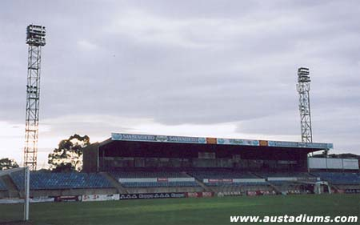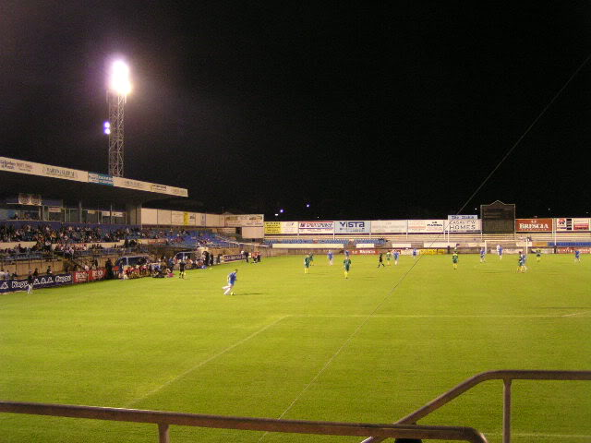

Grand finals AT MARCONI STADIUM – always a great atmosphere and a thrill to see our kids in a big stadium with our club name in lights on the scoreboard!

Managers a reminder that following the last match for your team please collect and wash all the jerseys and return them and the balls, cones and training bibs to me within the week.

Thanks, Greg

RESULTS – 22nd & 23rd August 2015

U9 White semi final vs Hills Spirit Green 1 - 0
It was a tough game today. Both teams played very well and it could have gone either way. An arm wrestle to the end. We then managed to break through mid way through the second half to take the slender lead. Although just 1-0 up I felt that was enough and wasn't going to give it up, so we stacked the defence and they shut the fortress down. Looking forward to the Grand Finals - kids are already champions for getting there. Well done team.
Goal scorer: Joey Farah 1

U10 Red semi final vs Hills Spirit Red 2 - 0
Details of the semis and finals will be included in the final end of year report. See you at Marconi Stadium!
Goal scorers: Makuac Kuol 1, Mohammed Matar 1
U11 White semi final vs Lidcombe Churches 2 – 0
Semi finals day, and what a beautiful day to play. We started the game strong with an excellent counter attacking goal from a nice pass by Aaran which made its way onto Abdul who finished a with a bomb of a shot! We set the tone of the match with that play and from there onwards we put our foot on the pedal with attack after attack. In latter stages of the half we ran out of steam which allowed the opposition opportunities to grab an undeserved goal. We however didnt concede due to an excellent performance from Adam in the back! The second half began slow but again we slowly began to pile pressure on them and were rewarded with a goal from Gregory 'The man, the myth' Farah. It all in all was a good game to watch and now we're moving forward on to the next game high in confidence! Great work to all and special mention to the MOTM Adam who, as per usual, was a little machine.
Goal scorers – Abdul Agha 1, Gregory Farah 1

U12 Red semi final vs St Bernadettes Castle Hill 0 – 0 (won 2 – 1 on penalties)
Most intense game of the season. Again our boys played with the utmost power and passion. We seemed to have 100% possession of the ball . Kicking at goals more than we could count but we were just unlucky and unfortunate not to finish them off . Full time went off with an extra five minutes added for a golden goal , again no ball went through another five minutes added and the boys put in all their effort with full possession and great passing for a chance but no luck . The semi finals goes to penalties so of course we were watching a professional game . Krish is just so strong as a goal keeper saving two of their kicks with his smart moves although their goal keeper had no chance against our powerful kicks made by Thyson and John-Luke which almost broke the net to send the fans cheering so loud . The boys deserved to win they played their heart out, every player put in 100% with great defence and lots of possession.. Well done again and again and the best of luck at the Grand Final . Woohooo
Goal scorers: Thyson Huynh 1, John - Luke El-Rahi 1

U13 semi final vs Lidcombe Churches 2 - 1
Grand final here we come!! It was a very intense game today but the team pulled through winning 2-1 against lidcombe, to make the grand final. Great work team
Goal scorer – Joe Azzi 2
U14 semi final vs Hills Spirit 3 - 0
Bring on the grand finals as today we won 3-0.. Within 5mins we scored the first goal. With in 10min we scored the second. Then we just played smart soccer. Jakob should have had 4 goals with open headers but could not bring it down. But we will work on that. Fred played a great game and got man of the match. Please parents, let’s let make it a great turn out for the grand finals
Goal scorers: Ryan Carder 1, Jakob Kaihea 1, Nicholas Azar 1

U15 semi final vs Greystanes FC 1 - 3
No need to post mortem the last game of the season. Unfortunately we weren’t good enough today. At the start of the season we had 7 new players, 4 of whom had not played soccer before. To qualify for the semis (and with 1 game to go still be in the running for the minor premiership) in Div 2 is a remarkable achievement and one the boys should all be very proud of. Third year in a row qualifying for semis. A year with the same team next season and we would be giving ourselves every chance of grabbing a premiership. Get up for the challenge boys! Thanks for the 2015 season. Goal scorer – Ali Hawchar 1

Ladies semi final vs Castle Hill RSL White 3 – 2
Happy days – a semi final win! We came out very strongly and dominated the early play and kept creating, but not finishing , our opportunities. Castle Hill then got one against the run of play and then a second in quick succession. We dropped our heads for about 15 minutes but came again for the last 10 minutes creating still more chances. The pressure paid off and Taufa took a great free kick to leave us just one down and half time. In the second half we came out like a train scoring two goals and silencing their quick forward who had terrorised us in the first half. Great win – two more to go.
Goal scorers – Taufa Kivalu 2, Laura Herbert 1
Premier Reserves semi final vs Greystanes United 0 - 10

Hi All,
NSW Churches Football Association are holding a golf day on Saturday 12th September 2015.
All money raised will go to support the 2015 National Titles which are being held in Sydney
To download details of the event click the link below.
Golf day download
Regards
Kim Sydenham | Secretary
NSW Churches Football Assoc Inc
Ph: (02) 8091 6100 | Fax (02) 8417-2666 | M: 0410 444 863

Saturday 29th August 2015

U9 White Grand final vs Lidcombe Churches Gold at Marconi Stadium (Prairievale Rd., Bossley Park)
9.00am Kickoff (meet at Marconi at 8.15am)

U10 Red Grand final vs McCredie White at Marconi Stadium (Prairievale Rd., Bossley Park)
10.00am Kickoff (meet at Marconi at 9.15am)

U11 White Grand final vs McCredie Red at Marconi Stadium (Prairievale Rd., Bossley Park)
10.00am Kickoff (meet at Marconi at 9.15am) (wear grey training shirts for match)

U12 Red Grand final vs Hills Spirit at Marconi Stadium (Prairievale Rd., Bossley Park)
12.00pm Kickoff (meet at Marconi at 11.15am)

U13 Grand final vs McCredie 14s at Marconi Stadium (Prairievale Rd., Bossley Park)
1.00pm Kickoff (meet at Marconi at 12.15am) (wear grey training shirts for match)

U14 Grand final vs McCredie 13s at Marconi Stadium (Prairievale Rd., Bossley Park)
1.00pm Kickoff (meet at Marconi at 12.15am)

Sunday 30th August 2015

All Age Ladies semi final vs Castle Hill RSL Black at Max Ruddock 2 (Romulus St., Winston Hills
12.30pm kick off (meet at Max Ruddock at 11.45am)

