OTB 24/15

Club Secretary – Greg 9682 7779 President – Peter 9632 9203

Interested in sponsoring a team or advertising in this newsletter? – call one of the above numbers.

www.mccredie.org.au/soccer Join our Facebook group

Some images from Saturday’s grand finals – plenty more on our Facebook page

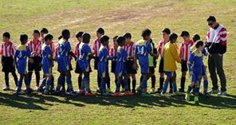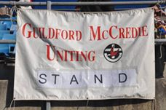
U9s shaking hands pre match We own Marconi Stadium!
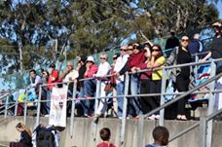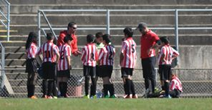
The anxious U9 crowd Wise words from the U10 coaching staff
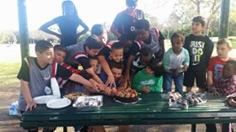
U10 parents – winners are grinners ... … and cake eaters

The U11 coaching staff taking club presentation to a new level

Under 12 grand final action (above and below)

U12 presentationThe U13s have been here before, but it was the 14s day today
Please note that the Presentation evening and AGM have been moved back one week

Managers a reminder that following the last match for your team please collect and wash all the jerseys and return them and the balls, cones and training bibs to me within the week.

Thanks, Greg

RESULTS – 29th & 30th August 2015

U9 White grand final vs Lidcombe Churches 1 - 2
It was a beautiful morning for soccer.
Our little champions played a great game, but Lidcombe deserved their win today and have been the standout team all season. It was an intense battle going down to literally the last minute. A fitting way to finish a grand final match. Thank you to all the kids and their Parents for a most memorable season.
Ahhhh...soccer season complete!
Goal scorer: Joey Farah 1

U10 Red grand final vs McCredie White 1 – 1 (2 -1 on penalties)
Details of the semis and finals will be included in the final end of year report.
Goal scorer: Makuac Kuol 1
U11 White grand final vs McCredie Red 1 – 1 (1 – 2 on penalties)
Goal scorer – Abdul Agha 1

U12 Red grand final vs Hills Spirit 1 - 0
Today we only had one thing on our mind 'the winning trophy' and boy did the boys play hard to earn it . The game started with an inspirational talk from the coach encouraging the boys to tell each other 'I've got your back' and from there they knew exactly what to do . The first half of the game was played so well with their attacking assuring the fans they've got the trophy secured . Mounir was given the striker position and knew so well he has the fitness and ability to smash in the winning goal and what a goal it was .Joel held his goalkeeper position with strength to let no opposition attempt through. The second half our opposition tried everything to get the ball but we easily stole it back fair and square . The boys played like machines Thyson Christian and JohnLuke taking many attempts at goals but they were unlucky to score . Angus Jude and Elias were on fire today in getting the ball to the front . Joel Ryan Yilmaz Aakrist and Deng held their defence line making sure no one had a chance to try and shoot at our super goal keeper Krish .Again and again Im so proud to repeat that this team gives it their best everytime, their 100% . the way they play together just shows how much they understand one another and how excited they are about their soccer . Angus and Jude were also on high spirits and did a great job at starting the fans to chant away 'lets go Guildford lets go' . A very Well deserved trophy even the opposition mentioned it . You are our champions . A much more relaxing game than the semifinals thanx for that .
Goal scorer: Mounir Hadid 1

U13 grand final vs McCredie 14s 0 - 1
U14 grand final vs McCredie 13s 1 - 0
Goal scorers: Jasper Carr 1

Ladies semi final vs Castle Hill RSL Black 0 - 3
Not the afternoon we were hoping for and unfortunately things just didn’t go our way. We pressed early and Castle Hill knew they were in for a torrid afternoon. When Taufa took a fall though and was forced from the field, momentum shifted. We stuck with it and went in to half time 0-0 but we were starting to tire and a few cracks at the back opened, partly because we couldn’t maintain pressure from the front and a few goals went in. Of course T wasn’t the only player missing and we can only wonder whether Natasha, Ania and T may have made the difference. Maybe we will find out in 2016. Great season girls, another giant leap forward from just a few years ago when much of the same team were struggling to get any points – there are now at least 13 teams below us!

Hi All,
NSW Churches Football Association are holding a golf day on Saturday 12th September 2015.
All money raised will go to support the 2015 National Titles which are being held in Sydney
To download details of the event click the link below.
Golf day download
Regards
Kim Sydenham | Secretary
NSW Churches Football Assoc Inc
Ph: (02) 8091 6100 | Fax (02) 8417-2666 | M: 0410 444 863

