OTB 4/15

Club Secretary – Greg 9682 7779 President – Peter 9632 9203

Interested in sponsoring a team or advertising in this newsletter? – call one of the above numbers.

www.mccredie.org.au/soccer Join our Facebook group

IMPORTANT NOTICES
- If for any reason your child is unable to play or attend training you MUST inform your coach or manager AS SOON AS POSSIBLE.

- If you have questions regarding your team ask your manager.

- If it is raining on a Saturday morning call the team manager to see if the game is on. Most often games will still be on so do not just stay at home, you will be letting your child's team down!!!

- Please assist the coach and manager, they are working unpaid for your child. There may be nets to put up or pull down, corner posts to stick in, players to be picked up (particularly if a parent has more than one child playing in different teams) or shirts to wash.

- This Club, the NSW Churches Football Association and Granville District SFA have high expectations of our parents and players. Please support our teams, but no abuse of players or officials will be tolerated and bans or fines could result.

Greg Wark – Secretary 9682 7779

Referees Courses - Free
(held at Wentworthville Uniting Church 7pm)
Anybody over 14 years welcome. Courses include lecture and exam on the one night.
Next dates: Weds 21/4

Team Coaches and Managers contact details
TEAM |  |  | Phone | Mobile | Training
U6 RED | Jennifer Griffiths | Manager | 9885 2006 | 0466 099 036 | Wednesday 5.30pm
U6 RED | Sarah Dubois | Coach |  | 0435 820 232
U6 WHITE | Ebru Lutfullahoglu | Manager | 8720 2246 | 0449 607 688 | Wednesday 5.00pm
U6 WHITE | Robert French | Coach | 9892 1428 | 0412 762 373
U7 RED | Emma Ali | Manager |  | 0412 492 779 | Wednesday 5.30pm
U7 RED | Andy | Coach
U7 WHITE | Mariella Spina | Manager | 9681 6556 | 0419 624 643 | Wednesday 5.30pm
U7 WHITE | Mika Oo | Coach | 9885 0960 | 0431 750 204
U8 | Peter Sultana | Manager | 9760 1176 | 0413 318 962 | Wednesday 6.00pm
U8 | Marco Cavasinni | Coach | 9681 1459 | 0409 457 403
U9 RED | Michelle Masigan | Manager |  | 0422 700 742 | Wednesday 5.30pm
U9 RED | George Ayoub | Coach | 8720 2313 | 0410 587 285
U9 WHITE | Mathew Lu | Manager |  | 0402 872 478 | Wednesday 5.30pm
U9 WHITE | Mathew Lu | Coach |  | 0402 872 478
U10 Red | Vera Doueihi | Manager | 8720 2902 | 0439 063 155 | Wednesday 6.00pm
U10 Red | Bilal Elbizri | Coach |  | 0405 789 464
U11 White | Amarvir Batth | Manager | 9682 6163 | 0421 757 818 | Wednesday 6.30pm
U11 White | Adem Stevens | Coach |  | 0405 369 064
U12 RED | James Wall | Manager | 8704 1919 | 0431 795 891 | Wednesday 6.00pm
U12 RED | Hamid Frangie | Coach | 9637 2299 | 0405 351 515
U12 WHITE | Salma Germanos | Manager |  | 0415 137 733 | Tuesday 5.30pm
U12 WHITE | Stephen Durbidge | Coach | 9721 3391 | 0418 962 893
U13 | Rosemary Farah |  | 8812 7080 | 0403 862 297 | Wednesday 5.00pm
U13 | Serhat (Sam) Tuzcuoglu | Coach | 9702 0197 | 0401 066 911
U14 | Mary Carr | Manager | 8006 5201 | 0402 407 015 | Wednesday 6.30pm
U14 | Darren Warren | Coach | 9630 2552 | 0412 970 249
U15 | Tim Booker | Manager | 9632 8545 | 0425 369 138 | Wednesday 5.15pm
U15 | Greg Wark | Coach | 9682 7779
U15 Girls | Mary Ayoub | Manager | 8720 2313 | 0420 906 556 | Wednesday 5.30pm
U15 Girls | Fatmeh Faraj | Coach |  | 0414 909 553
U15 Girls | Darren McGuire | Assistant Coach |  | 0418 253 651
U17 | Anita Tran | Manager | 9726 5803 | 0431 690 663 | Tuesday 6.00pm &  Wednesday 6.30pm
U17 | Darren McGuire | Coach |  | 0418 253 651
Challenge Cup Firsts | Moises Palacios | Manager | 9823 3843 | 0405 220 0589 | Wednesday 7pm
Challenge Cup Reserves | Moises Palacios | Manager | 9823 3843 | 0405 220 0589 | Wednesday 7pm
Premier League | Philip Rafter | Manager |  | 0414 461 371 | Wednesday 7pm
Premier Reserves | Philip Rafter | Manager |  | 0414 461 371 | Wednesday 7pm
LADIES | Hendrika Sharwood | Manager |  | 0420 831 960 | Wednesday 6.45pm
LADIES | Greg Wark | Coach | 9682 7779

If for any reason you or your child is unable to play
you must ring your team manager ASAP
(who will relay this information to the coach).

If you have not yet supplied a copy of your child’s birth certificate or passport, please email or forward to your manager immediately.

U6 Red
Makual Makua

U6 White
Alex Azar
Jonah Boutros
Muhammad Aeliya

U7 Red
Emily Sherlock
Talitha Chung

U7 White
Bol Dor

U8
Ahoi Ahoi

U9 Red
Malachi Daniels

U11
Duan Majak
Kuach Deng
Yacub Yacub

U12 Red
Krish Srestha

U13
Jeffrey Farah

U15 Girls
Ajok Dor

U15
Mahdi Wazefadost
Beshoye Angoang

Please note that fees are payable at the time of registration.

All fees must be played before the player can play competition matches.

RAIN – WHAT TO DO

It’s raining, it’s Saturday!! Is the game on??

Your manager will know if the game is on, give them a call. Very rarely is a decision made before Friday evening. If I have not called your manager, the game is on, even if it is raining!

Most often games will still be on so do not just stay at home, you will be letting your child's team down!!!

It’s raining and it’s training tonight!! Is training on??

Coaches and managers call the wet weather line 9294 8586. If the ground is closed you cannot train, even if it’s not raining!! Parents and players call the manager or coach.

RESULTS – 11th and 12th April 2015

U6 Red vs Hills Spirit Red 3 - 2
It was great to see all U6 Red players on the field early. Malik, Sunday and Danielle assisted Nour to score 3 goals. Gethyn also scored, but for the other team. Jackson, Lamar, Izaac, and Matthew all played with enthusiasm and joy. Everyone played well and had fun.
Goal scorers – Nour Eldine Matar 3
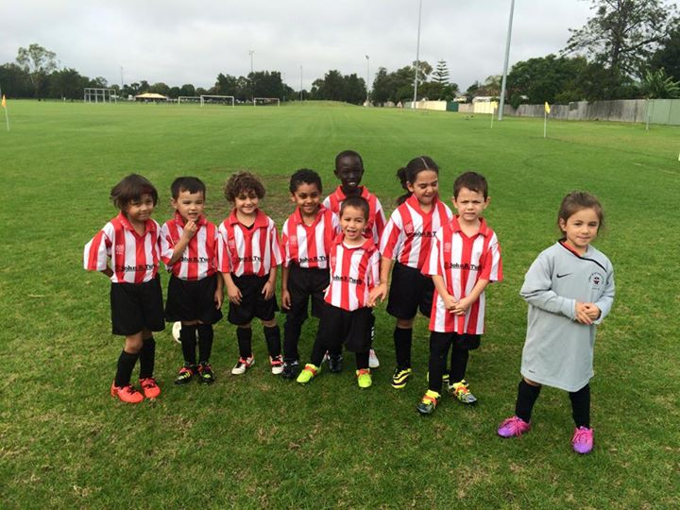
U6 White vs Hills Spirit Blue 4 - 3
It was a fantastic win for our under 6 white team on a cold, wet and miserable day. They played exceptionally well considering we had only 5 players compared to their 7. With 1 player as goal keeper that left us with 4 against 5 with no subs. We were down 2-0 yet came back to level it 2-2 with 2 fantastic goals by Mikhail. With great defending by Alex, Charbel, Deon and John we were able to hold back a strong attack by Hills Spirit. They kept coming at us but we held back and another goal by Mikhail made it 3-2 and we were in front. Some great defending by Alex kept the game level for a while but with a mix up at goal the game was levelled back at 3-3. The kids were getting very tired but kept pushing on and with a few minutes to go another fantastic assist by Deon created a chance for Mikhail to score and the game finished with a great win for us 4-3. Well done boys! The boys played the whole game with no subs so I am very pleased with all their efforts.
Goal scorers – Mikhail Khan 4
U7 Red vs Hills Spirit Red 15 - 0
First game of the season and we had a big WIN, our girl's an boy's played excellently and all should be so proud of them selves! If we keep up like how we played today we will be undefeatable. Omar and Joey not feeling well and still played so well scoring 1 goal each. Talitha and Emily showing good defence and passing of the ball. Keeyan trying his best and scoring 2 goals. Patrick and Adhar scoring a whopping 5 goals each. Keep up.the good work boys an girls.
Goal scorers – Patrick Matta 5, Adhar Yaac 5, Keeyan Ali 2, Joey Douehi 1, Omar Elbizri 1, own goal 1.

U7 White vs Hills Spirit Blue 0 - 12
It was a tough 1st game of the season but the team worked together and played well. It will only get better from here. Well done to Badih, Ryan and Mark for making Hills Spirit Blue work for their goals. Andrew and Bol were great goal keepers with Andrew saving the ball a number of times. And we couldn’t have done it without Fateh and Laura and their team work. A big THANK YOU to the parents for getting the players to the field nice and early, even though the weather looked very threatening, WELL DONE team!
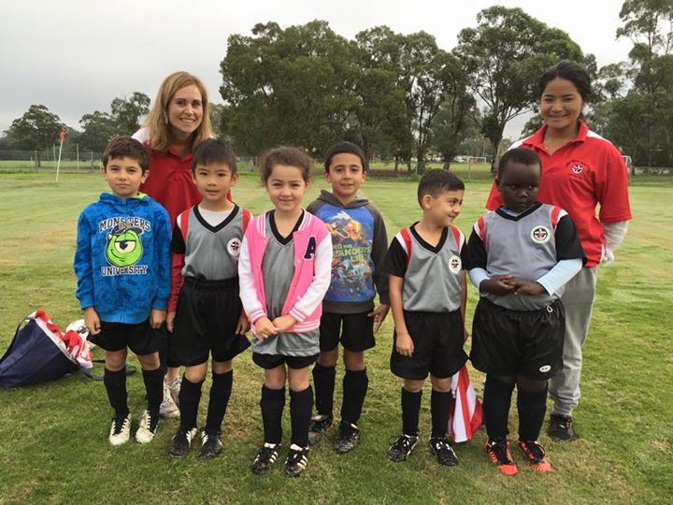

U8 vs Hills Spirit White 0 – 3
Today was the beginning of another soccer season and I am sure that the coaching staff and parents of all the players are filled with optimism for the year. In our first outing for the year the team came up against a Hills Spirit team that appeared to play a better positional pattern than our young players. Our team this year made up of first time players and seasoned players all playing like first time players. That is, the players all bunched up and played in an area no bigger than 3 square metres. The team needs to appreciate that the field is larger than this and that all the field can be used to play on. Our positional play was also not as we accepted but the players will learn this as the year progresses. The team seemed to tire due to all the running involved in today’s game. Training and more game time should help resolve all the problems that were encountered today.
On the bright side, all the new players; Huraira, Ali, Ameera, Exodus, Rhiannya and Solomon showed that they have the enthusiasm and the potential to improve on their skills, while the players from last year; Fayez, Gerardo, Isaiah, Lucy, Simon, Thomas and Zain have also got the enthusiasm to play competitively.
Our team was outplayed today and they lost 3 goals to nil. After letting in an early goal in the first half the team rallied back and went in at half time 1 goal down. At the half time break the players sat, listening intently to the coach’s views on the first half and encouraging them for the second half. In the second half, Simon came out of goals while one of our new players, Rhiannya put on the gloves. Within the first couple of minutes of play in the second half Rhiannya pulled off an amazing save from point blank range. Hills Spirit had pushed the ball across our goal and the biggest player in the opposition struck the ball from within the six yard box and Rhiannya used her forehead to stop the ball from going into the goal. This valiant effort earning Rhiannya player of the match. Our forwards had little opportunity today to score goals and the team rarely troubled the opposition goal keeper.
U9 Red vs Hills Spirit Red 1 - 6
Season started & not in the way we want it, the tough score does not reflect the actual run of the game.
We had the first chance in the game through Sajjad but unfortunately the keeper saved the shot, our next chance was when once again Sajjad scored our first & only goal to equalise the score, then from there we were unable to finish our chances which we had a fair bit. Yasmin was the Lady of the match, our goalie who stopped many & many shots for the opposition. Our defence was good but needs more work to get up to scratch with the age group. The midfield did ok, we need more positioning & bigger kicks sooner. Our attacker Sajjad had a big game, scoring a goal & had many other shots on target. Kareem was solid in defence & blocked a few shots. Malachi & Elisa worked in defence & assisted the midfield, Mujtaba, Saad & Zacheria ran really hard & tried to assist everywhere on the field. So well done to all especially the first time players & we have about 7 or 8 newbies in our team, so it looks very promising. Better luck next week where we can work on our faults from the first game & practice a bit more. A reminder to all parents, please check the news letter, Games time & location can be found on it, there is also a message sent weekly a day or 2 before the game which can help as well. Also wear the training jersey to the game. Player of the match - Yasmin Hasani
Goal scorer - Sajjad Karimi 1
U9 White vs Hills Spirit Green 5 - 3
It was usual suspect start to the season with rain in the morning, but full credit to the parents for getting all the available kids to the first game, which was out in Kellyville for an early 8:30am start with rain coming down. Well done!!! I feel this year, the team is quite blessed with reliable parents who make the extra effort for their kids to enjoy the game and be amongst their friends, giving them the opportunity to put in the effort for a good solid competitive game. Everyone wins when that happens, most of all the team as a whole.
For the first game it was sad to be without Sebastian (who was on holidays) and Daniel due to an injury. But they didn't let that affect them and went on with the job. Jack, Dylan, Joey, Jonathan, Joshua, Robert, Owen, Anthony, Ali and Fouad played marvellously as a team today. It was an excellent free flowing game with plenty of good passes and when on attack they just looked in control. Joey and Ali picked up 2 goals each in the first half and there were plenty of extra opportunities that just missed the mark. Anthony was solid in goals, bravely defending some good shots from the opposition. I think Sebastian and Anthony are going to make a good pair of goalies for this year which the team will definitely need. Going into the first half with a 4-1 lead it looked like this was going to go all our way and was heading for a blowout score. But the lesson, like so many times is to not get complacent, as the opposition started defending well and then went on the attack to claw back the deficit to be within striking distance at 4-3. Again in the second half we had a few players create some quality opportunities to score, but just missing the target. We even had a great penalty shot at goal from Owen which was spectacular saved by their goalie to deflect the ball over the top post. It started to look quite tight towards the end. But the team managed to hang in there and then Fouad was able to seal the game with a final goal near full time. Game 1 of the season over. Guildford McCredie U9 Whites victorious. Teamwork won it today. Well done kids. Goal scorers: Ali Fahme 2, Joey Farah 2, Fouad Ayoub 1.

U10 Red vs Hills Spirit White 8 - 1
Here we go again! A new season, new goal and bigger excitement and commitment. Our boys and girl have grown bigger and our team too. First of all I would like to welcome all last year players who stayed committed to their team and came back for another year of fun filled soccer. Also, I would like to welcome some new players who joined this year and very quick they managed to fit in to the team perfectly, Anthony Chiha, Fraz Maqsood, Makuac Koul along with their respective families. Today's game tells its own story. 8 goals and 5 scorers what else can be said but very good passing between the players, everyone in his position and communicating well with each other. Mohammed doesn’t miss a chance of grabbing the ball and keeping until it’s in. Makuac was the right player at the right place, the ball was passed on to him and he finished it perfectly. Matthew who also had a year off last season but showed up at every single game showing support and encouragement to his team is back on fire this year. Mustafa was all switched on today and his goal was unstoppable. Youssef's high kick was the goal of the day! Those boys and girl came a long way and that hard luck of not winning the grand final last year is giving them an extra push for this year. So guys, its just the beginning of a tough season ahead.
Very well played! See you all next week.
Goal scorers - Mohammed Matar 3, Makuac Koul 2, Matthew Youssef 1, Mustafa Elbizri 1, Youssef Maldini 1
U11 White vs Hills Spirit Red 2 – 2
A good way to start the season. There were improvements all over the park. A great second half ensured the draw through excellent defending and dangerous counter play. We we're a little unlucky, Joey nearly putting us ahead near the end of the game. Also with Greg in goals making what could be the save of the season! Keep it up kids, a great improvement all round.
Goal scorers- Aaran batth, own goal

U12 Red vs Lidcombe Churches 3 - 2
Nice start to the season, the boys started off a little rusty though! We struggled a little with our passing and ball possession. Our defence was solid throughout the game, not only shutting down the oppositions attacks but being able to play the ball out under pressure.
Our attacking game was nice to watch, giving us three nice goals; one was a nice header off a corner kick.
Nice win boys! Goal scorers - Christian Frangie 2, Mustapha Fahme 1

U12 White vs Hills Spirit 2 – 4
"Who knows what offside is?" u12 White can tell you but can't put it to practice. We had two offsides today. Both sides had no reserves so they had to play the full game which made them feel exhausted. They played well but need to practice playing in their position and not give up. Better luck next time boys. Man of the match – Daniel Berou
Goal scorer - Jayden Daily 2

U13 vs McCredie 14s 1 - 3
Unfortunately not the best start to the season we lost 3-1 to our u14s. There were a lot of great opportunities to score, just not enough luck. However, the boys all put in a great effort. Man of the match went to Charlie. Also would like to thank Nedim's dad who refereed the game. Goal scorer – Nedim Fazlic 1

U14 vs McCredie 13s 3 - 1
Great win today by the boys. First half was slow we looked very tired from the start. Guildford under 13 was pushing very hard to get a goal but we kept them scoreless at half time. Second half we looked better but went down early in the half. We came back with a nice little play with Ryan scoring. We lifted and Samuel scored a goal from 35yards out. That put us up 2-1. Then Ahmed scored a one on one to win us the game 3-1. William was the man of the match with same great saves and a lot of talk from goals
Goal scorers – Ryan Carder 1, Samuel Appiah 1, Ahmed Saad Ekdawy 1

U15 Girls vs Hills Spirit 0 - 5
The game started off strong with both teams delivering solid efforts to get the ball rolling. The defence of our girls started strong with Chloe’s effort in clearing the ball away and putting pressure on their forwards. Our goalie Tahlia really shined and owned her role by attacking the ball, calling for it and following through with superb throws and goal kicks. Sharlene as our sweeper controlled her area most of time and was communicating well with the girls in front. Alexia, Sulafa and Christine had some great attempts at goals thanks to the hard work and persistence of the other forwards, Ajok, Destiny, Maroa, Nargas, Hannah and Cameron. Also, Sarah delivered some important shots in areas that were unmarked and there were some superstar moments like Clementine’s head-on shot into our goal zone that gave us a shot at a goal. Our player of the match this week goes to Chloe. Well done team.

U15 vs Castle Hill United 3 - 0
Nice result to start the season and we got better as the game went on, but the first 35 minutes wasn’t special. Some nice finishing up front from Ali, Jake and Mahdi, great defensive work from Daniel, Joel and Jesse and a stellar effort in the midfield from Rusheel was what separated the teams.
Goal scorers – Ali Hawchar 1, Jacob Mitwaili 1, Mahdi Wazefadost 1

U17 vs Wenty Waratah 2 - 2
Disappointing. This was a win that we let go. We played very well until we went 2 up, then everyone wanted to push forward. With no mid-field, it was just a matter of time before they scored.
Goal Scorers: Ahmed Mahfoud 1, Vehid Dupovac 1

Over 35s vs Gymea Baptist 2 - 3

Challenge Cup vs Gymea Baptist 2 – 4
Not a good start for the season, but I can't deny the good fighting spirit of both our teams. Well done First and Reserve grades
Goal scorers – Santo Daneil 1, Jeff Eker 1

Premier Reserves vs Greystanes United 4 – 1
First real game together but we came away with the points. Once we get a little more organised we should have a good season.
Goal scorers – Mohammed Al Delaimi 1, Mohammed Shukur 1, William Wark 1, Sylvester Sein 1

Premier League vs Greystanes United 3 – 4
Disappointing result in the fact that we played better soccer than them but didn’t come away with the reward for the effort and commitment showed by all the boys.
Goal scorers – William Wark 1, Mick Massih 1, Amarvir Batth 1

Ladies vs Wenty Waratah 0 – 0
Not sure what to expect after our promotion this season, the Ladies really lifted, worked hard to hold possession and defended desperately today. Outstanding performance from the back four (Sarah I, Elise, Natasha and Laura B) and lots of running in midfield from Megan and Nyanut. We had fewer chances than we are used to and failed to convert, but we denied the opposition any real chances at all.
Saturday 18th April 2015

U6 Red vs Hills Spirit Blue at Kellyville 3 (Memorial Ave., Kellyville)
9.50am Kickoff (meet at Kellyville at 9.20am)

U6 White vs Hills Spirit White at Everley (mini) (Everley Rd., South Granville)
9.50am Kickoff (meet at Everley at 9.20am) (set up field)

U7 Red vs Hills Spirit Blue at Kellyville 3 (Memorial Ave., Kellyville)
9.00am Kickoff (meet at Kellyville at 8.30am)

U7 White vs Hills Spirit White at Everley (mini) (Everley Rd., South Granville)
9.00am Kickoff (meet at Everley at 8.30am) (dismantle field)

U8 vs Hills Spirit Red at Kellyville SSG (Memorial Ave., Kellyville)
11.00am Kickoff (meet at Kellyville at 10.30am)

U9 Red vs Hills Spirit Green at Kellyville SSG (Memorial Ave., Kellyville)
9.00am Kickoff (meet at Kellyville at 8.30am)

U9 White vs Bye

U10 Red vs Hills Spirit Red at Everley 3 (Everley Rd., South Granville)
9.00am Kickoff (meet at Everley at 8.30am) (set up field)

U11 White vs Lidcombe Churches at Everley 3 (Everley Rd., South Granville)
10.00am Kickoff (meet at Everley at 9.30am)

U12 Red vs Hills Spirit at Kellyville 1 (Memorial Ave., Kellyville)
12.00pm Kickoff (meet at Kellyville at 11.30am)

U12 White vs St Bernadettes Castle Hill at Everley 3 (Everley Rd., South Granville)
11.00am Kickoff (meet at Everley at 10.30am) (dismantle field)

U13 vs Lidcombe Churches at Phillips 1 (Martin St., Lidcombe)
12.00pm Kickoff (meet at Phillips at 11.30am)

U14 vs McCredie Girls at Everley 1 (Everley Rd., South Granville)
12.00pm Kickoff (meet at Everley at 11.30am)

U15 vs Baulkham Hills Sports at Everley 1 (Everley Rd., South Granville)
9.00am Kickoff (meet at Everley at 8.15am) (set up field)

U15 Girls vs McCredie 14s at Everley 1 (Everley Rd., South Granville)
12.00pm Kickoff (meet at Everley at 11.30am) (play in grey shirts)

U17 vs Merrylands SFC at Everley 1 (Everley Rd., South Granville)
10.30am Kickoff (meet at Everley at 10.00am)

Challenge Cup vs St George Rowers at Yatama (Alfred St., Cemton Park)
(Reserves Kick off at 1.15pm Firsts at 3.15pm) (Meet at Yatama at 12.45pm)

Premier League vs Macarthur Wasps at Everley 1 (Everley Rd., South Granville)
(Reserves Kick off at 1.15pm Firsts at 3.15pm) (Meet at Everley at 12.45pm) (dismantle field)

Sunday 19th April 2015

All Age Ladies vs Lidcombe Waratah at Binalong 4 (Binalong Rd., Old Toongabbie)
3.00pm Kickoff (meet at Binalong at 2.15pm)

