OTB 7/15

Club Secretary – Greg 9682 7779 President – Peter 9632 9203

Interested in sponsoring a team or advertising in this newsletter? – call one of the above numbers.

www.mccredie.org.au/soccer Join our Facebook group

CALENDAR OF UPCOMING EVENTS

May 12th State Cup senior knockout begins

May 20 5.45pm Club Lapathon

May 17 Sunday catch up games for 15s and 17s

May 23 Team photos for 6W, 7W, 9W, 11W, 12W, 14

May 30 Team photos for 6R, 7R, 8, 9R, 10R, 12R, 13, 15 Girls, 15, 17, CC, PL

June 6 Six a side Gala Day for 6s, 7s, 8s, 9s, 10s, 11s, 12s

June 8 Six a side Gala Day for 13s, 14s, 15s, 15 Girls, 17s, AAL, AAM, O35s

June 11 Zone rep trials for U8, U9, U10, U11, U12, U13, U14

June 14 Kings Sevens tournament (selected teams only)

June 22 & 29 National Titles Trials U16 Boys & U18 Boys (7pm) Jones Park

June 24 & July 7 National Titles Trials U16 Girls (5.30pm) & AAL (7pm) Freame Park

June 30 & July 7 National Titles Trials U23 & AAM (7pm) Jones Park

July 1 & 2 National Titles Trials U14 (6pm) Jones Park

To trial for National Titles (27/9 – 1/10/15) a nomination form must be completed prior to trialling (available at www.nswcfa.com.au)

Great save by Darren Warren in goals last Saturday!

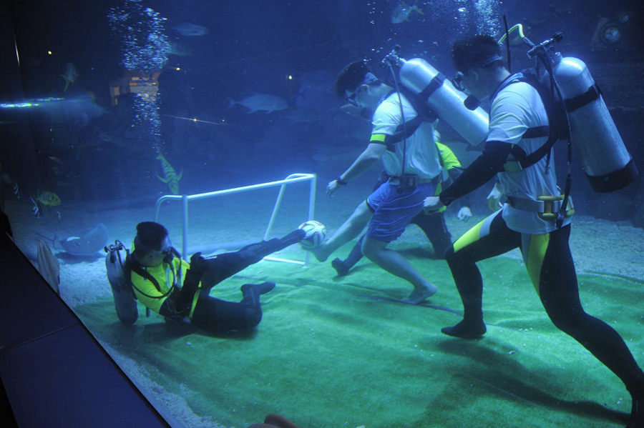

More of the weekend’s action

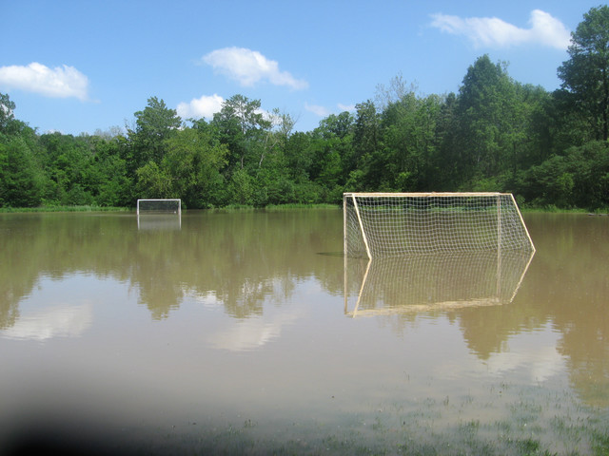

IMPORTANT NOTICES
- If for any reason your child is unable to play or attend training you MUST inform your coach or manager AS SOON AS POSSIBLE.

- If you have questions regarding your team ask your manager.

- If it is raining on a Saturday morning call the team manager to see if the game is on. Most often games will still be on so do not just stay at home, you will be letting your child's team down!!!

- Please assist the coach and manager, they are working unpaid for your child. There may be nets to put up or pull down, corner posts to stick in, players to be picked up (particularly if a parent has more than one child playing in different teams) or shirts to wash.

- This Club, the NSW Churches Football Association and Granville District SFA have high expectations of our parents and players. Please support our teams, but no abuse of players or officials will be tolerated and bans or fines could result.

Greg Wark – Secretary 9682 7779

RAIN – WHAT TO DO

It’s raining, it’s Saturday!! Is the game on??

Your manager will know if the game is on, give them a call. Very rarely is a decision made before Friday evening. If I have not called your manager, the game is on, even if it is raining!

Most often games will still be on so do not just stay at home, you will be letting your child's team down!!!

It’s raining and it’s training tonight!! Is training on??

Coaches and managers call the wet weather line 9294 8586. If the ground is closed you cannot train, even if it’s not raining!! Parents and players call the manager or coach.

If you have not yet supplied a copy of your child’s birth certificate or passport, please email or forward to your manager immediately.

U6 Red
Makual Makua

U6 White
Jonah Boutros
Muhammad Aeliya
Muhummad Hameed
Elias Hakimi
Jeremiah Elkadi

U7 Red
Emily Sherlock
Talitha Chung

U8
Ahoi Ahoi

U11
Duan Majak
Kuach Deng
Yacub Yacub

U12 Red
Krish Srestha

U13
Jeffrey Farah

U15
Mahdi Wazefadost
Beshoye Angoang

LAPATHON

This year’s annual lapathon, our club’s only significant additional fundraiser will be held on 13th May in lieu of training.

LAPATHON

Sponsorship form

Wednesday 20th May, 2015

Name | Telephone number | Amount per lap  or the sponsor may choose to donate a total amount. | Total donation
Total amount collected

It is expected that players under 14 years will complete not more than 25 laps
Saturday 9th May 2015

U6 Red vs Hills Spirit White at Kellyville 3 (Memorial Ave., Kellyville)
9.00am Kickoff (meet at Kellyville at 8.30am)

U6 White vs OLQP Falcons Yellow at Everley (mini) (Everley Rd., South Granville)
9.00am Kickoff (meet at Everley at 8.30am) (set up field)

U7 Red vs Hills Spirit White at Kellyville 3 (Memorial Ave., Kellyville)
9.50am Kickoff (meet at Kellyville at 9.20am)

U7 White vs OLQP Falcons Red at Everley (mini) (Everley Rd., South Granville)
9.50am Kickoff (meet at Everley at 9.20am)

U8 vs Kings Old Boys at Homelands Reserve (Homelands Ave., Telopea)
11.00am Kickoff (meet at Homelands at 10.30am)

U9 Red vs Bye

U9 White vs St Bernadettes Castle Hill Saints at Everley 1 (Everley Rd., South Granville)
9.00am Kickoff (meet at Everley at 8.30am) (set up & dismantle field)

U10 Red vs Lidcombe Churches at Phillips 1 (Martin St., Lidcombe)
10.00am Kickoff (meet at Phillips at 9.30am)

U11 White vs Wentworthville Uniting at Everley 1 (Everley Rd., South Granville)
10.00am Kickoff (meet at Everley at 9.30am) (set up field)

U12 Red vs St Bernadettes Castle Hill at Eric Mobbs 1 (Excelsior Ave., Castle Hill)
11.00am Kickoff (meet at Eric Mobbs at 10.30am)

U12 White vs Lidcombe Churches at Everley 1 (Everley Rd., South Granville)
11.00am Kickoff (meet at Everley at 10.30am)

U13 vs Hills Spirit at Everley 1 (Everley Rd., South Granville)
12.00pm Kickoff (meet at Everley at 11.30am) (dismantle field)

U14 vs St Columbas Castle Hill at Eric Mobbs 2 (Excelsior Ave., Castle Hill)
11.00am Kickoff (meet at Eric Mobbs at 10.30am)

U15 vs Greystanes FC at Granville Park (Claremont St., Merrylands)
9.00am Kickoff (meet at Granville at 8.15am)

U15 Girls vs Lidcombe Churches at Phillips 1 (Martin St., Lidcombe)
12.00pm Kickoff (meet at Phillips at 11.30am)

U17 vs Castle Hill United at Granville Park (Claremont St., Merrylands)
10.30am Kickoff (meet at Granville at 10.00am)

Challenge 35s vs Wentworthville Uniting at Jones 2 (Banks St., Merrylands)

1.15pm Kick off (meet at Jones 2 at 12.45pm)

Challenge Cup vs Parramatta Salvation Army at Jones 2 (Banks St., Merrylands)

3.15pm Kick off (meet at Jones 2 at 12.45pm)

Premier League vs St Barnabas Broadway at Wentworth Park 1 (Wentworth Park Rd., Ultimo)
(O35s Kick off at 1.15pm Firsts at 3.15pm) (Meet at Wentworth Park at 12.45pm)

Sunday 10th May 2015

All Age Ladies vs Castle Hill RSL White at Max Ruddock 1 (Romulus St., Winston Hills)
1.00pm Kickoff (meet at Max Ruddock at 12.15pm)

Tuesday 12th May 2015

State Cup Round 1 Challenge Cup Squad vs St Matthews Baulkham Hills at Jones 1 (Banks St., Merrylands)
8.30pm kick off (meet at Jones at 8.00pm) (dismantle field)

