OTB 10/16

Club Secretary – Greg 9682 7779 President – Peter 9632 9203

Interested in sponsoring a team or advertising in this newsletter? – call one of the above numbers.

Calendar of Events

Six a side tournament –
June Long weekend. GMUSC will endeavour to enter as many sides as possible so please keep these dates available
U6 – 12 Saturday 11th June
U13 – U18, AAM, O35, AAL Monday 13th June
Zone rep trials –
GMUSC is part of the southern zone and will compete in matches on Thursday nights in July against the northern zone.
U8, 9, 10, 11, 12 - Thursday 16th June

Club photos –
Information to follow soon

18th June 6 Black, 8 White, 11 Black, 11 Red, 12, 13 Black, 16, PL

25th June 6 White, 6 Red, 7, 8 Red, 9, 10 White, 13 White, 14, 15, 18

2nd July Challenge Cup (AAM)

AAL - TBA
National Titles trial dates –
The National Titles trials are for the NSW City side to compete in October against the other states and New Zealand. The tournament is a week long in the second week of the school holidays and will be held at Narrabeen.
National Titles Trial dates are as follows:
To be held at Jones Park, Banks St, Merrylands West
Under 14 Boys – 16th and 20th June, 5.30pm
Under 16 Boys – 21st and 27th June, 7pm
Under 18 Boys – 21st and 27th June, 7pm
Under 23 Men’s – 20th and 30th June, 7.30pm
Senior Men’s – 20th and 30th June, 7.30pm
To be held at Freame Park, Rees St, Mays Hill
Under 16 Girls – 15th and 23rd June, 5.30pm
Senior Ladies – 15th and 23rd June, 7.30pm
Nominations due by 29th May 2016

Lapathon – most laps per age

Age | Name | Laps
6 | Izaac Chung | 18
7 | Sunday Makuedi, Malik Daniels | 20
8 | Wek Deng, Dut Atak | 23
9 | Malachi Daniels | 23
10 | Dylan Lu | 25
11 | Sean Sacriz, Ali Fatlawi, Samuel Kidane, Matthew Youssef | 21
12 | Abdul Agha, Yunus Saymar | 26
13 | Deng Aguok | 29
14 | Jayden Daily, Jeffrey Farah, Nedim Fazlic, Sharlene Muru-Tucker, Mahmoud Jalloh | 20
15 | Ahmad Saad-Ekdawy | 37
16 | Aiden Turner, Joel Booker | 27
18 | John Youssef | 29
AAL | Rana Karakus | 15
AAM | Darren Warren | 30

Please return all sponsorship money (if not done so yet) to your manager this week.

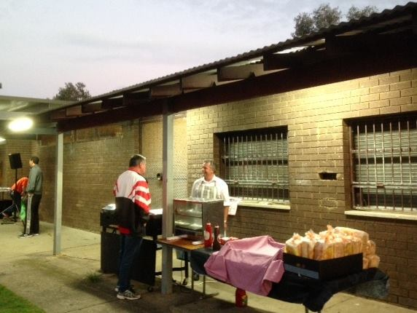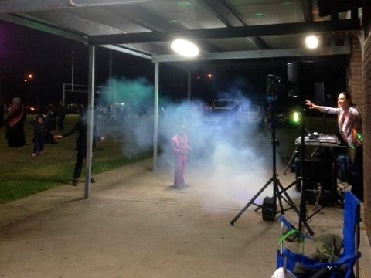

Lapathon pics - No rest for the sausage men or Disco Dave!

RESULTS – 14th & 15th May 2016

U6 Red vs OLQP Falcons Blue 6 – 0
Our boys played strong and hard today. We were attacking strong almost the whole game, especially Roham and Lual dribbling and shooting really well again. Abatar’s strong kick kept the ball going forward, and after a few shots, he scored a goal too. Izaac continued to win balls and dribble well all the way to the goal, almost scoring a few times. Aydin & had a very quiet time as goalkeeper, so he played on the field the 2nd half, and had some really great kicks at the ball. Then it was Roham’s turn to wait patiently in goals, with the ball not reaching him once! Well done again team.
Man of the Match: Lual Deng. Coach’s Award: Aydin.
Goalscorers: Roham Taghianpour 3, Lual Deng 2, Abatar Gurung 1

U6 White vs Kings Old Boys 10 – 0
Good effort by everyone this week. The star this time wa GEORGE TANGI who was most impressive with his tackling and passing.
Goal scorers: Alex Azar 5, Simon Taouk 3, Daniel Alouche 1, Josh Jaitani 1
U6 Black vs Hills Spirit Red 2 - 1
Today was a very close game but we came away with a 2/1 win. We all had great defence with no reserves again
Our goal keepers Aidan and Gethyn both made great saves, Rushil again was on fire, Telissa-lee had some good touches, Yusuf and Bentley again getting a goal each keep up the good team work
Goal scorers – Yusuf Hadi 1, Bentley Buenen 1

U7 vs Hills Spirit White 4 – 5
An unfortnately loss after a great game. Some excellent defending today from both Charbel and Malik. Great goal keeping from George and Alex both saving some great shots at goal. Noah, Abbas and Sunday never stopped running and keeped their defence busy all game. Player of the Match Charbel.
Goal scorers – Sunday Makuedi 2, Malik Daniels 1, Abbas Alkaabi 1
U8 Red vs St Columbas Castle Hill 1- 3
With both teams having only 8 players, it was an evenly matched game. We had a good amount of possession and attack. But the Lions held us back with good defending, which showed up one big weakness for us – not passing around, but too often our players trying to beat defenders. When the Lions went on attack, they broke through with big kicks, and skillful dribbling – which showed up our next weekness – not tackling well. We still had a chance at half time, being 0-1 down. But when we got to 0-3 down, we managed to fight back with only 1 goal. We’ve got some work to do team!
Player of the Match: Lachlan, goalkeeper first half, working hard in attack second half
Coach’s Award: Aaryan, for working hard to keep up with the play, and doing his best in goals in the second half.
Goalscorers: Adhar Yaac 1.

U8 White vs Lidcombe Churches 0 – 2
We've been improving each week and the kids played very well today but this didn't show on the scoreboard. We dominated possession but weren't able to find a way through their defence and with the limited chances Lidcombe had, they were able to get through, leading 0-2 at half time. We controlled the second half, but despite a few chances with Lochlan hitting the post on one shot and many others where we were just too slow to pass to the open player or we just failed to get a good strong shot at goal. That was the difference today, but the kids should be very happy with their performance against the top of the table opposition.

U9 vs OLQP Falcons Blue 1 - 3
The team showed determination and passion today. They went after the ball aggressively...some times too much. Thomas, Dylan, Yusuf, Malichi and Simon were at their best deflecting the ball away from our side. Isaiah gave it a good go being goalie, but a penalty shoot out got the better of him. Rhia, Lucy, and Benjamin got a good workout running around after the ball. In the second half, Ali K, Eli E and Musti put the pressure on. They came close, at least 4 times, to scoring. There was some confusion around the OLQP goalie that allowed Ali E to kick in a goal. The team were just getting their mojo back when the final whistle blew. We will need to work on longer passes, spreading out, and communicating to each other on the field. The team is improving every game. Player of the match: Lucy Sultana
Goal scorer: Ali Ekdawi 1

U10 White vs Lidcombe Churches 2 - 1
Tough win today we went 1 goal behind early in the 2nd half then we came back to score 2 goals and win. Man of the match – Daniel Kvesic 1
Goal scorers: Fouad Ayoub 1 , Daniel Kvesic 1

U11 Black vs Hills Spirit 1 – 2
Goal scorer – Sean Sacriz 1

U11 Red vs Lidcombe Churches 3 - 1
The game started in a very slow rhythm today. First half wasn't an eye catcher at all and we didn't score. At half time the players needed to be reminded how to play as a team. And it happened 2 amazing goals from Makuac assisted by the whole team and a heart warming goal from Matthew kicked all the way from the other side of the field. In conclusion, when it's a team work it's a good work. I felt proud of every single player today. Very well done boys and girls
Goal scorers – Makuac Kuol 2, Matthew Youssef 1

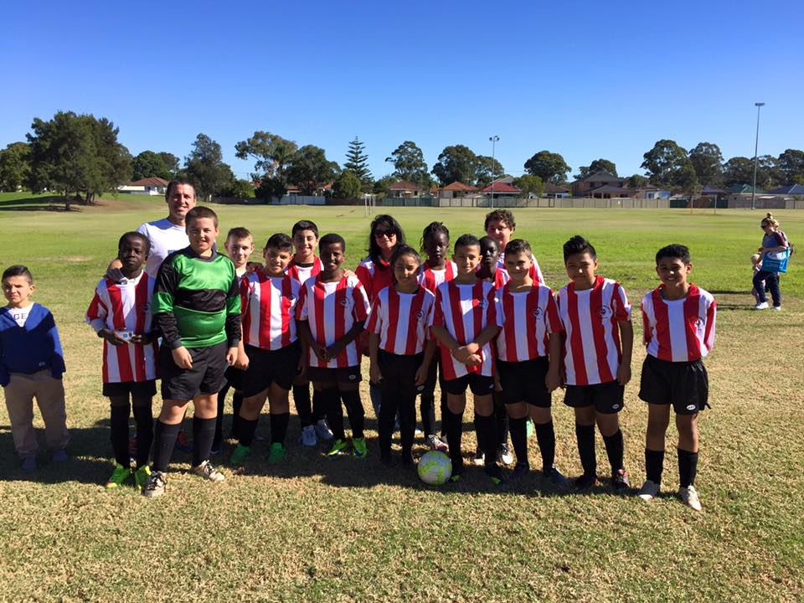
11 Reds celebrate a great win at the top of the table.

U12 vs Lidcombe Churches 0 - 2

U13 Black vs Rouse Hill Rams 12 – 1
After spending 40 minutes in traffic to get there, it was nice to have had it worth it in the end. From the kickoff we dominated and were the better team. Deng was outstanding in midfield, Elias played some lovely crosses and Mounir didn’t miss a scoring opportunity. Krish, the man of the match, was a huge presence in the central midfield creating opportunities for the strikers and simply passing to our team.
Goal scorers – Mounir Haddid 4, Ibrahim Koroma 3, Deng Aguok 2, Elias Matta 1, Krish Shrestha 1, Ryan Booker 1

U13 White vs Winston Hills 0 - 3
Today we seem intent on trying to go through the centre of the field which was already occupied by our opponents. Consequently we lost possession and had to fight hard to get the ball back. We then compounded the error by again trying to go through the centre of the field only to lose possession again. When we did use the sidelines we got ourselves into a good attacking positions and created enough chances to score. We had a number of shots on goal, but unfortunately they were straight at the keeper. William was our player of the match.

U14 vs Greystanes 3 – 1
We have had some big wins this year, but this was without doubt our best game. The opposition tested us but our passing and our ability to control long passages of play meant we created a number of opportunities. Andrew Elzain was player of the match after putting in his best performance of the year, getting to the ball first and being decisive. Nedim was strong, Qais had his best game and Mahmoud and Jayden terrorised their defence all morning. Well played team.
Goal scorers – Mahmoud Jalloh 1, Andrew Ibraheem 1, Qais Sungkar 1.

U15 vs Bye

U16 vs Merrylands SFC 0 – 0
That was the best game of the season, and I'm going to take it as a win. We are now starting to play like a very good team. The defensive line worked brilliantly together, and Matt was brilliant in goals. His 70m clearance kicks provided our best attacking opportunities. Salem was very unlucky not to score. Keeping the opposing team that's currently in third place scoreless with just 11 players was a gutsy, courageous effort. Jay and I were very proud.

U18 vs Pendle Hill 0 - 3
Great commitment from Will Booker and Musti Tadik but the better team won today, and it wasn't us.

Challenge Cup vs Sao Paulo Merrylands won on forfeit
We had 12 – they had 12. Problem was – theirs arrived at 2.05 and ours were there at 1.15. Winners!

All Age Ladies vs Holroyd Rangers 2 – 1
With a forward line on the bench injured (except for Genell who powers on) and up against second place we battled out a gutsy win. Holroyd pressured us for most of the match but could only break down our defence once (for just our second conceded goal this year) and we attacked maybe half a dozen times, bagging two with two cracking finishes. Hendrika was clearly player of the match denying Holroyd again and again. Sarah Irving played really well but one particular desperation tackle stands out in the memory. Jenna is the other player who demands mention, with fantastic defending in the backs and a clinical finish during her 15 mins up front (just quietly she also played the cross for Genell’s goal). No one played poorly and the midfield and backs dug deep. Great win.
Goal scorers – Jenna Nowlan 1, Genell Hunt 1

Premier Reserves vs St Barnabas Broadway 1 – 2
Goal scorer – James Rosandi 1

Premier League vs St Barnabas Broadway 0 - 5

State Cup result 12th May

Premier League vs Wentworthville Uniting PL 1 - 0
Goal scorer - Amarvir Batth 1
Saturday 21st May 2016

U6 Red vs St Columbas Castle Hill at Everley (mini) (Everley Rd., South Granville)
9.00am Kickoff (meet at Everley at 8.30am) (set up field)

U6 White vs Hills Spirit Red at Kellyville 7 (Memorial Ave., Kellyville)
9.00am Kickoff (meet at Kellyville at 8.30am)

U6 Black vs Bye

U7 vs Lidcombe Churches Gold at Everley (mini) (Everley Rd., South Granville)
10.00am Kickoff (meet at Everley at 9.30am) (dismantle field)

U8 Red vs OLQP Falcons Red at Everley 2 (Everley Rd., South Granville)
11.00am Kickoff (meet at Everley at 10.30am) (set up & dismantle field)

U8 White vs Kings Old Boys at Homelands Reserve (Homelands Ave., Telopea)
11.00am Kickoff (meet at Homelands at 10.30am) (set up field)

U9 vs Hills Spirit White at Kellyville 7 (Memorial Ave., Kellyville)
11.00am Kickoff (meet at Kellyville at 10.30am)

U10 White vs Hills Spirit at Everley 1 (Everley Rd., South Granville)
12.00pm Kickoff (meet at Everley at 11.30am)

U11 Red vs Wentworthville Uniting at Freame (Rees St., Mays Hill)
12.00pm Kickoff (meet at Freame at 11.30am)

U11 Black vs Wentworthville Uniting at Freame (Rees St., Mays Hill)
11.00am Kickoff (meet at Freame at 10.30am)

U12 vs Bye

U13 Black vs Merrylands SFC at Everley 1 (Everley Rd., South Granville)
8.30am Kickoff (meet at Everley at 7.45am) (set up field)

U13 White vs Pendle Hill Tigers at Binalong 4 (Binalong Rd., Toongabbie)
8.30am Kickoff (meet at Binalong at 8.00am)

U14 vs Pendle Hill Tigers at Binalong 4 (Binalong Rd., Toongabbie)
9.45am Kickoff (meet at Binalong at 9.00am)

U15 vs Newington Gunners at Wilson 2 (Newington Ave., Silverwater)
11.30am (meet at Wilson at 11.00am)

U16 vs Pendle Hill Black at Everley 1 (Everley Rd., South Granville)
9.45am Kickoff (meet at Everley at 9.15am)

U18 vs Wenty Waratah at Ted Burge 1 (Hollywood St., South Wentworthville)
1.00pm Kickoff (meet at Ted Burge at 12.30pm)

Challenge Cup vs Columna at Everley 1 (Everley Rd., South Granville)

3.15pm Kickoff (meet at Everley at 2.45pm) (dismantle field)

Premier League vs Greystanes Churches at Jones (Banks St., Merrylands)
(Reserves Kick off at 1.15pm Firsts at 3.15pm) (Meet at Jones at 12.45pm)

Sunday 22nd May 2016

All Age Ladies vs Greystanes FC at Bathurst Street 2 (Bathurst St., Greystanes)

1.00pm kick off (meet at Bathurst St at 12.15pm)

Thursday 22nd May 2016

State Cup Quarter Final

Premier League vs Chester Hill Sports at Phillips 3 (Martin St., Lidcombe)
8.00pm kick off (meet at Phillips at 7.30pm)

