OTB 11/16

Club Secretary – Greg 9682 7779 President – Peter 9632 9203

Interested in sponsoring a team or advertising in this newsletter? – call one of the above numbers.

Calendar of Events

Coaches & Managers Meeting
Thursday June 2nd 7.30pm – Church Hall 486 Guildford Rd
Six a side tournament –
June Long weekend. GMUSC will endeavour to enter as many sides as possible so please keep these dates available
U6 – 12 Saturday 11th June
U13 – U18, AAM, O35, AAL Monday 13th June
Zone rep trials –
GMUSC is part of the southern zone and will compete in matches on Thursday nights in July against the northern zone.
U8, 9, 10, 11, 12 - Thursday 16th June
U8 Phillips Park 1 6.00pm
U9 Phillips Park 2 6.00pm
U10 Phillips Park 1 7.00pm
U11 Phillips Park 2 7.00pm
U12 Phillips Park 1 8.00pm
Club photos –
Information to follow soon

18th June 6 Black, 8 White, 11 Black, 11 Red, 12, 13 Black, 16, PL

25th June 6 White, 6 Red, 7, 8 Red, 9, 10 White, 13 White, 14, 15, 18

2nd July Challenge Cup (AAM)

AAL - TBA
National Titles trial dates –
The National Titles trials are for the NSW City side to compete in October against the other states and New Zealand. The tournament is a week long in the second week of the school holidays and will be held at Narrabeen.
National Titles Trial dates are as follows:
To be held at Jones Park, Banks St, Merrylands West
Under 14 Boys – 16th and 20th June, 5.30pm
Under 16 Boys – 21st and 27th June, 7pm
Under 18 Boys – 21st and 27th June, 7pm
Under 23 Men’s – 20th and 30th June, 7.30pm
Senior Men’s – 20th and 30th June, 7.30pm
To be held at Freame Park, Rees St, Mays Hill
Under 16 Girls – 15th and 23rd June, 5.30pm
Senior Ladies – 15th and 23rd June, 7.30pm
Nominations due by 29th May 2016

Lap a thon fundraising update

If you have not returned your lapathon sponsorship yet, please do so this week.

At this time we have raised $3098.10. Well done all.
____________________________________________________________________________________________

These envelopes will be given out by your team manager this week as we get ready for photo day!

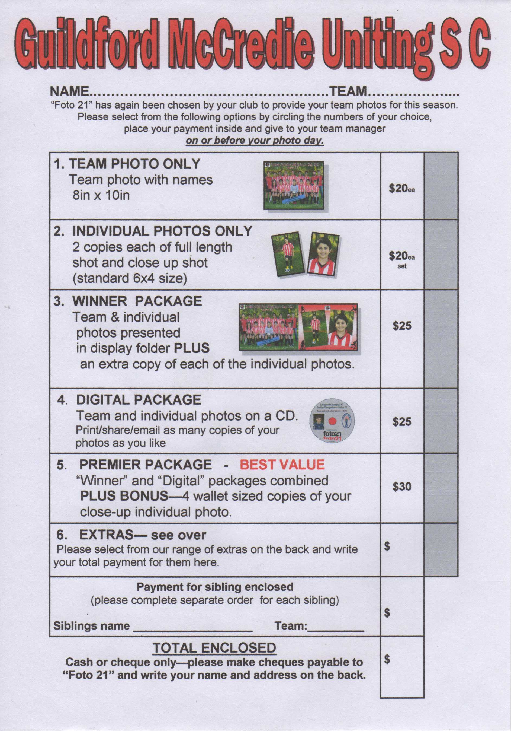

If you liked the music at the lapathon then why not let David Le Pow Newey aka DISCO DAVE host your next party.

RESULTS – 21st & 22nd May 2016

U6 Red vs St Columbas Castle Hill 6 - 0
We had a good game today, with another win, 6-0. The opposition had some strong plays that we had to fight to defend. But our defenders did well, especially Izaac, Lual, Roham and Abatar. Jerone, Leigh Shah and Aydin each helped out too with some good tackles and kicks. Most of the game, though, we were attacking strong, with some great goals from Roham and Izaac. Jerone scored an exciting goal by dribbling hard all the way to the goal, even through some tackles; well done on your first goal of the season Jerone! Man of the match: Jerone, playing hard and well in each position today, both back & forward, including scoring a goal. Coach’s Award: Leigh Shah , getting some great kicks and runs in the game, and doing his best!
Goalscorers: Izaac Chung 2, Roham Taghianpour 2, Jerone Johnson 1, Own goal 1

U6 White vs Hills Spirit Red 3 – 0
Another fabulous win today. Great defending today by the entire team with George Esber taking player of the match trophy. Georges skills have been persistently improving week after week with great defence and passing. Our enthusiastic goal scorers this week were Simon 2 and Alex 1 with the challenging Hills Spirit Red team failing to score despite a strong demosntration of great skill.
Goal scorers: Simon Taouk 2, Alex Azar 1

U6 Black vs Bye

U7 vs Lidcombe Churches Gold 15 – 1
An amazing comeback from the team this week. Incredible control of the ball and teamwork from Charbel and Fidaa. George made an excellent save, catching the ball in the air when the other team attempted to score. Malik and Noah demonstrated fantastic goals as they kept communicating with their team as well as focusing on the ball. Nour, Abbas and Sunday showed their training skills on the field, demonstrating incredible passes, control and defending which kept leading them to scoring more goals.
Goal scorers – Sunday Makuedi 4, Abbas Alkaabi 4, Nour Matar 3, Noah Bosanac 2, Malik Daniels 1, own goal 1
U8 Red vs OLQP Falcons Red 6 – 0
We had a good, solid, 6-0 win this week, which was nice after last week’s loss. The other team was weaker, which meant that we were on the attack almost the whole game. Patrick and Lachlan played strong, attacking games as forwards, scoring 3 goals between them. Wek had a fantastic game in the centre midfield position, winning balls constantly, and dribbling, passing and shooting well, with 3 goals as a result. Talitha and Zak played great games in the midfield too, getting right into the action, winning tackles, passing the ball on to teammates in attack. Aaryan and Jessie did really well too, getting into the action more and more, getting some good kicks in the game. And Joey, Omar and Adhar did well in the backs, not their usual position, but giving them a good chance to develop their defending and passing skills. Well done team.
Player of the Match: Wek. Coach’s Award: Jessie.
Goal scorers – Wek Deng 3, Patrick Matta 2, Lachlan Lin 1

U8 White vs Kings Old Boys 1 - 4
Tough game to watch today. Kings had only 8 players but they made up for that in talent with their 2 stars, just standouts. We did well to keep them to just 2 goals in the first half and we had chances ourselves but just couldn't get through. And when their stars got into a little open space unfortunately our defence looked like training cones for them. At the start of the second half, the kids listened to their instructions and did very well to deny the Kings 2 stars from even getting the ball and this showed as we started to dominate, piling on the pressure and Dut managing to break through with an excellent goal to trail 1-2. We needed to convert more during that momentum swing, but like last week we weren't able to. As our kids started to tire, the tight marking fell away and they put away 2 late goals. Looking forward to training and next Saturday to continue improving on this form.
Goal scorer: Dut Atak 1.

U9 vs Hills Spirit White 0 – 4
All the kids got a good run around today. It was good to see them playing more in the oppositions half. Yusuf, Dylan, Thomas, Lucy and Simon were challenging the ball with skill and nerve. Benjamin, Malachi, Issaiah and Ali E were all over the field chasing down the ball. Moustafa, Ali K and Rhia broke away a few times and came close to scoring. Fayez, as goalie, showed he wasn't afraid of the ball by making some awesome saves.
Thanks coach Steve for filling in. Player of the match: Ali Khan. He gave 100% effort all the time.

U10 White vs Hills Spirit 4 - 6
I don't know what happened to our players today. Too much confidence cost them a loss. In the first 5 minutes of the game our opponents scored 4 goals. Our team woke up second half and scored 4 goals but not enough to win. Listening and playing in position will get us to the finals. Better luck next time. Player of the match Fouad Ayoub
Goal scorers: Joey Farah 2, Fouad Ayoub 2

U11 Black vs Wentworthville Uniting 4 - 0
A dominant 4-0 win to break a two game losing streak. A strong performance from midfield and defence kept them from having a shot on goal. Man of the match, Duan.
Goal scorers – Sean Sacriz 1, Ali Fatlawi 1, Jean Pierre Kortas 1, Abdallah Khan 1

U11 Red vs Wentworthville Uniting 2 - 0
Hats off to our defenders in this game. They stayed active the whole time to keep our goal clean. Solid team coordination good positioning and this is the result. Well done team
Goal scorers – Makuac Kuol 1, Matthew Youssef 1

U12 vs Bye

U13 Black vs Merrylands SFC 3 – 0
A good win today against a competitive opposition. Only being 1-0 up at halftime whilst attacking in their half for the majority of the time was quite concerning, however the second half started with us kicking off and us scoring 30 seconds later without Merrylands touching the ball which relieved the team and the coach. Good games from Deng, Aakrist and John-Luke. Thyson was man of the match for sticking to their one player in the second half and stopping him from being involved in any play
Goal scorers – Mounir Hadid 2, Ibrahim Koroma 1

U13 White vs Pendle Hill Tigers 3 - 1
We played some good football today. We used the width of the field to our advantage, before crossing towards goal. This resulted in us gaining many corners keeping up the pressure their defence. This pressure eventually created the opportunities to score which Abdul and Ruben willingly took. Our defence was solid, limiting Pendle Hill’s chances to score.
Abdul was our player of the match. His energy & enthusiasm with & without the ball was infectious. He created many chances up front and helped out at the defence when the opposition was attacking.
Goal scorers - Abdul Agha 2, Ruben Yu 1

U14 vs Pendle Hill Tigers 2 – 2
Up against the top side today and to be honest the boys did not seem to have believed that this was going to be a tough game. We started slowly giving up one goal and then another before half time. In the second half we came out much more positively, dominated a 15 minute period and pulled one goal back courtesy of a superb strike from Mahmoud. Pendle Hill got themselves back in control only to see us attacking again with just minutes to go and Qais’ determination saw him also send a magnificent strike goal bound. Sharlene was strong and Abdul had a great game for his first game with the team, but Mahmoud was sensational throughout the game.
Goal scorers – Mahmoud Jalloh 1, Qais Sungkar 1.

U15 vs Newington Gunners 7 - 1
What a game of soccer to watch. The team came out switched on, passing the ball around and maintaining 90% of possession. We finally got a goal and by half time it was 2-0. I told the boys at half time to keep pushing and the goals would come, and they did. With our new player Sajjad scoring a nice header. The whole team played great. Player of the match – Chloe Hildred.
Goal scorers- Ahmad Saad Ekdawy 3, Jakob Kaihea 2, Sajjad Al Khafajji 1, Ryan Carder 1.

U16 vs Pendle Hill Black 2 – 3
The only weakness we are showing at the moment is the inability to get to games on time. We don’t do ourselves any favours by starting most games with only 10 on the field and then wonder why we’re behind at half-time. Despite that we kept Pendle Hill scoreless until the 32 minute mark, but then let in 2. That took us to half-time. But then players arrived and we started the second half with 11 on the field and 2 on the bench! Alleluia! And we dominated the second half. Every player rose to the occasion. Great goals from Beshoye and Salem turned the game and had their coach panicking. Both goals were set up by the player of the match, Sulafa, who fought hard against much bigger opposition. Well done again, a great team effort!
Goalscorers: Beshoye Angoang 1, Salem Boustany 1

U18 vs Wenty Waratah 2 – 1
No report
Goal scorers – Ahmad Mahfoud 1, own goal 1

Challenge Cup vs Columna 6 – 2
We did it – a win, our first for the season. We did well to deserve this one, playing better than the opposition most of the game, except the start of the 2nd half where we didn’t control the midfield, and were weak in defending their fast breaks. Our new recruit this week, Ridwan, made a fantastic difference, with good play-making as our attacking centre-mid position, scoring 2 great goals and setting up a few others. Our other goals were pretty spectacular – Oli being well placed at the near post to chip in a cross, Goran shooting accurately from deep and wide, Steve making a well-placed shot from about 18 yards past defenders, and Vadly beating a few defenders and the goal keeper for another well-placed shot. We had a full squad today as well, which helped greatly, with Muhammed very sacrificially running the lines so that the other 16 of us could play. Oh that’s right, there was another highlight – Luke came back from holidays, finally! Yes, Luke we really appreciated having you back! Luke had a massive game, with brilliant saves, especially an amazing save on a penalty shot, which could have leveled us when we were 2-1 ahead. When they did manage to score the leveler, we came back hard to score another 4 goals in the second half, sealing the win. Well done boys. It’s time for our turnaround!
Goalscorers: Ridwanullah Rahmatullah 2, Rivadly Atmadja 1, Goran Gesovski 1, Olivier Pepin 1, Steve Vrtkovski 1.

All Age Ladies vs Greystanes FC 2 – 0
We made really hard work of this game, squandering too many chances early and keeping Greystanes in the game. We won the game but Greystanes made us work for it all the way and our second goal only came with minutes to go. Monique played really well today and Elise had the toughest job on the park, successfully keeping Greystanes’ main weapon goaless.
Goal scorers – Genell Hunt 1, Monique Loveday 1

Premier Reserves vs Greystanes United 1 – 6
Goal scorer – Adem Stevens 1

Premier League vs Greystanes United 5 – 0
Goal scorers – Mohammed Shukur 2, Mohammed Rahimi 1, Mick Massih 1, Soleiman Hassan 1

State Cup result 19th May

Premier League vs Chester Hill Sports 1 - 0
Goal scorer - Amarvir Batth 1
Saturday 28th May 2016

U6 Red vs OLQP Falcons Yellow at Daniel 2 (Daniel St., Greystanes)
9.00am Kickoff (meet at Daniel at 8.30am)

U6 White vs Bye

U6 Black vs OLQP Falcons Red at Everley (mini) (Everley Rd., South Granville)
10.00am Kickoff (meet at Everley at 9.30am) (set up & dismantle field)

U7 vs OLQP Falcons Yellow at Daniel 2 (Daniel St., Greystanes)
11.00am Kickoff (meet at Daniel at 10.30am)

U8 Red vs Hills Spirit White at Eric Mobbs 2 (Excelsior Ave., Castle Hill)
11.00am Kickoff (meet at Eric Mobbs at 10.30am)

U8 White vs OLQP Falcons Blue at Everley 2 (Everley Rd., South Granville)
9.00am Kickoff (meet at Everley at 8.00am to set up field) (set up field)

U9 vs OLQP Falcons Green at Everley 2 (Everley Rd., South Granville)

10.00am Kickoff (meet at Everley at 9.30am) (dismantle field)

U10 White vs Bye

U11 Red vs OLQP Falcons Blue at Everley 1 (Everley Rd., South Granville)
12.00pm Kickoff (meet at Everley at 11.30am)

U11 Black vs Lidcombe Churches at Everley 2 (Everley Rd., South Granville)
11.00am Kickoff (meet at Everley at 10.30am) (set up field)

U12 vs OLQP Falcons Red at Daniel 1 (Daniel St., Greystanes)
12.00pm Kickoff (meet at Daniel at 11.30am)

U13 Black vs Granville Waratah at Robin Thomas 1 (Macarthur St, Parramatta)
9.20am Kickoff (meet at Robin Thomas at 8.35am)

U13 White vs Bye

U14 vs Wentworthville Uniting at Jones 1 (Banks St., Merrylands)
9.00am Kickoff (meet at Jones at 8.15am)

U15 vs Pendle Hill Black at Binalong 3 (Binalong Rd, Old Toongabbie)
11.15am kick off (meet at Binalong at 10.45am)

U16 vs Rydalmere at Everley 1 (Everley Rd., South Granville)
9.45am Kickoff (meet at Everley at 8.45am to set up field) (set up field)

U18 vs Merrylands Black at Everley 2 (Everley Rd., South Granville)
12.30pm Kickoff (meet at Everley at 12.00pm) (dismantle field)

Challenge Cup vs Zimwarriors at Beaumont (Bexley Rd, Kingsgrove)

1.15pm Kickoff (meet at Beaumont at 12.45pm)

Premier League vs Chester Hill Sports at Everley 1 (Everley Rd., South Granville)
(Reserves Kick off at 1.15pm Firsts at 3.15pm) (Meet at Everley at 12.45pm)

Sunday 29th May 2016

All Age Ladies vs Wenty Waratah at Freame (Rees St., Mays Hill)

1.00pm kick off (meet at Freame at 12.15pm)

Thursday 26th May 2016

State Cup Semi Final

Premier League vs Wentworthville Uniting Gold at Phillips 3 (Martin St., Lidcombe)
8.00pm kick off (meet at Phillips at 7.30pm)

