OTB 1/16

Club Secretary – Greg 9682 7779 President – Peter 9632 9203

Interested in sponsoring a team or advertising in this newsletter? – call one of the above numbers.

WELCOME TO THE 2016 SEASON!
During the season, draws, results, newsletters and links will be available on the website.

www.mccredie.org.au/soccer

It’s now time to bring in your proof of age (copy of birth certificate or passport if you are new to our club)
These can be emailed to gmusoccer@optusnet.com.au or given to Greg, Carolynne or the canteen ASAP.

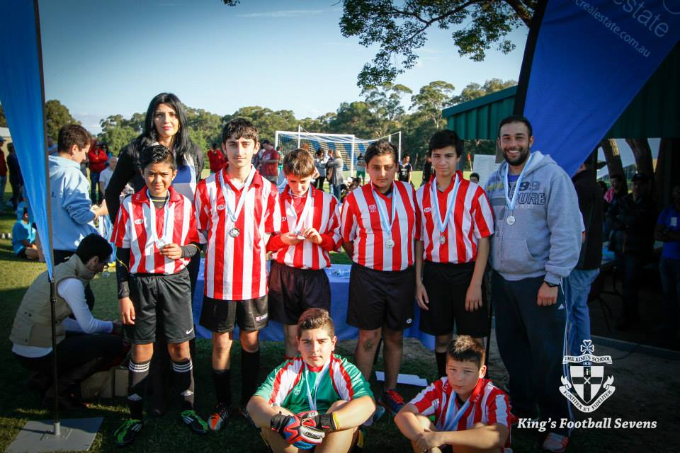

Under 13 Kings Sevens runners up 2015

IMPORTANT NOTICES
- If for any reason your child is unable to play or attend training you MUST inform your coach or manager AS SOON AS POSSIBLE.

- If you have questions regarding your team ask your manager.

- If it is raining on a Saturday morning call the team manager to see if the game is on. Most often games will still be on so do not just stay at home, you will be letting your child's team down!!!

- Please assist the coach and manager, they are working unpaid for your child. There may be nets to put up or pull down, corner posts to stick in, players to be picked up (particularly if a parent has more than one child playing in different teams) or shirts to wash.

- This Club, the NSW Churches Football Association and Granville District SFA have high expectations of our parents and players. Please support our teams, but no abuse of players or officials will be tolerated and bans or fines could result.

Greg Wark – Secretary 9682 7779

RAIN – WHAT TO DO

It’s raining, it’s Saturday!! Is the game on??

Your manager will know if the game is on, give them a call. Very rarely is a decision made before Friday evening. If I have not called your manager, the game is on, even if it is raining!

Most often games will still be on so do not just stay at home, you will be letting your child's team down!!!

It’s raining and it’s training tonight!! Is training on??

Coaches and managers call the wet weather line 9294 8586. If the ground is closed you cannot train, even if it’s not raining!! Parents and players call the manager or coach.
___________________________________________________________________________________________

Junior Referees Course - Free
Monday 14th March 2016 at 7pm
DOOLEYS Regents Park Sports Club
Address: Terrene St,
Regents Park NSW 2143
The purpose of this workshop is for all junior referees to look at the rules of the game and the application of how to conduct the game.

Anybody over 14 years welcome. Courses include lecture and exam on the one night.

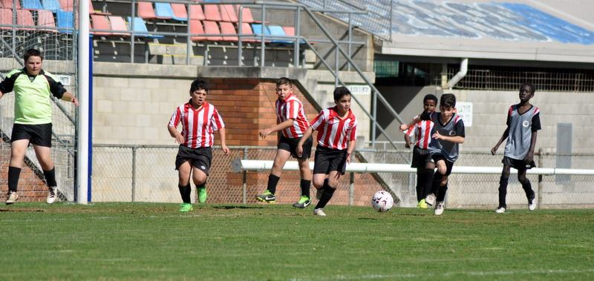

Grand final day action 2015 at Marconi Stadium

For the trial matches the grounds will be prepared on Friday afternoon 11th March from 3.30pm.
Please come down to Merrylands HS to assist if you can, bring a lawn mower or just your enthusiasm.

TRIAL MATCHES

FULL UNIFORM IS REQUIRED FOR TRIAL MATCHES
Socks will be available at the trials for $12 a pair. Shorts ($28) will also be available.

From 7.30am both Saturdays the fields need to be set up as does the canteen.
We will require help in the canteen, cooking sausages and serving as Dorothy is away. Please assist where you can. Thanks.

Team Coaches and Managers contact details

TEAM |  |  | Phone | Training
U6 RED | Andy Chung | Coach |  | Wednesday 5.00pm
U6 RED | Yasmin Atasoy | Manager | 0468 937 674
U6 WHITE | Henry Tangi | Coach | 0450 631 567 | Wednesday 5.30pm
U6 WHITE | Robert French | Assistant Coach | 0412 762 373
U6 WHITE | Ola Hamed | Manager | 0405 070 007
U7 | Sarah Dubois | Coach | 0435 820 232 | Wednesday 5.30pm
U7 | Elise Burrows | Coach | 0419 475 888
U7 | Lucy Calderon | Manager | 0421 744 831
U8 RED | Andy Chung | Manager |  | Wednesday 6.00pm
U8 RED | Kamal Mathiruparajah | Coach | 0433 298 449
U8 WHITE | Mathew Lu | Manager | 0402 872 478 | Wednesday 5.30pm
U8 WHITE | Mathew Lu | Coach | 0402 872 478
U9 | Jennifer Griffiths | Manager | 0466 099 036 | Wednesday 5.30pm
U9 | Mika Oo | Coach | 0431 750 204
U10 | Danny Sorojevic | Coach | 0409 992 152 | Wednesday 5.30pm
U10 | Salma Germanos | Manager | 0415 137 733
U11 RED | Vera Doueihi | Manager | 0439 063 155 | Wednesday 6.00pm
U11 RED | Bilal Elbizri | Coach | 0405 789 464
U11 WHITE | Need a volunteer | Manager |  | Wednesday 6.00pm
U11 WHITE | Gerard McKeown | Coach | 0409 710 717
U12 | Peter Sultana | Manager | 0413 318 962 | Wednesday 6.00pm
U12 | Need a volunteer | Coach
U13 BLACK | William Wark | Coach | 0468 311 297 | Wednesday 6.00pm
U13 BLACK | Lina Hadid | Manager | 0415 823 442
U13 WHITE | Stephen Durbidge |  | 0418 962 893 | Tuesday 5.30pm
U13 WHITE | Need a volunteer | Manager
U14 | Rosemary Farah | Manager | 0403 862 297 | (after this week) Wednesday 5.15pm
U14 | Greg Wark | Coach | 9682 7779 | (this week 9/3 6pm)
U15 | Need a volunteer | Manager |  | Wednesday 6.00pm
U15 | Darren Warren | Coach | 0412 970 249
U16 | Tim Booker | Manager | 0425 369 138 | Wednesday 5.15pm
U16 | Jay | Coach
U16 Girls | Need a volunteer | Manager |  | Wednesday 5.30pm
U16 Girls | Fatmeh Faraj | Coach | 0414 909 553
U18 | Anita Tran | Manager | 0431 690 663 | Wednesday 6.30pm
U18 | Darren McGuire | Coach | 0418 253 651
Challenge Cup | Philip Rafter | Manager | 0414 461 371 | Wednesday 7.30pm
Raahauge Cup | Christian Diaz | Coach | 0404 027 698 | Wednesday 7.30pm
Raahauge Cup | Philip Rafter | Manager | 0414 461 371
Raahauge Cup Reserves | Philip Rafter | Manager | 0414 461 371 | Wednesday 7.30pm
LADIES | Hendrika Sharwood | Manager | 0420 831 960 | Wednesday 6.45pm
LADIES | Greg Wark | Coach | 9682 7779

Trial match schedule for Saturday 12th March 2016

U6 Red vs McCredie White at Merrylands HS 3 (Bristol St., Merrylands)
10.30am Kickoff (meet at Merrylands HS 10.00am)

U6 White vs McCredie Red at Merrylands HS 3 (Bristol St., Merrylands)
10.30am Kickoff (meet at Merrylands HS 10.00am)

U7 vs Lidcombe Churches at Merrylands HS 3 (Bristol St., Merrylands)
8.30am Kickoff (meet at Merrylands HS 8.00am)

U8 Red vs Lidcombe Churches at Merrylands HS 1 (Bristol St., Merrylands)
8.30am Kickoff (meet at Merrylands HS 8.00am)

U8 White vs Wentworthville Uniting Gold at Merrylands HS 1 (Bristol St., Merrylands)
9.30am Kickoff (meet at Merrylands HS 9.00am)

U9 vs Wentworthville Uniting Gold at Merrylands HS 1 (Bristol St., Merrylands)
10.30pm Kickoff (meet at Merrylands HS 10.00am)

U10 vs Lidcombe Churches at Merrylands HS 1 (Bristol St., Merrylands)
11.45am Kickoff (meet at Merrylands HS 11.15am)

U11 Red vs Wentworthville Uniting at Merrylands HS 1 (Bristol St., Merrylands)
1.15pm Kickoff (meet at Merrylands HS 12.45pm)

U11 White vs Lidcombe Churches at Merrylands HS 1 (Bristol St., Merrylands)
12.30pm Kickoff (meet at Merrylands HS 12.00pm)

U12 vs Lidcombe Churches at Merrylands HS 4 (Bristol St., Merrylands)
9.40am Kickoff (meet at Merrylands HS 9.00am)

U13 Black vs Wentworthville Uniting at Merrylands HS 2 (Bristol St., Merrylands)
8.30am Kickoff (meet at Merrylands HS 7.45am)

U13 White vs Wentworthville Uniting 12s at Merrylands HS 4 (Bristol St., Merrylands)
12.00pm Kickoff (meet at Merrylands HS 11.30am)

U14 vs Lidcombe Churches Gold at Merrylands HS 2 (Bristol St., Merrylands)
9.45am Kickoff (meet at Merrylands HS 9.15am)

U15 vs Wentworthville Uniting 14s at Merrylands HS 2 (Bristol St., Merrylands)
11.00am Kickoff (meet at Merrylands HS 10.30am)

U16 vs Wentworthville Uniting at Merrylands HS 4 (Bristol St., Merrylands)
8.30am Kickoff (meet at Merrylands HS 8.00am)

U16 Girls no game on the 12th – girls are asked to fill in with U14s, 15s and 16s depending on your age. See above for times, Thanks

U18 vs Wentworthville Uniting 17s at Merrylands HS 4 (Bristol St., Merrylands)
11.45am Kickoff (meet at Merrylands HS 11.15am)

Challenge Cup vs Wentworthville Uniting Gold at Merrylands HS 4 (Bristol St., Merrylands)
1.15pm kick off (Meet at Merrylands HS at 12.45pm)

Raahauge Cup vs Lidcombe Churches at Merrylands HS 2 (Bristol St., Merrylands)
(Reserves Kick off at 1.15pm Firsts at 3.15pm) (Meet at Merrylands HS at 12.45pm)

Monday 14th March 2016

All Age Ladies vs Wentworthville Uniting at Freame (Rees St., Mays Hill)
7.45pm Kickoff (meet at Freame at 7.00pm)

If for any reason you or your child is unable to play
you must ring your team manager ASAP
(who will relay this information to the coach).
If you have not yet supplied a copy of your child’s birth certificate or passport, please email or forward to your manager THIS WEEK. Your child cannot play until all requirements are met.

All new players and under 8s will also need to email a photo to gmusoccer@optusnet.com.au for their ID card. The photo does not need to be a passport photo but does need to be a clear photo of the head.

KEEP READING NEXT PAGE FOR TRIAL MATCH TIMES FOR SATURDAY 19th March.
Trial match schedule for Saturday 19th March 2016

U6 Red vs Wentworthville Uniting at Merrylands HS 3 (Bristol St., Merrylands)
8.30am Kickoff (meet at Merrylands HS 8.00am)

U6 White vs no game organised yet

U7 vs Wentworthville Uniting Gold at Merrylands HS 3 (Bristol St., Merrylands)
9.30am Kickoff (meet at Merrylands HS 9.00am)

U8 Red vs Wentworthville Uniting Gold at Merrylands HS 1 (Bristol St., Merrylands)
10.30am Kickoff (meet at Merrylands HS 10.00am)

U8 White vs Wentworthville Uniting Blue at Merrylands HS 1 (Bristol St., Merrylands)
9.30am Kickoff (meet at Merrylands HS 9.00am)

U9 vs Wentworthville Uniting Blue at Merrylands HS 1 (Bristol St., Merrylands)
8.30pm Kickoff (meet at Merrylands HS 8.00am)

U10 vs Wentworthville Uniting at Merrylands HS 1 (Bristol St., Merrylands)
1.15pm Kickoff (meet at Merrylands HS 12.45pm)

U11 Red vs Lidcombe Churches at Merrylands HS 4 (Bristol St., Merrylands)
9.30am Kickoff (meet at Merrylands HS 9.00am)

U11 White vs Lidcombe Churches at Merrylands HS 1 (Bristol St., Merrylands)
11.45am Kickoff (meet at Merrylands HS 11.15am)

U12 vs Wentworthville Uniting at Merrylands HS 1 (Bristol St., Merrylands)
12.30pm Kickoff (meet at Merrylands HS 12.00pm)

U13 Black vs Wentworthville Uniting at Merrylands HS 2 (Bristol St., Merrylands)
9.30am Kickoff (meet at Merrylands HS 8.45am)

U13 White vs Wentworthville Uniting at Merrylands HS 4 (Bristol St., Merrylands)
10.45am Kickoff (meet at Merrylands HS 10.15am)

U14 vs Wentworthville Uniting at Merrylands HS 2 (Bristol St., Merrylands)
8.30am Kickoff (meet at Merrylands HS 8.00am)

U15 vs Wentworthville Uniting 16s at Merrylands HS 2 (Bristol St., Merrylands)
12.00pm Kickoff (meet at Merrylands HS 11.30am)

U16 vs Wentworthville Uniting 17s at Merrylands HS 4 (Bristol St., Merrylands)
10.50am Kickoff (meet at Merrylands HS 10.00am)

U16 Girls no game on the 19th – girls are asked to fill in with U14s, 15s and 16s depending on your age. See above for times, Thanks

U18 vs Wentworthville Uniting Blue AAM at Merrylands HS 4 (Bristol St., Merrylands)
3.00pm Kickoff (meet at Merrylands HS 2.30pm)

Challenge Cup no game – please assist RC Reserves

Raahauge Cup vs Wentworthville Uniting PL at Merrylands HS 2 (Bristol St., Merrylands)
(Reserves Kick off at 1.15pm Firsts at 3.15pm) (Meet at Merrylands HS at 12.45pm)

Sunday 20st March 2016

All Age Ladies vs Wentworthville Uniting at Freame (Rees St., Mays Hill)
3.00pm Kickoff (meet at Freame at 2.15pm)

